Submit response?

You can only respond to this form once. Continue?

[SWITCH ACCOUNT](https://accounts.google.com/AccountChooser?continue=https://docs.google.com/forms/d/e/1FAIpQLSecseUiYD56Zwz602bkaWGVp-9weAbpY-ze94qlgHZZBBo4gQ/formResponse&service=wise" \t "_blank)

SUBMIT

Top of Form

Web Services Exam

Rest API Questions

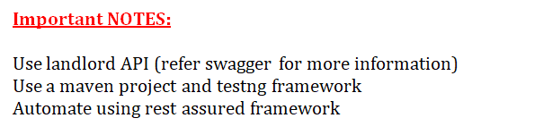

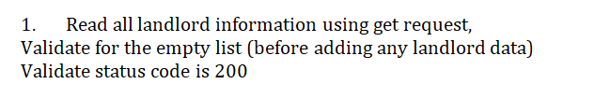

Submitted the answer in Drive

Don't know the answer

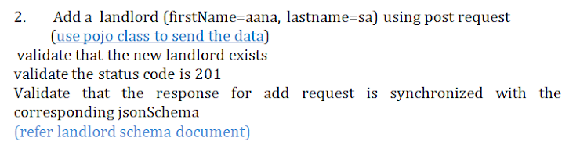

Submitted the answer in Drive

Don't know the answer

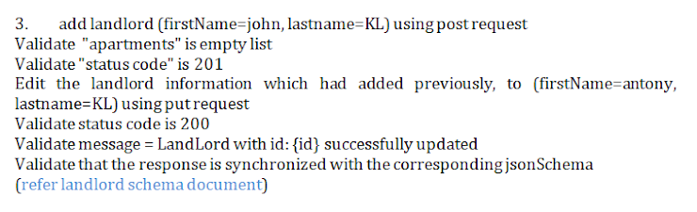

Submitted the answer in Drive

Don't know the answer

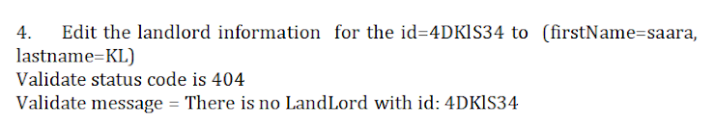

Submitted the answer in Drive

Don't know the answer

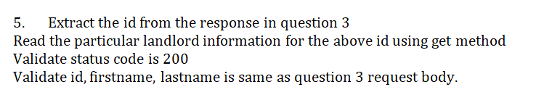

Submitted the answer in Drive

Don't know the answer

BACK

SUBMIT

Never submit passwords through Google Forms.

Bottom of Form

This form was created inside of TekArch. [Report Abuse](https://docs.google.com/forms/d/e/1FAIpQLSecseUiYD56Zwz602bkaWGVp-9weAbpY-ze94qlgHZZBBo4gQ/reportabuse?source=https://docs.google.com/forms/d/e/1FAIpQLSecseUiYD56Zwz602bkaWGVp-9weAbpY-ze94qlgHZZBBo4gQ/viewform) - [Terms of Service](http://www.google.com/accounts/TOS)

[Forms](https://www.google.com/forms/about/?utm_source=product&utm_medium=forms_logo&utm_campaign=forms)