Vaughn College of Aeronautics and Technology

Fundamentals of Mechatronics Laboratory

Mce 310-L

Lab 2

Function Blocks in PLC Programs

Prepared for:

Dr. Miguel Bustamante

Experiment Conducted by:

Jason Becker

Omomhene Eimunjeze

Tylar Giraud

Date of Experiment: 3/7/19

Due Date: 3/14/19

**Table of Contents**

Objective 2

Equipment 2

Results 3

Conclusion 11

References 11

# 

# **Objective**

In this lab, we are supposed to code and test a wide variety of codes and task to be performed on the UniTrainer. In addition, we are supposed to get familiar with function blocks in PLC programming language. As well as code these problems in both Instruction Language (IL) and Structured Text (ST).

## **Equipment**

* LUCAS-NUELLE Labsoft, PLC and Bus technology
* UniTrain Experimenter SO4203-2B

### 

### 

### 

### 

### 

### **Results**

Question 1

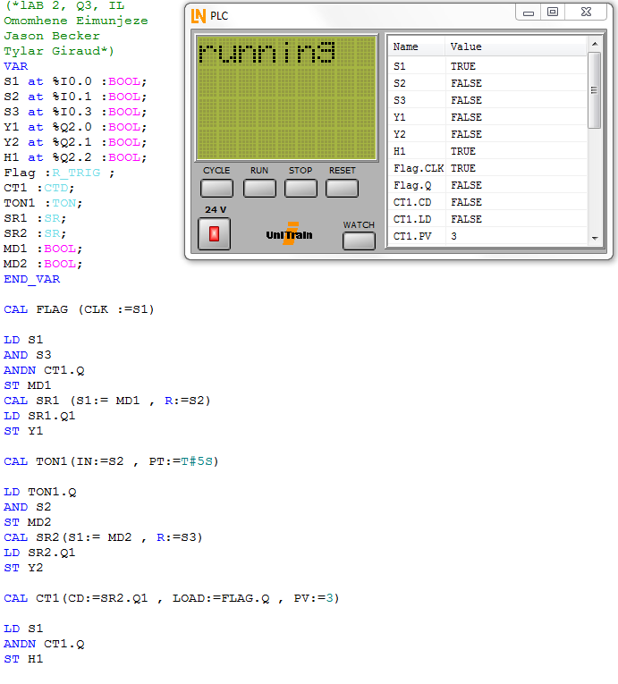

Explanation:

In the first question, we were giving a real world example of using water to clean metal components. Using Set Reset or SR function in the code Having to toggle the on/ off switch the hydraulic process to activate three times and upon the last time of the process, the cleaning process or Q2.2 should activate. This program was written in ST.

Question 2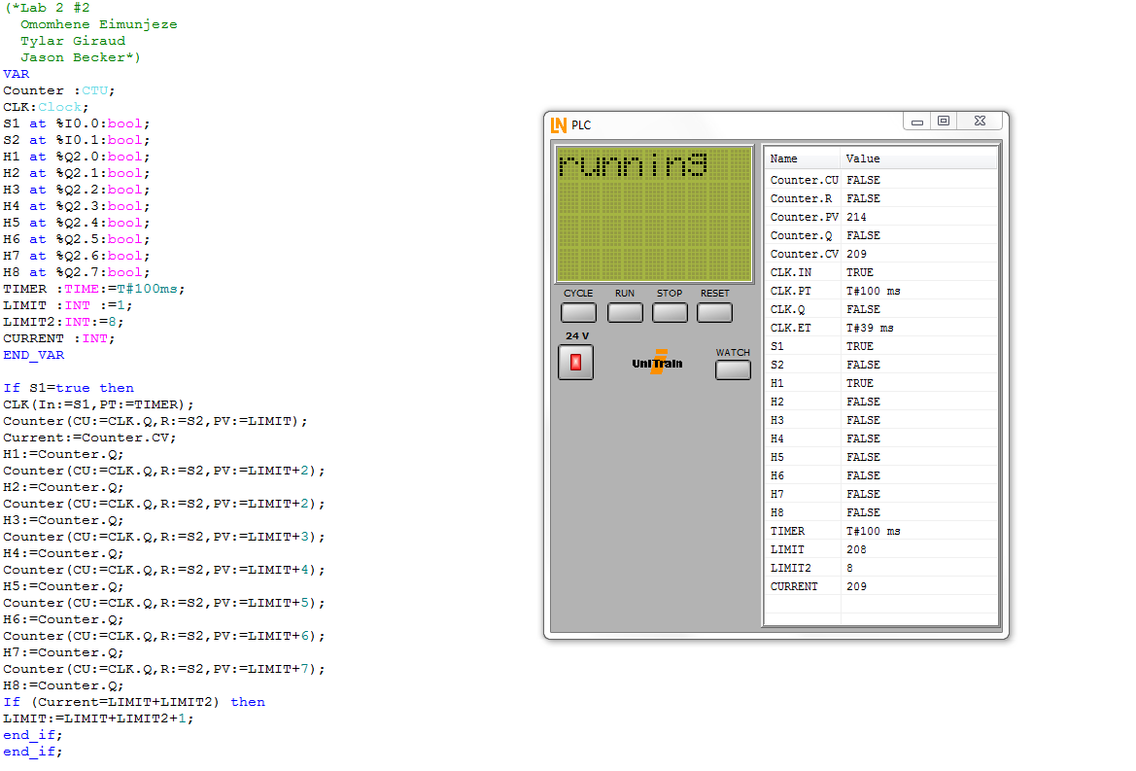

Explanation:

Question 2 (seen above) is a real world example of airport runway landing lights. Using ST, we used SetReset function to activate the next light and the next from there. Using two Limits, we can control when the last light should light and then repeat indefinitely.

Exercise 1-1

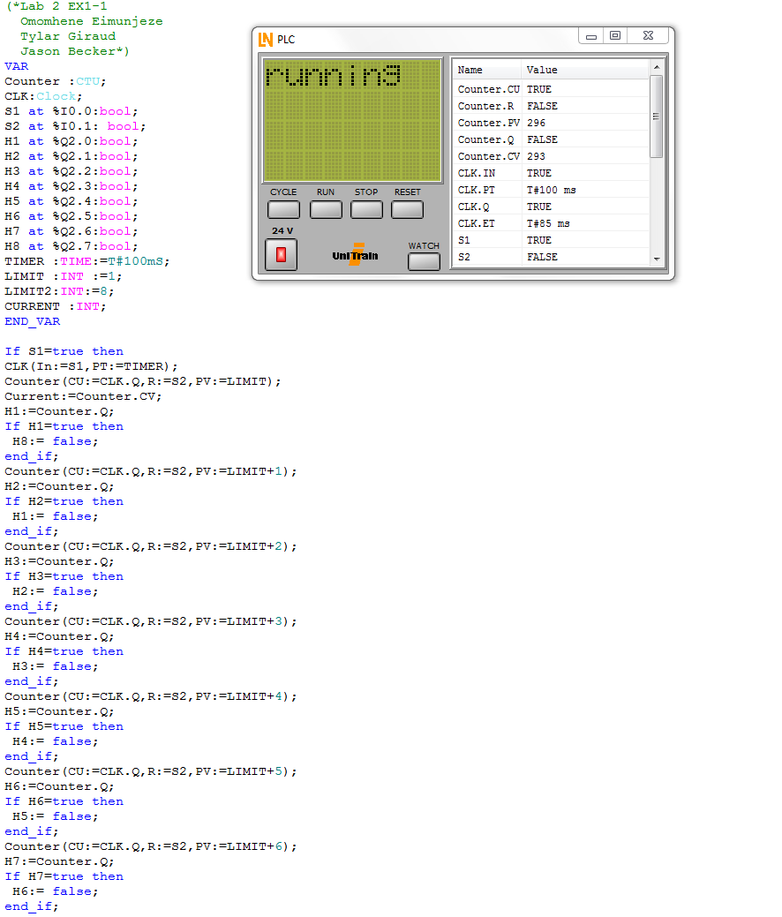

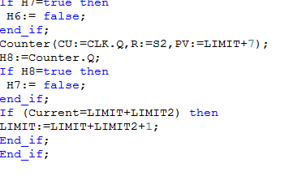

Explanation

In this exercise, we took the landing light example from the previous question and tweaked it to turn off the previous light when moving to the next light. This code would repeat itself indefinitely as well.

Exercise 1-2

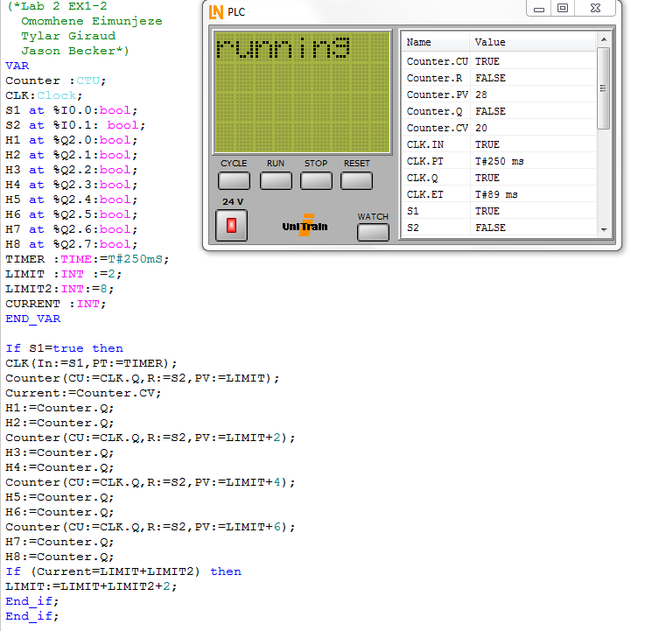

Explanation

Much like the previous code, Exercise 2 makes us display the light in pairs and this code again shall repeat indefinitely. Agin in Structure Text, we use set and reset functions to toggle the lights in the correct pattern.

Exercise 1-3

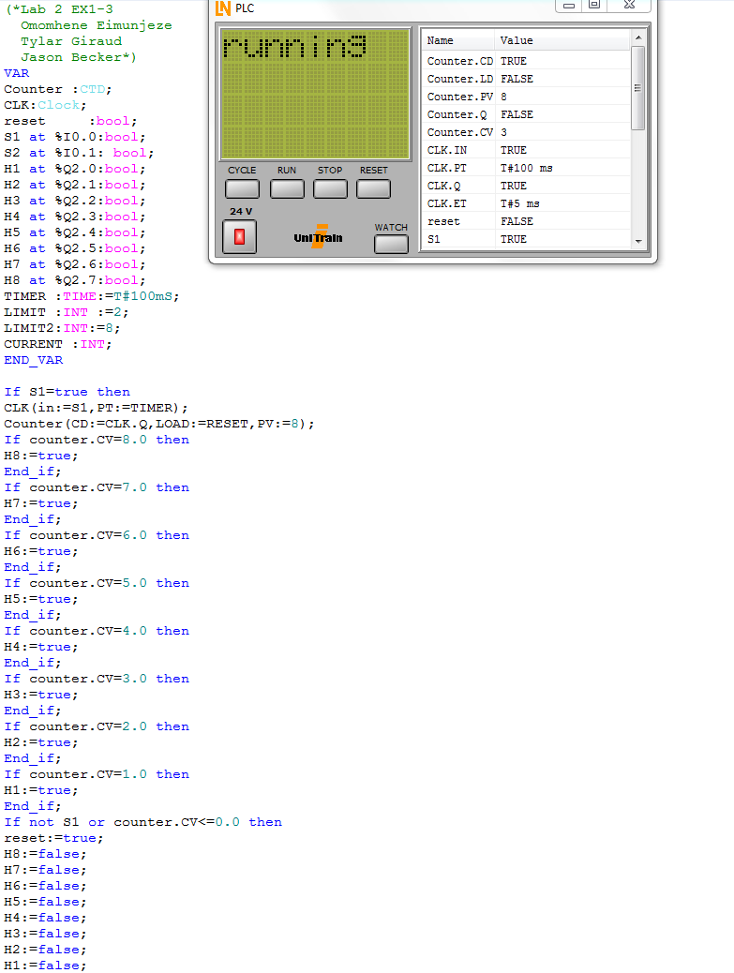

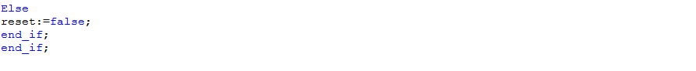Explanation:

In the above code, in Structure Text, we are supposed to count down from light 8 to light 1 and upon the light hitting one all lights are to shut off.

Exercise 2

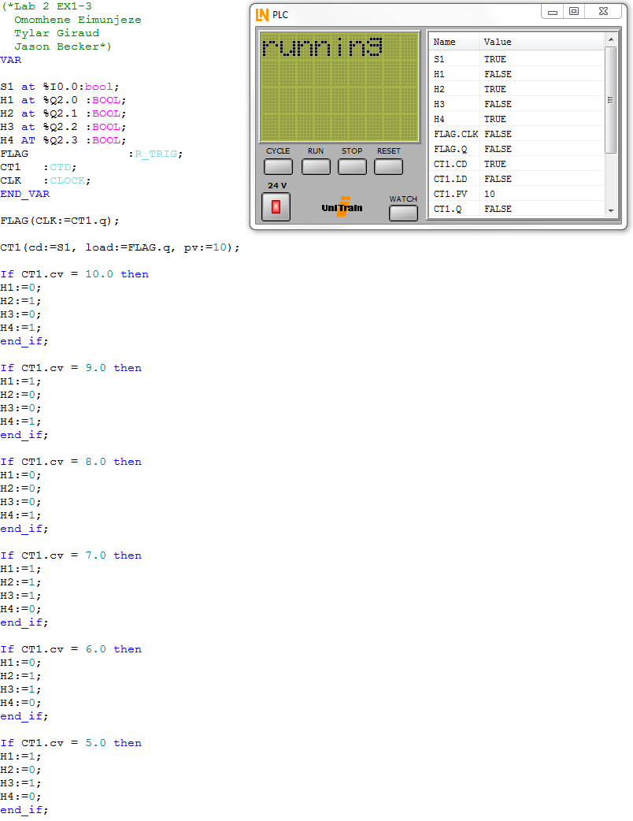

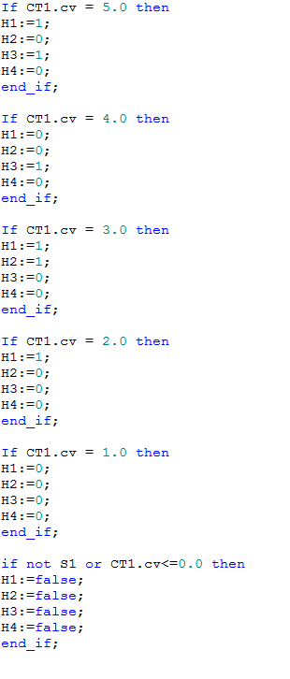

Explanation

In the code above, in Structure Text, we are supposed to use the countdown block to generate an the pulse input to count down from 10 to zero. The 4 lights that will display the number of the triggered, in binary.

#### **Conclusion**

In conclusion, this lab is a great introduction to a variety of functions such as the countdown block, function block and the set reset and reset set function in Labsoft. Using Structured Text, we can see a great application of real world examples handled in the coding language.

##### **References**

LUCAS-NUELLE L@Bsoft, PLC and Bus Technology – Function Blocks.