AN ANALYSIS AND DISCOURSE

*on the Origins of the World’s Seafood Supply with Respect to Our Cherished Continent’s*

SEA TURTLES

*and the Most Glorious Differences betwixt Their and Their Well-Known Counterpart’s*

SPINY BRISTLES’ EFFECTIVENESS

*Regarding Defensive Abilitiyes Most Numerous Vis-à-vis Our*

MAGNIFICENT FISHERMEN’S

*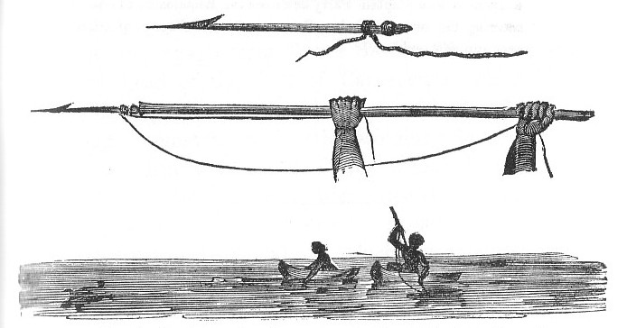Assiduous and Persistent Intrusions into Their Private Affairs*