MOCK GROUP DISCUSSION FOR PLACEMENT PREPARATION
07.01.2026 – 04:30 PM
A mock Group Discussion session was organized by senior students as part of placement preparation. The objective was to give juniors a clear understanding of how GD rounds are conducted during recruitment and how they help in evaluating candidates’ communication, thinking ability, and teamwork.
The session included two types of discussions. The first was an open format, where participants could share their ideas freely in a relaxed setting, helping them gain confidence and improve clarity of expression. The second was a competitive format, where participants had to actively take part, present strong points, and respond to others to make their presence noticeable.
Participants also learned the importance of listening to others, structuring their thoughts quickly, and maintaining relevance in the discussion. Time management and equal participation were emphasized during the activity.
At the end, seniors provided feedback on both individual performance and overall group coordination. They also shared useful tips on speaking confidently, initiating or concluding discussions, and maintaining a respectful and professional approach.
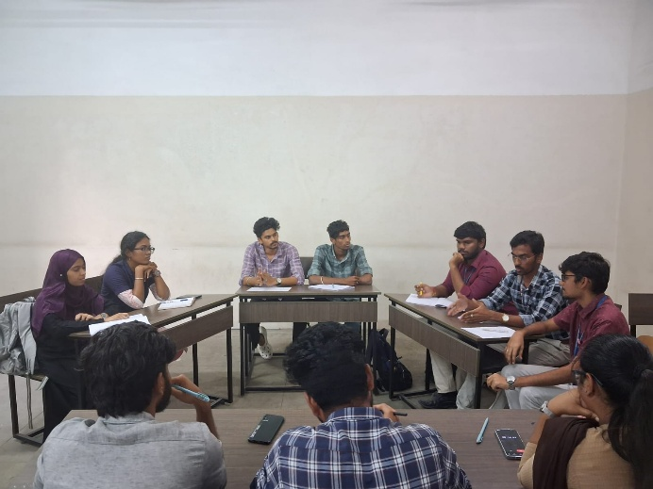
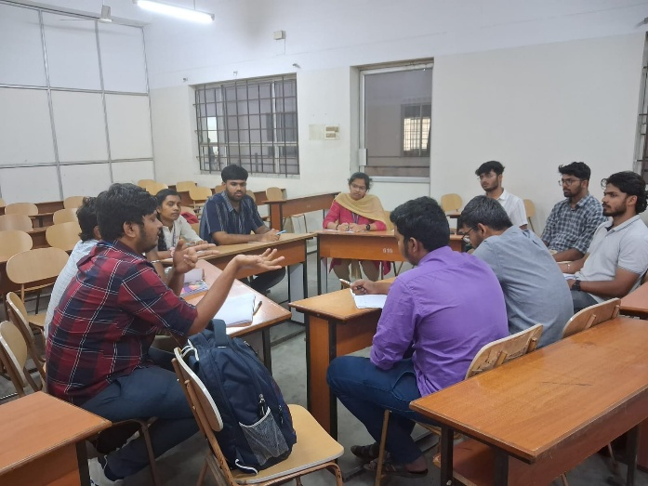
Overall, the session helped participants develop better communication skills, improve their confidence, and gain practical exposure to real placement GD scenarios.

