GENESIS 2025
02-09-2025

“Just like the first light of dawn brightens the world, every new beginning carries the warmth of hope and the promise of growth.”

The ECE Association started its academic year for 2025-2026 with its main event, ‘Genesis 2025’, on 6 September 2025 at the ‘F’ Block Assembly Hall. This occasion symbolized a fresh start for the department and showed the association’s dedication to innovation, unity, and student success. Mrs. Vanitha Kumar, Senior Vice-President of Software Engineering at Qualcomm Technologies in California, USA, was the Chief Guest. Her impressive career and leadership in engineering inspired the young audience.

Other notable guests included Dr. V. Krishnaveni, Head of the Department of ECE; Dr. L. Thulasimani, Faculty Advisor of ECEA; Mr. N. Nabuhan, Secretary of ECEA; and Ms. Neha Babu Rajkumar and Mr. T. Visnu Tharshan, Co-Secretaries of ECEA, along with faculty members and students from the department. The ceremony began with a moving performance of Tamizh Thaai Vaazhthu by Ms. Prathusha, a Third Year ECE student. Dr. L. Thulasimani then delivered a warm Welcome Address, setting an uplifting tone for the day.

Dr. V. Krishnaveni, the Head of the Department, followed with the Presidential Address. She shared valuable insights about the department’s growth, placement successes, and collaborative research projects. Her encouraging words motivated students to strive for excellence with focus and determination. Next, an engaging video presentation took the audience on a “Visual Journey through ECEA,” highlighting the association’s milestones and previous achievements.

Ms. Neha Babu Rajkumar, the Co-Secretary, presented the Year Plan for 2025-2026, outlining the association’s goals for academic and extracurricular development. The focus was on building leadership, technical skills, and community involvement.
Several top-performing students who landed prestigious placements shared their success stories and experiences, offering insights into the perseverance needed to reach professional goals.

Ms. K.C Meera Ramani, introduced Chief Guest Mrs. Vanitha Kumar. Her standout career at Qualcomm serves as a model of dedication and innovation. In her speech, Mrs. Kumar stressed the importance of flexibility, ongoing learning, and integrity for achieving goals. She encouraged students to dream big, remain resilient, and view challenges as opportunities for growth. Her message resonated strongly with the audience.

A key moment of the event was the recognition of Academic Toppers and Winners of the Innovation Practices Laboratory for the 2024-2025 academic year. The awards were given by the Chief Guest and the Head of the Department, acknowledging the students’ dedication to excellence and creative problem-solving.

The event concluded with a Vote of Thanks from Mr. T. Visnu Tharshan, Co-Secretary of ECEA. He expressed sincere appreciation to the Chief Guest, dignitaries, faculty, and students for contributing to a successful day. The gathering ended with the National Anthem, leaving everyone feeling energized and proud.
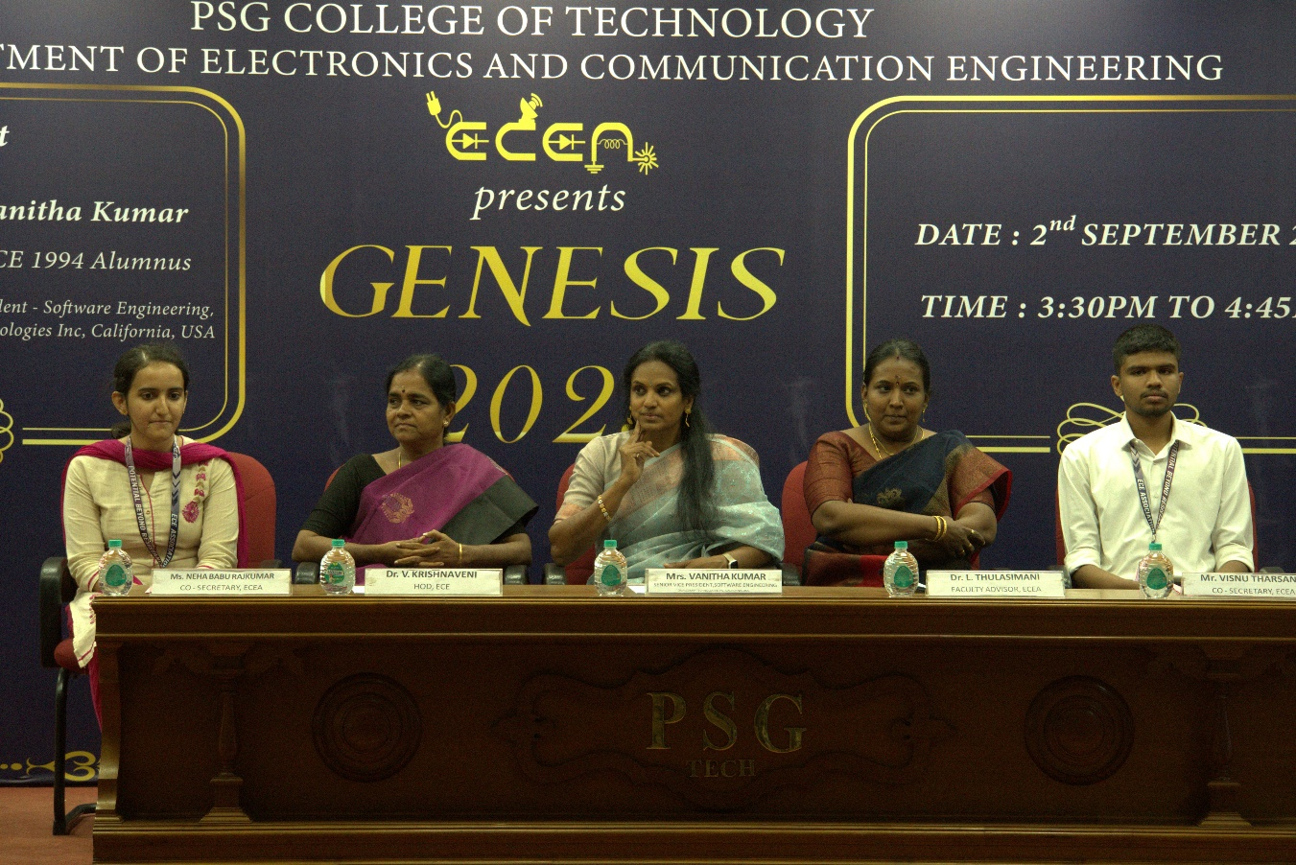
Fig. 1: The Chief Guest seated along with the Head of the Department, Faculty Advisor, and Co-secretaries of the ECE Association

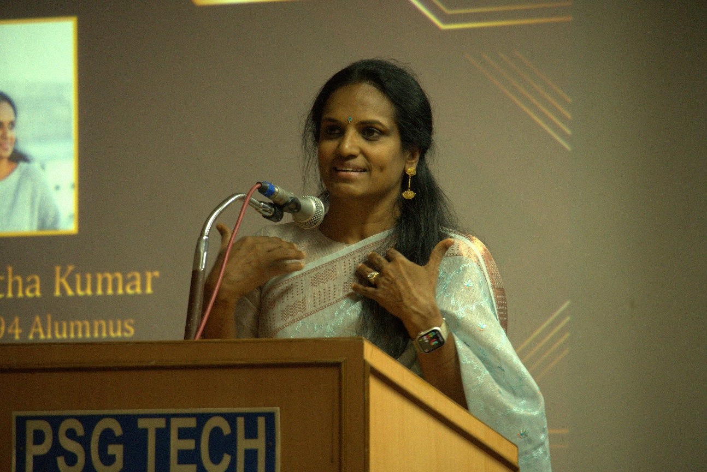
Fig 2. An inspirational speech was delivered by the chief guest of the day Mrs. Vanitha Kumar

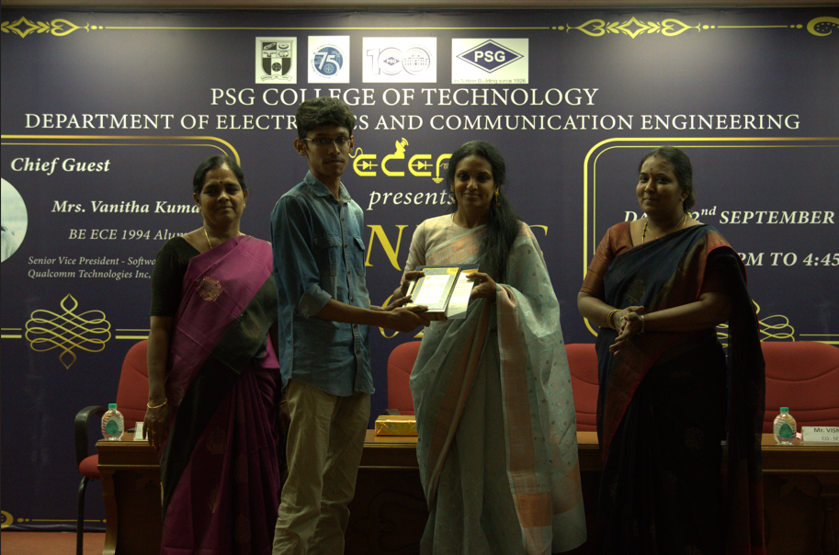
Fig 3. The toppers of even semester For the academic year 2024-2025 were honored.

