PSG COLLEGE OF TECHNOLOGY
COIMBATORE



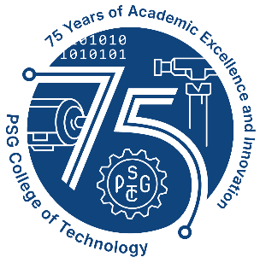
DEPARTMENT OF ELECTRONICS AND COMMUNICATION ENGINEERING



REPORT OF THE INDUCTION PROGRAMME 2025 - 2026
08.08.2025 -14.08.2025

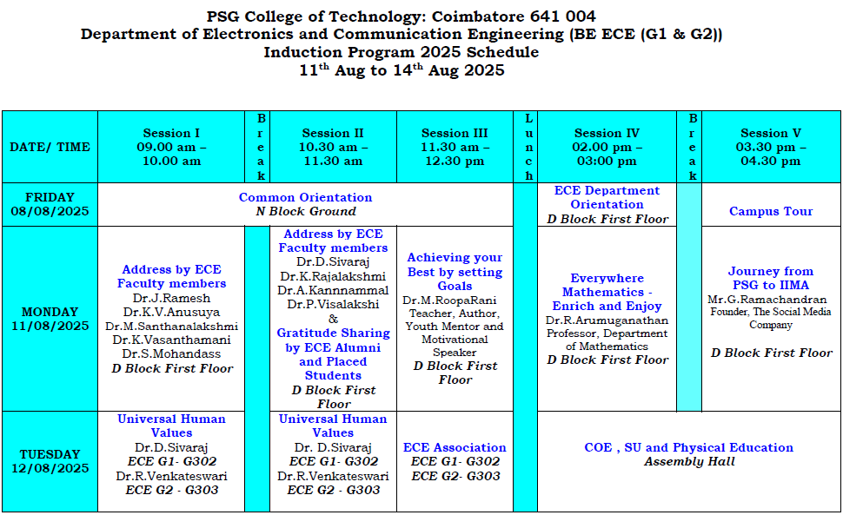
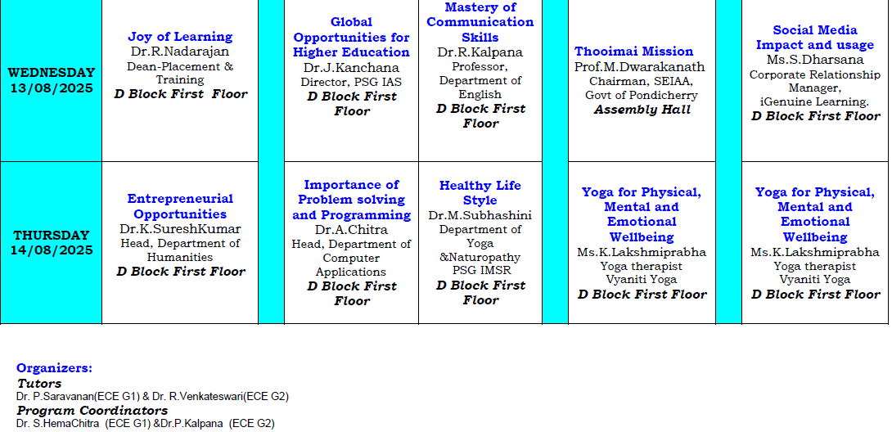

Report on the Inaugural of the Five day Induction Ceremony held on 08.08.2025 to 14.08.2025
ORIENTATION DAY DATE: 08.08.2025
TIMING: 2:30pm - 4:00pm

The students of the batch 2025-2029 had their department orientation where the students were enlightened regarding various details. Professors welcomed the students and gave a detailed description on different aspects such a duration and structure of program, feedback processes etc.
Firstly, Dr. V Krishnaveni, Professor (CAS) and Head of department of ECE welcomed the gathering. Followed by Dr. S. HemaChitra, Associate professor, Department of ECE addressed the gathering on Duration and structure of program for the BE ECE Regulation 2023.Secondly, Dr.P.Saravanan,Associate professor and the class tutor for ECE G1 gave a note on feedback processes. Furthermore, Dr.R.Vekateshwari, Associate Professor and the class tutor of ECE G2 shared her insights on Assessment and Passing requirements for the BE ECE 2023 Regulation. At the end, the students were taken around the campus for the campus tour.

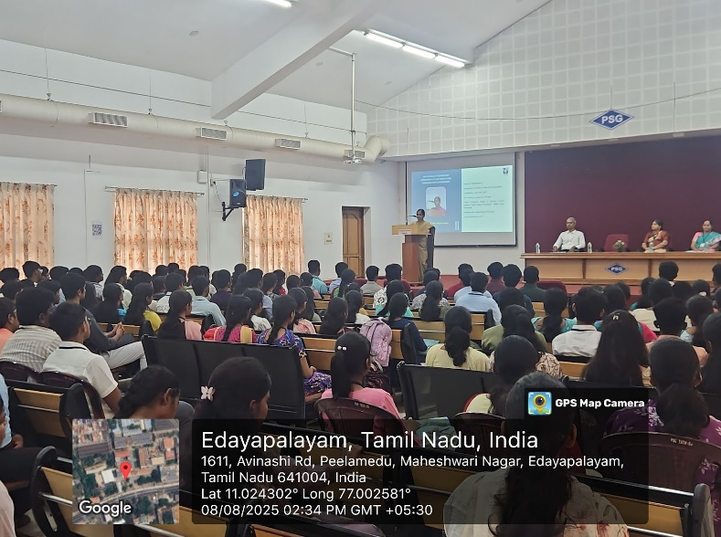

Faculties addressing the students

INDUCTION DAY 1 DATE: 11.08.2025
TIMING: 9:00pm -11:30pm
Session 1: Address by ECE Faculties, ECE Alumni and the Chief Guest

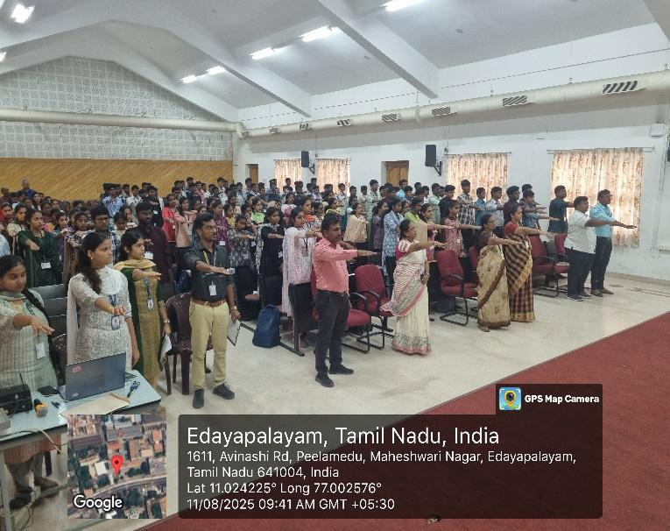
On Monday, as a part of induction program students were addressed by ECE faculties for giving them a broad perspective on various topics. Session began with Dr. J Ramesh, Professor, ECE Department, who shared his insights on the importance of discipline in academics and professional life which was inspiring to us to uphold it in our daily life and throughout the professional journey .Followed by Dr. K. V. Anusuya, Associate Professor, Department of ECE, addressed the Significance of Academic Performance. Next, Dr. M. Santhanalakshmi, Associate Professor, addressed the gathering on Attendance Requirements.
Students taking an oath

Thirdly, Dr. K. Vasanthamani, Assistant Professor, shared her insights on the Institution’s Innovation Council (IIC) and its pivotal role in fostering innovation and entrepreneurship. Furthermore, Dr. S Mohandass, Associate Professor, Department of ECE, gave his interpretations on Institution of Electronics and Telecommunication Engineers (IETE) and shared how it provides valuable knowledge to the students.In addition, Dr. D. Sivaraj, Assistant Professor and Placement Coordinator of ECE Department gave a description on Placements. Next, Dr. A. Kannammal, Associate Professor gave a note on NPTEL and Online Courses and its value in enhancing learning and professional development. Meanwhile, Dr. P. Visalakshi, Professor, ECE Department, enlightened the audience on the importance of alumni support and how it contributes to academic advancement and community building. Importantly, few accomplished students from the present final year who have secured placements in prestigious companies addressed the gathering and shared their journey at PSG College of Technology and provided insights into how they achieved their success. Finally, the fresher’s were addressed by the chief guest, DR.ROOPA RANI M, visiting professor in Mechanical engineering department of PSG College of Technology, Coimbatore.
TIMING: 2:00pm-3:00 pm
Session 2: Everywhere Mathematics – Enrich and Enjoy

On August 11, 2025, Dr.R.Arumuganathan delivered an insightful session titled “Everywhere Mathematics – Enrich and Enjoy” as a part of the induction programme at the D block Conference Hall first floor.The session was enlightening, providing students with valuable perspectives on the omnipresence and applicability of mathematics in engineering.He actively engaged the session by asking creative and thought provoking questions to the students, making sure that every student was involved throughout the session.
The importance of Mathematics in Electronics and Communication Engineering using various real life scenarios were highlighted. Explanation to terms like - Existence of solution, Mathematical modelling etc were given in the session. Real time applications of Probability and Statistics were shared in the session. Finally the importance of mathematical knowledge to simplify the process of coding enabling engineers to write efficient code with fewer lines was also demonstrated in the session. The session was concluded as the speaker shared the importance of problem solving skills and the applications of Mathematics in the various domains of Engineering.

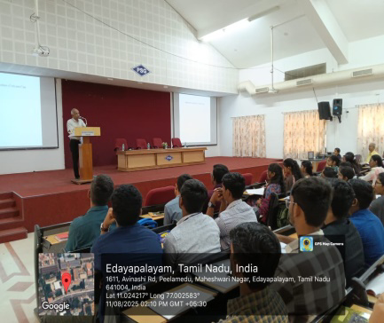
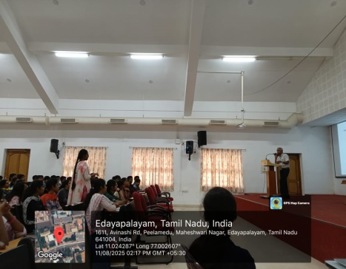
Speaker sharing his insights
Students sharing their ideas

TIMING: 3:30pm - 4:30 pm
Session 3: JOURNEY FROM PSG TO IIMA

Mr. G. Ramachandran, Founder of The Social Media Company, is a visionary leader whose work blends innovation, mentorship, and professional excellence. With his entrepreneurial background, he brings real-world insights to students, encouraging them to look beyond textbooks and embrace the skills that shape true success. His sessions focus on the mastery of time management, the art of clear and persuasive communication, and the value of teamwork in achieving collective goals. He highlights the importance of choosing Electronics and Communication Engineering (ECE) as a pathway to diverse opportunities in technology, research, and entrepreneurship, showing students how their field is deeply connected to the evolving digital age.
Beyond academics, he nurtures personal development by guiding learners to overcome stage fear, build confidence, and step into leadership roles. Under his mentorship, students are motivated to take charge of organizing events, managing responsibilities, and presenting themselves with poise, thereby gaining practical exposure alongside theoretical knowledge. With his inspiring approach, Mr. Ramachandran not only educates but also empowers the next generation to become skilled professionals, confident communicators, and responsible leaders ready to Make a meaningful impact on society.

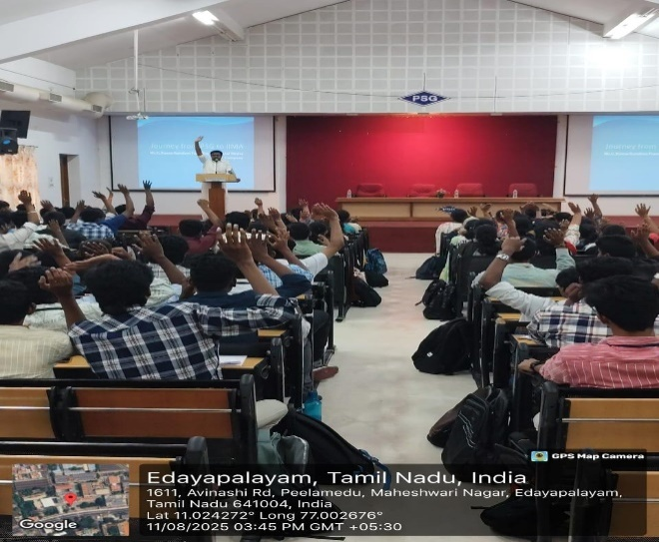
Interaction with students

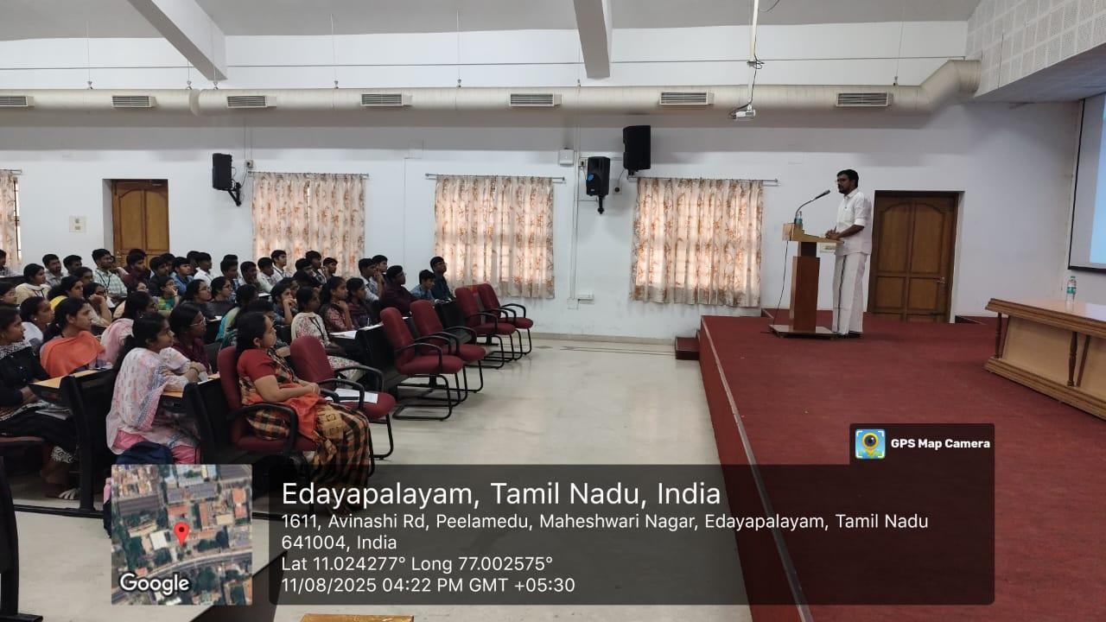
Speaker sharing his experience

INDUCTION DAY 2 DATE: 12.08.2025
TIMING: 9:00 am – 11:30 am

Session 1: Universal Human Values (G1)
A session on Universal Human Values was conducted by Dr. D. Sivaraj from the Department of ECE, PSG College of Technology. The session emphasized that the basic human aspiration is continuous happiness and prosperity. Dr.Sivaraj explained that while physical facilities like food can satisfy the body, they alone cannot ensure happiness. Unlike animals, human beings are a coexistence of self and body, where the self requires feelings of relationship and right understanding. He stressed that happiness comes when the needs of both body and self are fulfilled in balance.
The three essentials identified for continuous happiness are Right Understanding, Relationship, and Physical Facility. Engaging stories and real-life examples highlighted the importance of values, compassion, and prosperity through contentment. Students actively participated in discussions and debates, making the session lively and reflective. The program sowed the seed for continuous happiness, inspiring students to live meaningfully with responsibility and joy.

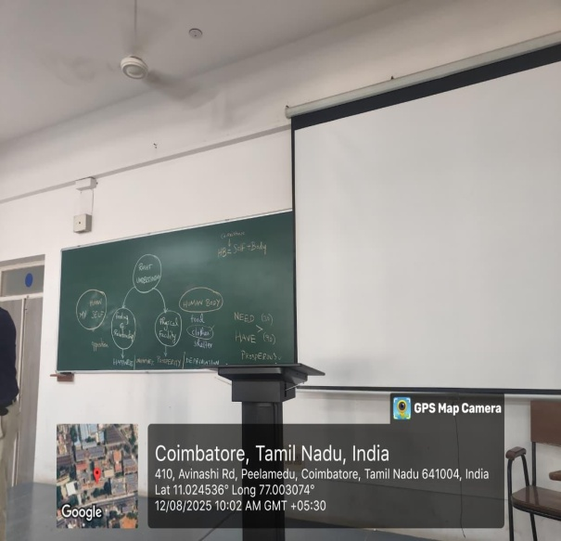
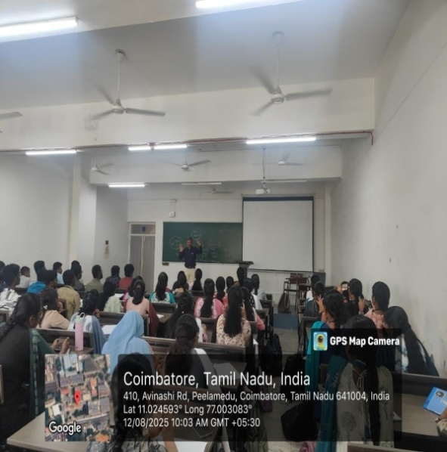
Explaining different types of human emotions

Interaction with students

Session 1: Universal Human Values (G2)
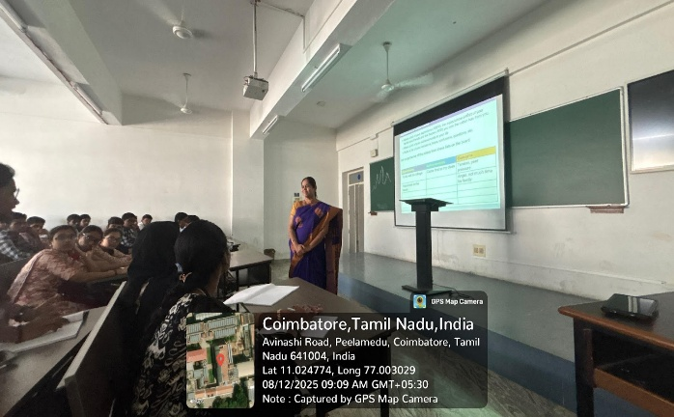
A session on Universal Human Values was conducted by Dr. R. Venkateswari from the Department of ECE, PSG College of Technology. The session focused on the idea that the fundamental human aspiration is continuous happiness and prosperity. Dr.Venkateswari highlighted that while physical facilities such as food can meet the needs of the body, they alone cannot guarantee lasting happiness. She explained that unlike animals, human beings are a combination of both self and body, where the body needs physical resources, but the self seeks right understanding and fulfilling relationships. True happiness, she emphasized, can be achieved only when the requirements of both body and self are addressed in harmony.
,Dr.Venkateswari sharing her insights
The three essentials identified for continuous happiness were Right Understanding, Relationship, and Physical Facility. Through inspiring stories and practical examples, Dr.Venkateswari illustrated the significance of human values, compassion, and prosperity attained through contentment. Students enthusiastically engaged in discussions and interactive debates, making the session both thought-provoking and lively. The program instilled in the participants the essence of living with responsibility, joy, and meaningfulness, planting the seed for continuous happiness in their lives.
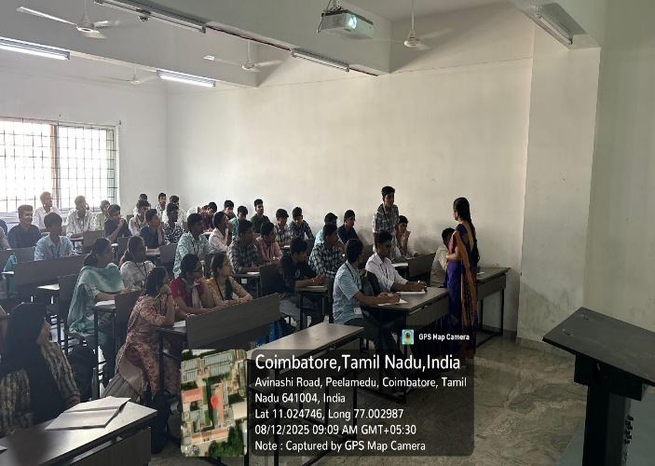
Dr.Venkateswari explained that the fundamental aspiration of every human being is continuous happiness and prosperity. She highlighted that many times, people experience unhappiness because they do not reflect on the real reasons behind it. By understanding the causes of unhappiness, one can move towards making conscious choices that nurture inner satisfaction, right relationships, and holistic well-being.
Students expressing their views on human values

Through relatable examples and engaging discussions, she demonstrated how value education equips students to distinguish between temporary pleasures and lasting happiness. The interactive nature of the session encouraged students to share their perspectives, making it lively and thought-provoking.The program left the participants with deeper insights into responsibility, harmony, and the essence of living a life rooted in values.

TIMING: 11:30 am -12:30 pm
Session 2: ECE ASSOCIATION

The ECE Association members introduced themselves to all the first years. An ice breaker session was conducted and this provided a platform for all the fresher’s to get to know about different blocks in the college. A game “Block Hunt” was conducted where all the students were split into groups and were questioned. Upon answering correctly, it provides the path for them to the next block where another question would be put up. The team which completes visiting all the blocks and coming back to the class is considered as the winner. They were gifted with chocolates. This session gave a brief idea about the college map.

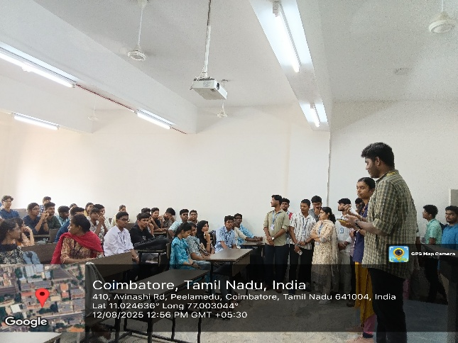
Introducing Association

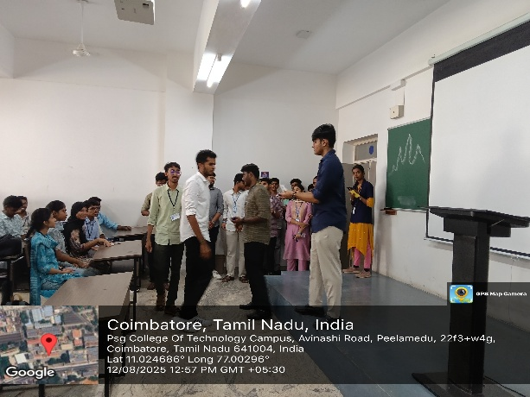
Announcing Winners

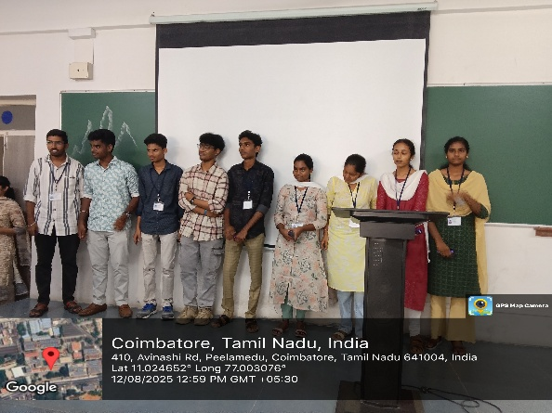
Prize Distribution

INDUCTION DAY 3 DATE: 13.08.2025
TIMING: 9.00am – 10.00 am

Session 1: Roadmap to Career Success – A Refresher for Placements
A session on placement preparation was conducted by Dr. R. Nadarajan, Placement Dean of PSG College of Technology, where he delivered an inspiring talk on how students can face upcoming placements with confidence and clarity.
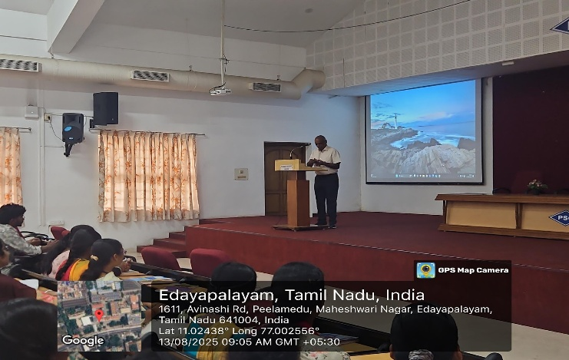
Dr.R.Nadarajan addressing the students
He stressed that while technical knowledge forms the base of engineering, it is communication, confidence, and consistency that help candidates stand out in interviews. He also pointed out that recruiters value not just problem-solving ability but also teamwork, adaptability, and a continuous learning mindset.
Dr.R. Nadarajan advised students to make the most of their college years by treating every project, lab work, and presentation as steps toward their career growth. He emphasized that placements should be seen not merely as securing a job but as building a career aligned with one’s skills and passion.
The session remained interactive, with students voicing their concerns and expectations. Dr. Natarajan reassured them that regular Preparation through mock interviews, aptitude practice, and soft-skill improvement—can transform fear into confidence. He concluded by encouraging students to stay disciplined, believe in themselves, and keep learning, as opportunities favor those who are prepared.

TIMING: 10.30am -11.30 am
Session 2: Global Opportunities for Higher Education
Dr. J. Kanchana delivered a presentation on Global Opportunities for Higher Education, emphasizing the two pillars of PSG IAS—NRIIC and International Education. The NRIIC focuses on thrust areas such as nanomaterials, clean energy, smart coatings, sensors and energy storage, and healthcare products. To strengthen these fields, the institute provides opportunities through international collaborations, Indo-US bilateral workshops, visits from expert professors, and the organization of workshops, conferences, and seminars. Faculty and students are also deputed for training, PhD programs, in-country PhDs, and postdoctoral fellowships, leading to significant research publications and patents.
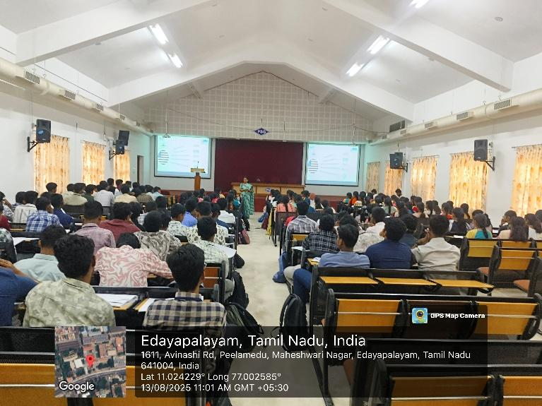
Dr. J. Kanchana addressing the students
The institute is equipped with advanced facilities, including a clean room with thermal and beam evaporators, DC and RF sputtering, RADAK sources, a Parylene coater, an Inductively Coupled Plasma-CVD system, and a parametric analyser with a probe station. These facilities have enabled international collaborations, industry partnerships, patents, technology transfers, centers of excellence, and increased funding for projects.
On the international education front, PSG IAS maintains collaborations with universities in the UK, Germany, Switzerland, and Australia, aiming to expand partnerships, develop bilateral research programs, introduce new courses, adopt innovative research approaches, and boost student enrollment, thereby strengthening its global presence.

TIMING: 11.30am – 12.30 pm
Session 3: Mastery of Communication Skills
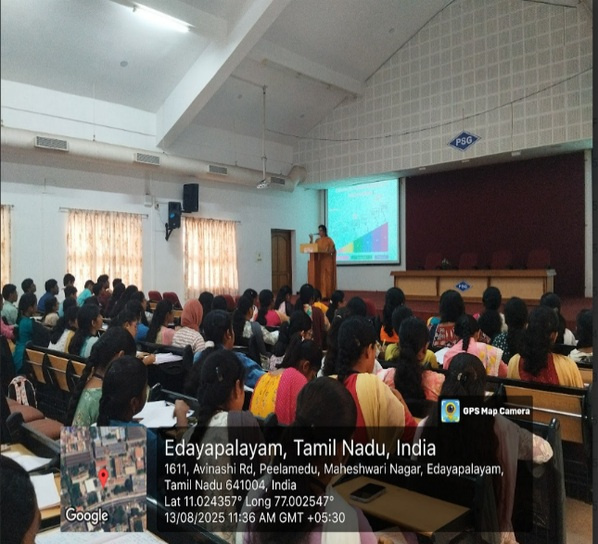
A session was conducted by Dr. Kalpana R from the Department of English, PSG College of Technology, providing an overview of the Common European Framework, which classifies individuals into different levels based on their English language proficiency. She explained that, as per the framework, school graduates are expected to reach level B1; however, this is often not achieved, making it necessary for students to improve their speaking skills during college to become job ready.
Dr. Kalpana R Addressing the gathering
The session highlighted key aspects of spoken English such as fluency, vocabulary, and grammar, while also pointing out that written English is generally more formal than spoken English, where emotions can be conveyed more naturally. It was conducted in an interactive manner, encouraging students to share their views on what fluency means and how it can be developed. Several engaging exercises were included, prompting students to identify phrasal verbs, collocations, and connotations in a passage. The activities created curiosity among participants and enhanced their understanding of effective communication.

TIMING: 2.00pm – 3.00 pm
Session 4: Thooimai Mission
A special session on Waste Management and Sustainable Practices, The invited speaker, Dr. Dwarakanath, delivered the session, sharing valuable insights on the importance of sustainable living and effective waste management within the campus and hostels.
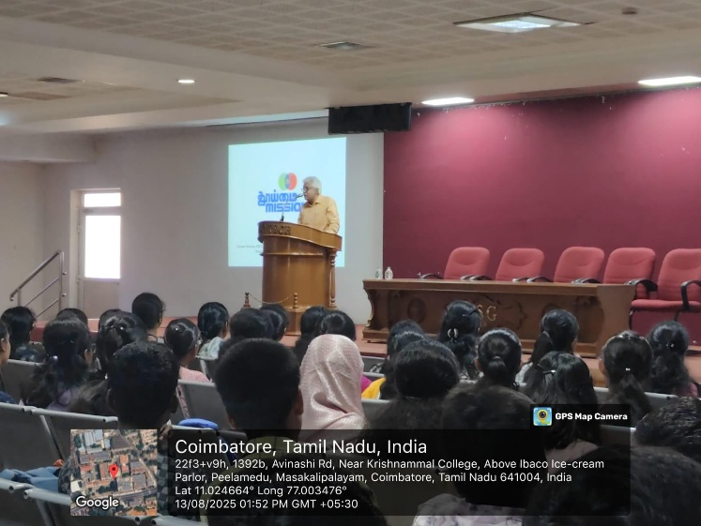
Prof .M. Dwarakanath addressing the gathering
The session aimed to create awareness among fresher’s about waste segregation, recycling, and eco-friendly practices. Dr. Dwarakanath began by addressing the challenges of solid waste in urban areas and sensitized students to the 3R principle: Reduce, Reuse, And Recycle.
He further explained the Waste Management Cycle at PSG, which includes segregation at source through designated bins—green for biodegradable, blue for recyclable, and red for non-recyclable wastes. He also highlighted practices such as composting biodegradable waste, recycling materials, and organizing awareness campaigns and workshops to encourage sustainable living.The session concluded with a call for students to adopt eco-conscious habits and contribute actively to building a cleaner and greener campus.

TIMING: 3.30pm– 4.30 pm
Session 5: Social Media Impact and Usage
The session on social media impact and usage was conducted by Ms.S.Dharsana. She introduced the STAR Method—Situation, Task, Action, Result—as an effective framework to present achievements clearly. Highlighting the scope of marketing, she emphasized that beyond technical knowledge, five essential skills stand out: communication, storytelling, digital skills, networking, and entrepreneurial thinking.
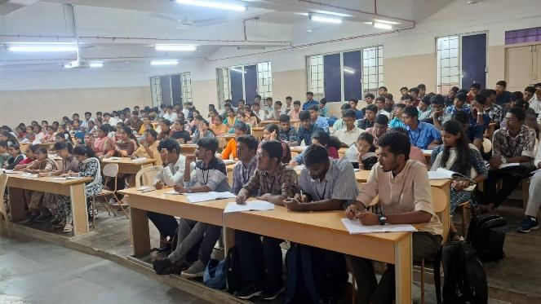
Students listening to Ms.Dharsana’s Session
Discussing market trends, Ms. Dharsana pointed to the rise of live influencer marketing roles, fuelled by rapid AI developments through tools like ChatGPT and DeepSeek. She underlined the importance of communication and storytelling, which requires explaining the context, challenge, process, result, and key takeaway. For engineers aiming to strengthen their online presence, she recommended platforms such as LinkedIn, GitHub, Medium, and X. LinkedIn should showcase a professional photo, headline, engaging summary, detailed experiences, and endorsements.
GitHub serves as a credible technical portfolio reflecting continuous learning, while LeetCode and HackerRank can help demonstrate coding readiness. She concluded by stressing that a strong online brand—built through networking and authentic portfolio display—is vital to succeed in today’s competitive, AI-driven job market.

INDUCTION DAY 4 DATE: 14.08.2025
TIMING: 9.00am – 10.00 am
Session 1: Natural and Healthy Diet
Dr.Subashini explained that the main objective of this session was to help students understand the importance of a healthy diet. She taught them about the significance of gut health and advised them to engage in regular physical activity. Students also learned about naturopathy, a system in which patients are treated without medicine. She advised us to avoid consuming excessive junk food, especially biscuits. Being a naturopathist, she explained how various disorders that affect a normal lifestyle can be cured and prevented
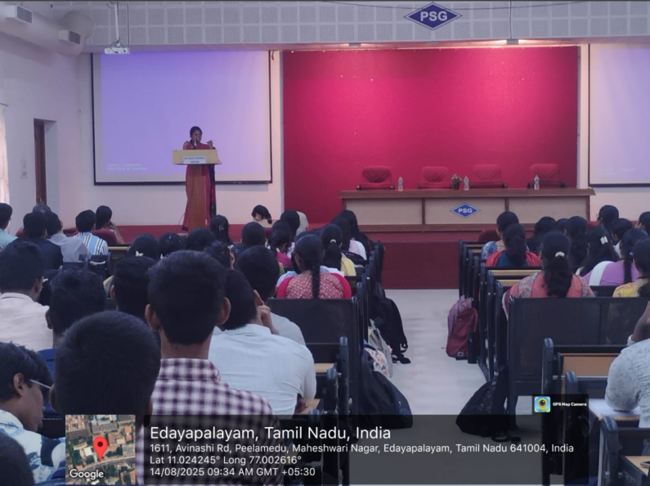
First year students listening to Dr.Subashini’s session

TIMING: 10.30am -11.30 am
Session 2: Importance of Problem Solving and Programming

Ms. Manoranjitham explained that the main objective of this session was to help students develop problem-solving skills, an essential ability for engineering students, especially in Electronics and Communication Engineering (ECE). She emphasized the need for a systematic approach to identifying, analyzing, and solving problems in both technical and everyday situations. Students were introduced to the IDEAL problem-solving method, the step-by-step programming process, and the importance of logical thinking, consistent practice, and seeking feedback. Through interactive logical puzzles, the session enhanced critical thinking and encouraged students to view challenges as opportunities to learn. The session was highly informative and interactive, helping students understand the structured approach required for effective problem-solving and programming.
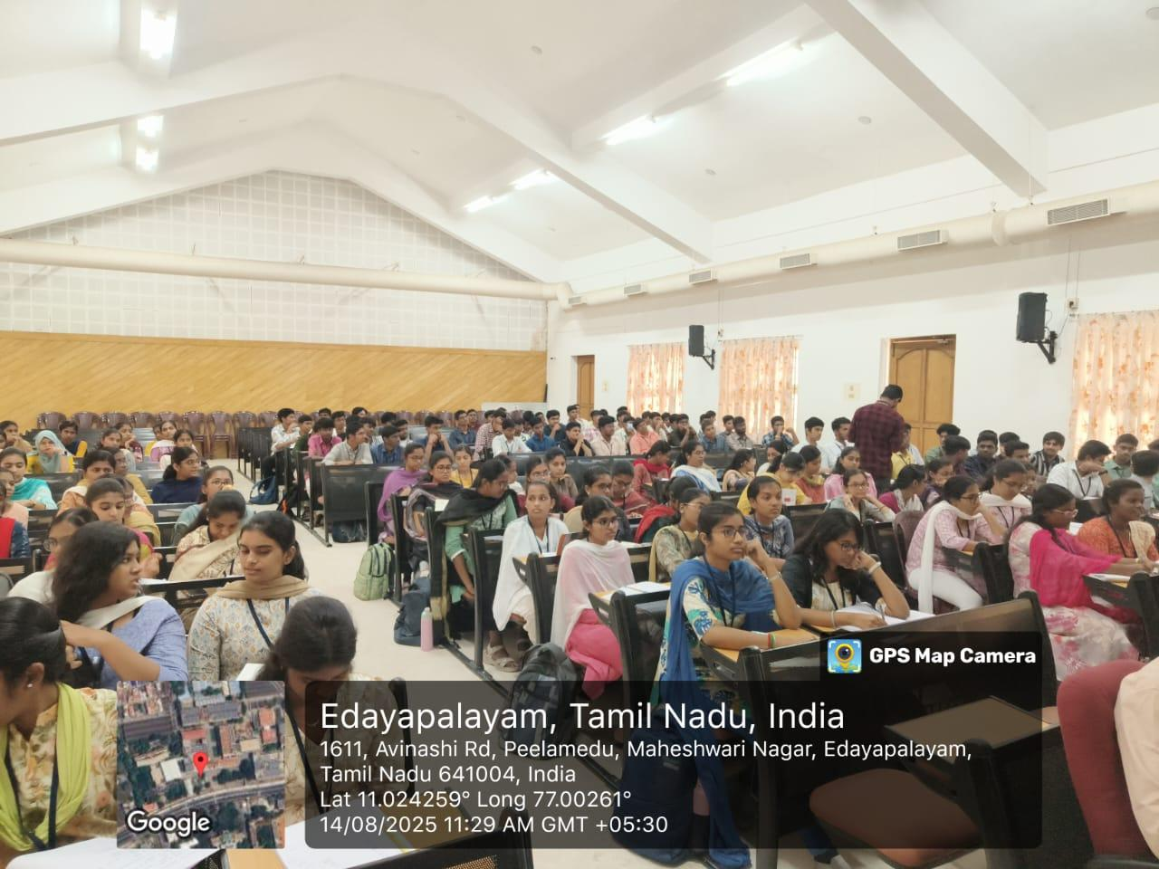
First year students attending the session

TIMING: 11.30am – 12.30 pm
Session 3: Entrepreneurial Opportunities

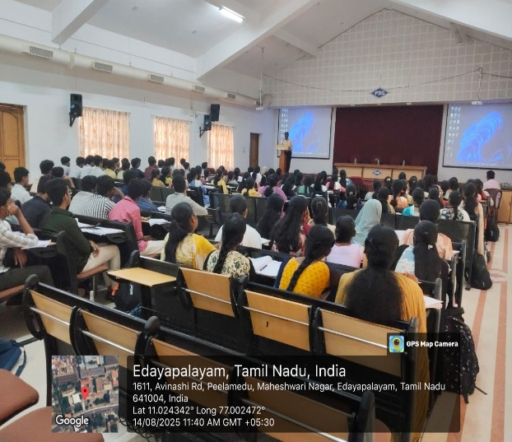
Session conducted by Dr. K. Suresh Kumar, Head of the Department of Humanities, PSG College of Technology, focused on the concept of entrepreneurship as a mind-set rather than merely starting a business. Entrepreneurship involves decision-making, risk-taking, creativity, and innovation. An entrepreneur is someone who does the right things at the right time, takes responsibility, and looks beyond routine work to create value. Even an employee can develop an entrepreneurial mind-set if they are willing to make decisions and go beyond their assigned tasks, whereas those who avoid risks remain only employees. The first five years after graduation are especially important for shaping this mind-set, as they determine whether one becomes a passive worker or an innovative professional. Listening well, learning continuously, and contributing ideas beyond regular duties are key traits that help transform an individual into an entrepreneur or intrapreneur, building a strong and meaningful career.
Students listening to Dr.K.Suresh Kumar

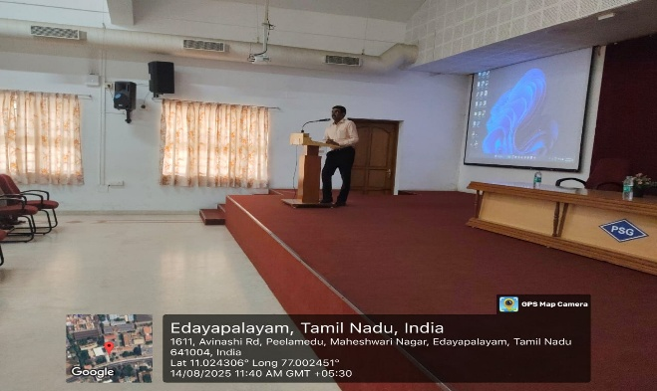
Dr.K.Suresh Kumar addressing the gathering

TIMING: 2.00pm – 4.30 pm
Session 3: Yoga For physical, mental and Emotional Wellbeing
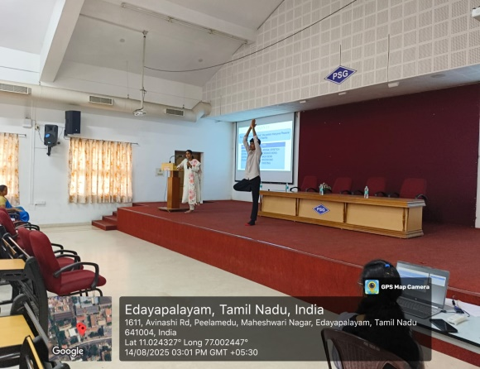
Ms. K. Lakshmiprabha conducted a session on yoga, highlighting its significance as a holistic discipline that unites the body, mind, and spirit while addressing the challenges of a fast-paced modern lifestyle. She began by explaining the true meaning of yoga and its role in promoting overall health, mental clarity, and spiritual growth. Students were introduced to the various branches of yoga, helping them understand the different approaches available to achieve physical fitness, emotional balance, and inner harmony. The speaker elaborated on the Eight Limbs of Yoga (Ashtanga Yoga) as described by Patanjali, emphasizing how self-discipline, mindfulness, and ethical living contribute to building a stable and peaceful life. She clarified that yoga is not merely a series of physical postures but a comprehensive way of living that enhances well-being at every level.
Yoga poses performed by students

Common misconceptions about yoga were addressed, encouraging students to view it as a practice that extends far beyond physical fitness. To make the session interactive and experiential, She guided students through pranayama (yogic breathing practices), allowing them to feel calm, focused, and energized. A volunteer demonstrated Vrikshasana (Tree Pose) under her guidance, during which she explained its benefits for improving balance, concentration, and stability. The session proved to be highly informative and motivating, creating awareness about yoga as a transformative practice for personal growth. By inspiring students to include yoga in their daily lives, the session conveyed its value as a tool for holistic development, emotional strength, and a disciplined lifestyle.
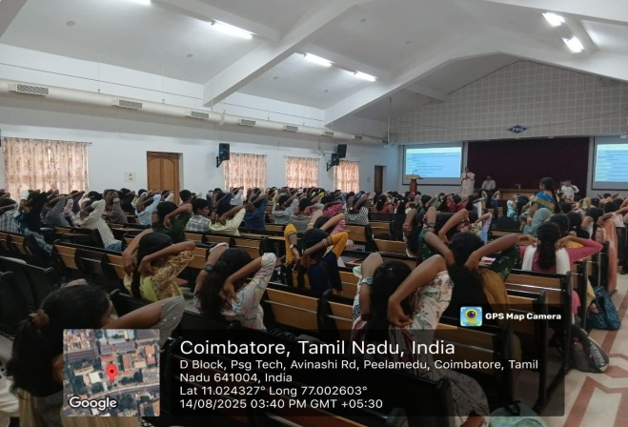
Students practicing yoga in the session

