DAY 1
21.02.2026
INAUGRATION
[09:00 AM – 10:00 AM]
• The formal inauguration of KAIRO was graced by our esteemed Chief Guest, Senthil Raja Sennimalai, Founder and Chief Executive Officer of NammaOffice.
• A proud alumnus of PSG College of Technology, he completed his Bachelor of Engineering in Electronics and Communication Engineering in 2005.
• He is widely recognized as a multifaceted business architect, known for building scalable and emotionally intelligent organizations.
• His entrepreneurial journey highlights the integration of infrastructure, operations, sales, governance, and brand into a unified growth framework.
• During the session, he shared valuable insights on leadership, innovation, and the importance of combining technical expertise with emotional intelligence.
• He emphasized the significance of structured thinking, adaptability, and purpose-driven entrepreneurship in today’s evolving business landscape.
• The session inspired participants to rethink their approach towards leadership, innovation, and building meaningful careers.
• The inauguration concluded with his motivating address, setting a strong and inspiring tone for the events of KAIRO.
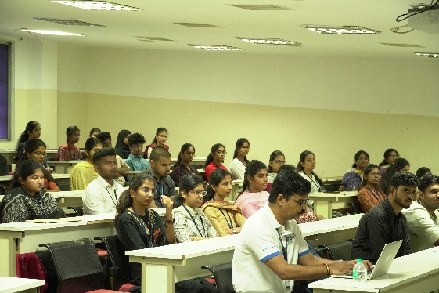
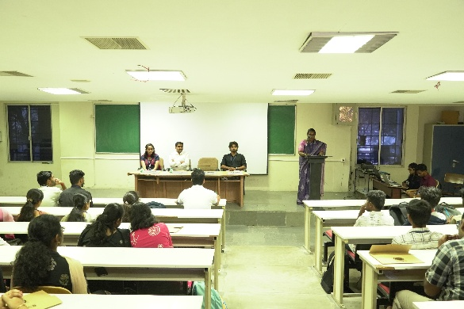
Participants attending the inauguration ceremony

WORKSHOP
FPGA Prototyping Using HDL: [09:00 AM – 05:00 PM]
- A hands-on workshop on FPGA prototyping using Hardware Description Language (HDL).
- Conducted by Mr. Sreejeesh from NIELIT, providing practical exposure to FPGA design.
- Focuses on learning Verilog and understanding modern digital design workflows.
- Includes explanation of FPGA architecture and the complete design process.
- Participants will practice writing and simulating Verilog programs.
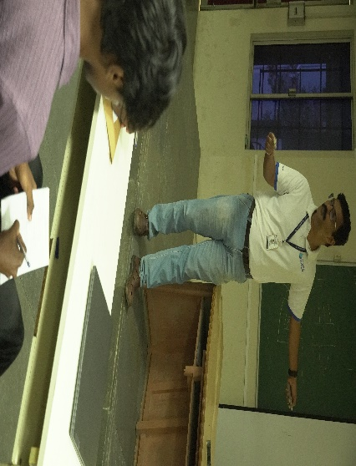
- The session concludes with real-time implementation and testing on FPGA hardware.
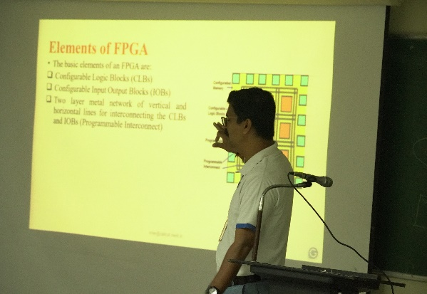

Session on basics of Digital Electronics and FPGA

Analog and Mixed-Signal Design using CADENCE Tools with Verilog-A and Verilog-AMS:[10:30 AM – 05:00 PM]
• A hands-on workshop on analog and mixed-signal design using Verilog-A and Verilog-AMS.
• Conducted by Michael Arul Abel JJ, Analog Education Application Engineer at Cadence Design Systems, Bengaluru.
• Focused on behavioral modeling techniques for analog and mixed-signal systems.
• Bridged theoretical concepts with practical, real-world design applications.
• Introduced participants to industry-relevant workflows using Cadence design tools.
• Provided insights into modeling, simulation, and verification of complex circuits.
• Participants gained exposure to best practices followed in the semiconductor industry.
• The session enriched students with practical knowledge and industry perspectives in analog and mixed-signal design.
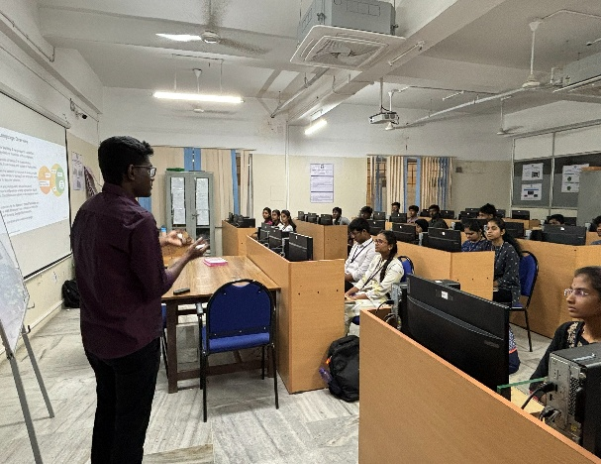
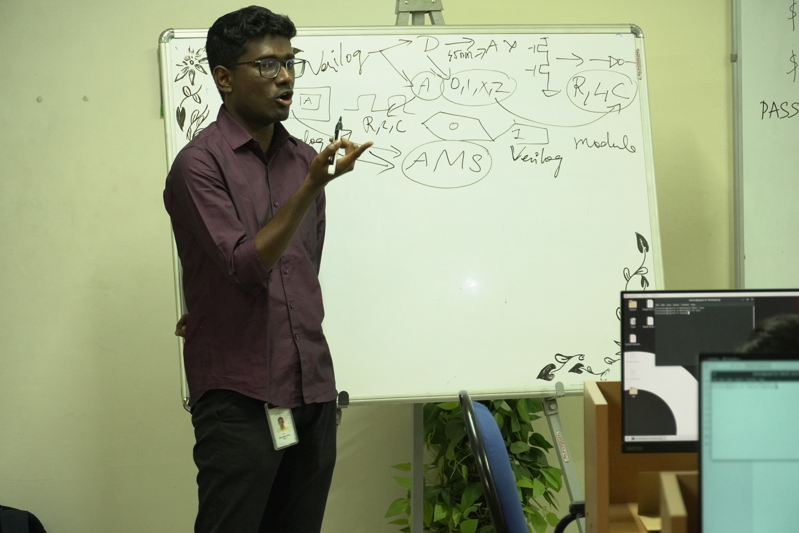
Participants attending the workshop

EVENTS
Epoch Sprint: [ 10:00 AM – 01:00 PM]
The Time-Travel Tech Challenge is a multi-round technical competition where teams journey through different eras to test their aptitude, hardware, and coding skills.
Round 1 – The Five Trials
- Teams travel through different eras and solve aptitude questions from each era.
- Teams can move to the next era only after completing the current one.
- The time taken to complete each era will be recorded.
Round 2 – Resonatia (Hardware)
- Teams must build a circuit to produce the given input and output.
- Components required for the circuit are earned by answering questions.
Round 2 – Zentrix (Software)
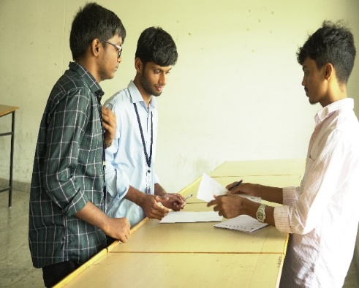
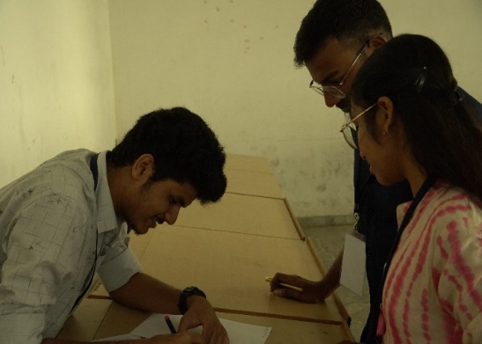
- Teams must solve coding problems using C or Python.The correct solution generates a passcode to unlock the time machine.

Participants actively solving the given aptitude questions
PulseZero: [ 02:00 PM – 05:00 PM]
A competitive event where pairs participate in a series of skill-based mini games and challenges. Teams navigate different tasks to earn advantage cards and overcome various obstacles.
Round 1 – VoidSurge
- Teams participate in skill-based mini challenges at assigned tables.
- Their performance determines whether they receive an Easy card or a Hard card.
- Each task tests speed, accuracy, and problem-solving ability.
Round 2 – ClockBreak
- Qualified teams enter the next round with a time bank of 600 seconds.
- Only one team performs the challenge at a time.
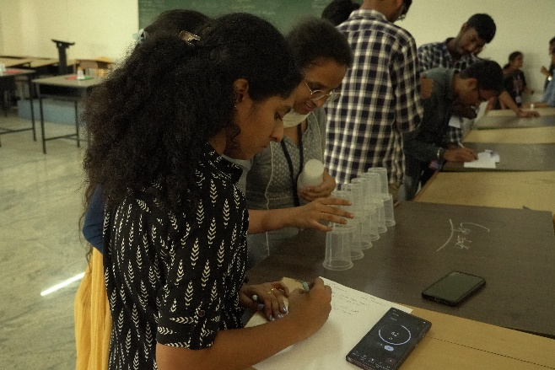
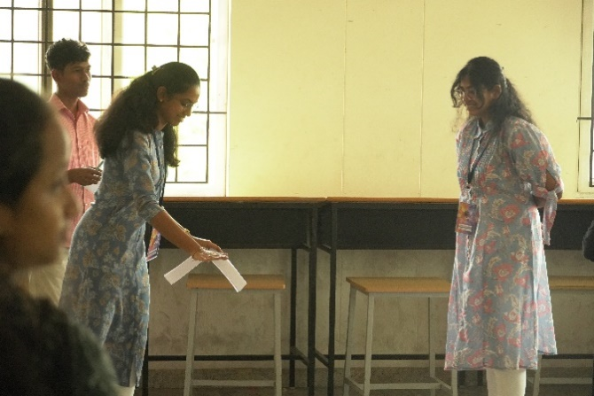
- Teams must clear a series of checkpoints arranged in sequence.

Participants are keen to complete the given task

HackNova: [ 09:00 AM – 05:00 PM]
It is an 8-hour hackathon at KAIRO ’26 designed to encourage innovation, creativity, and real-world problem solving. Participants choose a problem statement from domains such as smart healthcare, smart cities, disaster management, renewable energy, assistive technology, environmental monitoring, home automation (IoT), AI/ML systems, and student innovations, and develop a functional hardware or software solution.
Round 1 – Initial Presentation
- Teams select a domain and present their proposed solution with a prototype.
- The jury evaluates feasibility, innovation, and implementation.
- Feedback is provided highlighting limitations and improvements.
Round 2 – Final Presentation
- Teams present the improved solution after incorporating the jury’s feedback.
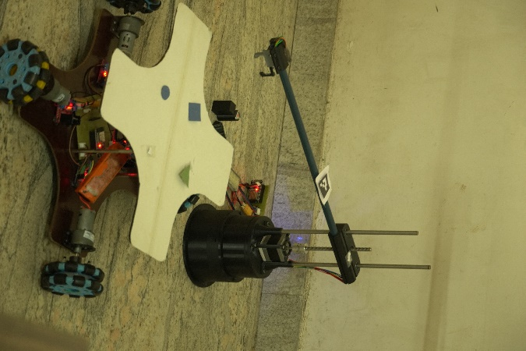
- Emphasis is placed on technical depth, adaptability, and effectiveness of the solution.
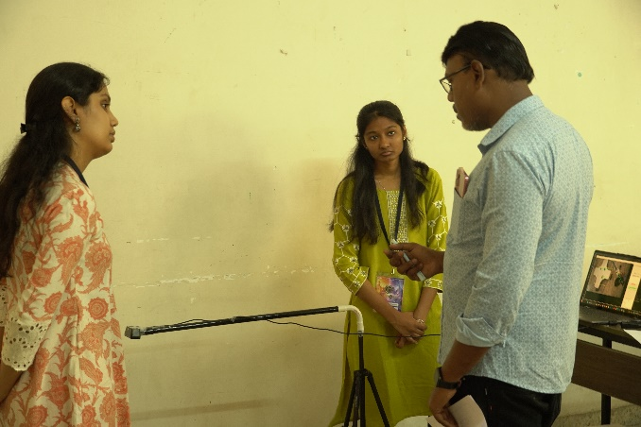
Participants showcasing their ideas and prototypes

Kick Nexus:[02:00 PM – 05:00 PM]
Kick Nexus is a 2-vs-2 robot soccer competition that tests technical skill, navigation accuracy, and strategic decision-making through two challenging rounds.
Round 1 – Goal Rush
- Teams use wireless robots with on-board power within the allowed size and weight limits.
- Robots must start in the Start Zone and complete all zones in the defined order.
- Touching obstacles or skipping zones results in penalties or invalid attempts.
Round 2 – Strike Arena
- Two robots compete in the arena in a timed robot soccer match.
- The ball starts at the center and bots must return to the start zone after each goal or out-of-bounds.
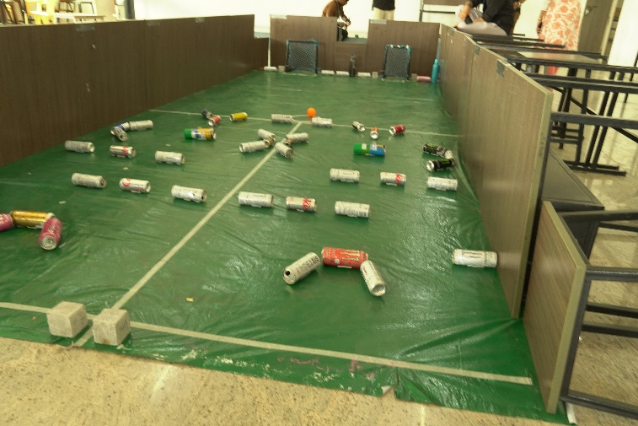
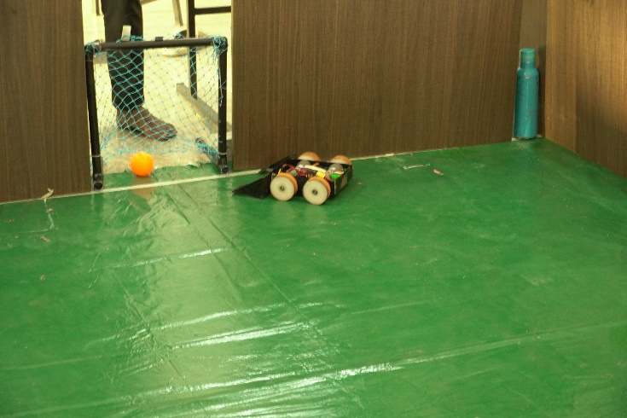
- Teams must score goals from both directions during the match.

Challenging trails for participants to activate their bots

FURONIX: [09:00 AM – 12:00 PM]
• A technical paper presentation event aimed at fostering research, innovation, and practical application of modern software technologies.
• Provided a platform for participants to present technical solutions and real world implementations.
• Covered emerging domains such as software engineering, cloud computing, cybersecurity, artificial intelligence, and IoT.
solutions.
•Key topics presented included:
– Implementing Machine Learning Algorithms in real-world software applications
– Enhancing cybersecurity using multi-factor authentication techniques
– Optimizing cloud-based applications through microservices architecture
– Improving software transparency using Explainable Artificial Intelligence
– Building scalable IoT applications using cloud and edge computing
– Reducing software failures through automated testing and quality assurance
• A dedicated segment for student innovations highlighted creative ideas and novel approaches to current technological problems.
• The session enhanced participants’ presentation skills, technical knowledge, and ability to connect theory with practical implementation.
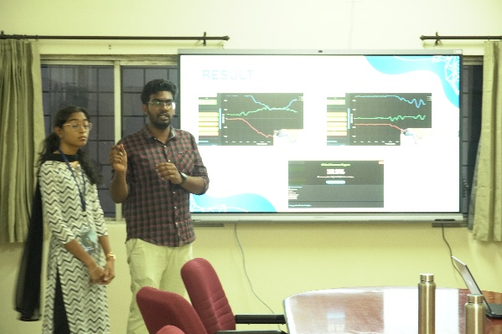
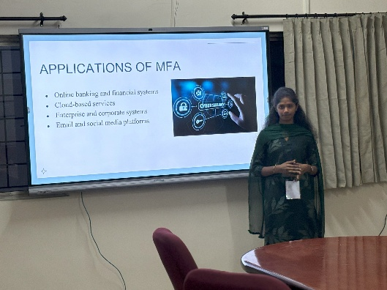

Participants presenting their paper
DAY 2
22.03.2026
WORKSHOP
Connecting Intelligence : IoT & Sensor Integration: [09:00 AM – 05:00 PM]
- Connected Intelligence: IoT & Sensor Integration is a hands-on workshop on embedded systems and IoT conducted by Mr. Vigneswaran from Vi Microsystems Pvt. Ltd.,
- It provided practical insights into real-world IoT and embedded system development.
- Participants will learn to program the Raspberry Pi Pico W using Python and MicroPython, interface sensors and actuators for real-time data acquisition, work with wired and wireless communication protocols, connect devices to cloud platforms for monitoring and control, and develop basic IoT-based applications.

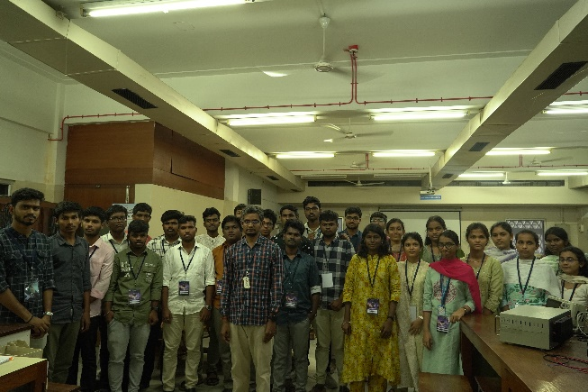
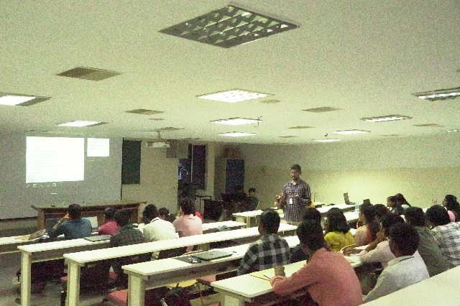
Participants having an insight on IoT and its applications

PARADOX PROTOCOL: [10:00 AM – 01:30 PM]
A multi-round technical event designed around a time-travel theme, where teams progress through different timelines by solving challenges. Conducted as a two-member team event to promote collaboration, analytical thinking, and technical problem-solving.
Round 1 – Timeline Trail:
• All teams were given a common set of technical questions.
• Teams advanced to the next timeline only after answering correctly.
• The first set of qualifying teams received an additional bonus challenge.
• No hints or external assistance were allowed during the round.
Round 2 – Nexus Express:
• Included objective-type questions such as MCQs and match-the following.
• Teams were required to complete the questions within a fixed time limit.
• Evaluation was based on accuracy followed by response time.
• Top-performing teams from each group qualified for the next round.
Round 3 – Trace X:
• Each team had two members assigned with fixed roles: hardware and software.
• One member performed hardware tracing while the other analysed software logs.
• Teams combined both analyses to identify a single root cause.
• Only one final answer was accepted per team for evaluation.
The event provided an engaging platform for participants to apply technical knowledge, teamwork, and critical thinking in a competitive and immersive environment.
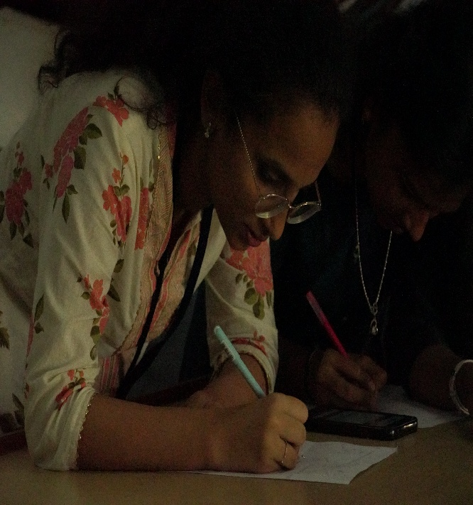
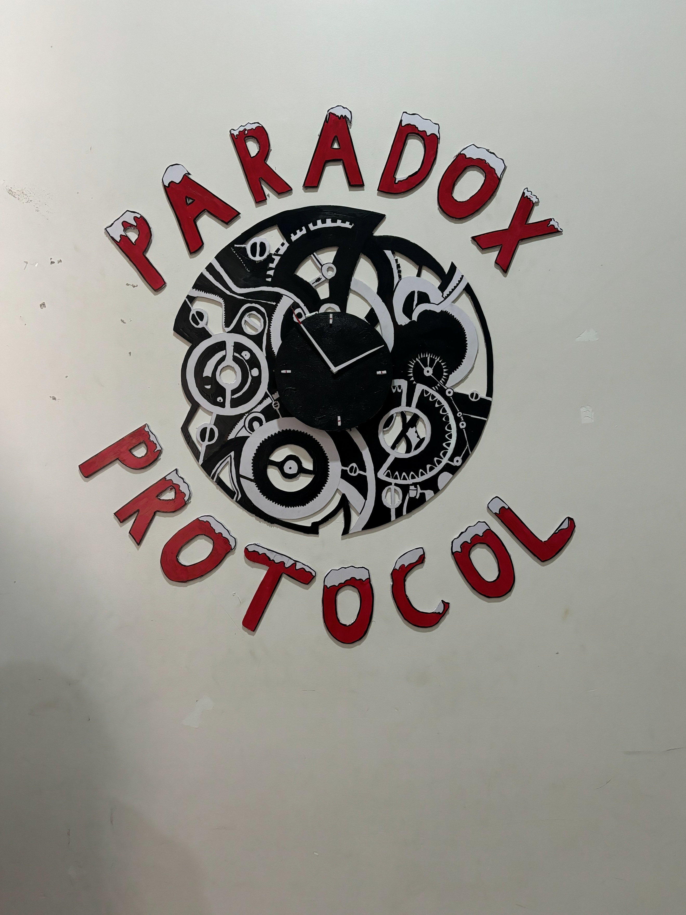
Participants attend the rounds

WANDERBLIND: [02:00 PM – 05:00 PM]
• A fun and interactive event designed to test participants’ creativity, coordination, and teamwork through a maze-based challenge.
• Conducted as a team event emphasizing trust, communication, and quick decision-making skills.
• Participants worked in pairs, where one member guided the blindfolded teammate through the maze using verbal instructions.
• The event created an engaging and energetic atmosphere, encouraging participants to rely on teamwork and effective communication.
• Performance was evaluated based on how efficiently teams navigated and exited the maze.
• The event successfully enhanced participants’ trust, coordination, and ability to perform under pressure in a challenging yet enjoyable environment.
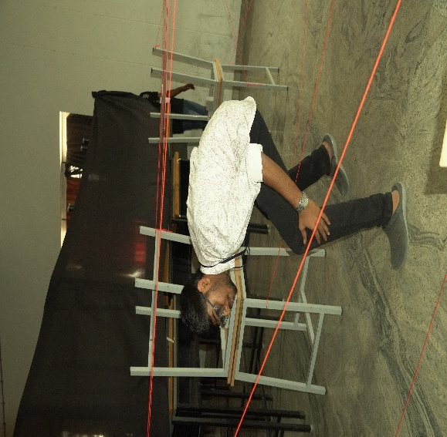
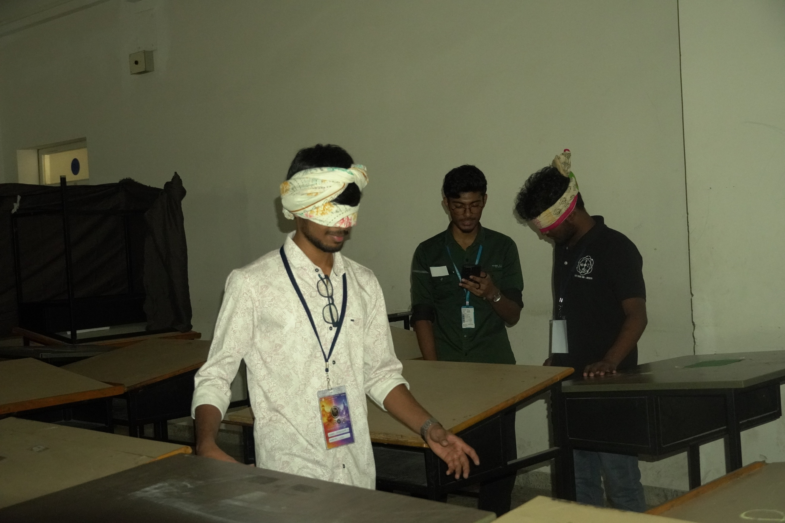
Participants attending the round enthusiastically

SYNTRA SURGE: [09:00 AM – 12:00 PM]
• A technical paper presentation event aimed at encouraging innovative thinking and research-oriented learning among students.
• Provided a platform for participants to present technical ideas and real-time applications related to emerging technologies and engineering concepts.
• Enhanced students’ communication skills, technical knowledge, and problem-solving abilities through structured presentations.
• Key topics presented included:
– Wearable Technology and Health Monitoring
– Neural Chips (e.g., Neuralink): Future of Communication without Phones
– Role of Signal Processing in Everyday Applications
– Robotics in Healthcare: Surgery and Rehabilitation Robots
– Why EVs Still Need Mechanical Engineers
– Smart Fire Detection and Early Warning Systems
– Student Innovations
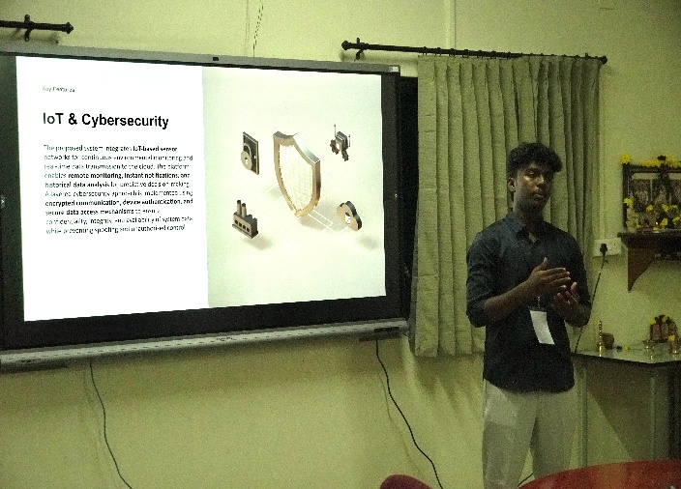
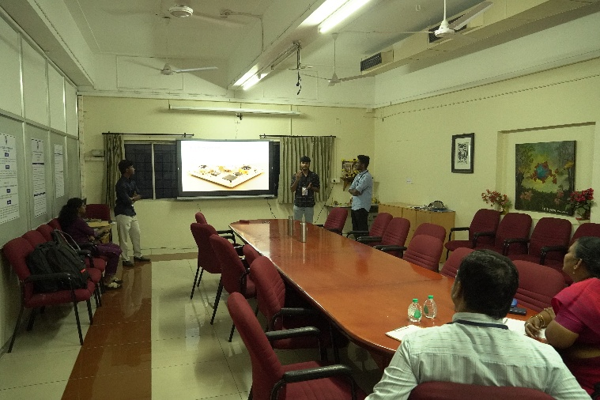
• The event provided valuable exposure to current technological advancements and encouraged participants to explore creative and impactful solutions in engineering.
Participants presenting their paper

CHRONEXA: [02:00 PM – 05:00 PM]
• A high-intensity technical quiz event featuring a confidence-based written round followed by an exciting live buzzer showdown.
• Designed to test participants’ knowledge, decision-making skills, and confidence under pressure.
• Conducted as a competitive team event, encouraging quick thinking and strategic answering.
Round 1 – The Risk Run:
• A confidence-weighted written round where participants answered questions along with a confidence level.
• Evaluation was based on both accuracy and the confidence indicated by the participants.
• The scoring system rewarded high-confidence correct answers while penalizing incorrect ones.
• Focused on analytical thinking and risk assessment abilities.
Round 2 – Crown Chase:
• A fast-paced live buzzer round conducted on stage.
• Teams competed to answer questions by pressing the buzzer first.
• Only the fastest team got the opportunity to respond.
• Incorrect answers resulted in loss of points, increasing the competitive intensity.

The event created an electrifying atmosphere, challenging participants to combine knowledge, confidence, and speed, making it both competitive and engaging.
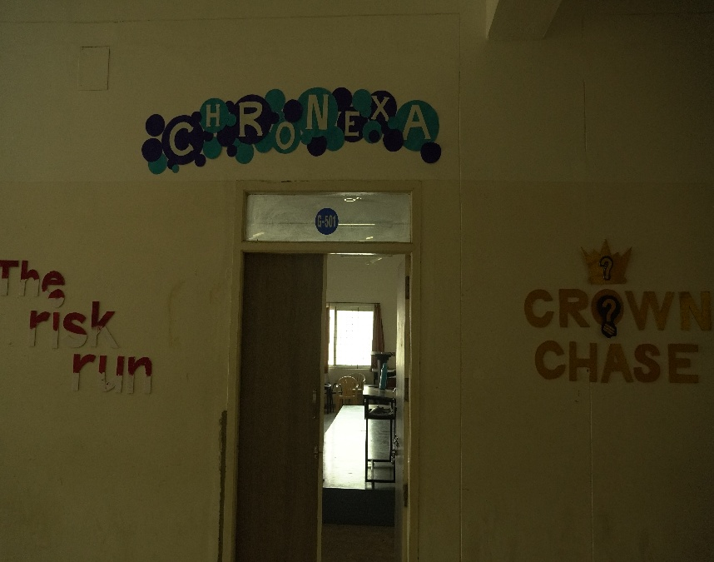
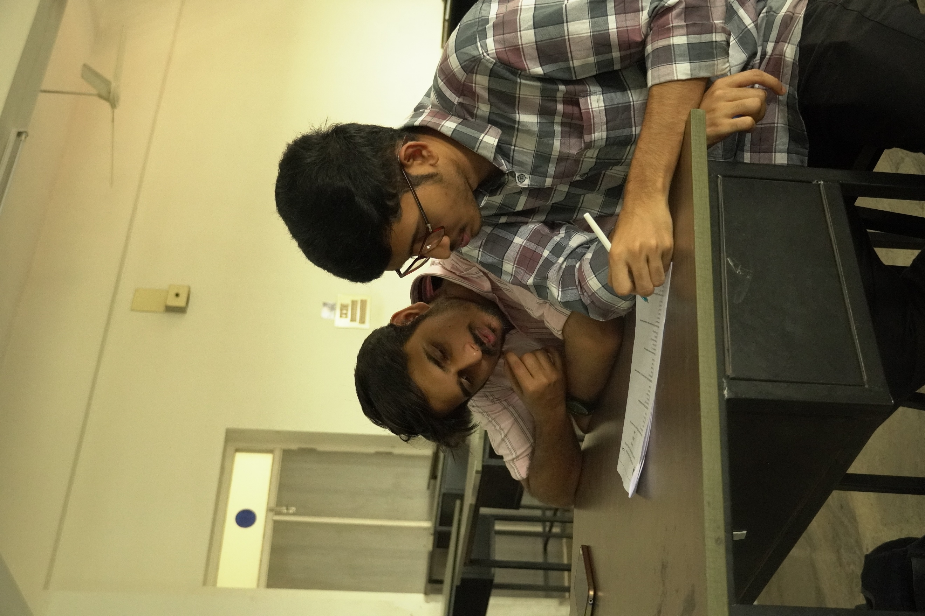
Participants attending the quiz events

Pixel Pulse: [10:00 AM – 04:00 PM]
- A mobile photography event where participants capture moments from the fest and present them as a creative visual time-travel story.
- The event focuses on creativity, storytelling, and unique perspectives through photographs.
- Participants must capture photos within the fest venue during the event using mobile phones only.
- Teams must create a sequence of 5–10 photos connected with a short storyline.
- Photos should highlight fest ambience, people, activities, or installations.
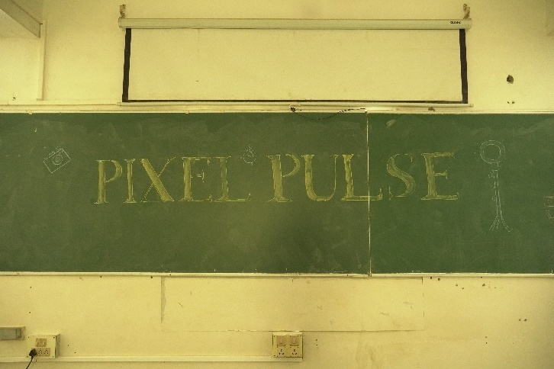
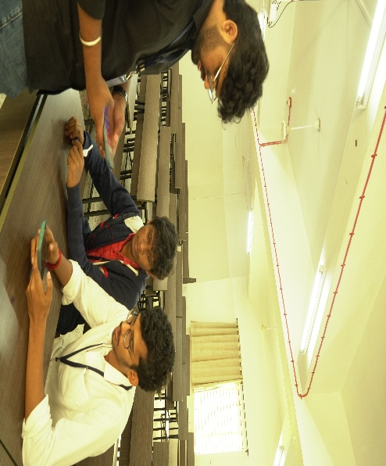

Participants being enthusiastic to showcase their photography skills

