REPORT ON SYNAPSE
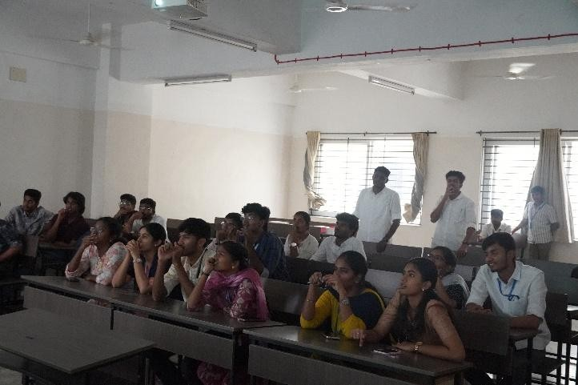
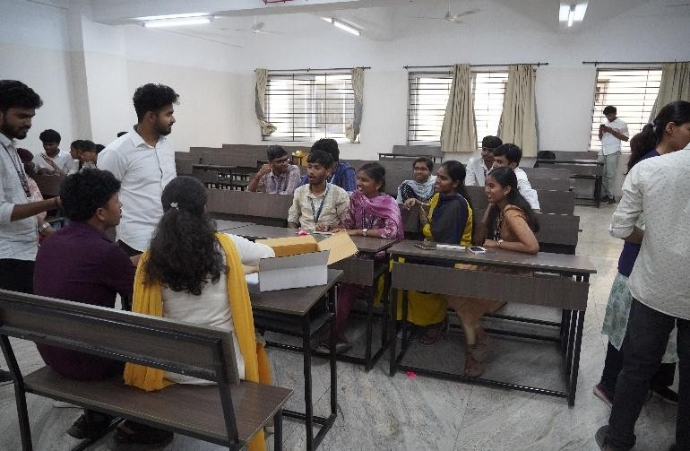
The SYNAPSE event, organized by the Electronics and Communication Engineering Association (ECEA) of PSG College of Technology, was conducted as an engaging and intellectually stimulating technical event aimed at fostering innovation, teamwork, and practical thinking among students. Held on March 17th at 4:30 PM in venues J414 and J415, the event brought together enthusiastic participants eager to test their knowledge and creativity in the field of electronics and communication. The event was structured into two distinct rounds, each designed to challenge different skill sets of the participants. The first round, titled “Electro Auction,” introduced a unique and interactive format where participants were required to bid strategically on electronic components and concepts. This round tested not only their technical knowledge but also their decision-making abilities and teamwork. Participants had to carefully evaluate the importance and application of each component before placing their bids, simulating real-world scenarios where engineers must make cost-effective and efficient choices. The round created an atmosphere of excitement and competition, as teams strategized to build the most valuable set of components within given constraints. The second round, “Unbox the Idea,” shifted the focus from analytical thinking to creativity and innovation. In this round, participants were presented with a conceptual challenge where they had to develop and present an idea based on given themes or problem statements. This encouraged students to think beyond theoretical knowledge and apply their understanding to real-world applications. Teams showcased their ability to brainstorm, collaborate, and articulate their ideas effectively. The round emphasized originality, feasibility, and clarity of presentation, providing a platform for students to express their innovative potential. The event was well-coordinated by the organizing team of ECEA, ensuring smooth transitions between rounds and maintaining a high level of enthusiasm throughout. The presence of coordinators and volunteers contributed significantly to the efficient management of the event. Participants actively engaged in both rounds, demonstrating a strong grasp of technical concepts as well as creative problem-solving skills. SYNAPSE not only served as a competitive platform but also as a learning experience for all involved. It encouraged students to step out of their comfort zones, enhance their communication skills, and develop a deeper understanding of practical electronics applications. The event also fostered a sense of collaboration and healthy competition among peers. Overall, SYNAPSE was a successful and impactful event that aligned with the objectives of ECEA in promoting technical excellence and innovation among students. It provided a well-balanced mix of knowledge, creativity, and interaction, leaving participants with valuable insights and memorable experiences.

