VLSI DAY 2025
20.09.2025
VLSI Day 2025 was organized by the Department of Electronics and Communication Engineering, PSG College of Technology, in association with the VLSI Society of India (VSI), providing a platform for students to gain exposure to advancements in semiconductor technologies. The event, centered around the theme “Building the Next Generation of Chip Designers: Education, Innovation & Industry,” aimed to bridge the gap between academic learning and industry requirements.
The event commenced with an insightful session by Smt. Sunita Verma, Group Coordinator (R&D), Ministry of Electronics and Information Technology (MeitY), Government of India, who spoke on future opportunities for VLSI designers in the global market, highlighting India’s growing role in the semiconductor ecosystem. This was followed by sessions from industry experts including Smt. Aparajita Banerjee, Semiconductor Professional (ex-Intel, ex-Meta, USA) on overcoming bottlenecks in modern SoC development, and Shri. Sundararajan Subramanian, Vice President – Engineering, SoC Design Center, Qualcomm India Pvt. Ltd., Bengaluru, on the role of VLSI in enabling AI at the edge.
Further enriching the event, Shri. Satya Gupta, President, VLSI Society of India (VSI), spoke about the “VLSI & 1 TOPS Program,” encouraging students to align their skills with industry expectations. Shri. Jayaraj U Kidav, Executive Director, National Institute of Electronics and Information Technology (NIELIT), Aurangabad, provided insights into “Shaping the Next Decade with Machine Intelligence,” highlighting the integration of AI and semiconductor technologies in future innovations.
The technical depth of the event continued with sessions by Shri. S.C. Parthasarathy, Senior Director – DFT, Intel Technology, Bengaluru, on “The Unspoken Rule of Hardware Design: Make it Testable,” where he stressed the importance of design-for-testability in hardware systems. Shri. David Selvakumar, Scientist G, Centre for Development of Advanced Computing (C-DAC), Bengaluru, introduced participants to “RISC-V in Perspective,” offering insights into open-source processor architectures, while Shri. Nithin Gopinath, Analog Applications, Validation and Test Manager, Texas Instruments, Bengaluru, elaborated on the “Role of Semiconductors in Aerospace & Defense,” showcasing real-world applications in critical industries.
An interactive “Ask Me Anything” session moderated by Smt. Chitra Hariharan, Head – University Relations, Government Affairs and Startup Collaborations, Renesas Electronics, Bengaluru, and Secretary, VLSI Society of India (VSI) allowed participants to engage directly with experts, gaining clarity on career paths and industry expectations. The event witnessed active participation from students across various institutions and was executed smoothly with effective coordination.
Overall, VLSI Day 2025 was a highly informative and successful event that enriched participants’ understanding of semiconductor technologies and inspired them to explore opportunities in the VLSI domain.

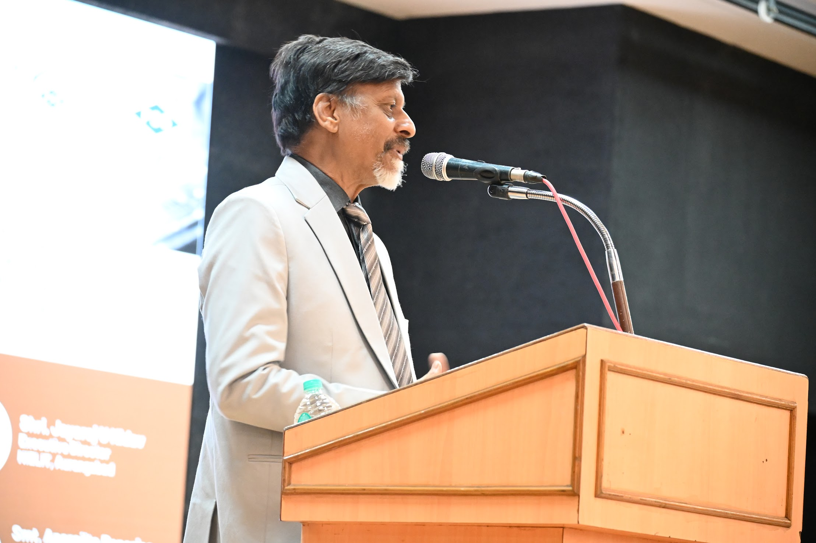
Shri. Satya Gupta, President of VLSI addressing the crowd
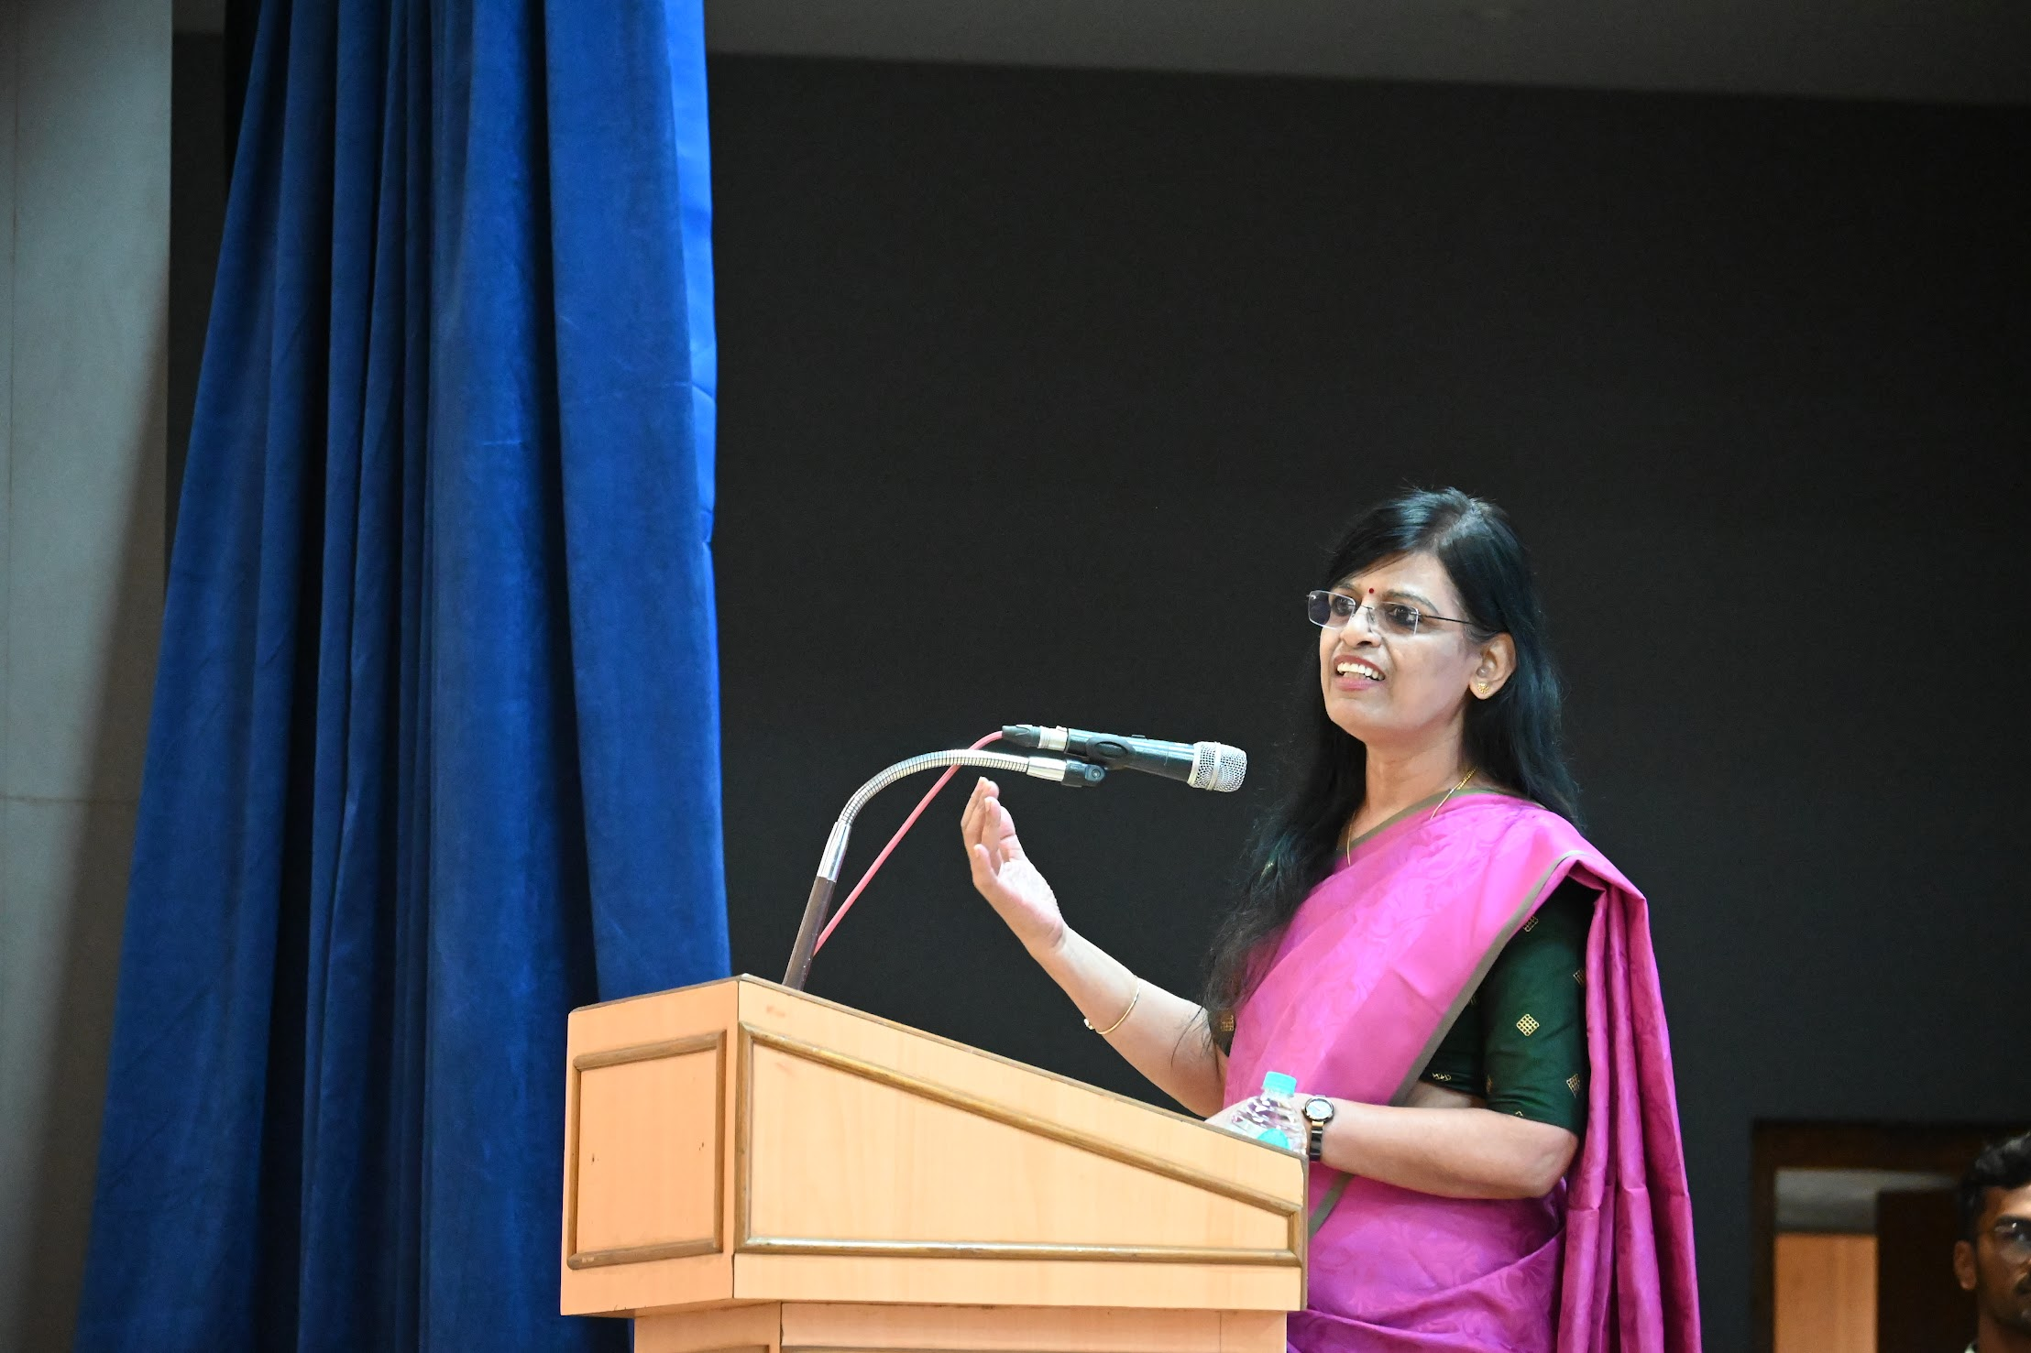
‘Ask Me Anything’ session with Smt. Chithra Hariharan

