**Hands – On Lab**

**Workshop 1**

# Survey Form

Using HTML and CSS (inline and internal) only, create a survey form as in the given figure:



Ans:

# Creating a Simple Web Page

Create a simple web page which must include the following sections:

1. Logo
2. Navigation Menu (Home, About, Service, Contact)
3. Search Box and icon
4. Heading Text
5. Use of <p> and <span> tag with different styling
6. Button
7. Form
8. Social media icons 9. Footer section

10. Background image

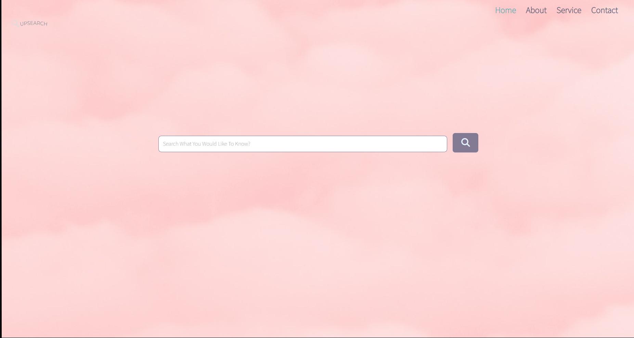

# XAMPP Control Panel

Download and install Xampp Server on your computer and run the web page build in question 1 and 2 using localhost. See the difference between running a page with localhost and directly.

# Web Performance Visualization

For the created web pages, visualize the web performance using devtools, following the steps:

1. After running the file in the browser, right click on mouse and go to inspect 2. Check the network and performance options for the visualization