**Hands – On Lab**

**Workshop 2**

*Note: It is mandatory for all students to draw the diagram in drawing tools as well as in a A4 paper describing the flow of each diagram in a paragraph.*

# Activity Diagram

1. Using an activity diagram, describe the process of student enrollment in an

University.

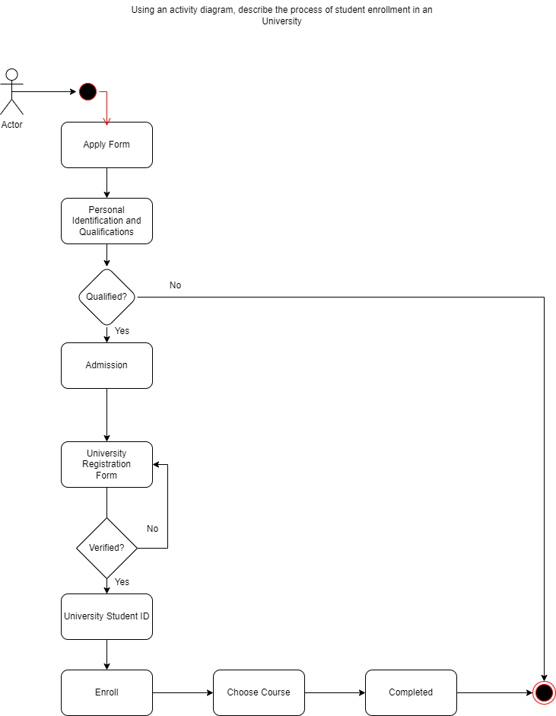

Firstly, the student applies for the college in form. Then the college verifies the personal information and qualifications of student while applying the form and if the student is not qualified they cannot join the college hence the process ends or else they are ready for the admission process. Then after admission the university registration form is given which if it is not verified it is tried to make it verify and after the verification university student ID is provided to the student and told to enroll where they can choose the courses and after that it is completed and hence the person is enrolled.

1. Consider the scenario of Order Processing. Once the order is received, the activities split into two parallel sets of activities. One side fills and sends the order while the other side handles the billing. On the Fill Order side, the method of delivery is decided conditionally. Depending on the condition either the

Overnight Delivery activity or the Regular Delivery activity is performed. Finally, the parallel activities combine to close the order. With activity diagram, describes the processing of ordering.

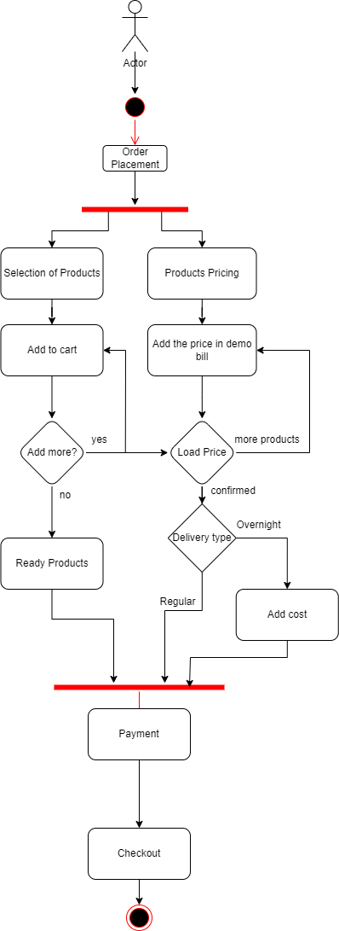

Firstly, a person when decides to place an order he selects the products the adds where simultaneously the product pricing management also takes place when the prices are added in the cart and then it askes the person to add more to the cart and continue shopping if yes then it will add cart and again add money then when the produces are ready on the stock the person is told to pay the money selecting the delivery type i.e. either regular which has constant money added or overnight which takes extra money then he proceeds to pay and checkout the product and end.

1. Show the flow of word processing application software with the help of activity diagram

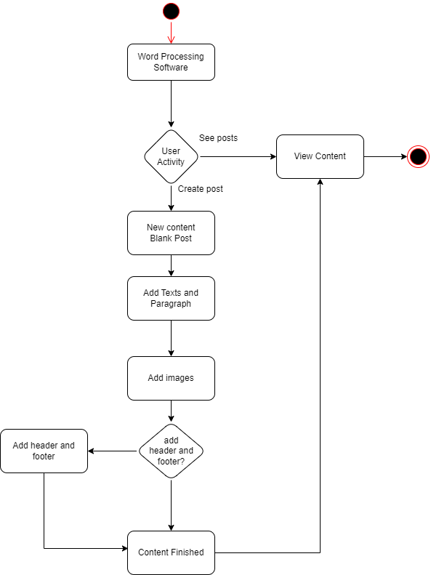

First the word processing software starts and asks the user to either see posts or create post if the user chooses to create post a new content with a blank post is made where then the person can add texts and paragraph then they can also add images and it asks either to add header and footer or not and the user as per their needs and the content finished is passed to view content and the flow ends.

# Sequence Diagram

1. Consider a Library Management System. Using sequence diagram, show the interaction of objects in the system to perform the function ‘Create new library user account’

First the user logs in the system then the librarian verifies the data searching in the database then if true the user requests for the book then the librarian searches for the book in database if it is available the librarian gives the details to the user and the details of user is given by user and the details are filled by librarian in the database and also manage the time to return the book and the required book and specified time is given to the user .

1. In which sequence does the Online Exam System flow? Describes using sequence diagram.

First the student login in the exam app and the exam app verifies the credentials in the database. Then the student presses on the take exam in the app and the app prepares for the exam format and searches questions in the database and returns it to exam then the exam app provides shuffled questions to the student then the student submits the answers and the answers are registered in the database through the exam app then the student wants result they tap on get result in the app the app extracts the answers from the database and the exam provides evaluated answers and result to the students.

1. Represent the School Management System with sequence diagram

First the student is admitted in the school reception and verifies it in the database. Then the student asks for the books and course in the reception where the receptionist searches it in database and gives the book lists to the student. The student asks for the routine and the receptionist provides the calendar. If the student asks for transportation, then the person searches in the database about the routes and provides the bus list to the student. When asked for the academics the person searches the student performance in the database and the database provides the results and the receptionist provide the feedbacks.

# Deployment Diagram

1. Show the necessary nodes, artifacts, associations and components required for

Hospital Management System

The hospital management system applies the patient’s name, contact, blood group and relatives and transfer it in the patient database then the report is evaluated from the report database and the patient is provided the medicines which are available in the medicine database and the medicine which is provided to the patient whose costs are evaluated in the billing database and provided to the patient.

1. Draw a deployment diagram for Hotel Management System

First the reception computer with management app asks the customer name which then searches for the available rooms in the rooms database and the room is provided to the student and registered in the room database as well in the customer data management server then when the customer is ready to leave and is asked for the payment and the paid amount goes in the customer data management server where the customer name, time spent, bill copy and suggestions and feedbacks are kept in the database.