**Hands – On Lab Workshop 3***.*

# AREA OF TRIANGLE

Write a function that takes the base and height of a triangle and return its area.

Example:

Areaoftriangle (3, 4) 6

Areaoftriangle (7, 8) 28 Notes

* Area of triangle is (base * height)/2
* Don’t forget to return the result

# BASKETBALL POINTS

You are counting points for a basketball game, given the amount of 2 – pointer scored and 3 – pointer scored, find the final points for the team and return the value.

Example:

points (3,5) 3*2 + 5*3 = 21 points (1,1) 5

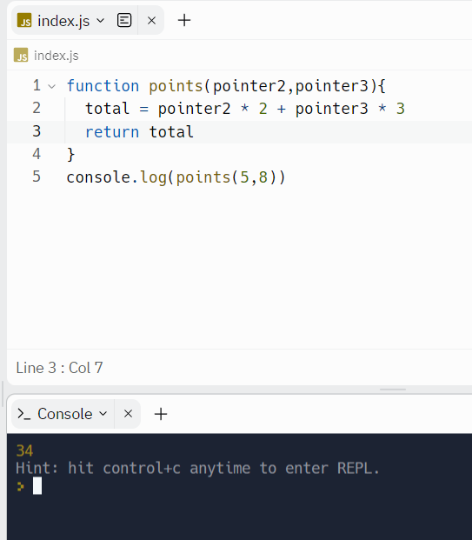

# ADD UPTO THE NUMBER FROM A SINGLE NUMBER

Create a function that takes a number as an argument. Add up all the numbers from 1 to the number you passed to the function. For example, if the input is 4 then your function should return 10 because 1+2+3+4 = 10

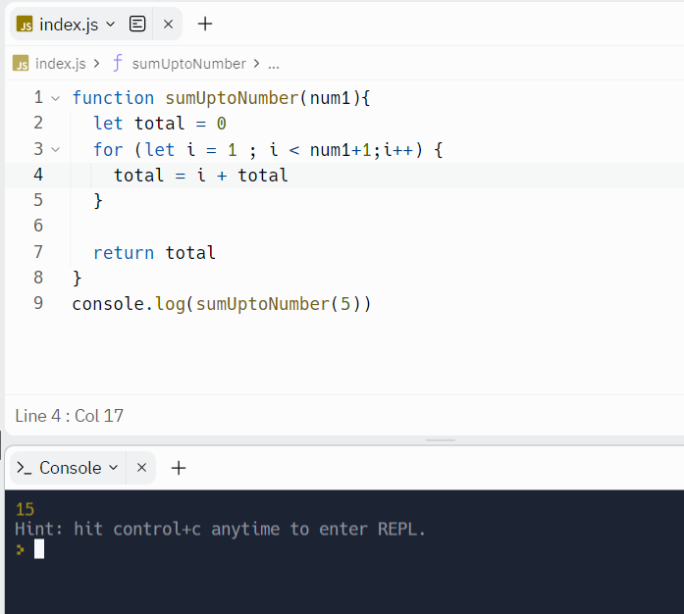

# ANY PRIME NUMBER IN RANGE

Create a function that return true if there is at least one prime number in the given range(n1 to n2) inclusive, false otherwise.

Example:

primeInRange(10,15) true wwww

// prime number is range : 11, 13

primeInRange(3,1) true

// prime number is range : 3, 5

# GUESSING GAME

Generate a random number (do research) and store it in a variable. Write a program to take input from the user and tell them whether their guessed number is correct, greater or lesser than the original number. (100 – number of guesses) is the score of user. The program is expected to terminate once the number is guessed. Number should be between 1 – 100.

Example:

Random number generated by computer: 54

User input: 34

// lesser than original number

User input: 67

// greater than original number

User input: 54

// congratulations!!! The number you guessed matched the original number. Your score is 97!

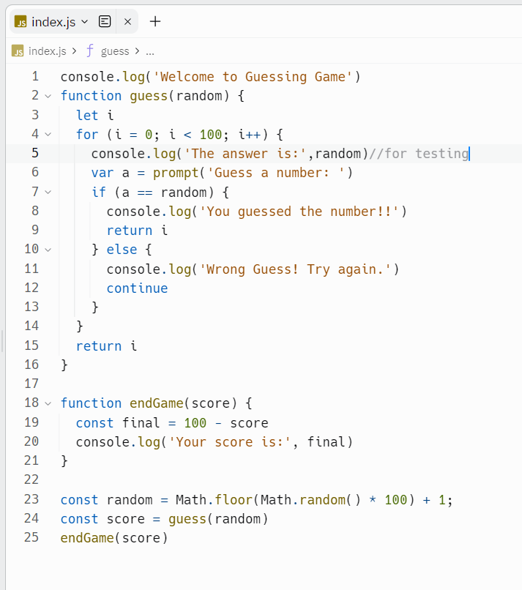

# HIGHER ORDER ARRAY METHODS

Const age = [23,34,12,54,23,54,11,9,29,17,15,19,20,21,13,7]

1. Filter the array of age who can apply for citizenships

1. Find the average age of a given array Const companies = [

{ name: "ABC", category: "Finance", start: 1981, end: 2004 },

{ name: "XYZ", category: "Retail", start: 1991, end: 20012 },

{ name: "DGF", category: "Finance", start: 1976, end: 2008 },

{ name: "LFT", category: "Retail", start: 1971, end: 1979 },

{ name: "MND", category: "Retail", start: 1995, end: 2010 },

{ name: "HCK", category: "Technology", start: 1987, end: 2011 },

{ name: "BMC", category: "Technology", start: 1989, end: 2009 },

{ name: "TIC", category: "Retail", start: 1993, end: 2005 },

{ name: "NAC", category: "Technology", start: 1991, end: 2010 },

{ name: "ITC", category: "Finance", start: 1998, end: 2016 }

];

1. Filter the retail companies
2. Get the 80s companies from the array
3. Get the companies that lasted for 10 or more years



