**Area of a Triangle**

Write a function that takes the base and height of a triangle and return its area.

# Examples

triArea(3, 2) ➞3 triArea(7, 4) ➞14 triArea(10, 10) ➞50

# Notes

● The area of a triangle is: (base * height) / 2 ● Don't forget to return the result.

**Return Something to Me!**

Write a function that returns the string "something" joined with a space " " and the given argument a.

# Examples

giveMeSomething("is better than nothing") ➞"something is better than nothing" giveMeSomething("Bob Jane") ➞"something Bob Jane" giveMeSomething("something") ➞"something something

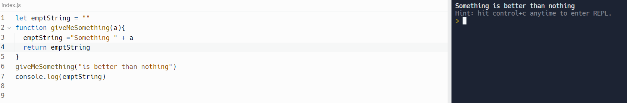

# Basketball Points

You are counting points for a basketball game, given the amount of 2-pointers scored and 3-pointers scored, find the final points for the team and return that value.

## Examples

points(1, 1) ➞5

points(7, 5) ➞29

points(38, 8) ➞100

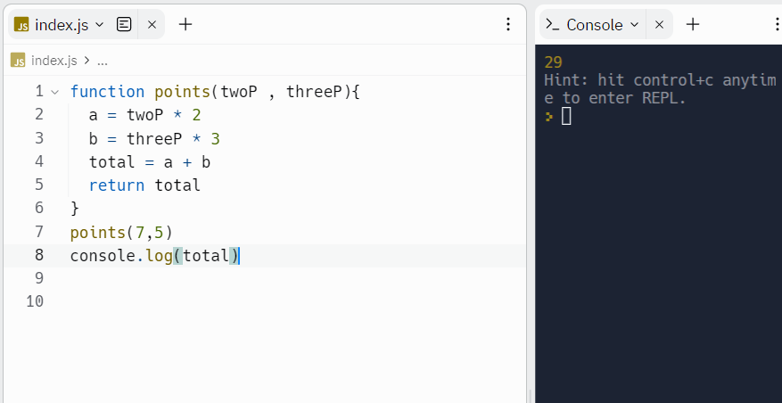

**Less Than 100?**

Given two numbers, return true if the sum of both numbers is less than 100.

Otherwise return false. **Examples**

lessThan100(22, 15) ➞true

// 22 + 15 = 37

lessThan100(83, 34) ➞false

// 83 + 34 = 117

lessThan100(3, 77) ➞true

# Add up the Numbers from a Single Number

Create a function that takes a number as an argument. Add up all the numbers from 1 to the number you passed to the function. For example, if the input is 4 then your function should return 10 because 1 + 2 + 3 + 4 = 10.

## Examples

addUp(4) ➞10

addUp(13) ➞91

addUp(600) ➞180300

**Notes**

Expect any positive number between 1 and 1000.

# Oddish vs. Evenish

Create a function that determines whether a number is **Oddish** or **Evenish**. A number is **Oddish** if the sum of all of its digits is odd, and a number is **Evenish** if the sum of all of its digits is even. If a number is **Oddish**, return "Oddish". Otherwise, return "Evenish".

For example, oddishOrEvenish(121) should return "Evenish", since 1 + 2 + 1 =

4. oddishOrEvenish(41) should return "Oddish", since 4 + 1 = 5. **Examples**

oddishOrEvenish(43) ➞"Oddish"

// 4 + 3 = 7

// 7 % 2 = 1

oddishOrEvenish(373) ➞"Oddish"

// 3 + 7 + 3 = 13

// 13 % 2 = 1

# Any Prime Number in Range

Create a function that returns true if there's at least one prime number in the given range (n1 to n2 (inclusive)), false otherwise. **Examples**

primeInRange(10, 15) ➞true // Prime numbers in range: 11, 13

primeInRange(62, 66) ➞false // No prime numbers in range. primeInRange(3, 5) ➞true

// Prime numbers in range: 3, 5

## Notes

●n2 is always greater than n1.

●n1 and n2 are always positive.

● 0 and 1 aren't prime numbers.

# Left Shift by Powers of Two

**The left shift operation is similar to multiplication by powers of two.**

**Sample calculation using the left shift operator (<<):**

**10 << 3 = 10 * 2^3 = 10 * 8 = 80**

**-32 << 2 = -32 * 2^2 = -32 * 4 = -128**

**5 << 2 = 5 * 2^2 = 5 * 4 = 20**

**Write a function that mimics (without the use of <<) the left shift operator and returns the result from the two given integers.**

## Examples

**shiftToLeft(5, 2)** ➞ **20**

**shiftToLeft(10, 3)** ➞ **80**

**shiftToLeft(-32, 2)** ➞ **-128**

**shiftToLeft(-6, 5)** ➞ **-192**

**shiftToLeft(12, 4)** ➞ **192**

**shiftToLeft(46, 6)** ➞ **2944 Notes**

* **There will be no negative values for the second parameter y.**
* **This challenge is more like recreating the left shift operation, thus, the use of the operator directly is prohibited.**
* **Alternatively, you can solve this challenge via recursion.**
* Graphical user interface, application, Teams

  Description automatically generated

# Convert a Number to Base-2

**Create a function that returns a base-2 (binary) representation of a base-10 (decimal) string number. To convert is simple: ((2) means base-2 and (10) means base-10) 010101001(2) = 1 + 8 + 32 + 128.**

**Going from right to left, the value of the most right bit is 1, now from that every bit to the left will be x2. The values of an 8 bit binary number are (256, 128, 64, 32, 16, 8, 4, 2, 1).**

## Examples

**binary(1)** ➞ **"1" // 1*1 = 1**

**binary(5)** ➞ **"101" // 1*1 + 1*4 = 5**

**binary(10)** ➞ **"1010"**

**// 1*2 + 1*8 = 10 Notes**

* **Numbers will always be below 1024 (not including 1024).**
* **The && operator could be useful.**
* **The strings will always go to the length at which the most left bit's value gets**

**bigger than the number in decimal.**

* **If a binary conversion for 0 is attempted, return "0".**

