**Software Requirements Specification**

**<Restaurant Management System>**

**<Apsara Siddiqui>**

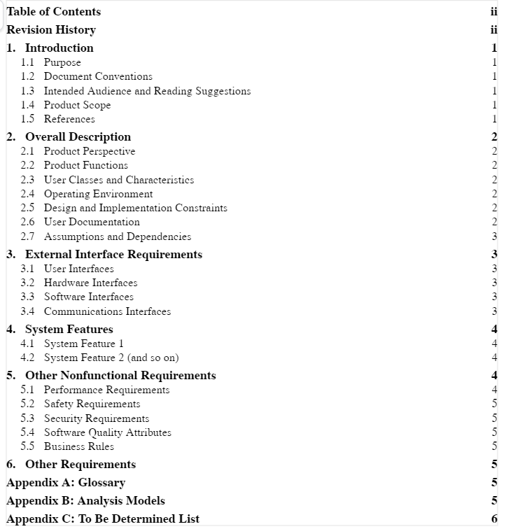

1. **Introduction:**

**1.1****Purpose:**

*The purpose of this document is to introduce the project“Kimchi and Kpop” and it’s technical*

*details. This project aims to develop a complete ordering system. It will allow*

*users(customers) to browse different menus and place orders in just a few clicks.*

**1.2 Document Convention:**

*Font: Arial, Font size: 11.*

**1.3 Intended Audience and Reading Suggestions:**

*General public, restaurant owner, riders.*

**1.4 Product Scope:**

*“Kimchi and Kpop” is user friendly and in natural language. It’s main aim is to simplify and*

*improve the efficiency of the ordering process for both customers and restaurants. Users*

*will also be able to view product menus and their ingredients and be able to have*

*confirmation messages that the order has been placed successfully.*

**1.5 References:**

*https://www.foodpanda.pk*

1. **Overall Description:**

**2.1 Product Perspective:**

*It’s main aim is to simplify and improve the efficiency of the ordering process for both*

*customers and restaurants. Users will also be able to view product menus and their*

*ingredients and be able to have confirmation messages that the order has been placed*

*successfully.It will facilitate foreigners to order their favourite food.*

**2.2 Product Function:**

*Kimchi and Kpop includes:*

* *View menu*
* *Place order*
* *Cancel order*
* *View Bill*
* *Give feedback*
* *Login*

**2.3 User classes and Characteristics:**

* *Users(customers, riders)*
* *Admin(to manage)*
* *Developer, tester, designer.*

**2.4 Operating Environment:**

*Operating System: Windows 10.*

*Technology(language): Java;*

*DataBase: My SQL;*

*Tools: Eclipse, My Sql workbench.*

**2.5 Design and Implementation Constraints:**

*KIMCHI AND KPOP should be written in an object oriented language. The primary*

*candidate tool chains are Java/SQL.*

**2.6 User Documentation:**

* *Online tutorials.*
* *User manual.*

**2.7 Assumptions and Dependencies:**

*Customers can place orders through smartphones. A good wifi connection is considered as*

*a basic assumption.*

1. **External Interface Requirements:**

*There are many types of interfaces that include:*

**3.1 User Interfaces:**

*Search bar: so the users can search for food of their choices.*

*Categories of food: to help our customer to select food they want.*

**3.2 Hardware Interfaces:**

*Reliable software device drivers shall be provided for every I/O board used in “Kimchi and*

*Kpop”. A system can handle a maximum 20 orders within a minute,and if the number of*

*orders increase then additional memory will be required.*

*We would require following technology for development of the system:*

*GPS to indicate locations.*

*Cloud can be used for backup or data retrieval.*

**3.3 Software Interfaces:**

*Kimchi and Kpop would be written in an object oriented language ,*

*Technology(language) would be java, for database MySQL, Tools can beEclipse, and*

*Operating system Window 10.*

**3.4 Communication Interfaces:**

*The system will use the following communication interfaces:*

*- Email*

*- Social media*

*-Text communication.*

1. **System Features:**

*This section demonstrates “Kimchi and Kpop” most prominent features.*

**4.1 Customer:**

4.1.1 Description and Priority:

*The feature will allow users to login to the system. Customers will be able to browse*

*through the menu and check out different deals and discounts.*

4.1.2 Stimulus/Response sequence:

*When a user login successfully, the homepage will appear.*

*The system will display various food categories according to customer*

*preferences.*

*On clicking the menu, the system will display the price and ask the user to continue*

*to order or return to the homepage.*

4.1.3 Functional requirements:

*REQ-1: Invalid login:*

1. *If the user enters invalid password or email address.*
2. *System will give 3 more chances.*
3. *Else terminate.*

**4.2 Order Food:**

4.2.1 Description and Priority:

*The feature will allow users to order food of their choice.*

4.2.2 Stimulus/Response sequence:

*When a user selects a food category, a list of foods according to that category will*

*appear.*

*The user will select food by clicking on it.*

*The system adds the food to the cart.*

*The user will then enter the details.*

4.2.3 Functional requirements:

*REQ-1: Cancel order:*

*1.System terminates the order.*

*2. User cancels the order*

*REQ-2: Food not available:*

*1.System will pop a dialogue box saying that food is not available.*

*System terminates the order.*

*User cancels the order.*

1. **Other Nonfunctional Requirements:**

**5.1 Performance Requirements:**

*Response Time: The system should respond to users according to their expectations. As*

*the delay in response, will lead to users losing their interest.*

*Workload: The system will support 20 orders within a*

*minute.The data entry of the users should be backup on*

*daily basis, otherwise it will disrupt the performance*

*experienced by the users .*

**5.2 Safety Requirements:**

*Backup of data and antivirus software are required.If the data is lost or any mishap occurs we*

*will have backup to deal with the situation.*

**5.3 Security Requirements:**

*The data entered by the user will be kept secured. And, the details entered by the users that*

*are saved in the database and will be cross checked during user login.*

**5.4 Software Quality Attribute:**

*Availability: The system should take orders and give the confirmation message, whenever*

*the user places an order.*

*Correctness: The system should confirm the right dish from the menu, which is selected by*

*the user.*

*Maintainability: The manager should maintain the price of food.*

*Usability: The menu should satisfy the needs and demands of maximum users.*

**5.5 Business Rules:**

* *A valid debit/credit card pin must be entered for order confirmation and payments.*
* *The customer should enter a local telephone number while placing an order.*
* *Managers can modify,delete and create restaurant menus.*
* *Charges of delivery will be added to the bill if the order has to be delivered outside the free delivery zone.*

**6.** **Other Requirements:**

**6.1 DataBase Requirement:**

*Kimchi and kpop will be connected to My SQL that is used to manage relational*

*databases and perform various operations on the data in them .As it lets us access*

*and manipulate the data entered by the user.*

**Appendix A: Glossary:**

*My SQL–Structured Query Language, used to communicate with the database.*

*Eclipse–, used to develop computer programs.*

*Java–Programming language to create computer programs.*

**Appendix B: Analysis Model:**

***Class Diagram****:*

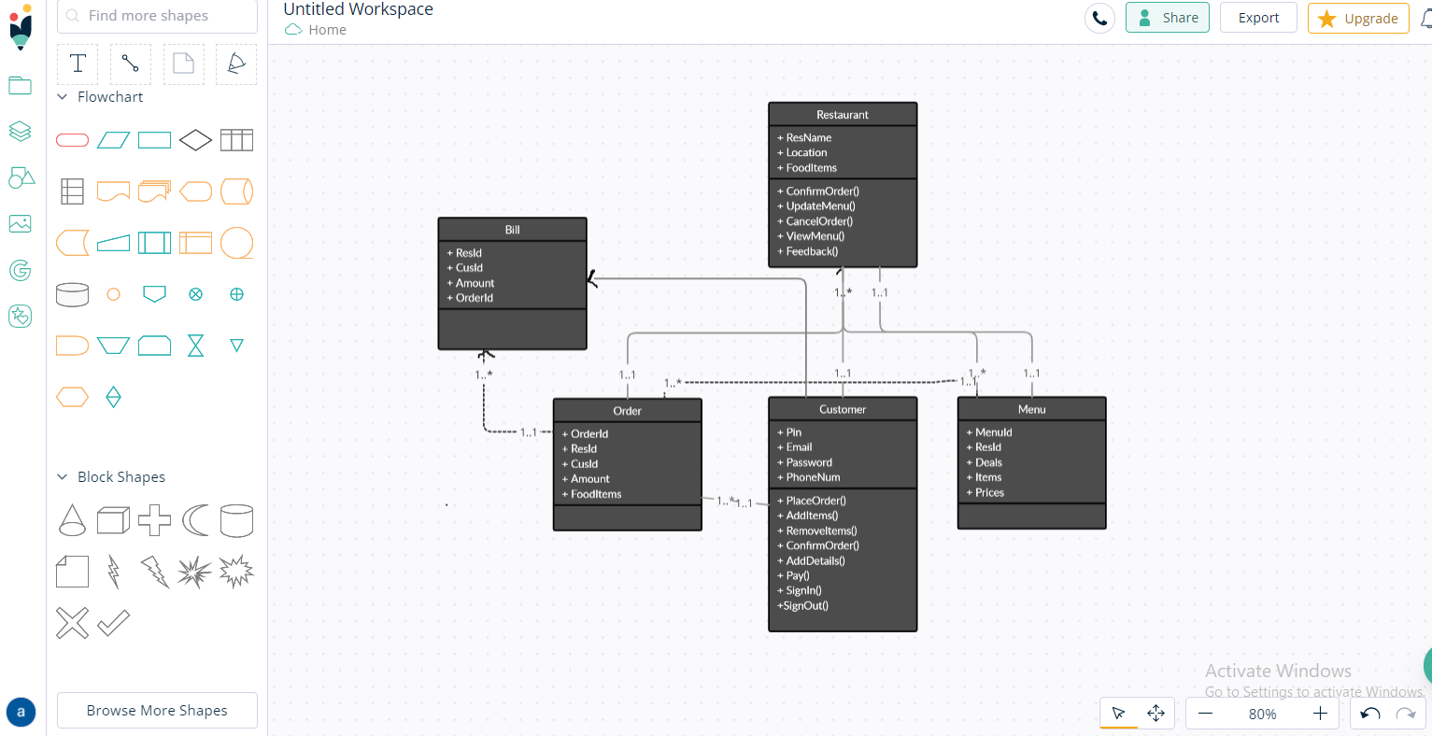

**Appendix C: To be determined:**

|  |  |
| --- | --- |
| *Performance Requirement* | *Evaluating other food ordering systems and determining what can be expected from our system and its performance level.* |
| *Java implementation research* | *Researching the different java platforms to determine which discrepancies need to be considered.* |
| *User Interface Specification* | *A study of an evaluation and usability of the user interface of other systems will be beneficial.* |

**SDS**

**Deployment Diagram:**

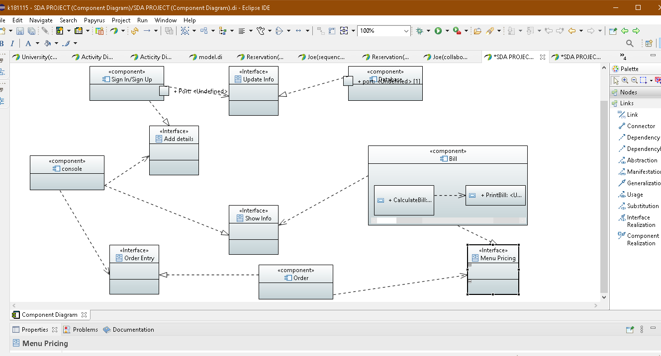

**Architecture:**

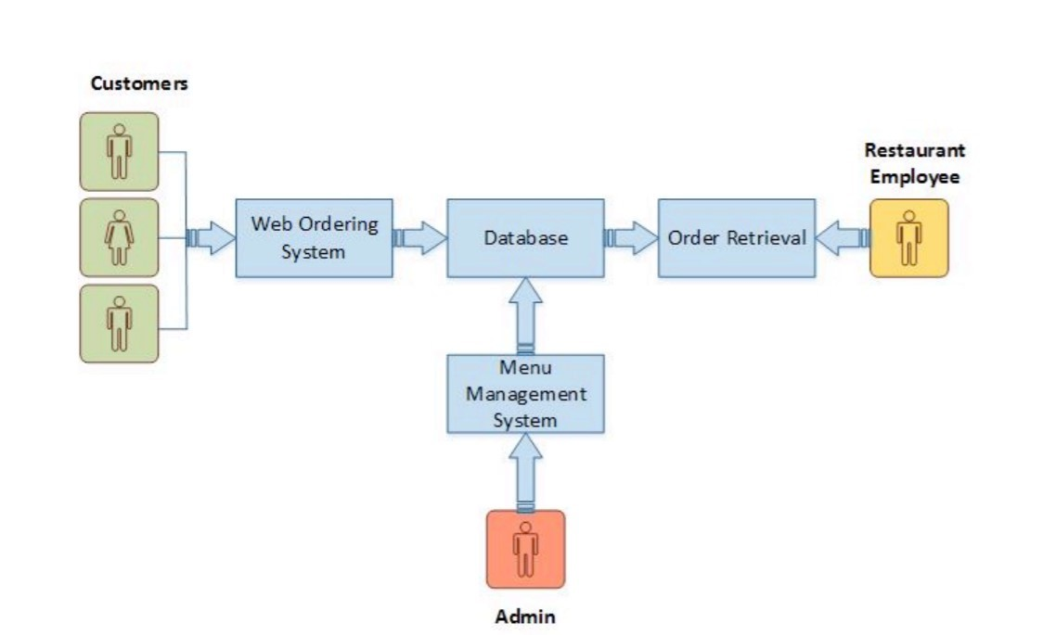

**USE CASE:**

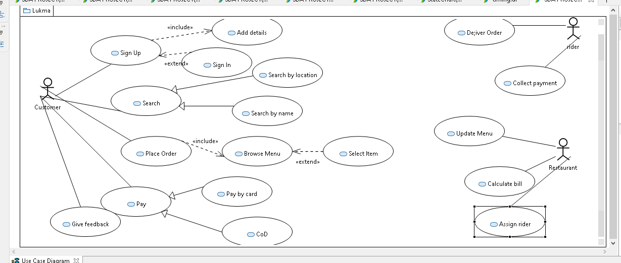

**ERD:**

