Test #1: End-to-End Measurement

Objective of Test:
Find out the motion-to-photon (end-to-end) latency time.

Test Setup:
This test will utilize the Latency Display Analysis Tool (LDAT) from Nvidia. By measuring the time from a custom event (LDAT Mouseclick) to the updated showing on the screen (captured by the light sensor) one can get an idea of the latency of the whole pipeline as a blackbox. Since this sensor cannot realistically be attached to a VR headset it will instead be attached to a display that also renders the game (without VR distortions).
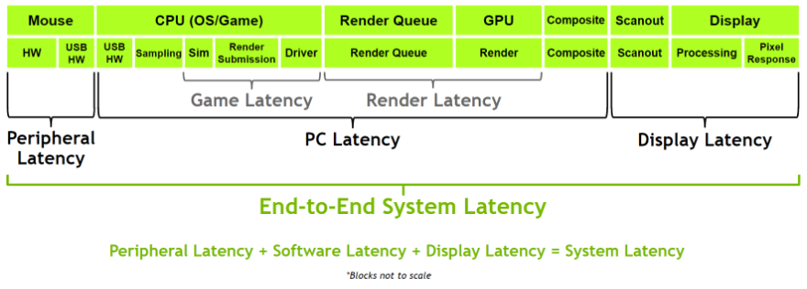

Test #2: Packet Measurement

Objective of Test:
Find out the impact of networking on the pipeline. The previous test treats the application as a blackbox, but here we got into a specific part.

Test Setup:
This test will utilize Wireshark to find out the time packets spent in transit. To get this information I will look at the interpacket delta times. By comparing the results with the measurements from test #1, I should be able to isolate the (average) impact of networking.

