

**USER GUIDE**

**HYPER TASK**

|  |  |  |
| --- | --- | --- |
| **Supervisor:** | *NGUYEN NGO PHUOC* | |
| **Semester:** | *3* | |
| **Batch No:** | *T1.1908.E0* | |
| **Group No:** | *02* | |
| **Order:** | **Full name** | **Roll No.** |
| *1.* | *Duong Ngoc Hai* | Student1198484 |
| *2.* | *Nguyen Hien Long* | Student1198731 |
| *3.* | *Nguyen Xuan Phong* | Student1198583 |
| *4.* | *Le Tuan Khang* | Student1204495 |

***Month****: 08* ***Year****: 2021*

# TABLE OF CONTENTS

TABLE OF FIGURE ii

I. USER PAGE 1

1. Header 1

2. Footer 2

3. Home page 3

4. Contact us page 4

5. Product Page 5

6. Product details page 6

7. Login Page 7

8. Register Page 9

9. Profile Page 10

10. Edit information page 11

11. Change Password 12

12. Change Avatar Page 13

13. Cart page 14

14. Checkout page 15

15. User order manager page 16

Admin pages Error! Bookmark not defined.

1. Dashboard 17

2. Product 18

3. Category 20

4. List User 21

5. Message 21

6. Feedback 22

7. Order 23

# TABLE OF FIGURE

Figure 1. Header before login 1

Figure 2. Header after login 1

Figure 3. Footer 2

Figure 4. Homepage #1 3

Figure 5. Homepage #2 3

Figure 6. Product page 5

Figure 7. Product detail page 6

Figure 8. Login Page 7

Figure 9. Register Page 9

Figure 10. Profile Page 10

Figure 11. Edit Profile Page 11

Figure 12. Change password page 12

Figure 13. Change avater page 13

Figure 14. Cart page 14

Figure 15. Checkout page 15

Figure 16. User order manager page 16

Figure 17. Admin DashBoard 17

Figure 18. Product managerment page 18

Figure 19. Add and edit image popup 19

Figure 20. Category managerment page - admin 20

Figure 21. Feedback list 22

Figure 22. Feedback details 22

Figure 23. Order list 23

# Login Page - Khang

# Register Page – Khang

# Header – Hải

# Dashboard page – Hải

# Features page – Hải

# Contact us – Hải

# Profile page - Phong

# User’s activity page - Phong

# User’s card page - Phong

# Contact page - Khang

# Change password page - Phong

# Boards page - Long

# Board details page - Long

# Chat component – Hải

# Note page – Phong

Boards page

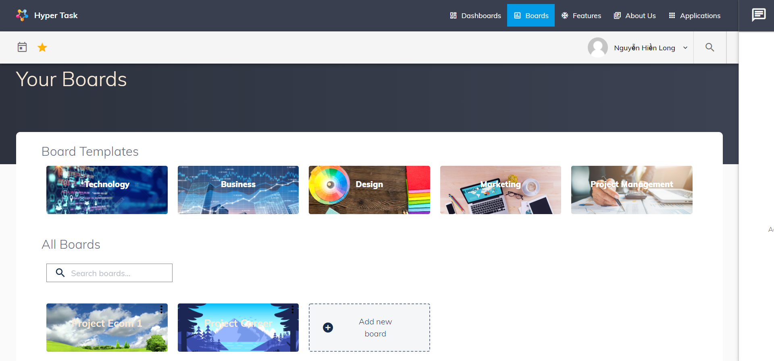

User can create or delete board in this page. To create board, user can click to Add new board or click to board template categories.

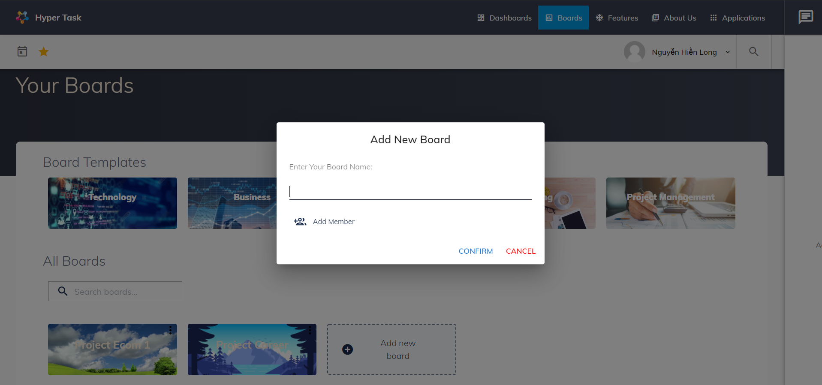

User can set board name and board member in creating new board, or skip it and new board will have default name and no member.

Board details page:

Appbar:

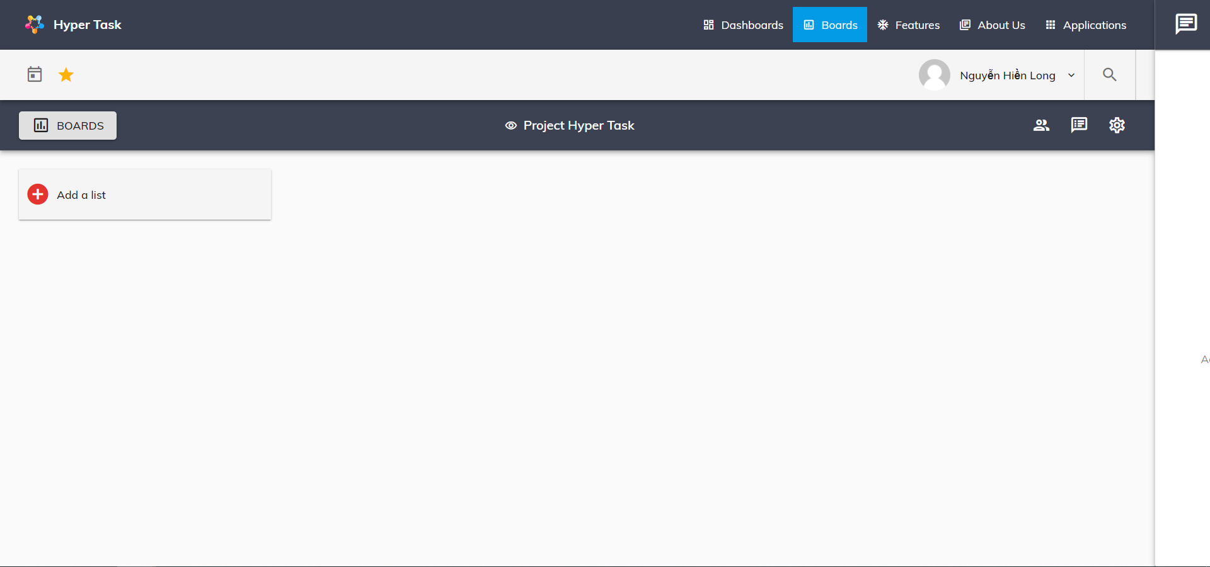

After create board. User will be push to board detail page. In this board user can edit board, create list and create card base on what user want.

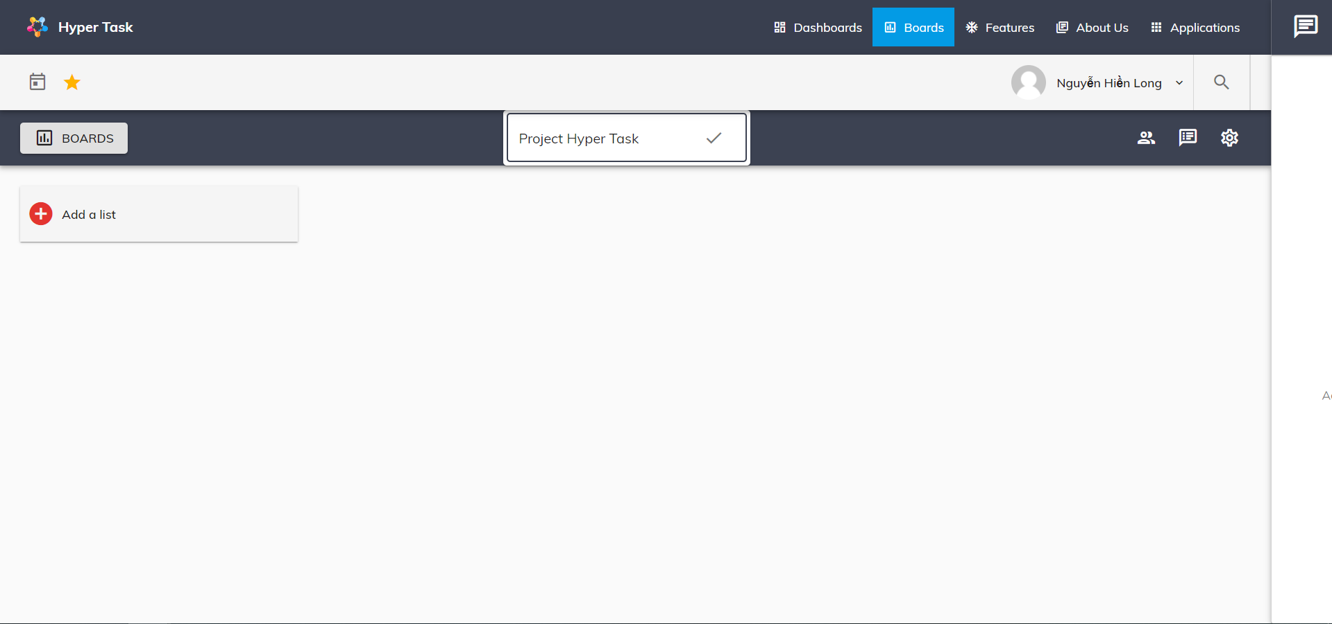

To rename board, user can click to board name and rename it.

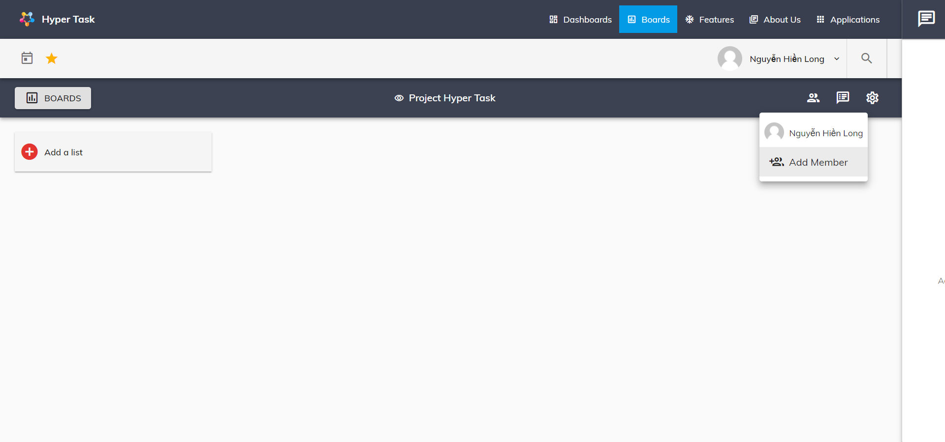

To view board member and add member, user can click to member icon to view and click to Add Member to add new member.

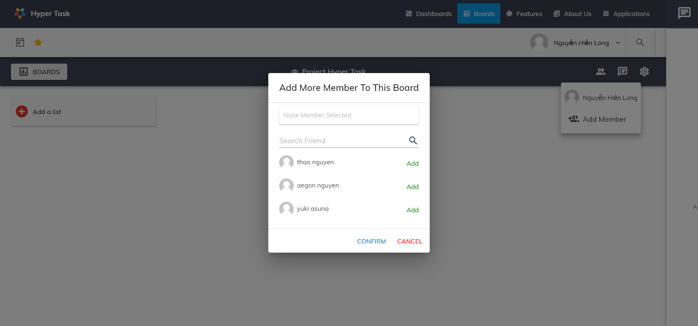

User can search member in search field and click Add and Confirm to add new member to this board

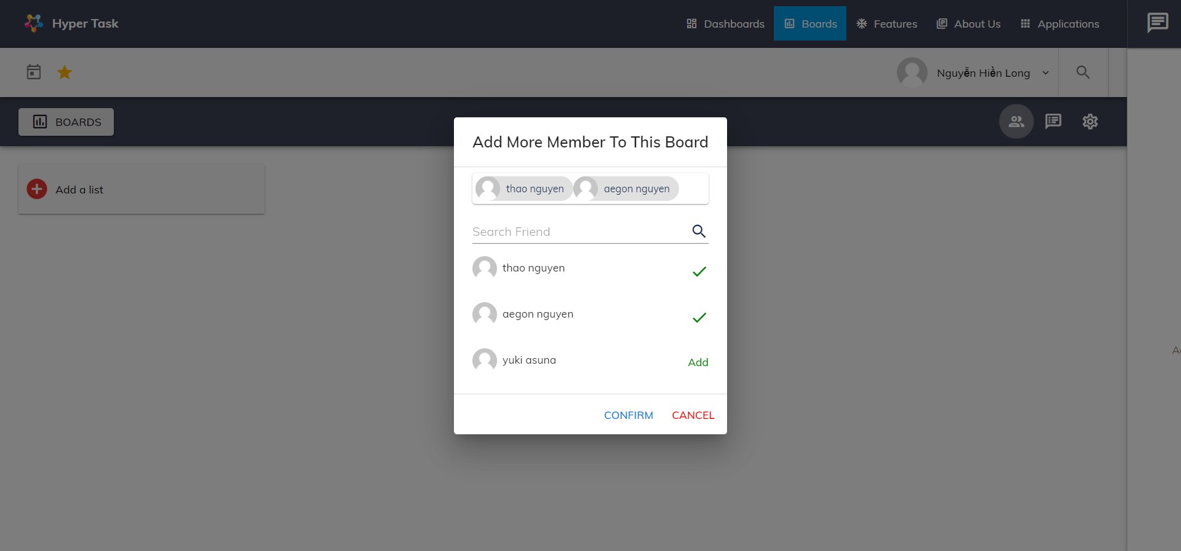

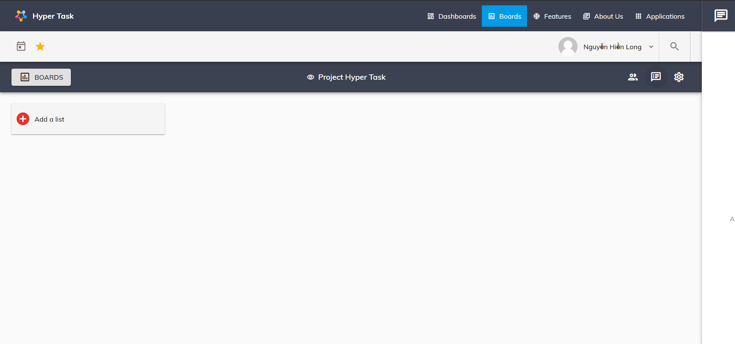

To view board activities, user can click to activity icon.

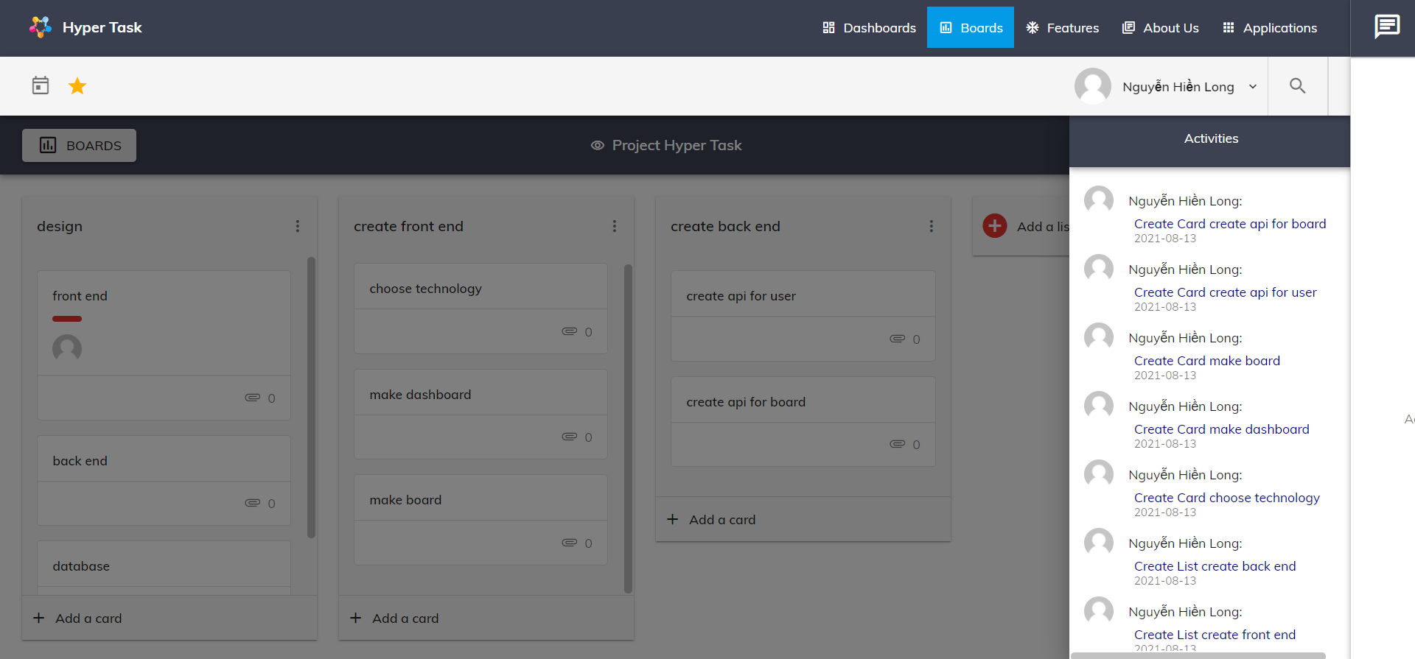

User can view all board activity in here

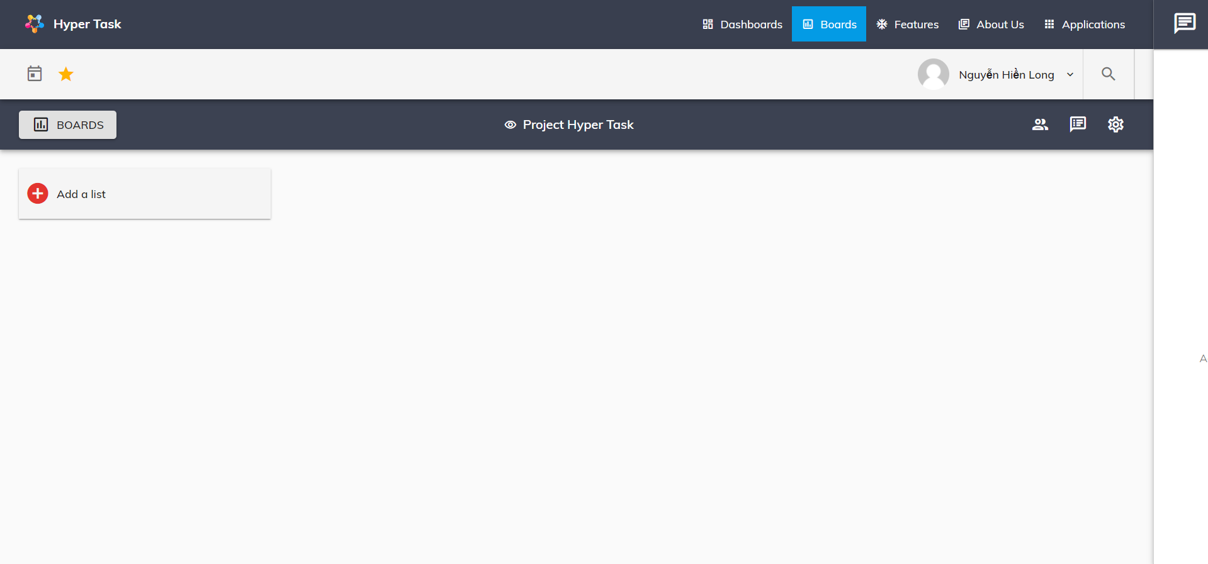

User can change setting board by click on setting icon

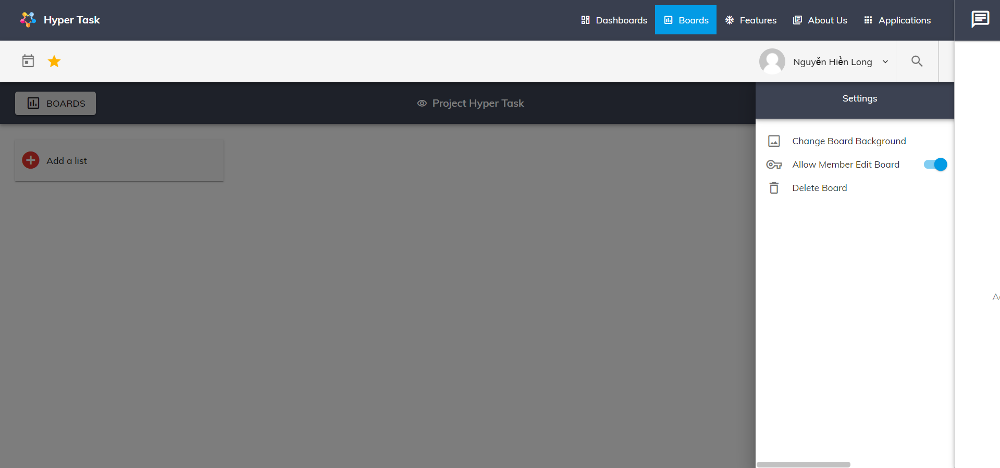

User can change board background by click on Change Board background

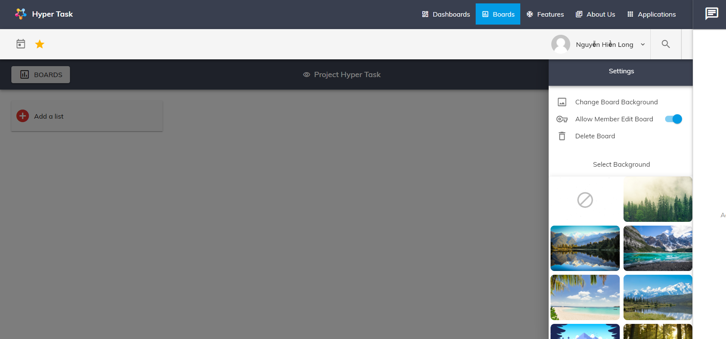

After that user can choose what background image they want.

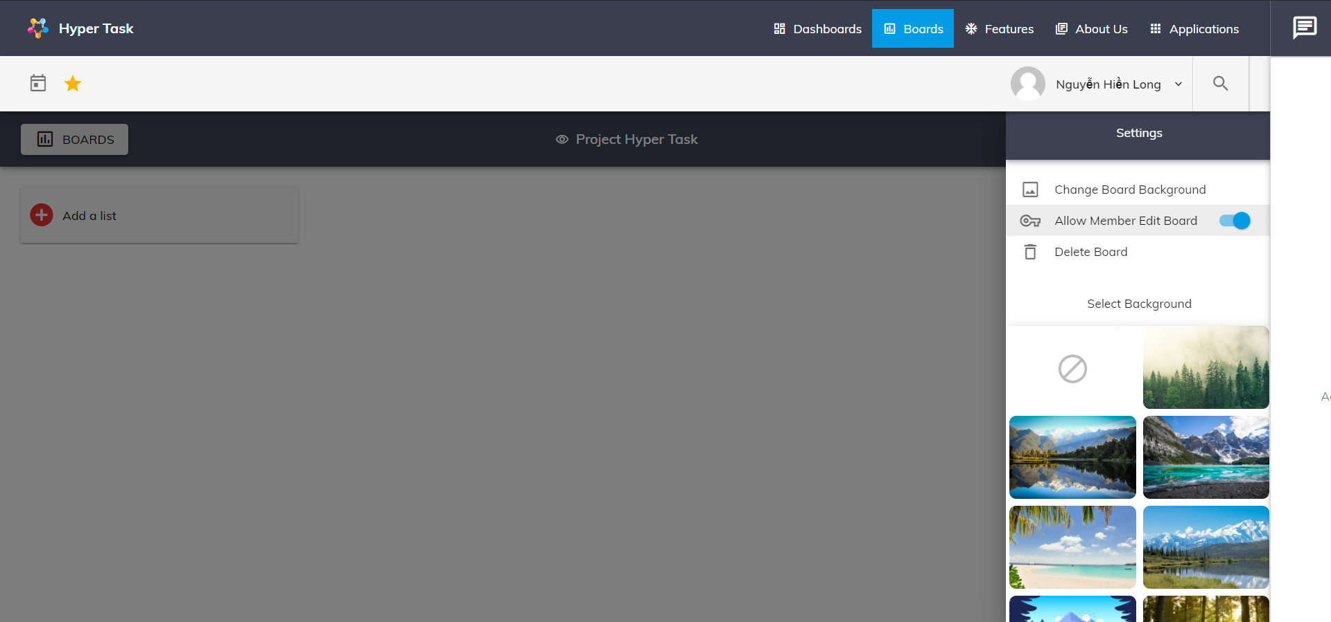

User can allow board member can edit this board or not. This function only available for admin (the one create this board).

List:

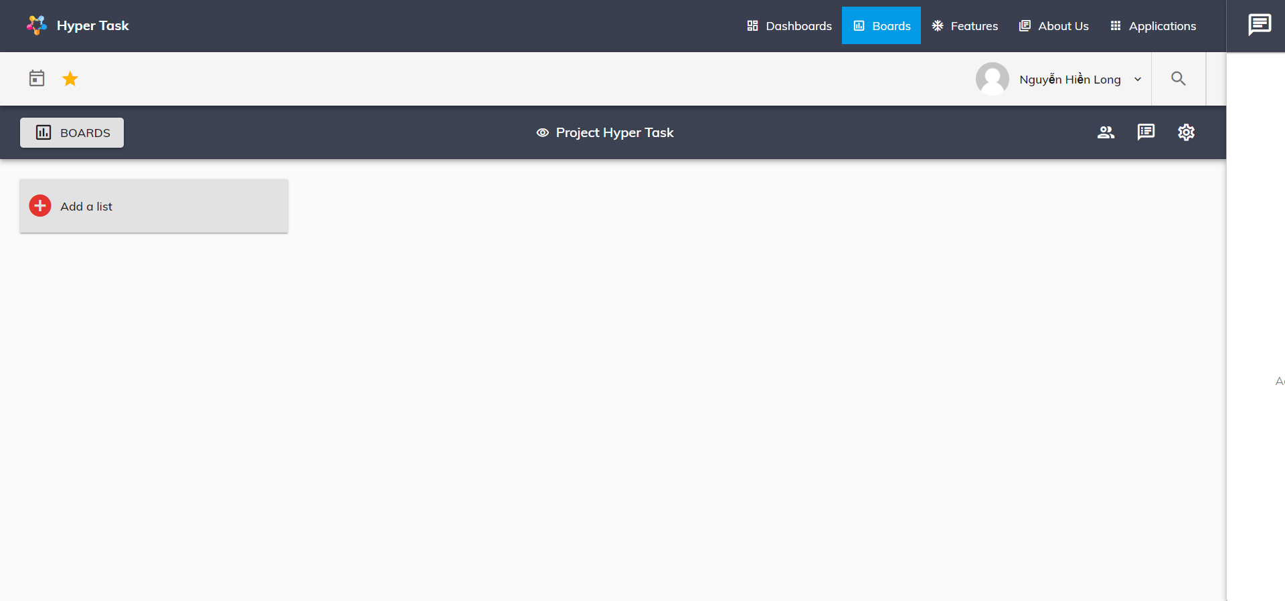

To create new list, user can click to Add a list button

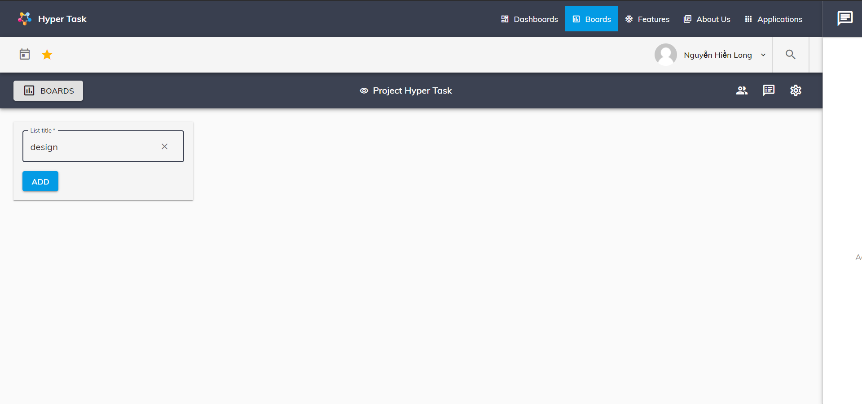

Add list name and click button ADD to create new list

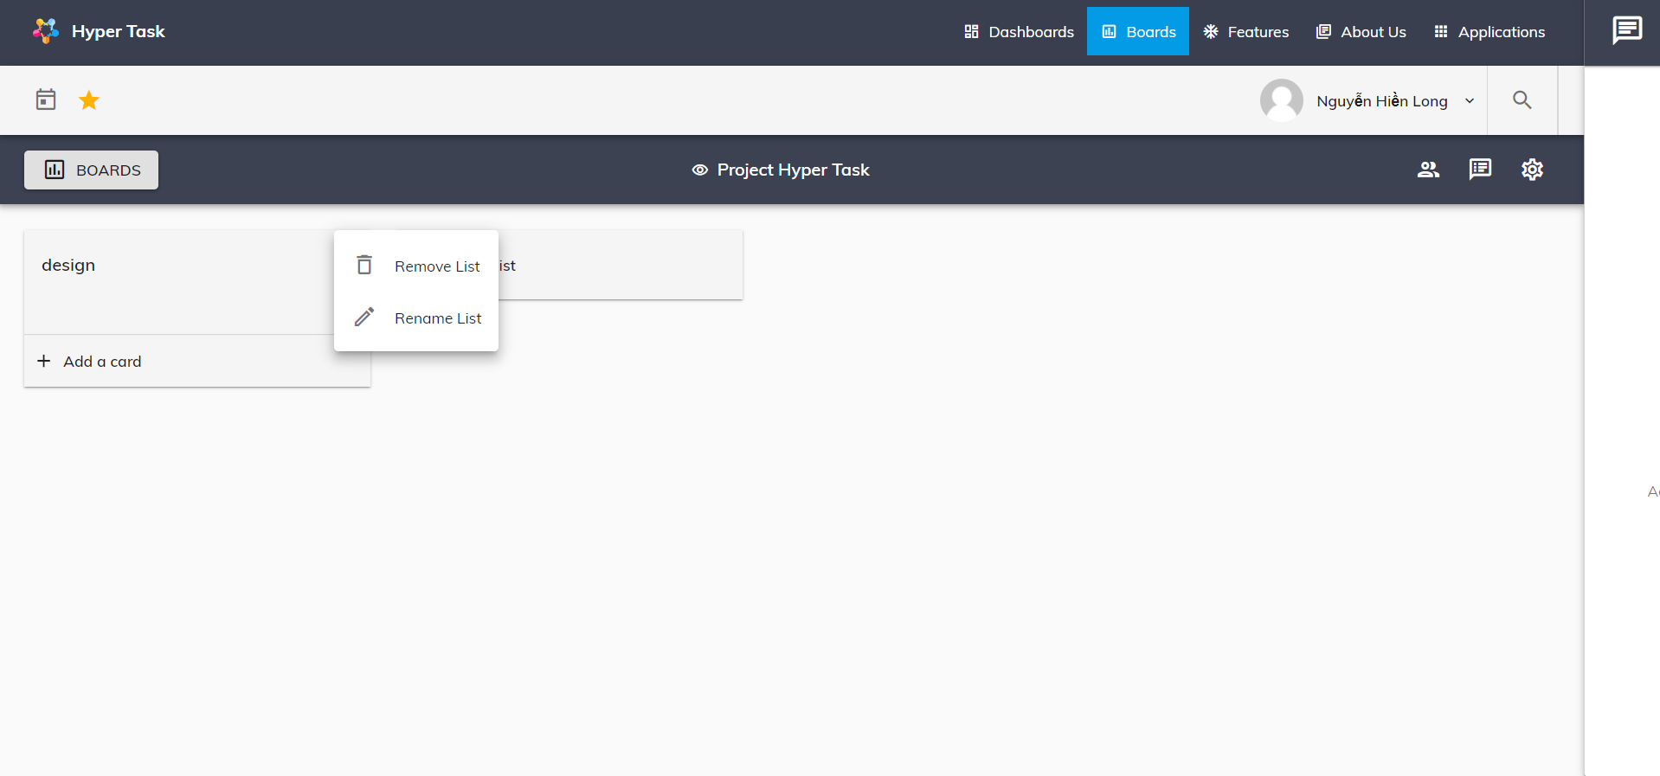

User can rename or remove list by click on setting list icon

Card

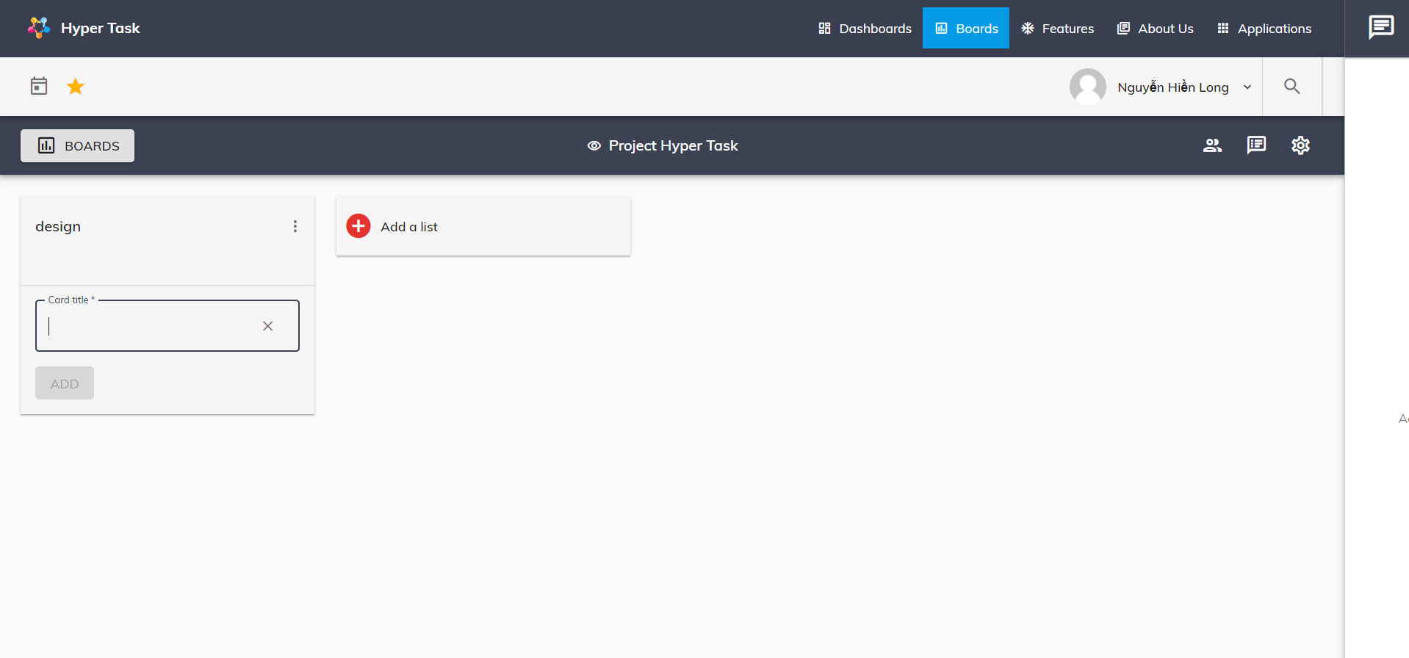

To add new card, user can click to button Add a card and add card name to text box and click button ADD.

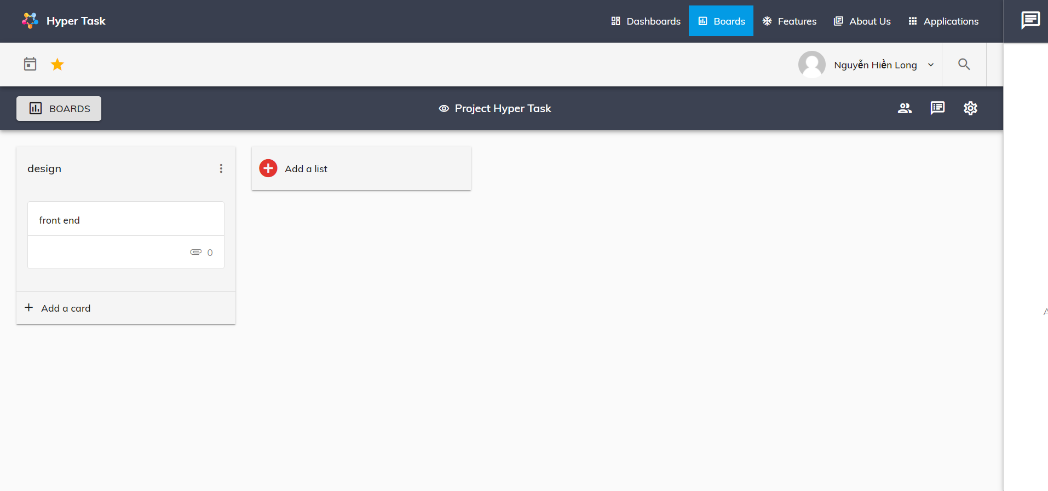

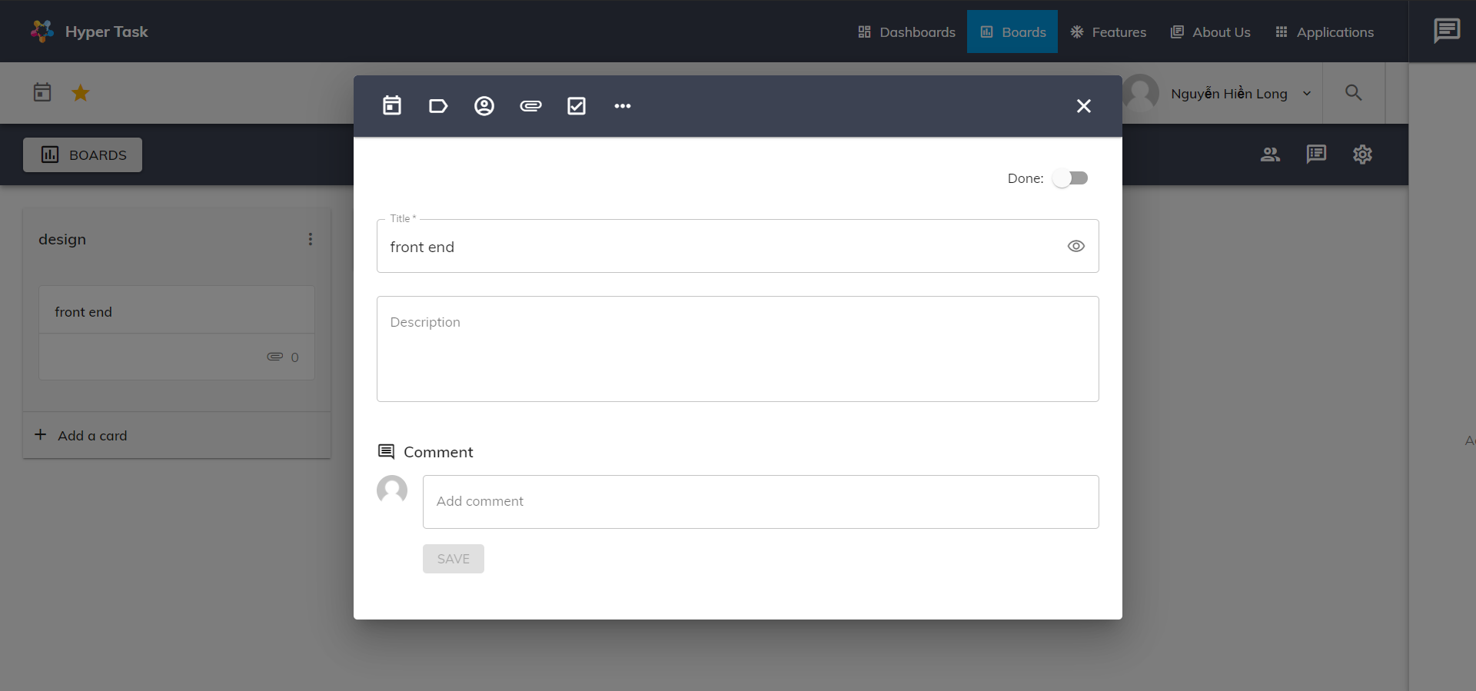

To edit card, user cand click to card and edit it. User can edit card name, card description, add date, add label, add member, add attachment, add check list, add comment, check card done or delete card.

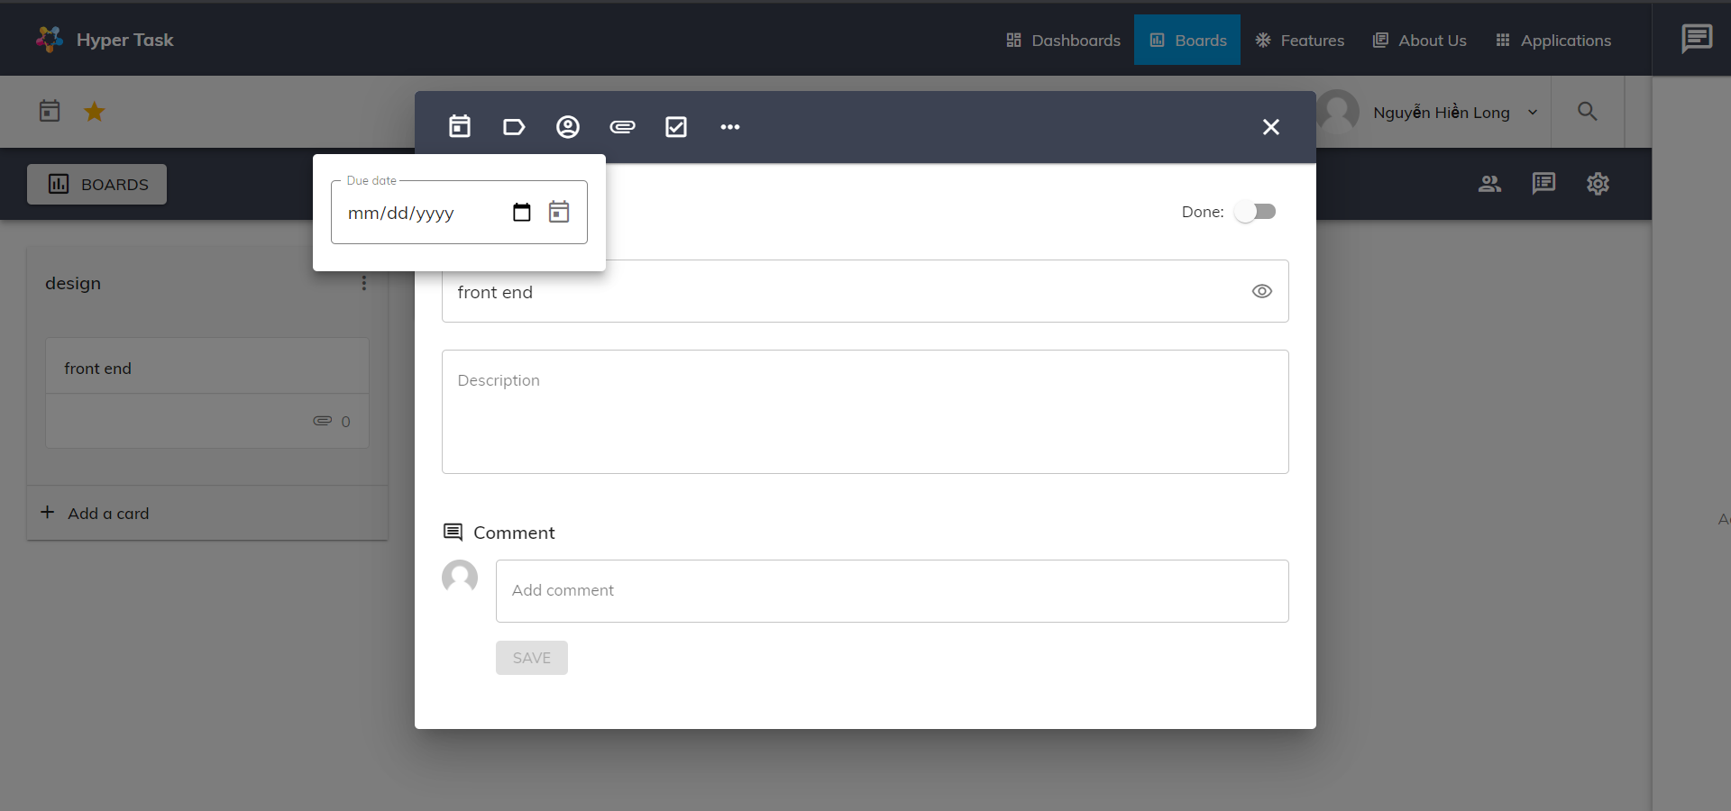

Add date to card

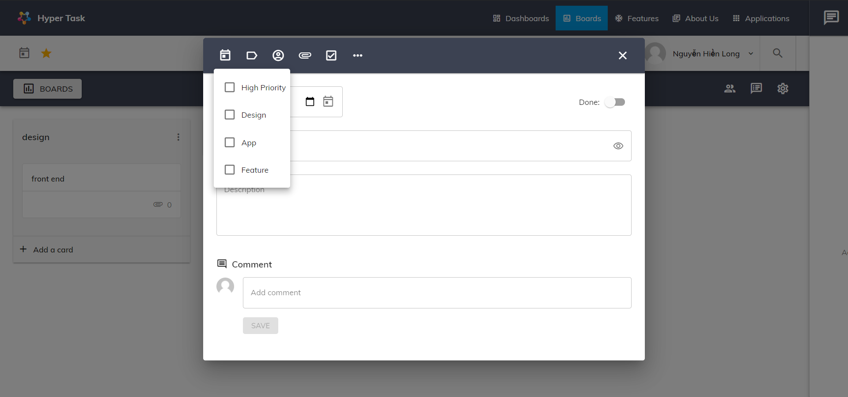

Add label to card

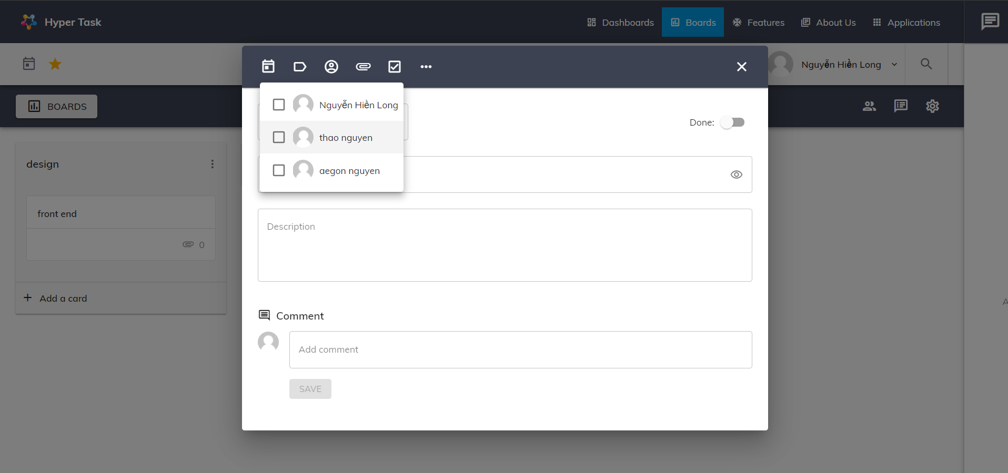

Add member to card. Only member in this board are appear to add

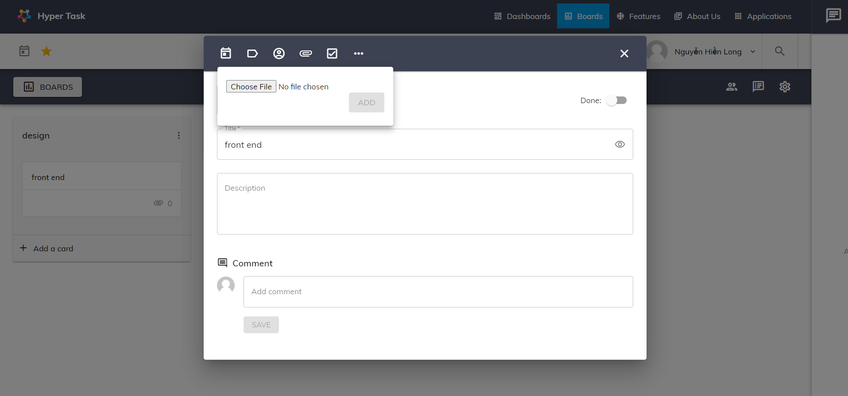

Add attachment to card

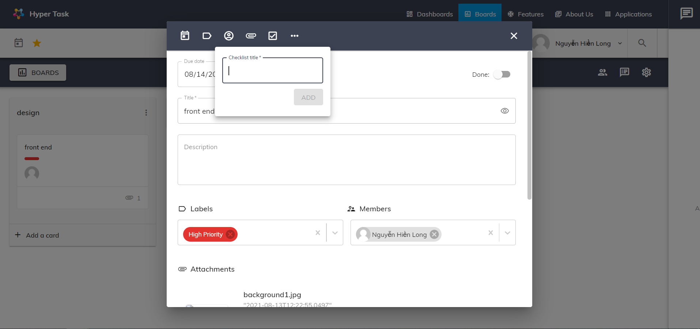

Add check list to card

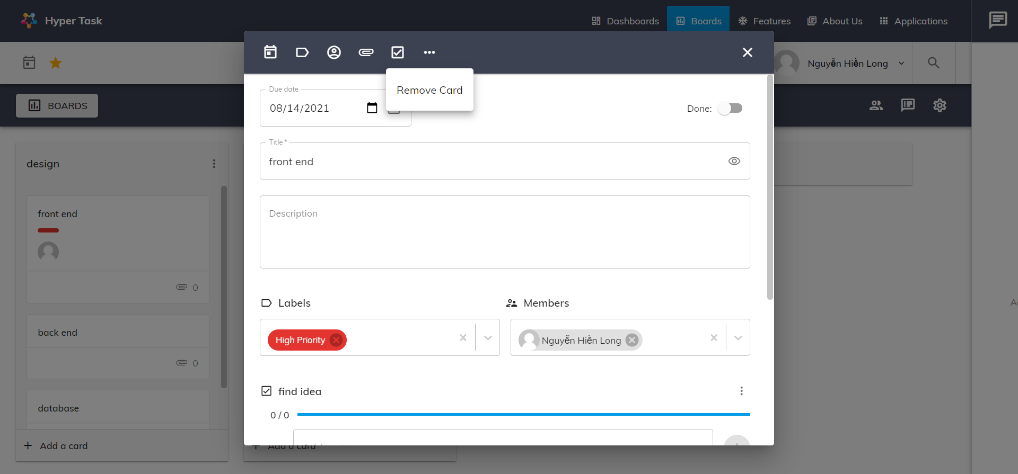

Remove card

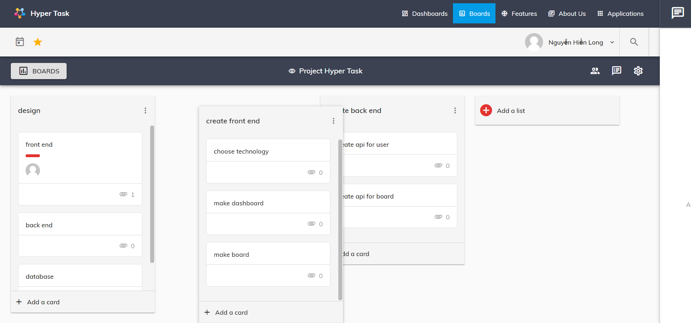

User can reorder list by drag a list and drop it to specific place

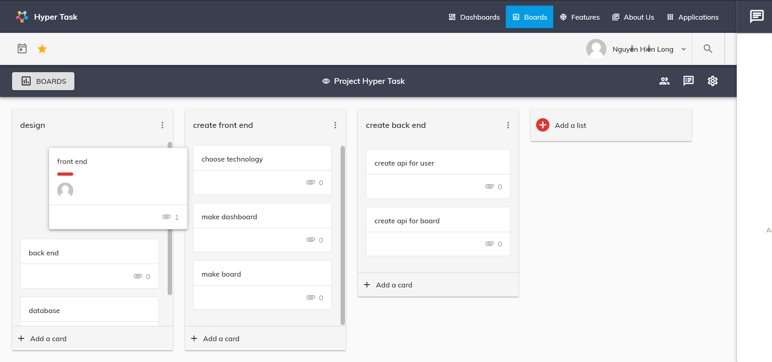

User can reorder card by drag a card and drop it to specific place