Problem definition
The project on Intranet Module shall be a useful product for managing the courier services within a organization. It facilitates the users to send the couriers to other person and to receive from others.

SCOPE:

This project should provide the facility to all users to send and receive the courier. They can also update and delete the courier, and also get the information of the status of the courier.
The scope of project shall be described in following points:
- BENEFITS :-

The main benefit of this project is that it facilitate user to

Communicate in a faster manner in comparison of manual system.

Through this system the current status of the courier can be known

easily whereas in manual system it is a difficult task.

- OBJECTIVE :-
To provide quick service without any delay.

Customer Requirements Specification (CRS)

Business Objectives
2.1 Administrator : -
This department have all right to provide or restrict to any department or employee to the functionality of the project.

2.1.1 Add Employee:-
Only the administrator will add the employee information and provide the login id and password when any new employee will recruit into the enterprise of the courier services.

2.1.2 Create alias:-
The administrator will provide the aliase of password of the employee who want to go on the leaves. This feature will provide the working by another employee in place of regular employee without knowing their password.

2.1.3 Attendance Sheet :-
The presentation or absent of the employee will be handled by the administrator. Any employee can not get their proxy attendance by the change of system date or any other type.

2.1.4 Courier information:-
Administrator has the right to get any information about the courier at any time without any permission of regarding department.

2.1.5 Employee information:-
The employee database can be updated by the administrator department and the administrator can get the any information about the employee working status.

2.1.6 Update calculation table:-
Only the administrator have right to change the Calculation table as per the changes in the transportation cost.

2.2 Working department:-

2.2.1 New courier entry:-
Only the working department will enter the information of the new courier into the data base.

2.2.2 Update courier :-
The working department employee can change the information about the courier as per the request of the user with in the fix time.

2.2.3 Delete Courier :
The working department employee can cancel the courier as per the request of the user with in the fix time.

2.3 Dispatching department :-

2.3.1 Update courier:-
It updates the status of the courier where the courier is at the current time.

    - Courier information :-
The dispatching department employees can get the information of the courier.

2.4 Enquiry:-

2.4.1 Enquiry of Charges:-
This feature will facilitate to make calculation of the amount for sending a courier on the basis of the destination, weight & rate/gm.

2.4.2 About Employee:-

Through this feature the employee can retrieve the information about the other employees.

2.4.3 About Courier:-
When the user is needed the information about the courier then employee can tell the current status of the courier by this feature.

Hardware Requirements

The performance requirements of this product shall be not very critical. The system shall be perform efficiently at 64 MB RAM. The product could run also at 32 MB RAM but to perform well it is necessary to require the above specified quantity of RAM.

Software Requirements

3.2. Safety Requirements

Should be absolutely safe to use. Its usage should not cause any damage or any type of loss to the systems already in use. Also the security model to be prepared regarding the safety of Database so that data is not lost in case of any damage to the system.

3.3. Security Requirements

Security of the system shall definitely be maintained through the password system. The system should be divided in the four security module concern. These are administrator, enquiry department, working department, dispatching department. Each and every employee of every department will be authenticated with a login id and password. Any employee can not change the system date to make proxy presentation of yourself.

Architecture & Design of the Project
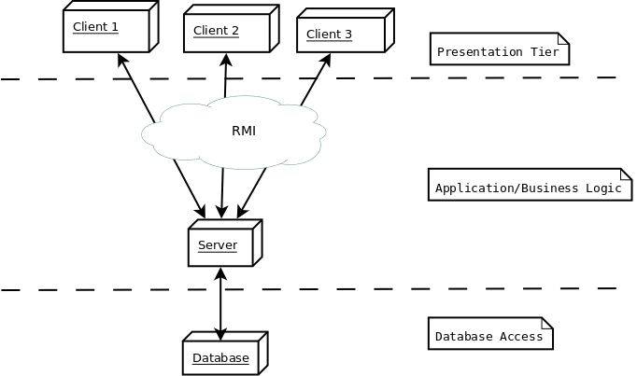

Database design
