

DDD v4.0 Quick Reference

March 23, 2007

Inset Map
Menu bar
Status pane
Map pane
Zoom control

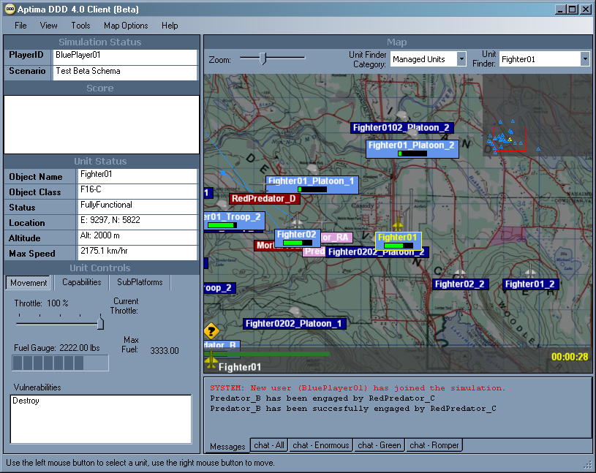
The scenario map
Communications pane

Object color associated with player name

Throttle control

Downloading the DDD Client Software and Logging In
- To download the DDD client software, use ClickOnce: click on the URL link provided. The DDD client software is installed and launched automatically, and the Aptima screen is displayed. (If the client software is already installed, open the Web browser and use the URL link provided to display the Aptima screen.)
- Click Run. The Login box is displayed.
- Enter the assigned user name and password in the Login box.
- Click Login. The Choose a Decision Maker box is displayed.
- Choose a name from the list.
- Click OK. The Player Briefing box is displayed.
- Read the player brief. Click Close when done.
- The scenario map is loaded. Click on the Windows maximize button for best results.

Navigating the Map
- The entire map is displayed by default. To zoom in and out, left-click on the Zoom bar or hold the left mouse button down on the Zoom slider and move it. When a portion of the map is displayed, the Inset Map appears automatically.
- To pan or move, hold the left mouse button down inside the Inset Map and drag to desired location.
- To lighten the playing field, select Lighten Map from the Map Options menu. To darken the playing field, select Darken Map.
- To change the color of the Inset Map background, select Inset Map Background Color from the Map Options menu and choose a new color.
- To identify objects by color in the Inset Map, select Display Unmanaged Unit Colors from the Map Options menu.
- To change the size of object icons, select Scale Unit Icon to Map from the Map Options menu.

Understanding Object Attributes
- Each object’s name is displayed in the same color associated with the player’s name. When selected, an object’s name and icon are displayed in the lower left corner of the map.
- Each object’s fuel level is displayed as a fuel bar under the object’s name.
- When an object is selected, it is highlighted in yellow. In the status pane, Unit Status displays information about that object’s name, class, status, location, altitude, and maximum speed.
- When an enemy object is attacked, a red line from the attacking object to the attacked object is displayed, as well as a small red box above the attacked object that counts down the seconds until the attack ends.

Moving an Object
- Position the cursor on top of an object.
- To select an object, left-click on it. If objects are grouped together, hold the mouse over that group and left-click repeatedly. With each click, a different object in that group is selected.
- To change the speed of an object, select that object then adjust the Throttle Slider.
- To move the object, move the cursor to a new destination and right-click on that destination. A blue line is displayed from the object to its destination. This line indicates the object’s new direction, heading, and final destination.
- To change direction, right-click on a new destination.
- To stop, right-click at the object’s current position.

Attacking an Object
- To learn which weapons to use, select an enemy object, then click on the Movement tab in Unit Controls. The Vulnerabilities box displays all weapons that can attack the selected object.
- To display a list of an attacking object’s weapons, select that object, then click on the Capabilities tab in Unit Controls. Some objects must be launched before their weapons can be used. To launch an object, select the Subplatforms tab, select the object, then right-click on a destination on the map. The object appears on the map and its weapons now can be used. (To recall the object back to its Subplatform, select that object, the Subplatforms tab of that object’s parent, and Dock to Parent. The object disappears from the map.)
- Select a weapon.
- Right-click on the object to be attacked. The Messages window reports that the attacked object has been engaged.
- When the attack ends, the Messages window reports the success or failure of the attack. An object disappears from the map when it is destroyed.

Using the Communications Pane
- To display the Messages window, click on the Messages tab. This window displays a text history of what has happened so far in the simulation.
- To display the Chat window, click on the Chat-All tab. This window displays the chat messages broadcast to all players.
- To communicate with other players, type a message in the Chat window’s text box and click Send. Messages appear below the text box, tagged with the time elapsed and player name.
- Players can use the Chat window even when the simulation has been paused.
- To create another Chat window, select New from the File menu, then select Chat Window. The Chat Window Properties box is displayed. In the Group ID field, enter a name for the new Chat window. Left-click on each player name allowed to use the new Chat window. Click Create. A new tab identifying the new Chat window appears at the bottom of the communications pane. Click on this tab to display the new Chat window. Each Chat tab displays the number of unread messages in that window.
- When needed, scroll bars will display automatically in the Messages and Chat windows.
- To resize the Chat or Messages window, resize the communications pane.
- To hide the communications pane, select Tab Windows from the View menu.

Getting Information
- To display the player brief, select Player Briefing from the Help menu.
- The status pane has four sections:
Section | Displays
Simulation Status | Player ID and scenario name
Score | All player scores
Unit Status | Information about the currently selected object
Unit Controls | Information about the movement, capabilities, and subplatforms of the currently selected object

- In Unit Controls, the Movement tab displays the throttle control, fuel gauge, and vulnerabilities of the selected object. The Capabilities tab lists the weapons available for use by the selected object. The Subplatforms tab lists objects that can be launched by the selected object.
- To locate objects that can be controlled, select Managed Units in the Unit Finder Category, then use the Unit Finder dropdown menu.
- To locate objects controlled by teammates or the enemy, select Unmanaged Units in the Unit Finder Category, then use the Unit Finder dropdown menu.
- The clock is displayed in the bottom right corner of the map.
- The icon and name of the currently selected object are displayed in the bottom left corner of the map.
- When the simulation ends, a Game Over box is displayed.
Note: Topographical map of Nanaimo, British Columbia provided by Spectrum Digital Imaging, www.mapsdigital.com.

