

DDD v4.0 Quick Reference

March 16, 2007

Inset Map
Menu bar
Status pane
Map pane
Zoom control

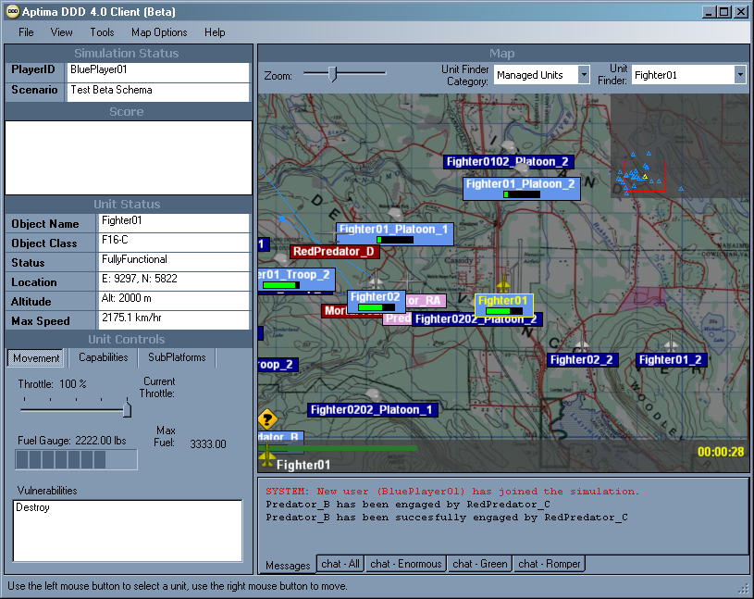
The scenario map
Communications pane

Object color associated with player name

Throttle control

Topographical map of Nanaimo, British Columbia provided by Spectrum Digital Imaging, www.mapsdigital.com.

Downloading the DDD Client Software and Logging In
- To download the DDD client software, use ClickOnce: click on the URL link provided. The DDD client software is installed and launched automatically, and the Aptima screen is displayed. (If the client software is already installed, open the Web browser and use the URL link provided to display the Aptima screen.)
- Click Run. The Login box is displayed.
- Enter the assigned user name and password in the Login box.
- Click Login. The Choose a Decision Maker box is displayed.
- Choose a name from the list.
- Click OK. The Player Briefing box is displayed.
- Read the player brief. Click Close when done.

Navigating the Map
- The entire map is displayed by default. To zoom in and out, left-click on the Zoom bar or hold the left mouse button down on the Zoom slider and move it. When a portion of the map is displayed, the Inset Map appears automatically.
- To pan or move, hold the left mouse button down inside the Inset Map and drag to desired location.
- To locate objects that can be controlled, select Managed Units in the Unit Finder Category, then use the Unit Finder dropdown menu.
- To locate objects controlled by teammates or the enemy, select Unmanaged Units in the Unit Finder Category, then use the Unit Finder dropdown menu.

Understanding Object Attributes
- Each object’s fuel level is displayed as a fuel bar under the object’s name.
- When an object is selected, it is highlighted in yellow. In the status pane, Unit Status displays information about that object’s name, class, status, location, altitude, and maximum speed.
- When an enemy object is attacked, a red line from the attacking object to the attacked object is displayed, as well as a small red box above the attacked object that counts down the seconds until the attack ends.

Moving an Object
- Position the cursor on top of an object.
- To select an object, left-click on it. If objects are grouped together, hold the mouse over that group and left-click repeatedly. With each click, a different object in that group is selected.
- To change the speed of an object, select that object then adjust the Throttle Slider.
- To move the object, move the cursor to a new destination and right-click on that destination. A blue line is displayed from the object to its destination. This line indicates the object’s new direction, heading, and final destination.
- To change direction, right-click on a new destination.
- To stop, right-click near the object.

Attacking an Object
- To learn which weapons to use, select an enemy object, then click on the Movement tab in Unit Controls. The Vulnerabilities box displays all weapons that can attack the selected object.
- To display a list of an attacking object’s weapons, select that object, then click on the Capabilities tab. Some objects must be launched before their weapons can be used. To launch an object, select the Subplatforms tab, select the object, then right-click on a destination on the map. The object appears on the map and its weapons now can be used.
- Select a weapon.
- Right-click on the object to be attacked. The Messages window reports that the attacked object has been engaged.
- When the attack ends, the Messages window reports the success or failure of the attack. An object disappears from the map when it is destroyed.

Using the Communications Pane
To create another Chat window, select New from the File menu, then select Chat Window. The Chat Window Properties box is displayed. In the Group ID field, enter a name for the new Chat window. Left-click on each player name allowed to use the new Chat window. Click Create. A new tab identifying the new Chat window appears at the bottom of the communications pane. Click on this tab to display the new Chat window. Each Chat tab displays the number of unread messages in that window.

