

DDD v4.0 Best Practices Guide

March 23, 2007
Contents
Using the DDD Simulation Server Console 2
Before the Experiment Begins 2
Logging onto the DDD Simulation Server 2
Changing a Scenario 3
Specifying the Directory for the Current Scenario’s Log File 3
Specifying a Simulation Run ID 3
Loading the Scenario 4
Verifying That the Minimum Number of Players Have Entered the Simulation 4
Starting the Simulation 4
Running the Simulation 5
Getting Information During the Simulation 5
Replaying a Simulation 5
Managing Simulation Data 7
Simulation Run ID Name Tips 7
File Directory Tips 8
Backup Tips 8
Providing Information to Players 8
The ClickOnce Link to Install the DDD Client Software 8
The User Name 9
The Password 9
The Player Briefing 9
Assets Available to the Player 9
Assets Required to Destroy Enemy Objects 9
Subplatform Information 9
Practice Sessions for New Players 9
Troubleshooting Tips 10
Understanding the Player’s View 10

Using the DDD Simulation Server Console
The DDD is used to run simulations (also known as experiments or training sessions) for individuals or teams participating in pre-defined “scripted” scenarios. Data for simulation participants (scripted or human) is logged during the execution of the scenario and is available for replay, analysis, and feedback purposes.
The person who runs the simulation (“the experimenter”) uses the PC on which the DDD Simulation Server is installed (“the server machine”) to log onto the DDD Simulation Server. The experimenter also uses the DDD Simulation Server console to start and stop the experiment and to manage data. All the data files generated by experiments are stored on the server machine. Players who participate in the experiment (meaning, play the scenario) are referred to as “Decision Makers.”
The experimenter should be aware that when DDD is installed, it also is possible to install the Visual Scenario Generator (VSG) version 0.5, which is a graphical scenario editor for modifying an existing DDD scenario file. With VSG v0.5, the user can change maps, move assets on the map, create new assets for the simulation, copy existing assets, and save the edited scenario. The VSG requires MySQL v5.0.

Before the Experiment Begins
The experimenter must make decisions before running an experiment. The experimenter will have normally one or more scenarios from which to choose, as well as one or more groups of players (“teams”).
The scenarios are loaded by the administrator who installs and configures the DDD Simulation Server. The experimenter chooses the scenario to be run from the DDD Simulation Server console. Before the experiment begins, it is important to verify or change the location where the data generated by that experiment will be stored.
Before the experiment begins, the experimenter performs the following tasks:
- Log onto the DDD Simulation Server.
- (Optional) If the current scenario will not be used, change the scenario.
- (Optional) Specify the directory for the current scenario’s log file.
- (Optional) Specify a Simulation Run ID name to identify the group of players.
- Load the scenario.
- Verify that the minimum number of players have entered the simulation.
- Start the simulation.

Logging onto the DDD Simulation Server
Use the following steps to log onto the DDD Simulation Server:
- To display the DDD Login dialog box, from the Microsoft Start menu on the server machine, double-click on the Aptima DDD 4.0 Server icon.
- Click Connect.
The DDD Simulation Server console is displayed, as shown below.
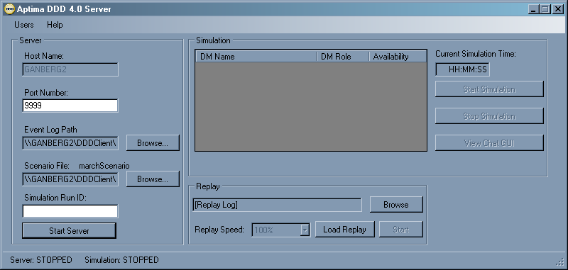

Changing a Scenario
Experimenters who use only one scenario will not have to change scenarios and can skip this section. However, experimenters who use more than one scenario should use the DDD Simulation Server console to verify the current scenario and possibly change the scenario before running a new simulation.
- The name of the scenario file in current use is displayed next to Scenario File in the Server field in the DDD Simulation Server console. Use Browse to display a new scenario file in the box below the current scenario file name.
- Click OK.
The new scenario will be in use until the DDD Simulation Server is stopped or another scenario is chosen using the above steps.

Specifying the Directory for the Current Scenario’s Log File
Once the experimenter chooses the scenario, the next step is to verify or change the location where the data generated by the experiment will be saved. The log file contains the data generated when the simulation is run.
When the DDD Simulation Server is configured, the administrator will verify or set new default values. Therefore, default values will have already been set for log files. The experimenter may save the log files in another directory, if desired. To do so, use Browse to select a new Event Log Path.

Specifying a Simulation Run ID
The experimenter can assign a name to each simulation being run as a strategy for organizing log file data. In other words, one way to make it easier to keep track of data is to add information to the log filename as a way to identify a simulation in a more specific way. The best type of information to add is information that identifies the group of players participating in the simulation.
For example, suppose two different teams play the same simulation, one in the morning and the other in the afternoon. Use Simulation Run ID to assign a name to each team, such as “A” and “B” or “Morning Team” and “Afternoon Team.” The Simulation Run ID will be included in the log file name, making it easier to keep track of data.
Use the following step to specify a Simulation Run ID:
- Enter a name in the Simulation Run ID box in the Server field.
- Start the server.
- Load the scenario.
Note: The order of the above steps is critical. The name for the simulation run must be entered before the server is started and the scenario is loaded. Otherwise, the name will not be added to the log filename.
See Simulation Run ID Name Tips on page 7 for more information.

Loading the Scenario
Click the Start Server button to load the scenario.
Notice the changes in the DDD Simulation Server console, shown below. In the Simulation field, the Decision Maker (DM) information box has been populated with player information. The name of the Start Server button has changed to Stop Server and the Start Simulation button is now enabled.
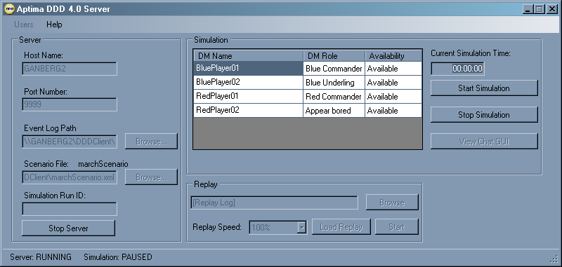
Also notice that in this example, the Load Replay button in the Replay field is currently disabled. This button is enabled only when a replay file is selected in the Replay field by using Browse, which is also disabled. The Replay field can only be used when the server is stopped.

Verifying That the Minimum Number of Players Have Entered the Simulation
Player information is displayed in the Simulation field in the DDD Simulation Server console. Player names are listed in the DM (Decision Maker) Name column, and player roles are listed in the DM Role column. Player availability status is listed in the Availability column.
The experimenter should verify that the minimum number of players required have entered the simulation. This means that players have used their user account names and passwords to log onto the DDD Simulation Server and have chosen a player name from a list of pre-defined names.
When “Not Taken” is displayed next to a Decision Maker name, this indicates that no one has used that name to enter the simulation. Therefore, when all DM names display “Not Taken,” this indicates that no one has entered the simulation.
Once a client is prepared to run the simulation, the availability changes to “Ready.” This typically happens a few seconds after a player chooses a Decision Maker name.

Starting the Simulation
To start the simulation, click Start Simulation. When the simulation begins, the timer starts ticking and the elapsed time is displayed in the Current Simulation Time box.
The experimenter can choose to start the simulation without the minimum number of players. In this case, a dialog box will display a message that not all Decision Makers have been assigned yet. Click Yes to run the simulation without the minimum number of players.

Running the Simulation
Once the simulation has begun, the experimenter can pause, resume, and stop the simulation. The current state of the server and the simulation is displayed in the status bar at the bottom of the DDD Simulation Server console. Once the simulation begins running, notice that the Start Simulation button changes to Pause Simulation.
The experimenter can take the following actions:
- To pause the simulation, click Pause Simulation. The simulation and timer will pause, and this button’s name changes to Resume Simulation.
- To resume the simulation, click Resume Simulation. The simulation and timer will resume, and this button’s name changes to Pause Simulation.
- To stop the simulation, click Stop Simulation.
- To end the simulation, click Stop Server.
Note: every time a scenario ends, all players must exit the DDD client.

Getting Information During the Simulation
The Current Simulation Time box in the DDD Simulation Server console displays the time that has elapsed during a simulation. When the simulation ends, a screen with scoring information is displayed on the server machine.

Replaying a Simulation
After a simulation has been completed and its data has been stored in a log file, it is possible to replay that simulation. Both the experimenter and the players can watch the replay. Scenario logs may be replayed faster, slower, or at the same speed at which they were logged. Before replaying a simulation, all players must be logged off, and the server must be stopped. It is not possible to replay a simulation while a current simulation is being played.
Use the following steps to replay a simulation:
- If the server is running, click Stop Server. The Replay field is now enabled, as shown below.
- To choose a log file, use Browse in the Replay field.
- To replay the simulation at the same speed at which it was played, leave the Replay Speed at its default of 100%. Otherwise, choose another value to replay the simulation at a faster or slower speed.
- Once a log file is chosen, click Load Replay. If a log file has not been chosen, an error message is displayed, which states that the selected file could not be opened for replay. If this happens, use Browse to choose a log file, then click Load Replay again.
The server starts running, and the Decision Makers are displayed in the Simulation field, as shown below. The players can now connect to the server so that they can watch the replay of the simulation. Notice that the Load Replay button has changed to Stop Replay.
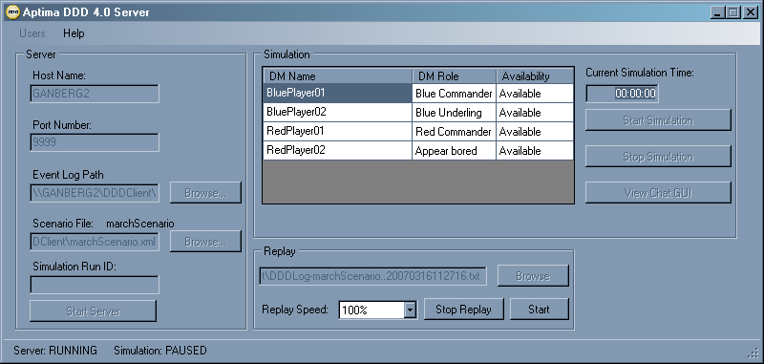
- Click Start to begin the replay of the simulation. The clock begins ticking, as shown in Current Simulation Time, below. Notice also that the Start button changes to Pause.
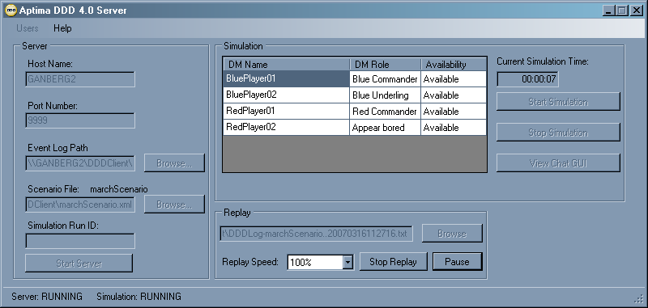
- Click Pause to pause the replay. When the replay is paused, the clock is also paused. Notice that the Pause button changes to Resume, as shown below. Notice also that the simulation is flagged as “PAUSED” at the bottom of the server console.
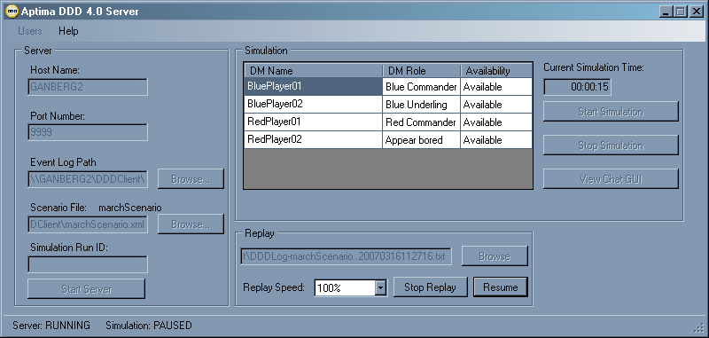
- Click Resume to continue the replay.
- Click Stop Replay to end the replay. When the replay stops, the server stops running, as well. Remember that it is not possible to run a simulation at the same time a log file is being replayed.

Managing Simulation Data
An experimenter is likely to run a variety of scenarios with different teams over a period of time. For example, an experimenter might have three teams, called Team A, Team B, and Team C. The experimenter might have two different scenarios, called Scenario 1 and Scenario 2. The experimenter will draw up a schedule that lists the date and time at which a specific team will play a specific scenario. For example, Team A might play Scenario 1 from 10:00 to 10:30 a.m. on Monday and then play Scenario 2 from 10:30 to 11:00 a.m. the same day. Team B might play Scenario 2 on Tuesday from 2:30 to 3:15 p.m. and then play Scenario 1 from 3:15 to 4:00 p.m.
Use the following strategies to manage data that is generated by running each scenario:
- Specify a Simulation Run ID.
- Organize log files in directories for easy retrieval.
- Back up data on a regular basis.

Simulation Run ID Name Tips
As previously described, a Simulation Run ID can be entered in the Simulation Run ID text box, but this must be done before starting the DDD server and loading a scenario. Files are named automatically using the following convention:
scenarioname.simulationrunID.datetime.txt
Therefore, if a Simulation Run ID is specified, it will be added to the file name between the scenario name and the date and time that the simulation is run. For example, if the name “TeamA” is entered in the Simulation Run ID box and a simulation named Scenario1 is run on September 1, 2007 at 10:00:00 a.m., then the log file name will be:
Scenario1.TeamA.20070901100000.txt
Alternatively, if no group name is specified in the Simulation Run ID box, the file name in this example will be:
Scenario1.20070901100000.txt

File Directory Tips
Before running simulations, it is a good practice to create a directory structure for storing the log files that will be created when simulations are run. It is a good practice to organize the directory structure according to either:
- Experiments or
- Teams

Organizing File Structure by Experiments
Use the following steps to organize the directory structure according to experiments:
- Create a folder for each experiment. For example, create a folder named Scenario1.
- Before running a new simulation, use the DDD Simulation Server console to specify the directory in which the log file for that simulation will be stored. For example, suppose there is a simulation scheduled for Team A to play Scenario 1. To specify the directory, use Browse to display the Scenario1 folder in the Event Logging Options box.

Organizing File Structure by Teams
Use the following steps to organize the directory structure according to teams:
- Create a folder for each team. For example, create three folders named TeamA, TeamB, and TeamC.
- Before running a new simulation, use the DDD Simulation Server console to specify the directory in which the log file for that simulation will be stored. For example, suppose there is a simulation scheduled for Team A to play Scenario 1. To specify the directory, use Browse to display the TeamA folder in the Event Logging Options box.

Backup Tips
It is a good practice to back up all data at the end of each day that experiments have been run. Back up the entire data directory to some media separate from the server machine. The best approach is to burn the entire data directory onto a CD.

Providing Information to Players
It is a good practice to prepare a list of information to give to players before the simulation begins. This list should include the following:
- The ClickOnce link needed to install the DDD client software
- The user name assigned to that player
- The password assigned to that player
- (Optional) The player briefing
- (Optional) Assets available to the player
- (Optional) Assets required to destroy enemy objects
- (Optional) Subplatform information

The ClickOnce Link to Install the DDD Client Software
The DDD client software is downloaded when players connect their machines to the DDD server by using a ClickOnce installation link. This means players install the DDD client software by clicking once on a link provided to them. The DDD client can only be installed in online mode. This ensures that every player is using the same and the most current version of the DDD client software.
Players select the following file from a shared folder located on the machine on which the DDD Simulation Server is installed:
\\<hostname>\DDDClient\index.htm
where <hostname> is the name of the DDD server machine, DDDClient is the name of the shared folder on the server machine, and index.htm is the file needed to use ClickOnce. The DDDClient shared folder is created on the server machine automatically when the DDD Simulation Server is installed.
When the player exits the client application, the DDD client software is automatically removed from that user’s machine. In other words, this installation is not permanent. Therefore, it is always a good practice to give the ClickOnce installation link needed to players before the simulation.

The User Name
Once the DDD client software is installed, the players will be prompted to enter a user name and password. Before the simulation, a user account must be created for every player. However, these user accounts may be used by different groups of players, as long as those groups do not play at the same time. For example, suppose Team A has four players, Team B has six players, and the teams never play at the same time. That means it is necessary to create six user accounts, and each account must have a unique user name. Team B will need all six user accounts, and Team A will use four of those six accounts.
The DDD Installation and Configuration Guide has instructions on how to manage user accounts.

The Password
When players are prompted to enter a user name, they must also enter a password. When user accounts are created, a password must be created for the user name being created.

The Player Briefing
Some scenarios include a player briefing. When players enter the simulation, the player briefing is displayed, if one exists. Players can also display the briefing on the client screen during play. However, it may be useful to provide a hard copy of the player briefing before the players enter the simulation. For example, players may need time to strategize before the simulation begins.

Assets Available to the Player
Players can use the DDD client to discover which assets are available. If players need to strategize before the simulation begins, it will be helpful for them to have a list of the assets available to them.

Assets Required to Destroy Enemy Objects
Many scenarios assign a task of destroying enemy objects. Each enemy object can have an individual set of vulnerabilities. In other words, every enemy can have its own set of requirements for what is needed to destroy it. A given player may not have all the weapons required to destroy an enemy, necessitating team attack planning. Therefore, it is helpful for players to have a list of the assets they need to destroy each type of enemy object.

Subplatform Information
Some scenarios use subplatforms, which are objects that must be launched from a parent object before they can be used. For example, a parent object might be a submarine. The submarine might have a platoon of soldiers as a subplatform, and those soldiers are armed with weapons. However, it makes no sense for those soldiers to use their weapons while on the submarine. In this case, the soldiers must be launched from the submarine, and they will then appear on the scenario map. Once those soldiers have been launched, their weapons can be used.
Players can locate subplatforms during the simulation, but finding subplatforms can be time consuming, especially if there are many objects in the scenario. If a scenario includes subplatforms, it is helpful for players to know in advance the subplatforms that are available and where they are located.

Practice Sessions for New Players
It is a good practice to train novice Decision Makers (players) in DDD concepts and operations by having them participate in practice simulations prior to running experiments where data will be captured and analyzed.

Troubleshooting Tips
If it is not possible to start the DDD Simulation Server, another application installed on the machine may be using the port number specified in the Port Number box on the DDD Simulation Server console. Try entering a different number above 9000 in the Port Number box and try starting the server again.
Do not use Ctrl-Alt-Del to bring up the task manager or when switching applications on the server. Otherwise, it will be necessary to restart the server.
Between scenario runs, be sure to exit the simulation server and restart it. Otherwise, the DDD client’s Decision Maker list may not be populated correctly.

Understanding the Player’s View
It may be helpful for experimenters to understand what the players see on the DDD client.
After the player uses the ClickOnce link provided by the experimenter to install the DDD client software, the following DDD Client installation screen is displayed.
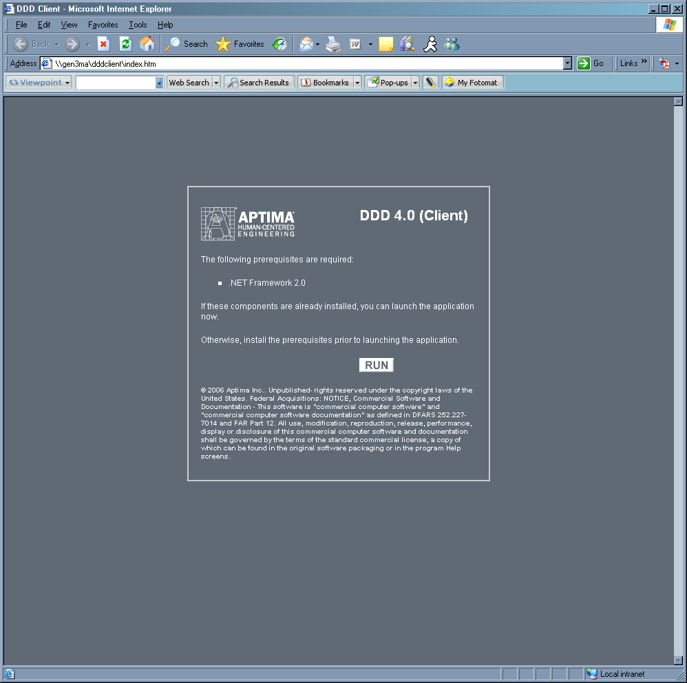
After the player clicks Run, the player enters the user name and password provided by the experimenter in the following dialog box, then clicks Login.
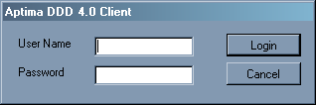
Next, the player chooses a Decision Maker name from a list of pre-defined names, as shown below.
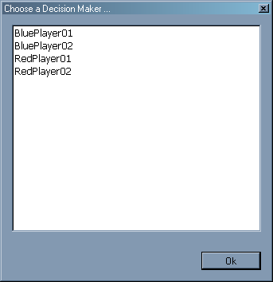
After the player chooses a Decision Maker name, clicks OK, and enters the simulation, the scenario map begins loading.

