

DDD v4.0 Installation and Configuration Guide

January 2, 2008
Contents
Overview 2
DDD Simulation Server System Requirements 2
Installing the DDD Simulation Server 2
Configuring the DDD Simulation Server 5
Creating User Accounts 6
Changing the Password in a User Account 8
Deleting a User Account 9
Getting Help 9
Troubleshooting Tips 9
DDD Client System Requirements 10
Installing the DDD Client Software 10
Troubleshooting Tips 12

Overview
To install and configure the DDD products, complete the following tasks:
- Check that the DDD Simulation Server system requirements (listed below) are satisfied.
- Install the DDD Simulation Server on the server machine.
- Configure the DDD Simulation Server.
- Check that the DDD client system requirements are satisfied.
- Install the DDD client software on each client machine.
Ideally, the DDD Simulation Server should be installed on a computer that is designated as the server machine. The DDD client software should be installed on other machines. It is possible to install the DDD Simulation Server and the DDD client software on the same computer, if needed.

DDD Simulation Server System Requirements
The server and the client PCs must be connected to the same local area network (LAN). The minimum hardware requirements for installing the DDD Simulation Server include:
- Windows XP with Service Pack 2 (SP2)
- Pentium 4 (2.0 Ghz processor or equivalent)
- CD-ROM drive
- 200 MB available hard drive space
- 512 MB RAM
- VGA graphics card, 128 MB
In addition to the above minimum requirements, the following configurations (or greater) are recommended:
- Dual-core Pentium 4 (3.2 Ghz or equivalent)
- 1 GB RAM

Running the DDD requires that the client and server machines have Microsoft’s .NET 2.0 Framework installed. The framework can be downloaded from the following URL:

http://www.microsoft.com/downloads/details.aspx?familyid=0856eacb-4362-4b0d-8edd-aab15c5e04f5&displaylang=en#top

The installation requires that you have administrative privileges on the machine that you are trying to install the framework on.

DDD client installations require DirectX 9. DirectX 9 can be found in your DDD distribution, under the Required Software folder.

Installing the DDD Simulation Server
On the server machine:
- Insert the DDD CD.
- If the CD does not run automatically, click Start, select Run, confirm that setup.exe is displayed in the Run window, and click OK.
- The Aptima License Key Verifier screen is displayed alongside the Welcome screen, as shown below. In the Aptima License Key Verifier screen, enter the license key provided with this product.
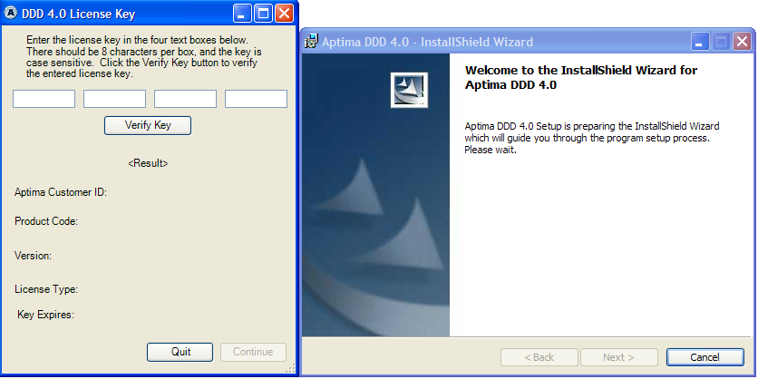
- In the Aptima License Key Verifier screen, click Verify Key.
- After the license key is verified, click Continue on the Aptima License Key Verifier screen. The Aptima License Key Verifier screen disappears.
- The Welcome screen is still displayed, and the InstallShield Wizard checks the operation system version. Once the operating system version has been checked, the Welcome screen states that the installation is ready to begin. Click Next.
- The Aptima DDD 4.0 license agreement is displayed. To accept the terms and continue installation, click Next.
- The Feature Selection Screen is displayed, as shown below. To change the default installation directory (shown in the lower left corner of the screen), use the Change button. In this example, DDD is the currently selected feature.
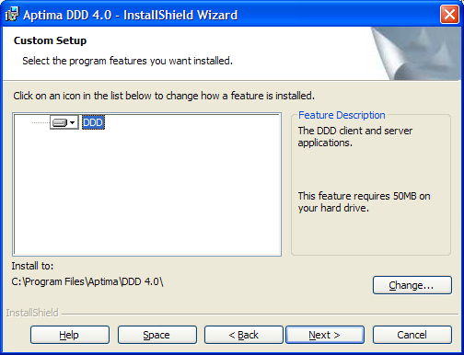
- Click Next to continue.
- The Ready to Install the Program screen is displayed. Click Install to install the DDD Simulation Server software.
- The Installing Aptima DDD 4.0 screen is displayed and a status bar indicates the progress of the installation. When installation is complete, click Next to continue.
- The InstallShield Wizard Completed screen is displayed. Check the Launch Aptima DDD 4.0 box, as shown below.
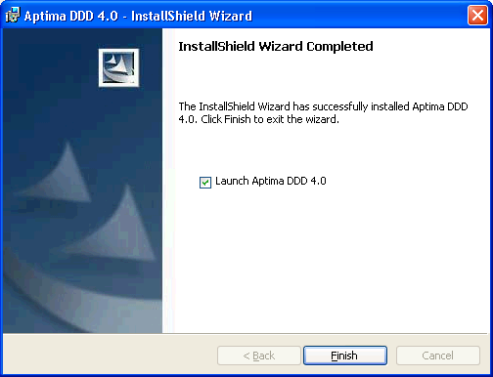
- Click Finish to finish the installation and launch the DDD Simulation Server. If you choose not to launch the server at this time, you may do so at a later date and continue the DDD Simulation Server configuration then.
Once the DDD Simulation Server is launched, the DDD 4.0 Simulation Server console will be displayed. Use this console to configure the DDD Simulation Server.

Configuring the DDD Simulation Server
When the DDD Simulation Server installation is complete and the DDD 4.0 Server is launched, the DDD Simulation Server console is displayed, as shown below.
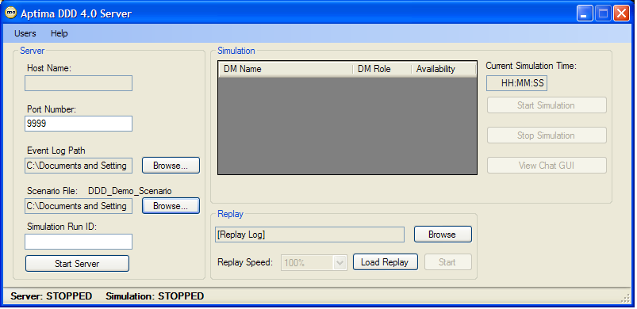
Use the following steps to configure the DDD Simulation Server console:
- A sample scenario file name is selected by default. Use Browse to select a new scenario. The new scenario will be in use until the DDD Simulation Server is stopped and another scenario is chosen.
- A default directory path is displayed in the Event Log Path box. The events in a simulation are logged by default. At the end of each simulation, a file of these events is automatically named and stored in the path specified in the Event Log Path box. Use Browse to change the Event Log Path, if desired. The new Event Log Path will be used to store all log files until that path is changed.
Note the following default information set in the DDD Simulation Server console:
- The host name of the server machine is displayed automatically in the Host Name box. This value cannot be changed.
- The default port number is 9999. If this port number is already in use by another application installed on the same machine, enter a different number above 9000.

Creating User Accounts
A user account consists of a user name and a password. Creating user accounts is a task that must be performed before the server is started and a simulation is run, because no player will be able to enter a simulation without a user account.
NOTE: User account passwords are disabled for web-downloaded evaluation copies of the DDD.
The number of user accounts that need to be created depends on the maximum number of players. For example, if a maximum of six players play any given scenario, then six different user accounts must be created—one user account for each player.
Use the following steps to create user accounts:
- Click Users in the menu bar. The User Administration dialog box is displayed, as shown below.
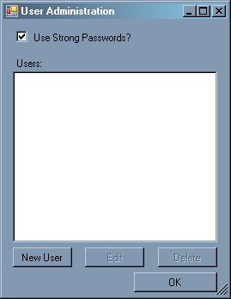
Notice that the Use Strong Passwords box is checked by default. Use Strong Passwords establishes specific requirements for the creation of passwords. These requirements are shown below.
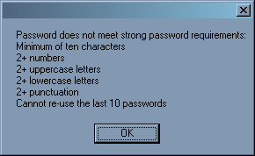
If the above requirements are not needed, then click on the Use Strong Passwords box to remove the checkmark.
- Click New User to display the New User dialog box, as shown below. Enter a name in the User Name text box and a password in the Password and Confirm Password text boxes. Note that the password will be displayed as a string of asterisks as a security measure. The same password must be entered in each password text box to ensure that the intended password has been entered correctly.
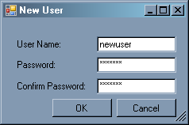
- Click OK. The User Administration dialog box appears, and the new user name is displayed, as shown below.
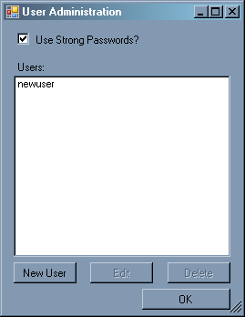
Once user accounts have been created, the experimenter will assign a different user account to every player. After a player installs and runs the DDD client, a user login box is displayed. That player enters the user account information (the user name and password given to the player) in the DDD Client login box, as shown below.
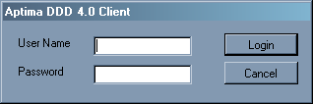
If a player enters an incorrect password, an error message will be displayed and that player will not be able to enter the simulation.

Changing the Password in a User Account
Use the following steps to change the password in an existing user account:
- Click Users in the menu bar to display the User Administration dialog box.
- Select the user name, as shown below.
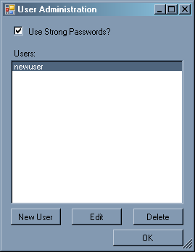
- Click Edit. The Edit User dialog box is displayed, as shown below.
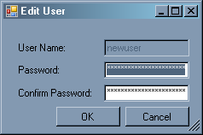
- Enter the same new password in each password text box.
- Click OK to accept the new password or Cancel to keep the existing password. The User Administration dialog box is displayed again.

Deleting a User Account
Use the following steps to delete an existing user account:
- Click Users in the menu bar to display the User Administration dialog box.
- Select the user name, as shown below.
- Click Delete. The user name is no longer listed in the User Administration dialog box.

Getting Help
This document is available online through the DDD Simulation Server Help menu. In the same menu, select About DDD 4.0 to learn more about the product. Select Contact Us to display an email address and phone number for DDD Support.

Troubleshooting Tips
If it is not possible to start the DDD Simulation Server, another application installed on the machine may be using the port number specified in the Port Number box on the DDD Simulation Server console. Try entering a different number above 9000 in the Port Number box and try starting the server again.
Between scenario runs, be sure to exit the simulation server and restart it. Otherwise, the DDD client’s Decision Maker list may not be populated correctly.
Do not use Ctrl-Alt-Del to bring up the task manager or when switching applications on the server. Otherwise, it will be necessary to restart the server.

DDD Client System Requirements
The server machine and the client machines must be connected to the same local area network (LAN).
Other client system minimum requirements include:
- Windows XP with Service Pack 2 (SP2)
- Pentium 4 (2.0 Ghz processor or equivalent)
- CD-ROM drive
- 512 MB RAM
- VGA graphics card (128 MB)
- A web browser with ClickOnce compatibility
The DDD Client installation has been tested with Microsoft Internet Explorer v6.0 and above, as well as Firefox v1.5 and v2.0. Firefox requires the addition of a ClickOnce plug-in that is freely available from mozilla.org. See Troubleshooting Tips on page 12 for details.

Installing the DDD Client Software
Once the DDD Simulation Server has been installed and configured, the DDD Client is downloaded on the fly by using ClickOnce. The DDD Client can only be installed in online mode by accessing the DDD server machine that stores the latest copy of the DDD client software. It cannot be installed from the DDD CD. ClickOnce provides a unique functionality of guaranteeing that the most up-to-date and compatible version of client software is always synchronized with the DDD Server. A temporary client software package is downloaded from the DDD Server and stored in a cache area for use. Prior to each run of the DDD client, the ClickOnce software verifies that the cached version of the DDD Client is the latest one available from the server and automatically updates the latest version if it is not.
Use the following steps to install the DDD client software on a client machine:
- From a web browser on the client machine, select and open the following file from a shared folder located on the server machine on which the DDD Simulation Server is installed:
\\<hostname>\DDDClient\index.htm
where <hostname> is the name of the DDD server machine, DDDClient is the name of the shared folder on the server machine, and index.htm is the file needed by ClickOnce. The DDDClient shared folder is created on the server machine automatically when the DDD Simulation Server is installed.
The DDD client installation screen is displayed, as shown below.
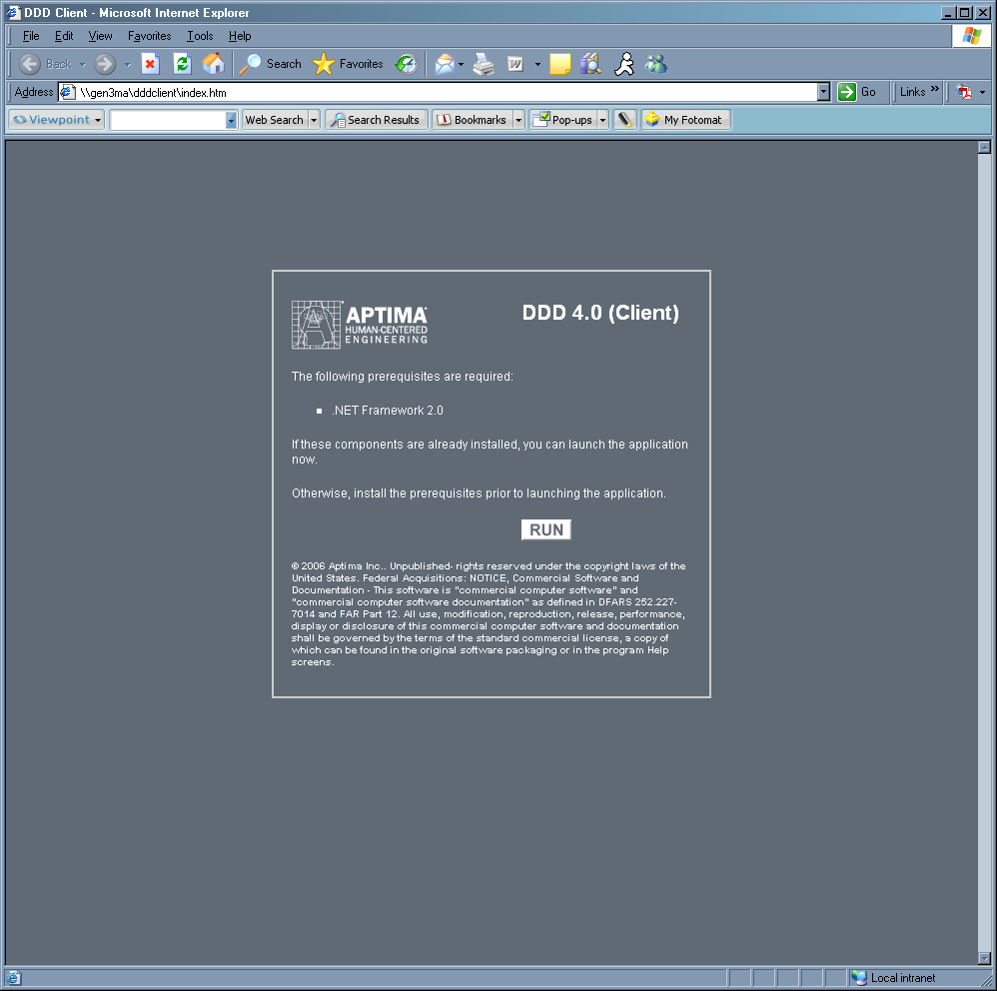
- Click Run. If the DDD Client fails to launch, this may mean it is necessary to install the prerequisite listed on the DDD Client installation screen.
Clicking Run installs and launches the DDD client installation. Users will not be able to specify an installation path. ClickOnce installs the DDD client software on the client computer in a ClickOnce application cache in a directory such as
C:\Documents and Settings\xxx\Local Settings\Apps\2.0\....
where xxx is the user login. This ClickOnce application cache is created by the operating system. This cache holds all the application’s files. The cache also is responsible for migrating the application’s data directory to the latest version, which means it provides self-updating functionalities without user intervention.
When the user exits the client application, it is automatically removed from the user’s machine. In other words, this installation is not permanent. Therefore, anyone using the client software may need to save the provided URL link for future use. Every time the DDD client is installed, the program automatically checks online for the latest version of the DDD client software. If there is a new version available, that new version is installed automatically.

Troubleshooting Tips
The DDD client installation process will automatically install Direct X, which is a graphical component required by DDD 4.0. There is a known conflict between Direct X and some applications that provide remote access to PCs. Therefore, do not install the DDD client software on a PC that is used to remotely access other PCs.
In FireFox versions 1.5.09 and above, the ClickOnce installation link will not work without a plug-in provided by FireFox. To resolve this issue, using FireFox, download the FFClickOnce add-on from the following URL:
https://addons.mozilla.org/firefox/1608/
Downloading the plug-in causes it to install automatically. Exit from and restart the browser. On the Tools menu choose Extensions (which may appear as “Add-ons” in some versions). Select the FFClickOnce line. Click Options and de-select the option “Don’t prompt before running application.” Then proceed with the installation of DDD.
Some users may have trouble installing the DDD client through a browser. Installation can depend on the permission settings on the computer and on the network. To resolve this issue, log in as “Admin” and try to install the DDD client. If this also is unsuccessful, find the DDDClient folder and run (double-click) the file with extension “application.” Should Windows report that it does not know what to do with such a file, go to Windows Explorer, select Tools, FolderOptions, and File Types. The type Application should be of type Application Manifest and set to open with Application Deployment Support Library. If this is not the case, it may be necessary to install this library and then set the file type association.

