Macroeconomics 1 Group Presentation
Group C4
knitr::opts_chunk$set(echo = FALSE)
knitr::opts_chunk$set(message = FALSE)
knitr::opts_chunk$set(warning = FALSE)
library(tidyverse)
## Warning: package 'ggplot2' was built under R version 4.4.3
## Warning: package 'readr' was built under R version 4.4.3
library(ggplot2)
library(readr)
library(readxl)
library(ggpubr)
library(knitr)

Question 2
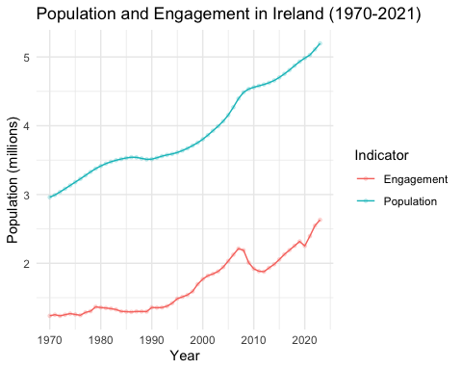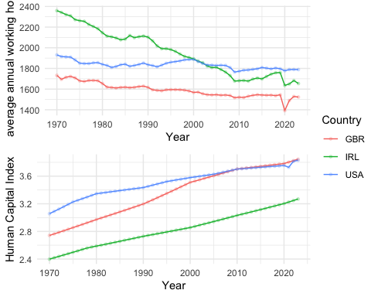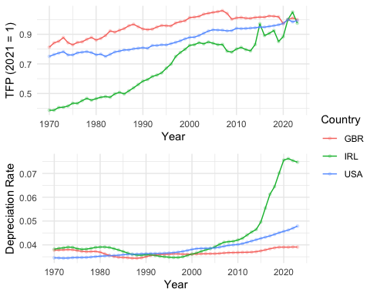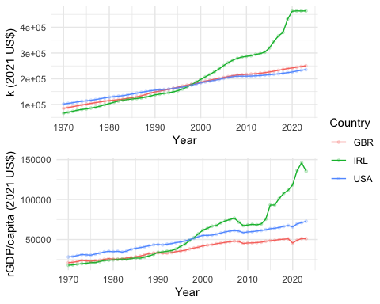
From the previous 4 graphs, we can primarily see the following happened in Ireland:
- There is a constant increasing rate in population and HCI growth rate;
- There is a higher falling rate in average working hours in the earlier period (1970-2000) than in the later period (2000-2021);
- There is a higher TFP growth rate in the earlier period (1970-2000), nd remained high and fluctuated in the later period;
- Capital stock is rising approximately at the same rate as GDP, while capital stock is not as responsive to the fall in GDP, which suggest that there could be some lags in the adjustment of capital stock to changes in GDP.
- After 2015, the depreciation rate rise dramatically.
Then we want to see how accurate was the Solow model in estimating the GDP in Ireland.
We note that in Solow Model
$$y_{t}=\overset{‾}{A}k^{α}$$
so we would like to name a new variable y* to estimate the predicted per capita output level by the Solow model.
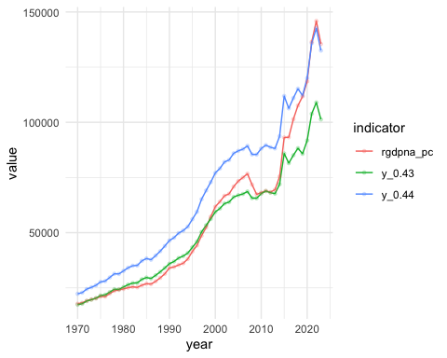
The above graph shows that the Solow model with $α=0.43$ is a good estimation of the actual per capita GDP during 1970 to around 2015, while the model with $α=0.44$ well estimated the actual per capita GDP from around 2020 onwards. however, the model fell to capture some short term fluctuations in the actual per capita GDP, such as 2000-2010 and 2015-2020. This may be due to a rapid improvement in technology or a rapid increase in capital stock during these periods, which are not explained by the Solow model.
We then find the contribution of capital and TFP to the growth of the per capita GDP growth. We use $α=0.43$ for 1970-2015, and $α=0.44$ for the following period.
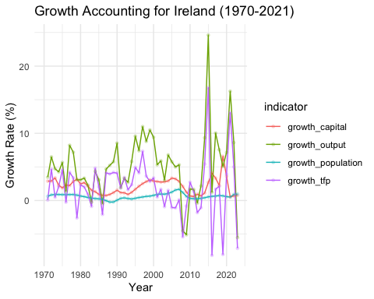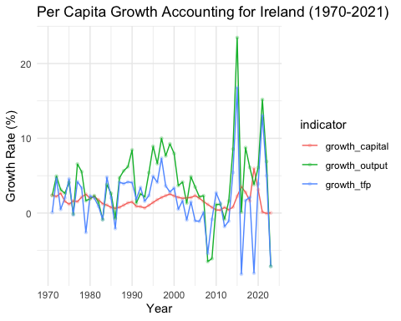
Growth Accounting for Ireland (1970-2021)
year | growth_capital | growth_population | growth_tfp | growth_output | max_contributor
1971 | 2.88 | 0.62 | 0.08 | 3.47 | growth_capital
1975 | 1.87 | 0.87 | 4.57 | 5.66 | growth_tfp
1980 | 2.47 | 0.66 | 2.31 | 3.08 | growth_capital
1985 | 0.92 | 0.24 | 2.05 | 3.08 | growth_tfp
1990 | 1.53 | 0.05 | 4.08 | 8.54 | growth_tfp
1995 | 1.67 | 0.33 | 4.93 | 9.58 | growth_tfp
2000 | 2.90 | 0.76 | 3.36 | 9.41 | growth_tfp
2005 | 3.33 | 1.25 | -1.04 | 5.76 | growth_capital
2010 | 0.67 | 0.31 | 2.71 | 1.70 | growth_tfp
2015 | 2.68 | 0.54 | 16.79 | 24.62 | growth_tfp
2020 | 3.60 | 0.57 | 3.91 | 7.15 | growth_tfp

Per Capita Growth Accounting for Ireland (1970-2021)
year | growth_capital | growth_tfp | growth_output
1971 | 2.39 | 0.08 | 2.36
1975 | 1.19 | 4.57 | 4.10
1980 | 1.97 | 2.31 | 1.91
1985 | 0.76 | 2.05 | 2.63
1990 | 1.49 | 4.08 | 8.45
1995 | 1.42 | 4.93 | 8.93
2000 | 2.29 | 3.36 | 7.97
2005 | 2.33 | -1.04 | 3.50
2010 | 0.42 | 2.71 | 1.14
2015 | 2.25 | 16.79 | 23.46
2020 | 3.12 | 3.91 | 6.09

