**Output:**

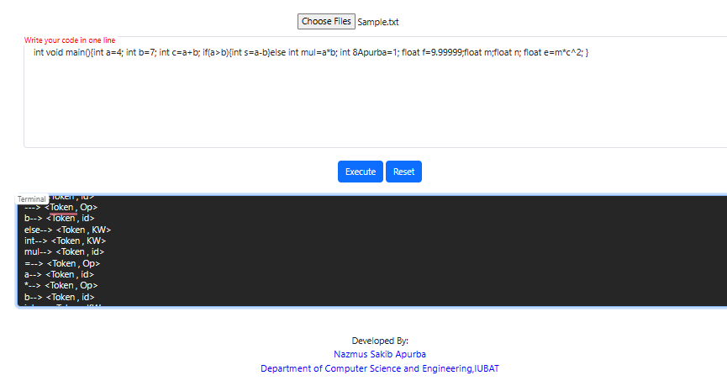

**Wrong Pattern:**

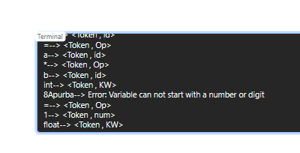

Here error message has shown that the operator can not start with any number or digit.