CAPACITORS

CHARGING OF CAPACITORS:

* A capacitor may be charged through high resistance from a battery of V volts.
* The voltage across the capacitor can be measured by a suitable voltmeter.
* When the switch is connected to the terminal, capacitor is charged, but when the capacitor is short-circuited through the resistor, it is discharged.
* The voltage across the capacitor does not rise to V instantaneously but builds up slowly, i.e exponentially not linearly.
* Charging current i.c is maximum at the start i.e when the capacitor is uncharged, then it decreases exponentially and finally ceases when the potential difference across the capacitor plates becomes equal and opposite to the battery voltage V.
* EQUATIONS-
$vc=V(1-\frac{e^{-t/lamda}}{1})$

$ic=I(e^{\frac{-t}{lambda}})$

* Where vc=voltage across capacitor

V=potential difference

T=time

Lambda=R\*C

* Graph-

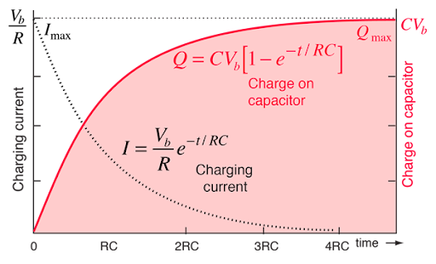

TIME CONSTANT:

* It is defined as the time during which the voltage across the capacitor would have reached its maximum value V and it has maintained its initial state of rise.
* It is the time during which capacitor voltage actually rises to 0.632 of its final steady value.
* It is the time during which the charging current falls to 0.37 of its initial maximum value.

DISCHARGING OF A CAPACITOR-

* When the capacitor is short circuited through resistor it is discharged.
* EQUATIONS-

$ic=-I(\frac{e^{-t}/lambda}{1})$

$vc=V(e^{-\frac{t}{lambda}})$

Where ic and vc are the current and voltage across capacitor

I and V are the initial current and potential difference

t-time

lambda-R\*C

* Graph-

