CUBESAT

* CUBESAT ARCHITECTURE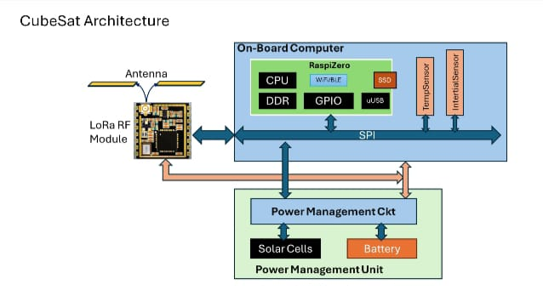
* Raspberry Pi Zero W has been used as a flight computer and as an instrument and sensor control board in CubeSats and larger satellites.
* Raspberry Pi Zero W is ideal for making embedded Internet of Things (IoT) projects. The Pi Zero W has been designed to be as flexible and compact as possible with mini connectors and an unpopulated 40-pin GPIO, allowing you to use only what your project requires.
* Serial Peripheral Interface (SPI) is a full-duplex serial protocol for communicating with high-speed peripherals
* The SPI Controller on Raspberry Pi® hardware can drive two SPI peripheral devices.
* CUBESAT COMMUNICATION SYSTEM

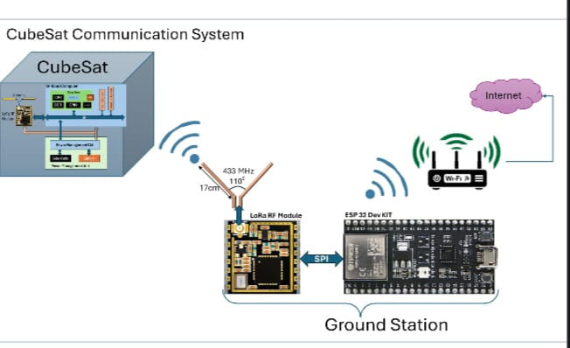

* ESPN32 DEVELOPMENT BOARD-

