VLSI

* It stands for Very Large-Scale Integration
* It is a process used in the design and fabrication of integrated circuits (ICs), which are electronic circuits that are made up of a large number of transistors and other components that are integrated into a single chip.
* It is the technology allows for the creation of highly complex and compact ICs that can be used in a wide range of applications, from consumer electronics and computers to communication systems and medical devices.
* It allows for the creation of highly complex and powerful ICs.
* It allows for the integration of a large number of components onto a single chip, it can reduce the number of discrete components that are needed in a circuit, which can help to reduce the overall cost of the circuit.
* It allows for the creation of ICs with high levels of performance and functionality, which can help to improve the overall performance and efficiency of a system.

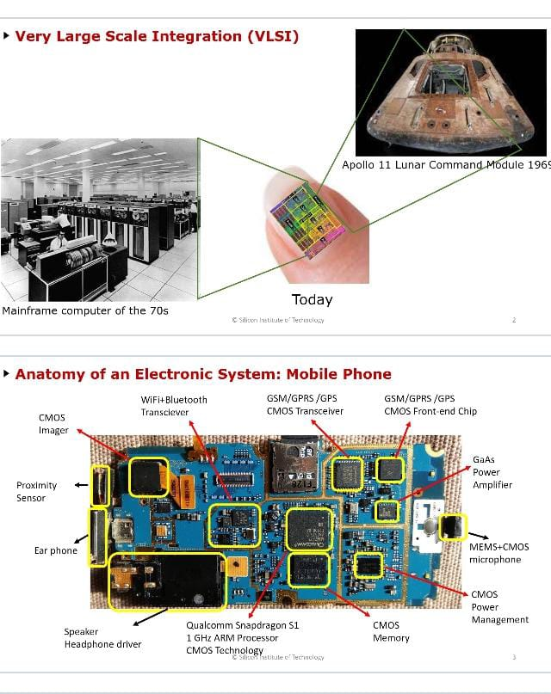

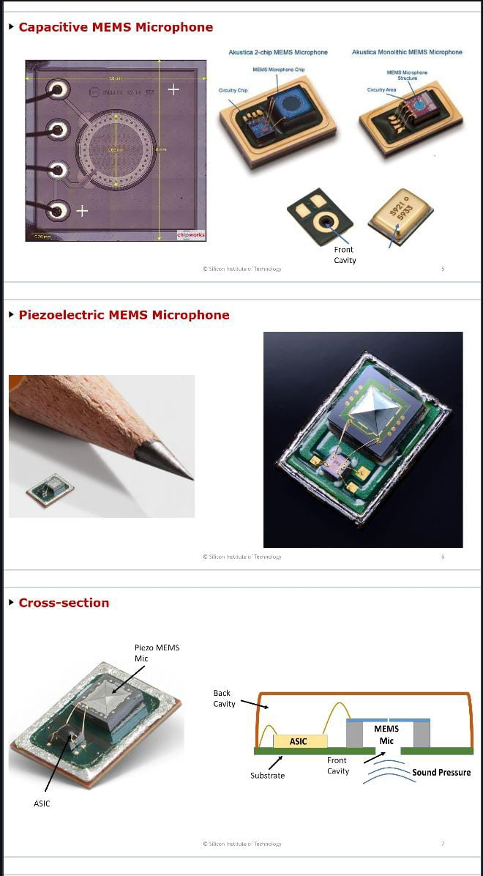

INERTIAL MEASUREMENT UNIT

* It is an electronic device that measures and reports a body's specific force, angular rate, and sometimes the orientation of the body, using a combination of accelerometers, gyroscopes, and sometimes magnetometers. When the magnetometer is included, IMUs are referred to as IMMUs.

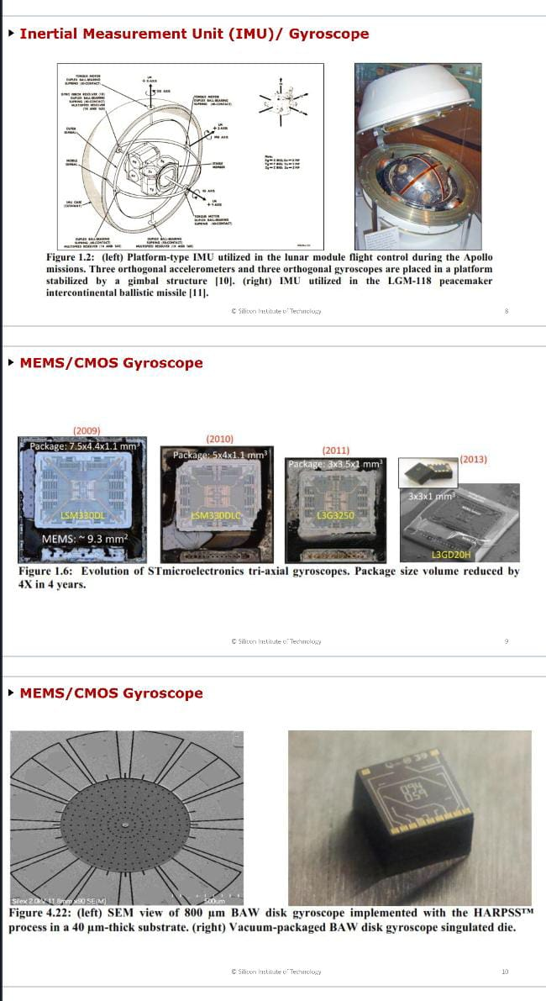

ANALOG FRONT END

* An **analog front-end** (**AFE** or **analog front-end controller AFEC**) is a set of analog signal conditioning circuitry that uses sensitive analog amplifiers, often [operational amplifiers](https://en.wikipedia.org/wiki/Operational_amplifier), filters, and sometimes [application-specific integrated circuits](https://en.wikipedia.org/wiki/Application-specific_integrated_circuit) for sensors, radio receivers, and other circuits to provide a configurable and flexible electronics functional block needed to interface a variety of sensors to an antenna, [analog-to-digital converter](https://en.wikipedia.org/wiki/Analog-to-digital_converter" \o "Analog-to-digital converter) or, in some cases, to a [microcontroller](https://en.wikipedia.org/wiki/Microcontroller).

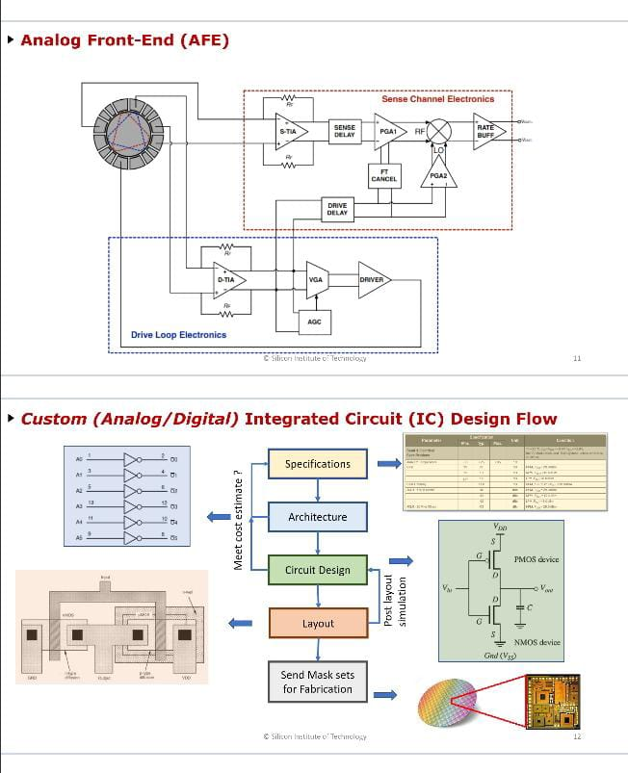

DIAGRAMS –

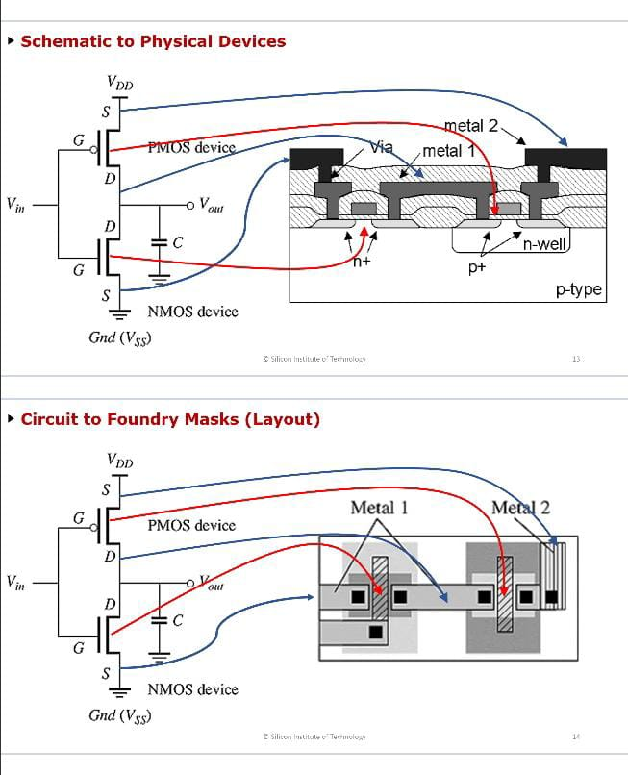

STEPS INVOLVED-

