**Exercise 3: Stored Procedures**

Sample tables in database after rows insertion:

CUSTOMERS

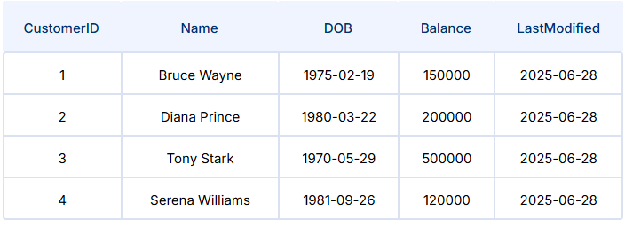

ACCOUNTS

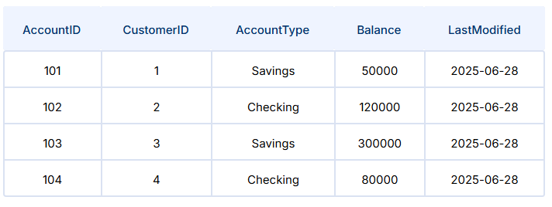

TRANSACTIONS

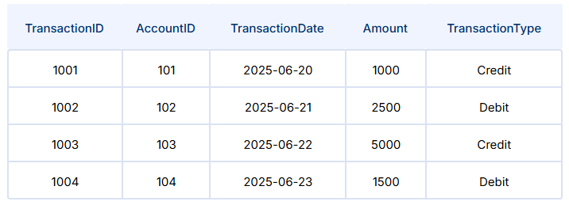

LOANS

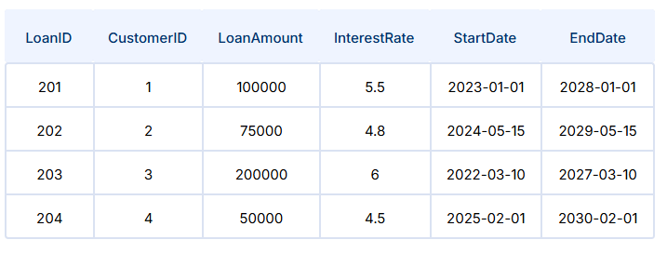

EMPLOYEES

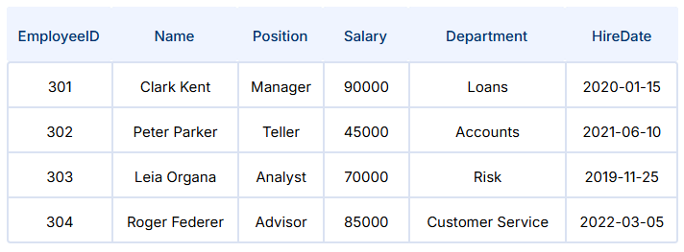

Scenario 1:

The bank needs to process monthly interest for all savings accounts.

* + **Question:** Write a stored procedure **ProcessMonthlyInterest** that calculates and updates the balance of all savings accounts by applying an interest rate of 1% to the current balance.

Code:

CREATE OR REPLACE PROCEDURE ProcessMonthlyInterest AS

BEGIN

    -- Update all savings accounts by applying 1% interest

    UPDATE Accounts

    SET Balance = Balance * 1.01

    WHERE AccountType = 'Savings';

    COMMIT;

    DBMS_OUTPUT.PUT_LINE('Monthly interest applied to all savings accounts.');

END;

/

Output:

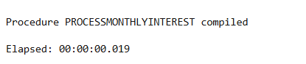

SET SERVEROUTPUT ON;

BEGIN

ProcessMonthlyInterest;

END;

/

Output:

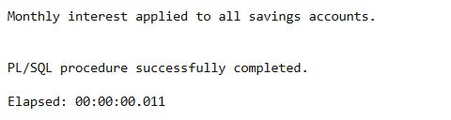

SELECT AccountID, CustomerID, AccountType, Balance

FROM Accounts

WHERE AccountType = 'Savings';

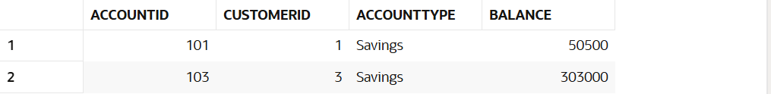

Scenario 2: The bank wants to implement a bonus scheme for employees based on their performance.

* + **Question:** Write a stored procedure **UpdateEmployeeBonus** that updates the salary of employees in a given department by adding a bonus percentage passed as a parameter.

Code:

CREATE OR REPLACE PROCEDURE UpdateEmployeeBonus (

    p_department     IN VARCHAR2,

    p_bonus_percent  IN NUMBER

) AS

BEGIN

    -- Update salary by bonus percentage for given department

    UPDATE Employees

    SET Salary = Salary + (Salary * p_bonus_percent / 100)

    WHERE Department = p_department;

    COMMIT;

    DBMS_OUTPUT.PUT_LINE(

        'Bonuses applied to department: ' || p_department ||

        ' with ' || p_bonus_percent || '% bonus.'

    );

END;

/

Output:

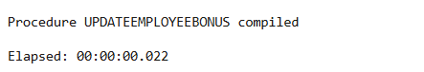

SET SERVEROUTPUT ON;

BEGIN

    -- Example: Add 10% bonus to all employees in 'Loans' department

    UpdateEmployeeBonus('Loans', 10);

END;

/

Output:

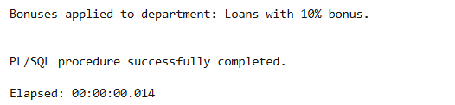

SELECT EmployeeID, Name, Department, Salary

FROM Employees

WHERE Department = 'Loans';



Scenario 3: Customers should be able to transfer funds between their accounts.

* + **Question:** Write a stored procedure **TransferFunds** that transfers a specified amount from one account to another, checking that the source account has sufficient balance before making the transfer.

Code:

CREATE OR REPLACE PROCEDURE TransferFunds (

    p_from_account_id IN NUMBER,

    p_to_account_id   IN NUMBER,

    p_amount          IN NUMBER

) AS

    v_from_balance Accounts.Balance%TYPE;

    v_to_exists     NUMBER;

BEGIN

    -- Validate positive transfer amount

    IF p_amount <= 0 THEN

        RAISE_APPLICATION_ERROR(-20001, 'Transfer amount must be greater than zero.');

    END IF;

    -- Check if source account exists and get its balance

    SELECT Balance

    INTO v_from_balance

    FROM Accounts

    WHERE AccountID = p_from_account_id;

    -- Check if destination account exists

    SELECT COUNT(*) INTO v_to_exists

    FROM Accounts

    WHERE AccountID = p_to_account_id;

    IF v_to_exists = 0 THEN

        RAISE_APPLICATION_ERROR(-20002, 'Destination account does not exist.');

    END IF;

    -- Check for sufficient balance

    IF v_from_balance < p_amount THEN

        RAISE_APPLICATION_ERROR(-20003, 'Insufficient funds in source account.');

    END IF;

    -- Perform transfer: deduct and add balance

    UPDATE Accounts

    SET Balance = Balance - p_amount

    WHERE AccountID = p_from_account_id;

    UPDATE Accounts

    SET Balance = Balance + p_amount

    WHERE AccountID = p_to_account_id;

    COMMIT;

    DBMS_OUTPUT.PUT_LINE('Transfer of $' || p_amount || ' from Account ' ||

                         p_from_account_id || ' to Account ' || p_to_account_id || ' completed successfully.');

EXCEPTION

    WHEN NO_DATA_FOUND THEN

        RAISE_APPLICATION_ERROR(-20004, 'Source account does not exist.');

    WHEN OTHERS THEN

        ROLLBACK;

        RAISE;

END;

/

Output:

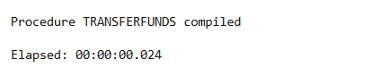

SET SERVEROUTPUT ON;

BEGIN

-- Example: Transfer $500 from Account 101 to Account 102

TransferFunds(101, 102, 500);

END;

/

