**Exercise 1: Control Procedures**

Sample tables in database after rows insertion:

CUSTOMERS

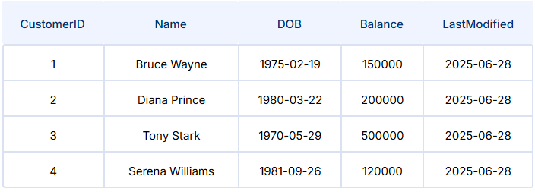

ACCOUNTS

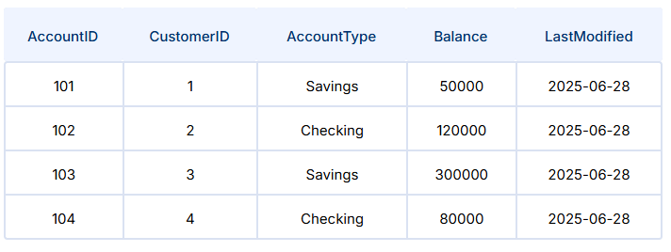

TRANSACTIONS

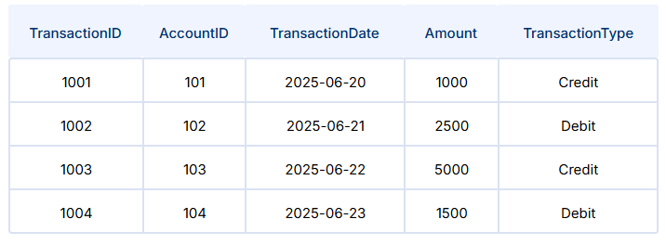

LOANS

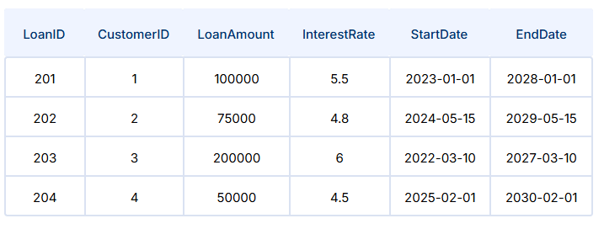

EMPLOYEES

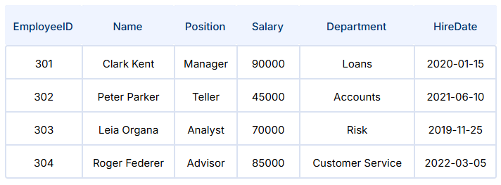

*Scenario 1:*

*The bank wants to apply a discount to loan interest rates for customers above 60 years old.*

* + ***Question:*** *Write a PL/SQL block that loops through all customers, checks their age, and if they are above 60, apply a 1% discount to their current loan interest rates.*

Sample Code:

SET SERVEROUTPUT ON;

BEGIN

    FOR cust_rec IN (

        SELECT CustomerID, DOB

        FROM Customers

    ) LOOP

        DECLARE

            v_age NUMBER;

        BEGIN

            v_age := TRUNC(MONTHS_BETWEEN(SYSDATE, cust_rec.DOB) / 12);

            IF v_age > 60 THEN

                UPDATE Loans

                SET InterestRate = InterestRate * 0.99

                WHERE CustomerID = cust_rec.CustomerID;

                DBMS_OUTPUT.PUT_LINE(

                    'Discount applied to Customer ID: ' || cust_rec.CustomerID ||

                    ' (Age: ' || v_age || ')'

                );

            END IF;

        END;

    END LOOP;

    COMMIT;

END;

/

Output:

Discount applied to Customer ID: 5 (Age: 75)

*Scenario 2:*

*A customer can be promoted to VIP status based on their balance.*

* + ***Question:*** *Write a PL/SQL block that iterates through all customers and sets a flag IsVIP to TRUE for those with a balance over $10,000.*

Code:

ALTER TABLE Customers ADD IsVIP CHAR(1);

Output:

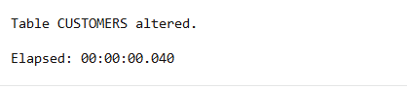

BEGIN

FOR cust_rec IN (

SELECT CustomerID, Balance

FROM Customers

) LOOP

IF cust_rec.Balance > 10000 THEN

UPDATE Customers

SET IsVIP = 'Y'

WHERE CustomerID = cust_rec.CustomerID;

DBMS_OUTPUT.PUT_LINE('Customer ID ' || cust_rec.CustomerID || ' is now VIP.');

END IF;

END LOOP;

COMMIT;

END;

/

Output:

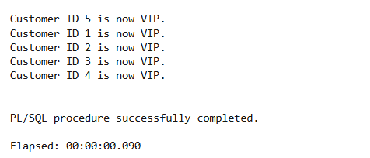

*Scenario 3:*

*The bank wants to send reminders to customers whose loans are due within the next 30 days.*

* + ***Question:*** *Write a PL/SQL block that fetches all loans due in the next 30 days and prints a reminder message for each customer.*

Code:

SET SERVEROUTPUT ON;

BEGIN

FOR loan_rec IN (

SELECT L.LoanID, L.EndDate, C.CustomerID, C.Name

FROM Loans L

JOIN Customers C ON L.CustomerID = C.CustomerID

WHERE L.EndDate BETWEEN SYSDATE AND SYSDATE + 30

) LOOP

DBMS_OUTPUT.PUT_LINE(

'Reminder: Loan ID ' || loan_rec.LoanID ||

' for customer ' || loan_rec.Name ||

' (Customer ID: ' || loan_rec.CustomerID || ') is due on ' || TO_CHAR(loan_rec.EndDate, 'YYYY-MM-DD')

);

END LOOP;

END;

/

Output:

