**Spring Core – Load Country from Spring Configuration XML**

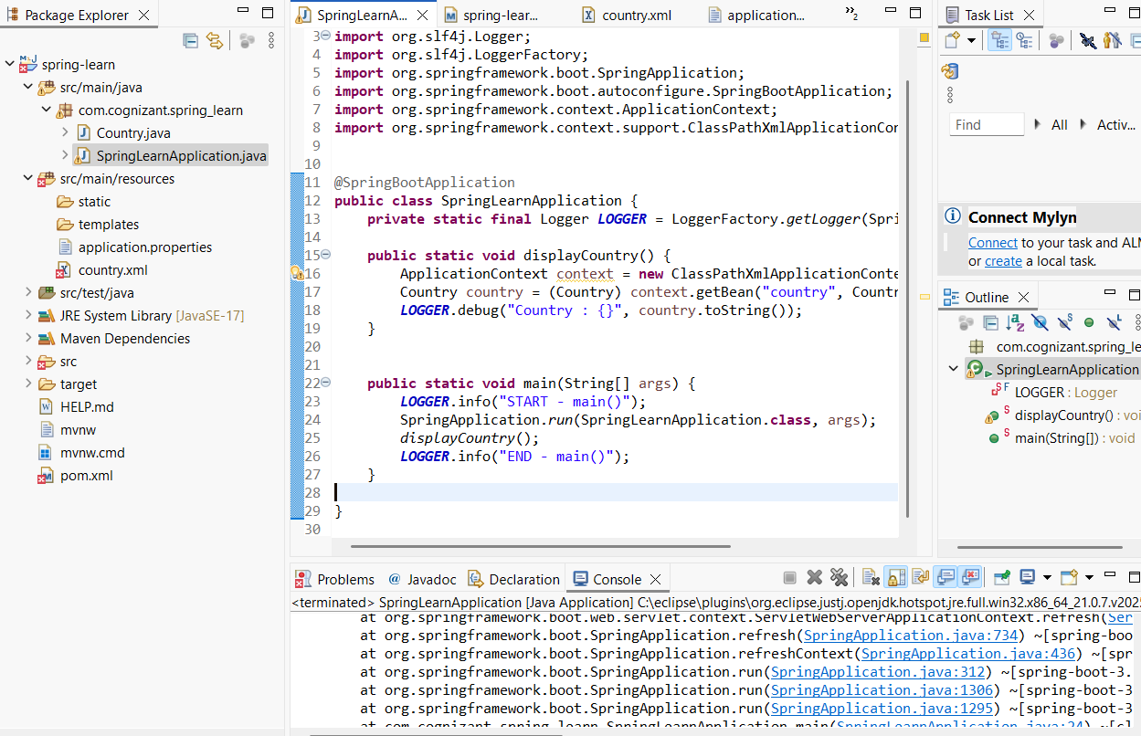

pom.xml:

<?xml version="1.0" encoding="UTF-8"?>

<project xmlns="http://maven.apache.org/POM/4.0.0"

xmlns:xsi="http://www.w3.org/2001/XMLSchema-instance"

xsi:schemaLocation="http://maven.apache.org/POM/4.0.0

https://maven.apache.org/xsd/maven-4.0.0.xsd">

<modelVersion>4.0.0</modelVersion>

<parent>

<groupId>org.springframework.boot</groupId>

<artifactId>spring-boot-starter-parent</artifactId>

<version>3.1.3</version> <!-- or keep 3.5.3 if you're using snapshot -->

<relativePath/> <!-- lookup parent from repository -->

</parent>

<groupId>com.cognizant</groupId>

<artifactId>spring-learn</artifactId>

<version>0.0.1-SNAPSHOT</version>

<name>spring-learn</name>

<description>Demo project for Spring Boot</description>

<properties>

<java.version>17</java.version>

</properties>

<dependencies>

<!-- Spring Boot Web Starter -->

<dependency>

<groupId>org.springframework.boot</groupId>

<artifactId>spring-boot-starter-web</artifactId>

</dependency>

<!-- Spring Context for XML-based bean loading -->

<dependency>

<groupId>org.springframework</groupId>

<artifactId>spring-context</artifactId>

</dependency>

<!-- Spring Boot DevTools (optional) -->

<dependency>

<groupId>org.springframework.boot</groupId>

<artifactId>spring-boot-devtools</artifactId>

<scope>runtime</scope>

<optional>true</optional>

</dependency>

<!-- Logging (SLF4J + Logback) - already included via Spring Boot -->

<!-- No need to add separately unless you want custom logging -->

<!-- Spring Boot Test Starter -->

<dependency>

<groupId>org.springframework.boot</groupId>

<artifactId>spring-boot-starter-test</artifactId>

<scope>test</scope>

</dependency>

</dependencies>

<build>

<plugins>

<!-- Spring Boot Maven Plugin -->

<plugin>

<groupId>org.springframework.boot</groupId>

<artifactId>spring-boot-maven-plugin</artifactId>

</plugin>

</plugins>

</build>

</project>

country.xml:

<?xml version="1.0" encoding="UTF-8"?>

<beans xmlns="http://www.springframework.org/schema/beans"

xmlns:xsi="http://www.w3.org/2001/XMLSchema-instance"

xsi:schemaLocation="http://www.springframework.org/schema/beans

http://www.springframework.org/schema/beans/spring-beans.xsd">

<bean id="country" class="com.cognizant.springlearn.Country">

<property name="code" value="IN"/>

<property name="name" value="India"/>

</bean>

</beans>

Country.java:

**package** com.cognizant.spring_learn;

**import** org.slf4j.Logger;

**import** org.slf4j.LoggerFactory;

**public** **class** Country {

**private** **static** **final** Logger ***LOGGER*** = LoggerFactory.*getLogger*(Country.**class**);

**private** String code;

**private** String name;

**public** Country() {

***LOGGER***.debug("Inside Country Constructor.");

}

**public** String getCode() {

***LOGGER***.debug("Inside getCode()");

**return** code;

}

**public** **void** setCode(String code) {

***LOGGER***.debug("Inside setCode()");

**this**.code = code;

}

**public** String getName() {

***LOGGER***.debug("Inside getName()");

**return** name;

}

**public** **void** setName(String name) {

***LOGGER***.debug("Inside setName()");

**this**.name = name;

}

@Override

**public** String toString() {

**return** "Country [code=" + code + ", name=" + name + "]";

}

}

SpringLearnApplication.java:

**package** com.cognizant.spring_learn;

**import** org.slf4j.Logger;

**import** org.slf4j.LoggerFactory;

**import** org.springframework.boot.SpringApplication;

**import** org.springframework.boot.autoconfigure.SpringBootApplication;

**import** org.springframework.context.ApplicationContext;

**import** org.springframework.context.support.ClassPathXmlApplicationContext;

@SpringBootApplication

**public** **class** SpringLearnApplication {

**private** **static** **final** Logger ***LOGGER*** = LoggerFactory.*getLogger*(SpringLearnApplication.**class**);

**public** **static** **void** displayCountry() {

ApplicationContext context = **new** ClassPathXmlApplicationContext("country.xml");

Country country = (Country) context.getBean("country", Country.**class**);

***LOGGER***.debug("Country : {}", country.toString());

}

**public** **static** **void** main(String[] args) {

***LOGGER***.info("START - main()");

SpringApplication.*run*(SpringLearnApplication.**class**, args);

*displayCountry*();

***LOGGER***.info("END - main()");

}

}