**Create a Spring Web Project using Maven**

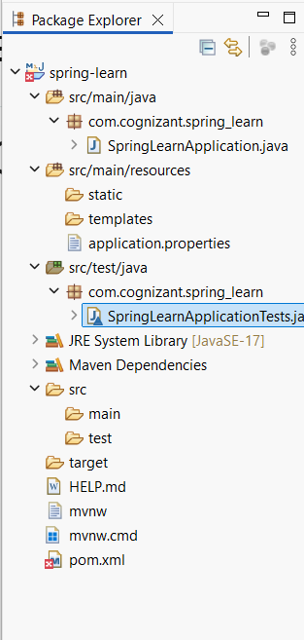

pom.xml:

<?xml version="1.0" encoding="UTF-8"?>

<project xmlns="http://maven.apache.org/POM/4.0.0" xmlns:xsi="http://www.w3.org/2001/XMLSchema-instance"

xsi:schemaLocation="http://maven.apache.org/POM/4.0.0 https://maven.apache.org/xsd/maven-4.0.0.xsd">

<modelVersion>4.0.0</modelVersion>

<parent>

<groupId>org.springframework.boot</groupId>

<artifactId>spring-boot-starter-parent</artifactId>

<version>3.5.3</version>

<relativePath/> <!-- lookup parent from repository -->

</parent>

<groupId>com.cognizant</groupId>

<artifactId>spring-learn</artifactId>

<version>0.0.1-SNAPSHOT</version>

<name>spring-learn</name>

<description>Demo project for Spring Boot</description>

<url/>

<licenses>

<license/>

</licenses>

<developers>

<developer/>

</developers>

<scm>

<connection/>

<developerConnection/>

<tag/>

<url/>

</scm>

<properties>

<java.version>17</java.version>

</properties>

<dependencies>

<dependency>

<groupId>org.springframework.boot</groupId>

<artifactId>spring-boot-starter-web</artifactId>

</dependency>

<dependency>

<groupId>org.springframework.boot</groupId>

<artifactId>spring-boot-devtools</artifactId>

<scope>runtime</scope>

<optional>true</optional>

</dependency>

<dependency>

<groupId>org.springframework.boot</groupId>

<artifactId>spring-boot-starter-test</artifactId>

<scope>test</scope>

</dependency>

</dependencies>

<build>

<plugins>

<plugin>

<groupId>org.springframework.boot</groupId>

<artifactId>spring-boot-maven-plugin</artifactId>

</plugin>

</plugins>

</build>

</project>

SpringLearnApplication.java:

**package** com.cognizant.spring_learn;

**import** org.slf4j.Logger;

**import** org.slf4j.LoggerFactory;

**import** org.springframework.boot.SpringApplication;

**import** org.springframework.boot.autoconfigure.SpringBootApplication;

@SpringBootApplication

**public** **class** SpringLearnApplication {

**private** **static** **final** Logger ***LOGGER*** = LoggerFactory.*getLogger*(SpringLearnApplication.**class**);

**public** **static** **void** main(String[] args) {

***LOGGER***.info("START - main()");

SpringApplication.*run*(SpringLearnApplication.**class**, args);

***LOGGER***.info("END - main()");

}

}

SpringLearnApplicationTests.java:

**package** com.cognizant.spring_learn;

**import** org.junit.jupiter.api.Test;

**import** org.springframework.boot.test.context.SpringBootTest;

@SpringBootTest

**class** SpringLearnApplicationTests {

@Test

**void** contextLoads() {

}

}

Output:

17:52:52.617 [main] INFO com.cognizant.spring_learn.SpringLearnApplication -- START - main()

17:52:53.027 [restartedMain] INFO com.cognizant.spring_learn.SpringLearnApplication -- START - main()

. ____ _ __ _ _

/\\ / ___'_ __ _ _(_)_ __ __ _ \ \ \ \

( ( )\___ | '_ | '_| | '_ \/ _` | \ \ \ \

\\/ ___)| |_)| | | | | || (_| | ) ) ) )

' |____| .__|_| |_|_| |_\__, | / / / /

=========|_|==============|___/=/_/_/_/

:: Spring Boot :: (v3.5.3)

2025-07-13T17:52:53.849+05:30 INFO 10812 --- [spring-learn] [ restartedMain] c.c.spring_learn.SpringLearnApplication : Starting SpringLearnApplication using Java 21.0.7 with PID 10812 (E:\spring-learn 1\spring-learn\target\classes started by bvssa in E:\spring-learn 1\spring-learn)

2025-07-13T17:52:53.853+05:30 INFO 10812 --- [spring-learn] [ restartedMain] c.c.spring_learn.SpringLearnApplication : No active profile set, falling back to 1 default profile: "default"

2025-07-13T17:52:53.947+05:30 INFO 10812 --- [spring-learn] [ restartedMain] .e.DevToolsPropertyDefaultsPostProcessor : Devtools property defaults active! Set 'spring.devtools.add-properties' to 'false' to disable

2025-07-13T17:52:53.947+05:30 INFO 10812 --- [spring-learn] [ restartedMain] .e.DevToolsPropertyDefaultsPostProcessor : For additional web related logging consider setting the 'logging.level.web' property to 'DEBUG'

2025-07-13T17:52:55.473+05:30 INFO 10812 --- [spring-learn] [ restartedMain] o.s.b.w.embedded.tomcat.TomcatWebServer : Tomcat initialized with port 8080 (http)

2025-07-13T17:52:55.492+05:30 INFO 10812 --- [spring-learn] [ restartedMain] o.apache.catalina.core.StandardService : Starting service [Tomcat]

2025-07-13T17:52:55.492+05:30 INFO 10812 --- [spring-learn] [ restartedMain] o.apache.catalina.core.StandardEngine : Starting Servlet engine: [Apache Tomcat/10.1.42]

2025-07-13T17:52:55.552+05:30 INFO 10812 --- [spring-learn] [ restartedMain] o.a.c.c.C.[Tomcat].[localhost].[/] : Initializing Spring embedded WebApplicationContext

2025-07-13T17:52:55.553+05:30 INFO 10812 --- [spring-learn] [ restartedMain] w.s.c.ServletWebServerApplicationContext : Root WebApplicationContext: initialization completed in 1604 ms

2025-07-13T17:52:56.046+05:30 INFO 10812 --- [spring-learn] [ restartedMain] o.s.b.d.a.OptionalLiveReloadServer : LiveReload server is running on port 35729

2025-07-13T17:52:56.097+05:30 INFO 10812 --- [spring-learn] [ restartedMain] o.s.b.w.embedded.tomcat.TomcatWebServer : Tomcat started on port 8080 (http) with context path '/'

2025-07-13T17:52:56.113+05:30 INFO 10812 --- [spring-learn] [ restartedMain] c.c.spring_learn.SpringLearnApplication : Started SpringLearnApplication in 3.078 seconds (process running for 3.8)

2025-07-13T17:52:56.123+05:30 INFO 10812 --- [spring-learn] [ restartedMain] c.c.spring_learn.SpringLearnApplication : END - main()