**Hello World RESTful Web Service**

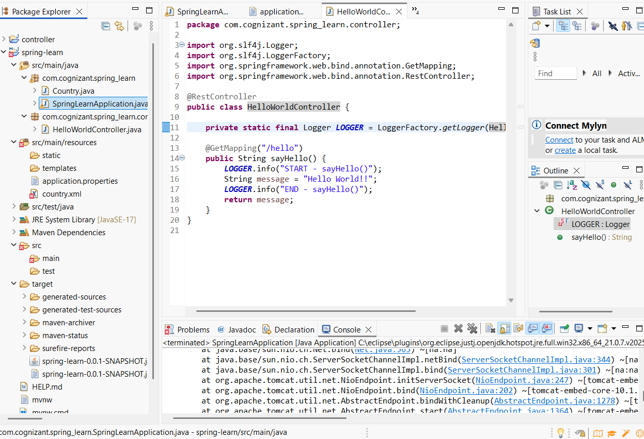

HelloWorldController.java:

**package** com.cognizant.spring_learn.controller;

**import** org.slf4j.Logger;

**import** org.slf4j.LoggerFactory;

**import** org.springframework.web.bind.annotation.GetMapping;

**import** org.springframework.web.bind.annotation.RestController;

@RestController

**public** **class** HelloWorldController {

**private** **static** **final** Logger ***LOGGER*** = LoggerFactory.*getLogger*(HelloWorldController.**class**);

@GetMapping("/hello")

**public** String sayHello() {

***LOGGER***.info("START - sayHello()");

String message = "Hello World!!";

***LOGGER***.info("END - sayHello()");

**return** message;

}

}

SpringLearnJavaApplication.java:

**package** com.cognizant.spring_learn;

**import** org.slf4j.Logger;

**import** org.slf4j.LoggerFactory;

**import** org.springframework.boot.SpringApplication;

**import** org.springframework.boot.autoconfigure.SpringBootApplication;

**import** org.springframework.context.ApplicationContext;

**import** org.springframework.context.support.ClassPathXmlApplicationContext;

@SpringBootApplication

**public** **class** SpringLearnApplication {

**private** **static** **final** Logger ***LOGGER*** = LoggerFactory.*getLogger*(SpringLearnApplication.**class**);

**public** **static** **void** displayCountry() {

ApplicationContext context = **new** ClassPathXmlApplicationContext("country.xml");

Country country = (Country) context.getBean("country", Country.**class**);

***LOGGER***.debug("Country : {}", country.toString());

}

**public** **static** **void** main(String[] args) {

***LOGGER***.info("START - main()");

SpringApplication.*run*(SpringLearnApplication.**class**, args);

*displayCountry*();

***LOGGER***.info("END - main()");

}

}

application.properties:

server.port=8083

spring.application.name=spring_learn

logging.level.root=DEBUG