**REST - Country Web Service**

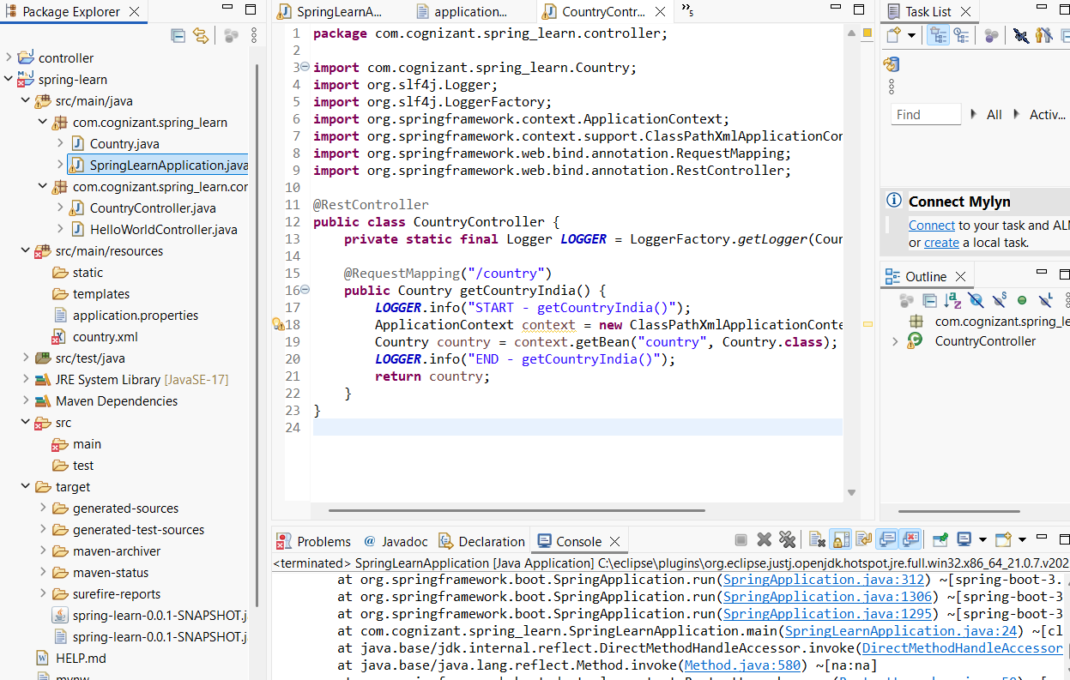

Country.java:

**package** com.cognizant.spring_learn;

**import** org.slf4j.Logger;

**import** org.slf4j.LoggerFactory;

**public** **class** Country {

**private** **static** **final** Logger ***LOGGER*** = LoggerFactory.*getLogger*(Country.**class**);

**private** String code;

**private** String name;

**public** Country() {

***LOGGER***.debug("Inside Country Constructor.");

}

**public** String getCode() {

***LOGGER***.debug("Inside getCode()");

**return** code;

}

**public** **void** setCode(String code) {

***LOGGER***.debug("Inside setCode()");

**this**.code = code;

}

**public** String getName() {

***LOGGER***.debug("Inside getName()");

**return** name;

}

**public** **void** setName(String name) {

***LOGGER***.debug("Inside setName()");

**this**.name = name;

}

@Override

**public** String toString() {

**return** "Country [code=" + code + ", name=" + name + "]";

}

}

CountryController.java:

**package** com.cognizant.spring_learn.controller;

**import** com.cognizant.spring_learn.Country;

**import** org.slf4j.Logger;

**import** org.slf4j.LoggerFactory;

**import** org.springframework.context.ApplicationContext;

**import** org.springframework.context.support.ClassPathXmlApplicationContext;

**import** org.springframework.web.bind.annotation.RequestMapping;

**import** org.springframework.web.bind.annotation.RestController;

@RestController

**public** **class** CountryController {

**private** **static** **final** Logger ***LOGGER*** = LoggerFactory.*getLogger*(CountryController.**class**);

@RequestMapping("/country")

**public** Country getCountryIndia() {

***LOGGER***.info("START - getCountryIndia()");

ApplicationContext context = **new** ClassPathXmlApplicationContext("country.xml");

Country country = context.getBean("country", Country.**class**);

***LOGGER***.info("END - getCountryIndia()");

**return** country;

}

}

application.properties:

server.port=8083

spring.application.name=spring_learn

logging.level.root=DEBUG