**REST - Get country based on country code**

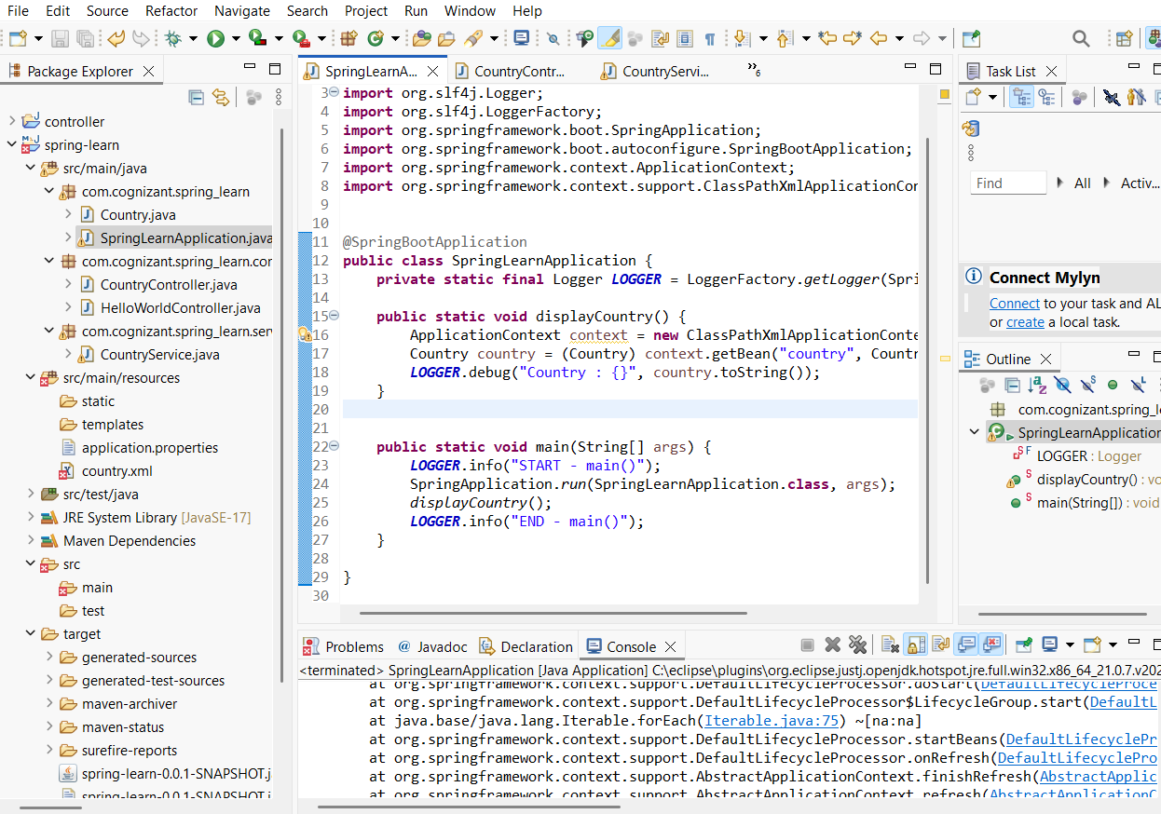

CountryController.java:

**package** com.cognizant.spring_learn.controller;

**import** com.cognizant.spring_learn.Country;

**import** com.cognizant.spring_learn.service.CountryService;

**import** org.slf4j.Logger;

**import** org.slf4j.LoggerFactory;

**import** org.springframework.beans.factory.annotation.Autowired;

**import** org.springframework.web.bind.annotation.*;

@RestController

**public** **class** CountryController {

**private** **static** **final** Logger ***LOGGER*** = LoggerFactory.*getLogger*(CountryController.**class**);

@Autowired

**private** CountryService countryService;

@GetMapping("/country/{code}")

**public** Country getCountry(@PathVariable String code) {

***LOGGER***.info("START - getCountry()");

Country country = countryService.getCountry(code);

***LOGGER***.info("END - getCountry()");

**return** country;

}

}

CountryService.java:  
**package** com.cognizant.spring_learn.service;

**import** com.cognizant.spring_learn.Country;

**import** org.slf4j.Logger;

**import** org.slf4j.LoggerFactory;

**import** org.springframework.context.ApplicationContext;

**import** org.springframework.context.support.ClassPathXmlApplicationContext;

**import** org.springframework.stereotype.Service;

**import** java.util.List;

@Service

**public** **class** CountryService {

**private** **static** **final** Logger ***LOGGER*** = LoggerFactory.*getLogger*(CountryService.**class**);

**public** Country getCountry(String code) {

***LOGGER***.info("START - getCountry({})", code);

ApplicationContext context = **new** ClassPathXmlApplicationContext("country.xml");

List<Country> countryList = context.getBean("countryList", List.**class**);

// Using Lambda (case-insensitive match)

Country result = countryList.stream()

.filter(c -> c.getCode().equalsIgnoreCase(code))

.findFirst()

.orElse(**null**);

***LOGGER***.info("END - getCountry()");

**return** result;

}

}

country.xml:

<?xml version="1.0" encoding="UTF-8"?>

<beans xmlns="http://www.springframework.org/schema/beans"

xmlns:xsi="http://www.w3.org/2001/XMLSchema-instance"

xsi:schemaLocation="http://www.springframework.org/schema/beans

https://www.springframework.org/schema/beans/spring-beans.xsd">

<bean id="countryList" class="java.util.ArrayList">

<constructor-arg>

<list>

<bean class="com.cognizant.spring_learn.Country">

<property name="code" value="IN"/>

<property name="name" value="India"/>

</bean>

<bean class="com.cognizant.spring_learn.Country">

<property name="code" value="US"/>

<property name="name" value="United States"/>

</bean>

<bean class="com.cognizant.spring_learn.Country">

<property name="code" value="DE"/>

<property name="name" value="Germany"/>

</bean>

<bean class="com.cognizant.spring_learn.Country">

<property name="code" value="JP"/>

<property name="name" value="Japan"/>

</bean>

</list>

</constructor-arg>

</bean>

</beans>