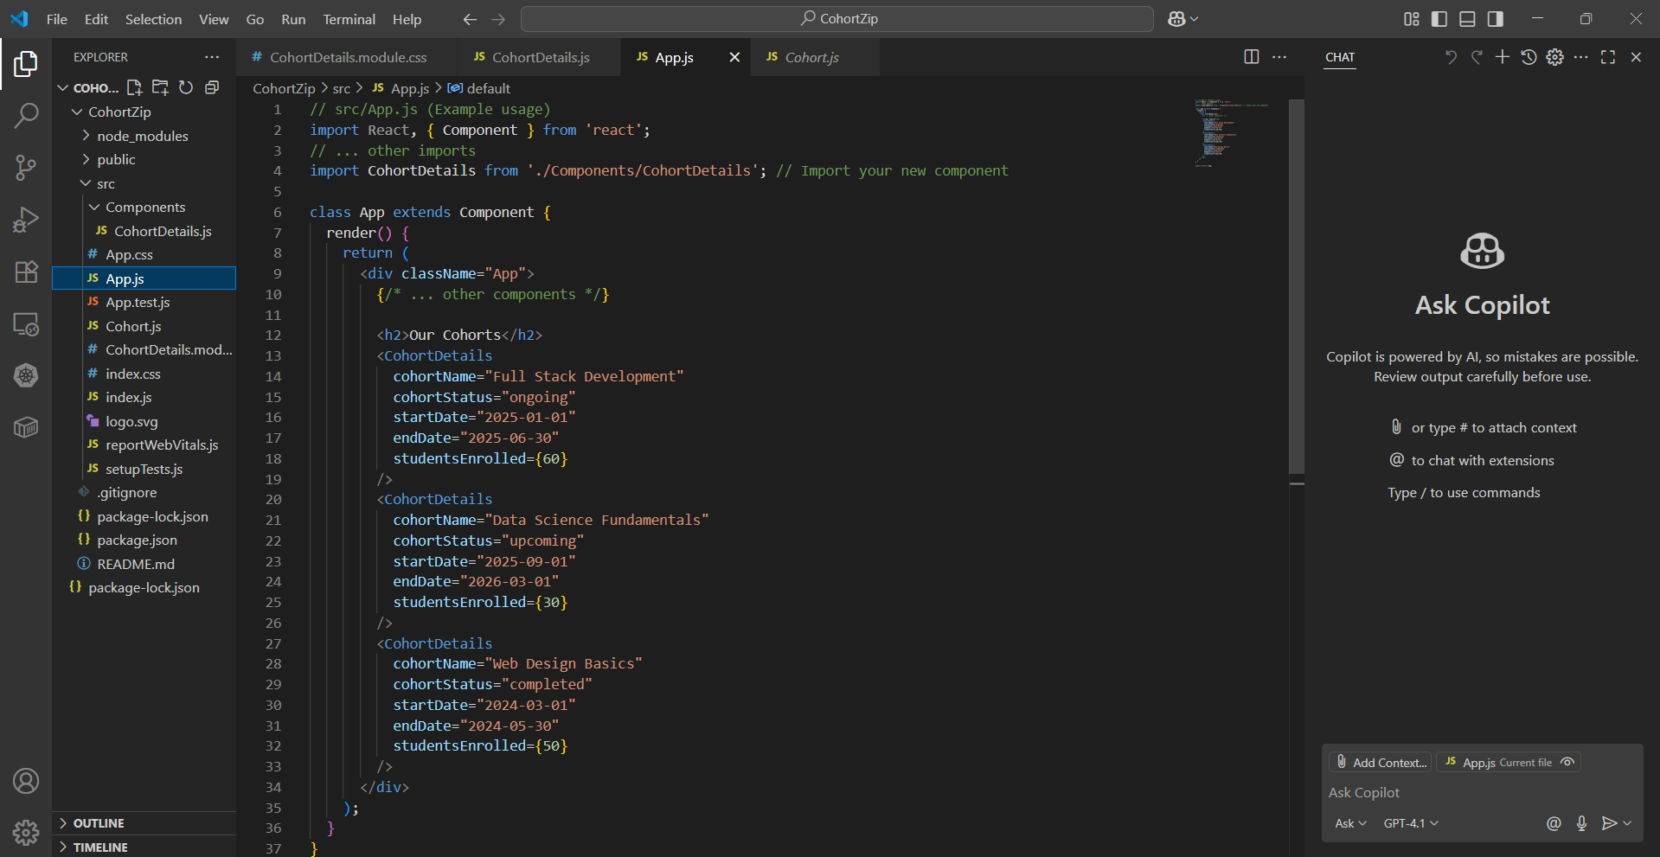

Cohort.js:

class Cohort {

    constructor(cohortCode,

        startDate,

        technology,

        trainerName,

        coachName,

        currentStatus) {

        this.cohortCode = cohortCode;

        this.coachName = coachName;

        this.trainerName = trainerName;

        this.technology = technology;

        this.startDate = startDate;

        this.currentStatus = currentStatus;

    }

}

const CohortsData =[

    new Cohort('INTADMDF10','22-Feb-2022', '.NET FSD', 'Jojo Jose','Aathma', 'Scheduled'),

    new Cohort('ADM21JF014','10-Sep-2021', 'Java FSD', 'Elisa Smith','Apoorv', 'Ongoing'),

    new Cohort('CDBJF21025','24-Dec-2021', 'Java FSD', 'John Doe','Aathma', 'Ongoing'),

    new Cohort('INTADMJF12','22-Feb-2022', 'Java FSD', 'To Be Assigned','Ibrahim', 'Scheduled'),

    new Cohort('CDE22JF011','24-Dec-2021', 'Java FSD', 'Emma Swan','Apoorv', 'Ongoing'),

    new Cohort('INTADMDF09','22-Feb-2022', 'Dataware Housing', 'Babjee Rao','Aathma', 'Scheduled'),

    new Cohort('ADM22DF001','10-Sep-2021', '.NET FSD', 'Marie Curie','Ibrahim', 'Ongoing'),

];

export {Cohort, CohortsData};

CohortDetails.js:

import React, { Component } from 'react';

// Step 4: Open the cohort details component and import the CSS Module

import styles from './CohortDetails.module.css'; // Adjust path if your CSS module is elsewhere

class CohortDetails extends Component {

    render() {

        // Assume cohort details are passed as props

        // For demonstration, let's use some dummy data or props

        const {

            cohortName = "Default Cohort",

            cohortStatus = "ongoing", // Can be "ongoing", "completed", "upcoming", etc.

            startDate = "2024-01-15",

            endDate = "2024-06-15",

            studentsEnrolled = 45

        } = this.props;

        // Step 6: Define the style for <h3> element to use "green" color font

        // when cohort status is "ongoing" and "blue" color in all other scenarios.

        const headerStyle = {

            color: cohortStatus === 'ongoing' ? 'green' : 'blue'

        };

        return (

            // Step 5: Apply the box class to the container div

            <div className={styles.box}>

                <h3 style={headerStyle}>{cohortName}</h3>

                <dl> {/\* Using a description list for details \*/}

                    <dt>Status:</dt>

                    <dd>{cohortStatus.charAt(0).toUpperCase() + cohortStatus.slice(1)}</dd> {/\* Capitalize first letter \*/}

                    <dt>Start Date:</dt>

                    <dd>{startDate}</dd>

                    <dt>End Date:</dt>

                    <dd>{endDate}</dd>

                    <dt>Students Enrolled:</dt>

                    <dd>{studentsEnrolled}</dd>

                </dl>

                {/\* Add more details as needed \*/}

            </div>

        );

    }

}

export default CohortDetails;

CohortDetails.module.css:

.box {

    width: 300px;

    display: inline-block;

    margin: 10px;

    padding-top: 10px;

    padding-bottom: 10px;

    padding-left: 20px;

    padding-right: 20px;

    border: 1px solid black;

    border-radius: 10px;

    box-shadow: 2px 2px 5px rgba(0, 0, 0, 0.2);

}

dt {

    font-weight: 500;

}

App.js:

// src/App.js (Example usage)

import React, { Component } from 'react';

// ... other imports

import CohortDetails from './Components/CohortDetails'; // Import your new component

class App extends Component {

  render() {

    return (

      <div className="App">

        {/\* ... other components \*/}

        <h2>Our Cohorts</h2>

        <CohortDetails

          cohortName="Full Stack Development"

          cohortStatus="ongoing"

          startDate="2025-01-01"

          endDate="2025-06-30"

          studentsEnrolled={60}

        />

        <CohortDetails

          cohortName="Data Science Fundamentals"

          cohortStatus="upcoming"

          startDate="2025-09-01"

          endDate="2026-03-01"

          studentsEnrolled={30}

        />

        <CohortDetails

          cohortName="Web Design Basics"

          cohortStatus="completed"

          startDate="2024-03-01"

          endDate="2024-05-30"

          studentsEnrolled={50}

        />

      </div>

    );

  }

}

export default App;

Output:

