Overall File Structure:

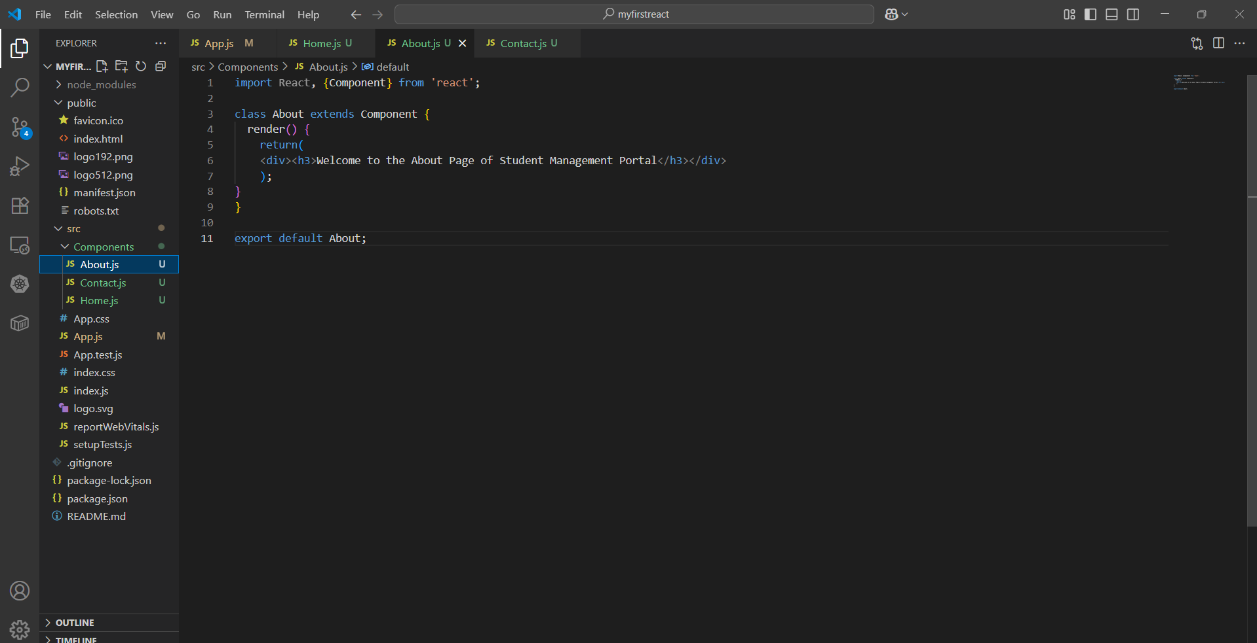

Home.js:

import React, {Component} from 'react';

class Home extends Component {

  render() {

    return (

    <div><h3>Welcome to the Home Page of Student Management Portal</h3></div>

  );}

}

export default Home;

About.js:

import React, {Component} from 'react';

class About extends Component {

  render() {

    return(

    <div><h3>Welcome to the About Page of Student Management Portal</h3></div>

    );

}

}

export default About;

Contact.js:

import React, {Component} from 'react';

class Contact extends Component {

  render() {

    return (

    <div><h3>Welcome to the Contact Page of Student Management Portal</h3></div>

);}

}

export default Contact;

Output:

