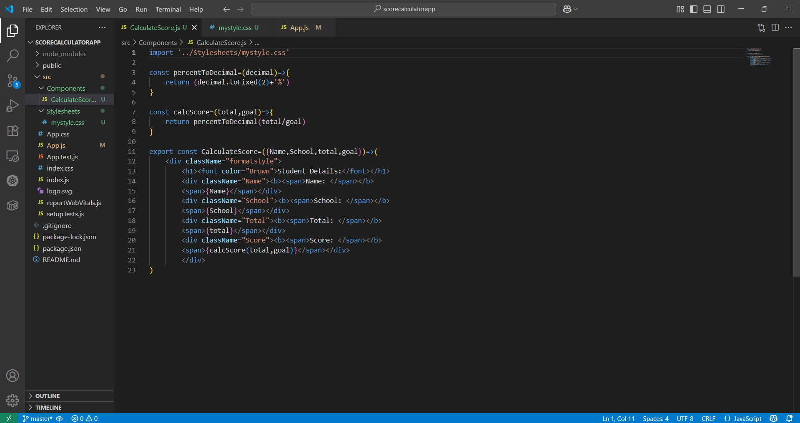

CalculateScore.js:

import '../Stylesheets/mystyle.css'

const percentToDecimal=(decimal)=>{

    return (decimal.toFixed(2)+'%')

}

const calcScore=(total,goal)=>{

    return percentToDecimal(total/goal)

}

export const CalculateScore=({Name,School,total,goal})=>(

    <div className="formatstyle">

        <h1><font color="Brown">Student Details:</font></h1>

        <div className="Name"><b><span>Name: </span></b>

        <span>{Name}</span></div>

        <div className="School"><b><span>School: </span></b>

        <span>{School}</span></div>

        <div className="Total"><b><span>Total: </span></b>

        <span>{total}</span></div>

        <div className="Score"><b><span>Score: </span></b>

        <span>{calcScore(total,goal)}</span></div>

        </div>

)

mystyle.css:

.Name{

    font-weight:300;

    color:blue;

}

.School{

    color: crimson;

}

.Total{

    color: darkmagenta;

}

.formarstyle{

    text-align: center;

    font-size: large;

}

.Score{

    color: forestgreen;

}

App.js:

import logo from './logo.svg';

import './App.css';

import { CalculateScore } from './Components/CalculateScore';

function App() {

  return (

    <div>

      <CalculateScore Name={"Steeve"}

      School={"DNV Public School"}

      total={284}

      goal={3}/>

    </div>

  );

}

export default App;

Output:

