**cricketapp**

ListofPlayers.js:

import React from 'react';

const ListofPlayers = () => {

  const players = [

    { name: 'Virat', score: 95 },

    { name: 'Rohit', score: 65 },

    { name: 'Dhoni', score: 55 },

    { name: 'Kohli', score: 85 },

    { name: 'Gill', score: 45 },

    { name: 'Hardik', score: 74 },

    { name: 'Rahul', score: 92 },

    { name: 'Bumrah', score: 33 },

    { name: 'Shami', score: 77 },

    { name: 'Ashwin', score: 88 },

    { name: 'Surya', score: 69 }

  ];

  const lowScorers = [];

  players.map((item) => {

    if (item.score <= 70) {

      lowScorers.push(item);

    }

    return null;

  });

  return (

    <div>

      <h2>All Players</h2>

      {players.map((item, idx) => (

        <div key={idx}>

          <li>

            Mr. {item.name} <span>{item.score}</span>

          </li>

        </div>

      ))}

      <h2>Players with Score ≤ 70 (Filtered)</h2>

      {lowScorers.map((item, idx) => (

        <li key={idx}>

          {item.name} - {item.score}

        </li>

      ))}

    </div>

  );

};

export default ListofPlayers;

IndianPlayers.js:

import React from 'react';

import { OddPlayers } from './OddPlayers';

import { EvenPlayers } from './EvenPlayers';

const IndianPlayers = () => {

  const team = [

    'Rohit Sharma',

    'Virat Kohli',

    'Shubman Gill',

    'KL Rahul',

    'Hardik Pandya',

    'Rishabh Pant'

  ];

  const T20Players = ['Suryakumar Yadav', 'Rinku Singh', 'Tilak Varma'];

  const RanjiTrophyPlayers = ['Cheteshwar Pujara', 'Ajinkya Rahane', 'Jaydev Unadkat'];

  const IndianPlayers = [...T20Players, ...RanjiTrophyPlayers];

  return (

    <div>

      <h2>Odd Team Players</h2>

      <OddPlayers team={team} />

      <h2>Even Team Players</h2>

      <EvenPlayers team={team} />

      <h2>Merged Indian Players</h2>

      <ul>

        {IndianPlayers.map((player, idx) => (

          <li key={idx}>{player}</li>

        ))}

      </ul>

    </div>

  );

};

export default IndianPlayers;

OddPlayers.js:

export function OddPlayers({ team }) {

  const [first, , third, , fifth] = team;

  return (

    <div>

      <li>First: {first}</li>

      <li>Third: {third}</li>

      <li>Fifth: {fifth}</li>

    </div>

  );

}

EvenPlayers.js:

export function EvenPlayers({ team }) {

  const [, second, , fourth, , sixth] = team;

  return (

    <div>

      <li>Second: {second}</li>

      <li>Fourth: {fourth}</li>

      <li>Sixth: {sixth}</li>

    </div>

  );

}

App.js:

import React from 'react';

import './App.css';

import ListofPlayers from './components/ListofPlayers';

import IndianPlayers from './components/IndianPlayers';

function App() {

  const flag = false;

  return (

    <div className="App">

      <h1>🏏 Cricket App</h1>

      {flag ? <ListofPlayers /> : <IndianPlayers />}

    </div>

  );

}

export default App;

if flag=true, output:

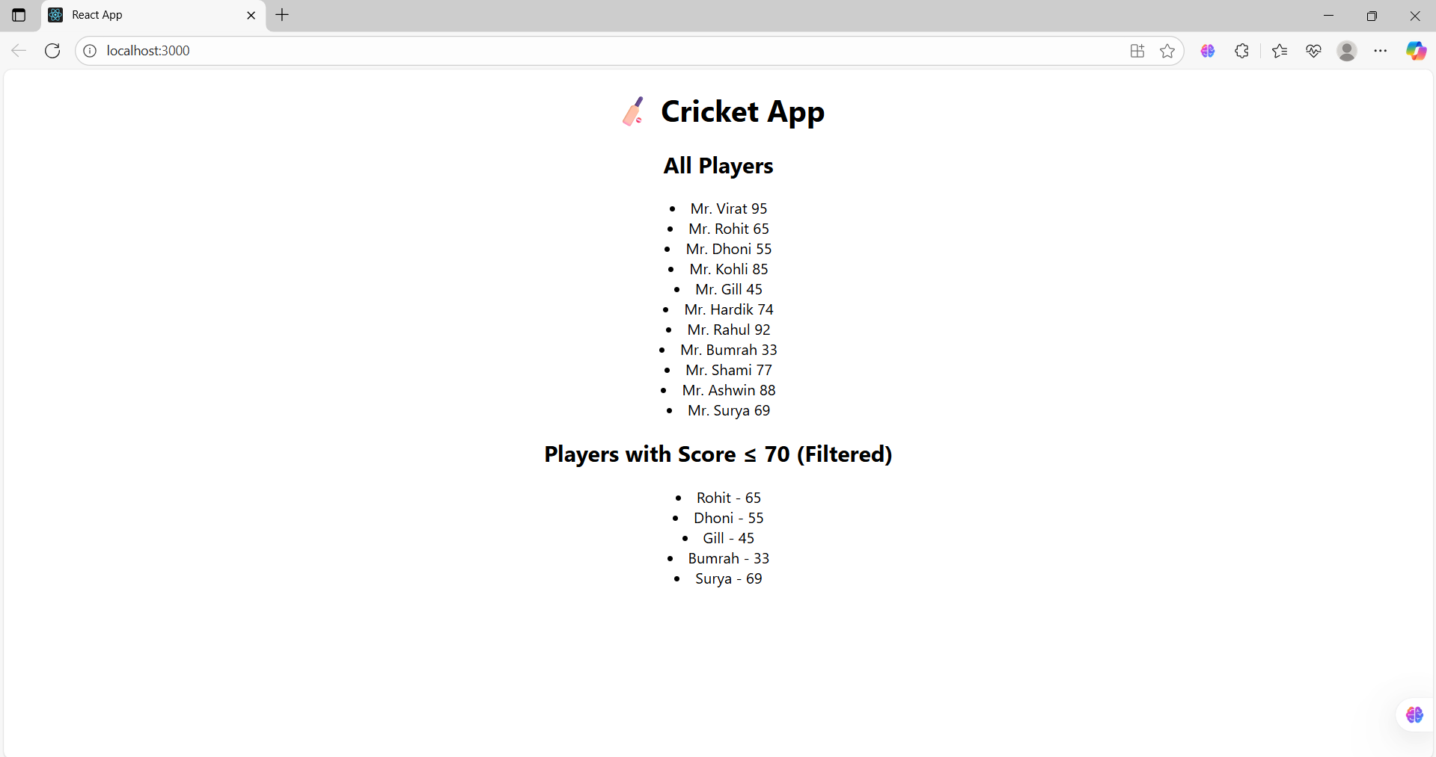

If flag=false, output:

