**officespacerentalapp:**

OfficeSpaceList.js:

import React from 'react';

import './OfficeSpaceList.css';

const OfficeSpaceList = () => {

  const officeSpaces = [

  {

    Name: 'DBS',

    Rent: 50000,

    Address: 'Chennai',

    Image: 'https://images.pexels.com/photos/3182763/pexels-photo-3182763.jpeg?auto=compress&cs=tinysrgb&dpr=2&h=650&w=940'

  },

  {

    Name: 'Regus',

    Rent: 75000,

    Address: 'Hyderabad',

    Image: 'https://images.pexels.com/photos/37347/office-sitting-room-executive-sitting.jpg?auto=compress&cs=tinysrgb&dpr=2&h=650&w=940'

  },

  {

    Name: 'IndiQube',

    Rent: 60000,

    Address: 'Bangalore',

    Image: 'https://images.unsplash.com/photo-1560448204-e02f11c3d0e2?auto=format&fit=crop&w=600&q=80'

  }

];

  const heading = "Office Space";

  return (

    <div>

      <h1>🏢 {heading} , at Affordable Range</h1>

      {officeSpaces.map((ItemName, index) => {

        let colors = [];

        if (ItemName.Rent <= 60000) {

          colors.push('textRed');

        } else {

          colors.push('textGreen');

        }

        const jsxatt = (

          <img

            src={ItemName.Image}

            width="30%"

            height="30%"

            alt="Office Space"

          />

        );

        return (

          <div key={index} className="office-box">

            {jsxatt}

            <h2>Name: {ItemName.Name}</h2>

            <h3 className={colors.join(' ')}>Rent: Rs. {ItemName.Rent}</h3>

            <h3>Address: {ItemName.Address}</h3>

          </div>

        );

      })}

    </div>

  );

};

export default OfficeSpaceList;

OfficeSpaceList.css:

.textRed {

  color: red;

  font-weight: bold;

}

.textGreen {

  color: green;

  font-weight: bold;

}

.office-box {

  margin: 30px 0;

}

App.js:

import React from 'react';

import './App.css';

import OfficeSpaceList from './components/OfficeSpaceList';

function App() {

  return (

    <div className="App">

      <OfficeSpaceList />

    </div>

  );

}

export default App;

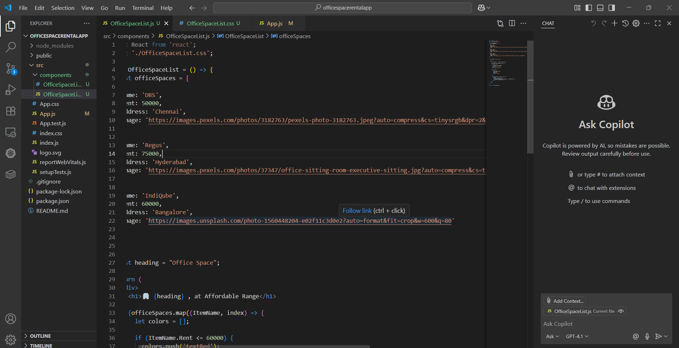

Output:

