**Event Examples App:**

App.js:

import React, { useState } from 'react';

import CurrencyConvertor from './CurrencyConvertor';

function App() {

  const [count, setCount] = useState(0);

  const incrementValue = () => {

    setCount(prev => prev + 1);

    sayHello();

    staticMessage();

  };

  const decrementValue = () => {

    setCount(prev => prev - 1);

  };

  const sayHello = () => {

    alert("Hello");

  };

  const staticMessage = () => {

    alert("This is a static message after Hello.");

  };

  const sayWelcome = (message) => {

    alert(message);

  };

  const handleClick = (e) => {

    alert("I was clicked");

  };

  return (

    <div className="p-4 space-y-4">

      <h1 className="text-xl font-bold">Event Examples App</h1>

      <div>

        <p>Counter: {count}</p>

        <button className="bg-blue-500 text-white p-2 m-1" onClick={incrementValue}>Increment</button>

        <button className="bg-red-500 text-white p-2 m-1" onClick={decrementValue}>Decrement</button>

      </div>

      <div>

        <button className="bg-green-500 text-white p-2 m-1" onClick={() => sayWelcome("Welcome!")}>Say Welcome</button>

      </div>

      <div>

        <button className="bg-gray-500 text-white p-2 m-1" onClick={handleClick}>Click Me</button>

      </div>

      <CurrencyConvertor />

    </div>

  );

}

export default App;

CurrencyConvertor.js:

import React, { useState } from 'react';

const CurrencyConvertor = () => {

  const [rupees, setRupees] = useState('');

  const [euro, setEuro] = useState(null);

  const conversionRate = 0.011; // Example: 1 INR = 0.011 Euro

  const handleSubmit = (e) => {

    e.preventDefault();

    const converted = parseFloat(rupees) * conversionRate;

    setEuro(converted.toFixed(2));

    alert(`Converted Amount in Euro: €${converted.toFixed(2)}`);

  };

  return (

    <div className="mt-4">

      <h2 className="text-lg font-semibold">Currency Convertor (INR to Euro)</h2>

      <form onSubmit={handleSubmit} className="space-y-2">

        <input

          type="number"

          placeholder="Enter amount in INR"

          value={rupees}

          onChange={(e) => setRupees(e.target.value)}

          className="border p-2"

        />

        <button type="submit" className="bg-purple-500 text-white p-2 ml-2">Convert</button>

      </form>

      {euro && <p className="mt-2">Amount in Euro: €{euro}</p>}

    </div>

  );

};

export default CurrencyConvertor;

Output:

Increment:

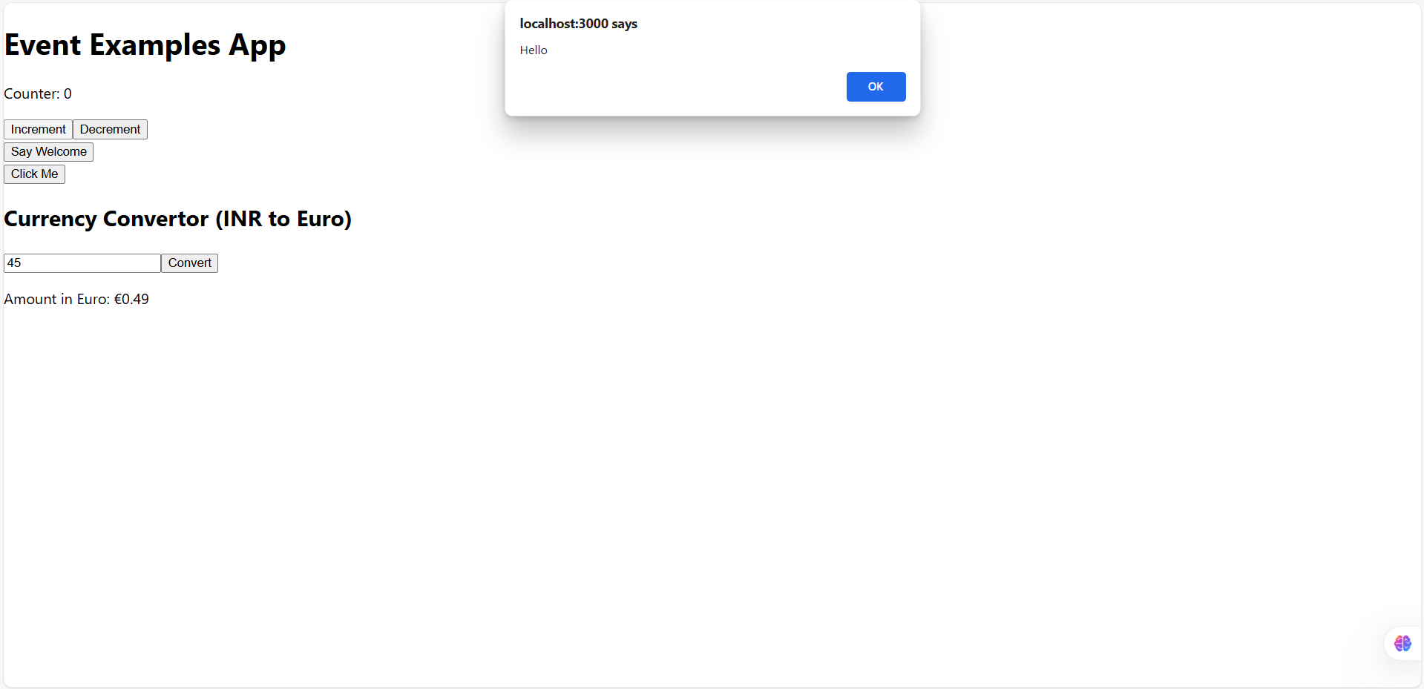

Decrement:

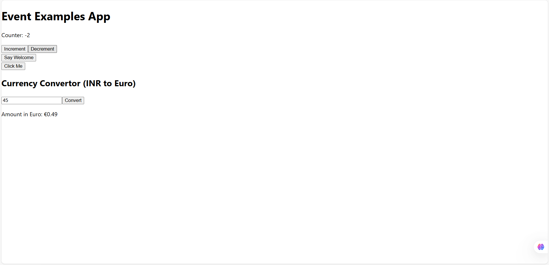

Welcome clicked:

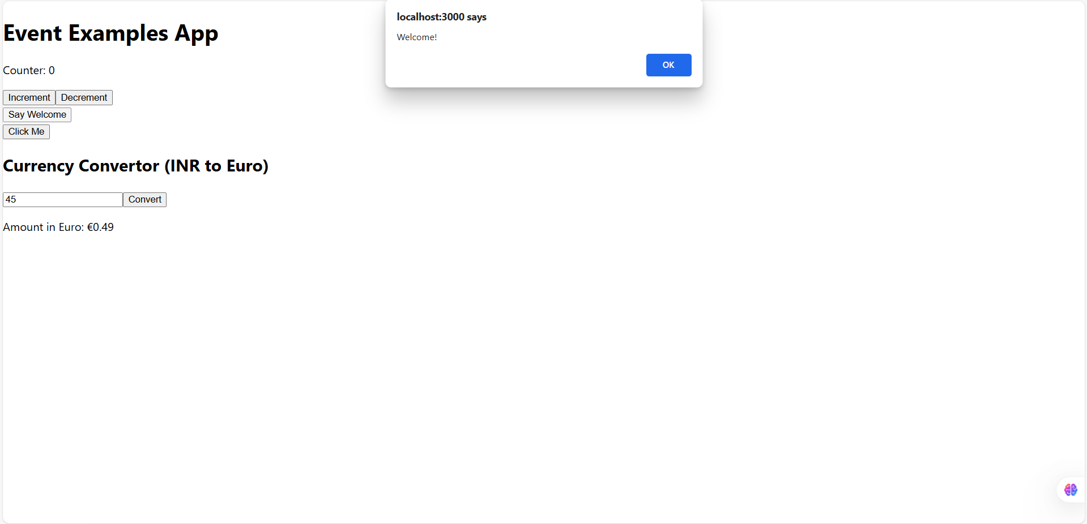

Click Me:

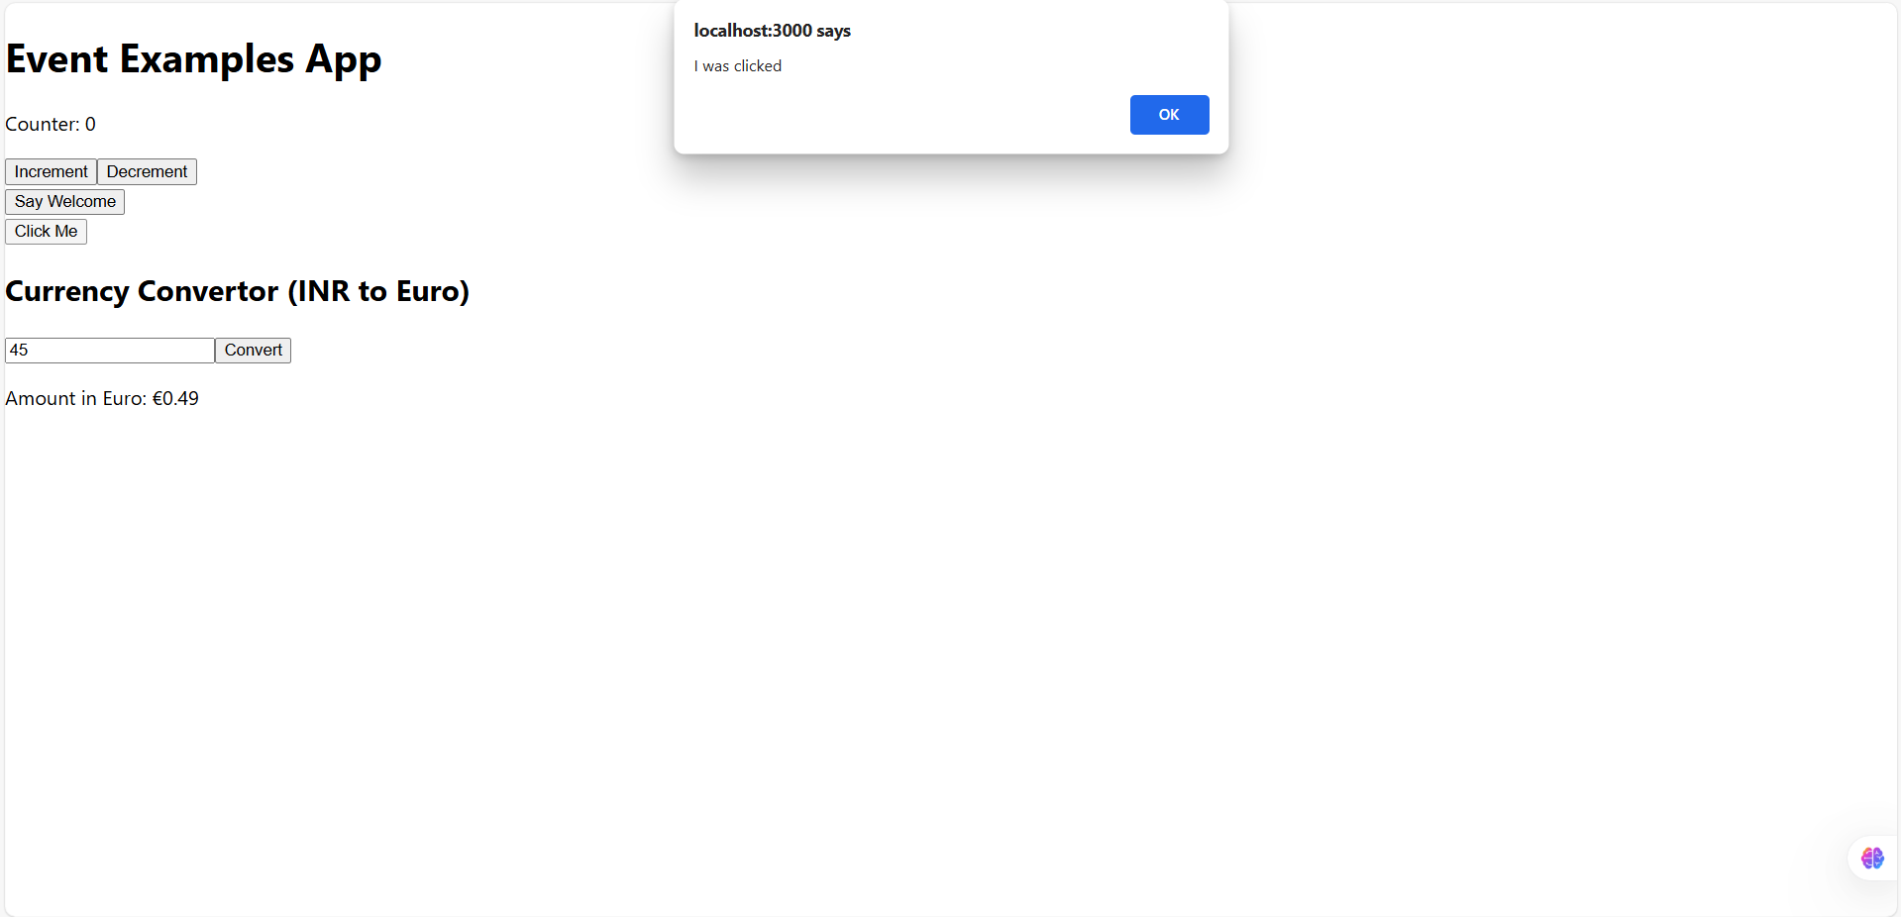

Currency Convertor:

