**Blogger App**

App.js:

import React, { useState } from 'react';

import BookDetails from './BookDetails';

import BlogDetails from './BlogDetails';

import CourseDetails from './CourseDetails';

import { books } from './data';

function App() {

  const [view, setView] = useState('book');

  const [showCourse, setShowCourse] = useState(true);

  const renderDetails = () => {

    switch (view) {

      case 'book':

        return <BookDetails books={books} />;

      case 'blog':

        return <BlogDetails />;

      case 'course':

        return <CourseDetails />;

      default:

        return <p>No view selected</p>;

    }

  };

  const content = <BlogDetails />;

  const coursedet = showCourse && <CourseDetails />;

  return (

    <div>

      <div className="p-4 space-x-2">

        <button className="bg-blue-500 text-white p-2" onClick={() => setView('book')}>Book Details</button>

        <button className="bg-green-500 text-white p-2" onClick={() => setView('blog')}>Blog Details</button>

        <button className="bg-purple-500 text-white p-2" onClick={() => setView('course')}>Course Details</button>

        <button className="bg-yellow-500 text-white p-2" onClick={() => setShowCourse(!showCourse)}>Toggle Course</button>

      </div>

      <div className="st2">

        <h1>Book Details</h1>

        <BookDetails books={books} />

      </div>

      <div className="v1">

        <h1>Blog Details</h1>

        {content}

      </div>

      <div className="mystyle1">

        <h1>Course Details</h1>

        {coursedet}

      </div>

      <div className="p-4">

        <h2 className="text-lg font-semibold">Switch/If-Else Rendering</h2>

        {renderDetails()}

      </div>

    </div>

  );

}

export default App;

BookDetails.js:

import React from 'react';

const BookDetails = (props) => {

  const bookdet = (

    <ul>

      {props.books.map((book) => (

        <div key={book.id} className="border p-2 my-2">

          <h3>{book.bname}</h3>

          <h4>₹{book.price}</h4>

        </div>

      ))}

    </ul>

  );

  return (

    <div>

      {bookdet}

    </div>

  );

};

export default BookDetails;

BlogDetails.js:

import React from 'react';

const BlogDetails = () => (

  <div className="border p-4">

    <h3 className="text-xl font-bold">Blog Details</h3>

    <p>Title: Learning React Patterns</p>

    <p>Author: Sarah D.</p>

  </div>

);

export default BlogDetails;

CourseDetails.js:

import React from 'react';

const CourseDetails = () => (

  <div className="border p-4">

    <h3 className="text-xl font-bold">Course Details</h3>

    <p>Course: Advanced React</p>

    <p>Instructor: John M.</p>

  </div>

);

export default CourseDetails;

data.js:

export const books = [

  { id: 101, bname: 'Master React', price: 670 },

  { id: 102, bname: 'Deep Dive into Angular 11', price: 800 },

  { id: 103, bname: 'Mongo Essentials', price: 450 },

];

Output:

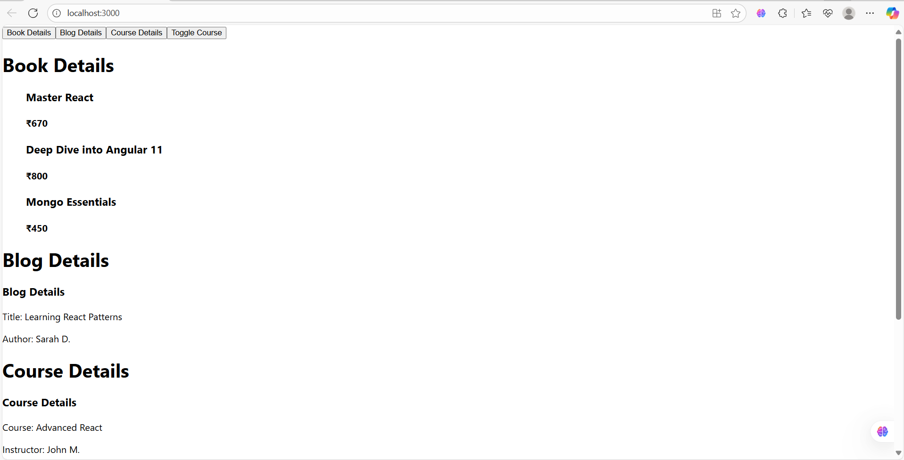

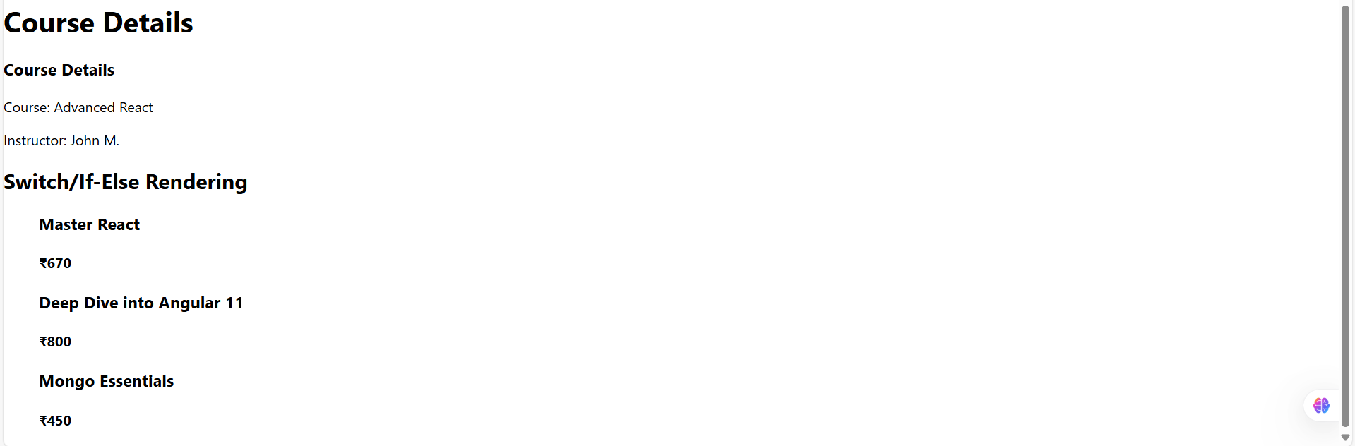

If course toggled:

