Software Requirements Specification
for
Skill Exchange Website

Prepared by
Group Name: SE – team 33
Ch.Arsha Akshara | Se22uari037 | Se22uari037@mahindrauniversity.edu.in
N.Mokshitha | Se22uari111 | Se22uari111@mahindrauniversity.edu.in
K.Pushpak Vishnu | Se22uari136 | Se22uari136@mahindrauniversity.edu.in
S.Apurupa | Se22uari156 | Se22uari156@mahindrauniversity.edu.in

Instructor: | Avinash Arun Chauhan
Course: | Software Engineering
Lab Section: | Programming Workshop
Teaching Assistant: | Swapna
Contents
Contents ii
Revisions ii
1 Introduction 1
1.1 Document Purpose 1
1.2 Product Scope 1
1.3 Intended Audience and Document Overview 1
1.4 Definitions, Acronyms and Abbreviations 1
1.5 Document Conventions 1
1.6 References and Acknowledgments 2
2 Overall Description 2
2.1 Product Overview 2
2.2 Product Functionality 3
2.3 Design and Implementation Constraints 3
2.4 Assumptions and Dependencies 3
3 Specific Requirements 4
3.1 External Interface Requirements 4
3.2 Functional Requirements 4
3.3 Use Case Model 5
4 Other Non-functional Requirements 6
4.1 Performance Requirements 6
4.2 Safety and Security Requirements 6
4.3 Software Quality Attributes 6
5 Other Requirements 7
Appendix A – Data Dictionary 8
Appendix B - Group Log 9

Revisions
Version | Primary Author(s) | Description of Version | Date Completed
Draft Type and Number | Full Name | Information about the revision. This table does not need to be filled in whenever a document is touched, only when the version is being upgraded. | 00/00/00

Introduction
The platform will enable users to engage in peer-to-peer tutoring, allowing them to exchange knowledge and skills, including language learning.

Document Purpose
This Software Requirements Specification (SRS) document outlines the requirements for the Skill Exchange Platform, a web-based application designed to facilitate peer-to-peer skill and language exchange. The platform allows users to create profiles, list their skills, and connect with others who want to learn those skills. It includes features such as user matching, session scheduling, real-time messaging, and video call integration. This document specifies the functional and non-functional requirements for the platform, serving as a guide for developers, designers, testers, and stakeholders involved in the project.

The scope of this SRS covers the entire system, including the frontend user interface, backend server logic, database management, and integration with third-party APIs (e.g., Zoom for video calls, Twilio for messaging, and SendGrid for email communication). The document also defines the constraints, assumptions, and dependencies that will influence the design and implementation of the platform. By clearly defining the requirements, this SRS ensures that all stakeholders have a shared understanding of the system's functionality and goals.

Product Scope
The Skill Exchange Platform is a web application that enables users to exchange skills and languages in a structured and user-friendly manner. The platform allows users to create profiles detailing the skills they can teach and the skills they want to learn. It uses a matching algorithm to connect users based on their skills, availability, and preferences. Once matched, users can schedule sessions, communicate via real-time messaging or email, and conduct video calls using integrated third-party APIs.

The platform is designed to be scalable, secure, and accessible across multiple devices (desktop, mobile, and tablet). It aims to foster global learning and cultural exchange by connecting users from different parts of the world. The scope of this SRS includes the development of the entire platform, from user registration and profile management to session scheduling and communication features. It also covers the integration of external APIs for messaging, email, and video calls, as well as the implementation of a robust matching algorithm.

By providing a clear and detailed description of the platform's requirements, this SRS ensures that the final product meets the needs of its users and stakeholders while adhering to technical and regulatory constraints.

Intended Audience and Document Overview
This SRS is intended for a variety of readers, each with different roles and responsibilities in the development and use of the Skill Exchange Platform. The primary audiences include:
- Developers: Focus on Section 3 (Specific Requirements) and Section 4 (Non-functional Requirements) to understand the platform's architecture, APIs, and third-party integrations (e.g., Zoom, Twilio, SendGrid).
- Project Managers: Review Section 2 (Overall Description) and Section 3 (Specific Requirements) to plan and track the project's scope, functionality, and feature delivery.
- Testers: Use Section 3 (Specific Requirements) and Section 4 (Non-functional Requirements) to create test cases and validate performance, safety, and usability.
- Stakeholders (Client and Professor): Start with Section 1 (Introduction) and Section 2 (Overall Description) for a high-level understanding of the platform's purpose and goals.
- Documentation Writers: Refer to Section 3 (Specific Requirements) and Section 4 (Non-functional Requirements) to create user manuals and guides.

Suggested Reading Sequence

- Stakeholders (Client and Professor): Start with Section 1 (Introduction) and Section 2 (Overall Description) to understand the platform's purpose and scope.
- Developers and Testers: Focus on Section 3 (Specific Requirements) and Section 4 (Non-functional Requirements) for detailed technical specifications.
- Project Managers: Review Section 2 (Overall Description) and Section 3 (Specific Requirements) to plan and track the project's progress.
- Documentation Writers: Use Section 3 (Specific Requirements) and Section 4 (Non-functional Requirements) to create user-facing documentation.

By following this structure, readers can easily navigate the document and find the information most relevant to their role in the project.

Definitions, Acronyms and Abbreviations
Abbreviations and Acronyms:

- API: Application Programming Interface – A set of protocols and tools for building software applications.
- CSS: Cascading Style Sheets – Used for styling the visual presentation of the website.
- HTML: Hypertext Markup Language – The standard language for creating web pages.
- NLP: Natural Language Processing – A field of AI focused on interactions between computers and human language.
- RDBMS: Relational Database Management System – A database system that stores data in tables (e.g., PostgreSQL).
- SRS: Software Requirements Specification – A document that describes the requirements for a software system.
- SSL/TLS: Secure Sockets Layer/Transport Layer Security – Protocols for encrypting data transmitted over the internet.
- UI: User Interface – The visual and interactive elements of the platform.
- UX: User Experience – The overall experience of users when interacting with the platform.

Definitions:

- Matching Algorithm: A system that connects users based on their skills, availability, and preferences.
- Peer-to-Peer Tutoring: A method of learning where users teach and learn from each other directly.
- Real-Time Messaging: Instant communication between users through text messages.
- Skill Exchange Platform: A web-based application that allows users to exchange skills and languages.
- User Profile: A collection of information about a user, including their skills, availability, and preferences.
These terms and abbreviations are specific to the Skill Exchange Platform project and are used throughout this document to ensure clarity and consistency.

Document Conventions
Formatting Conventions:

- Font: Arial, size 11and 14 is used for all text in the document.
- Spacing: The document is single-spaced with 1-inch margins on all sides.
- Section Titles: Section and subsection titles follow the template's formatting (e.g., bold and numbered headings).
- Italics: Italics are used for comments, notes, or additional explanations within the document.
- Bullet Points: Bullet points are used for lists to improve readability.

Naming Conventions:

- Functional Requirements: Functional requirements are labelled with an "F" followed by a number (e.g., F1, F2).
- Non-functional Requirements: Non-functional requirements are labelled with an "NF" followed by a number (e.g., NF1, NF2).
- Use Cases: Use cases are labelled with a "U" followed by a number (e.g., U1, U2).

Highlighting and Emphasis:

- Bold Text: Bold text is used for section titles and key terms.
- Italics: Italics are used for comments, notes, or additional explanations.
- Underline: Underlining is used sparingly to emphasize specific terms or phrases.
- Document Structure:
- Sections: The document is divided into sections and subsections, each with a clear heading and numbering (e.g., 1.1, 1.2, 2.1).

References and Acknowledgments
References:

The external documents, websites, or resources that are directly related to the project. These include:
- Technical Documentation: API documentation, SDKs, or libraries used in the project (e.g., Zoom API, Twilio API, Firebase Documentation).
- Templates and Frameworks: If you used a specific template or framework for the SRS (e.g., IEEE SRS template).
- Other Relevant Documents: For the creation and designing the website reference of some templates around the web.

Acknowledgments:

- Team Members: Thanks to all team members for their contributions to the project.
- Stakeholders: Special thanks to the client and professor for their guidance and feedback.
- Third-Party Services: Acknowledgment of Zoom, Twilio, SendGrid, and Firebase for providing the APIs and services that enable key functionalities of the platform.

Overall Description

Product Overview
The Skill Exchange Platform is a new, self-contained product designed to facilitate peer-to-peer skill and language exchange. It is not a replacement for any existing system but rather a unique platform that addresses the growing demand for informal, community-driven learning. The platform allows users to create profiles, list their skills, and connect with others who want to learn those skills. It includes features such as user matching, session scheduling, real-time messaging, and video call integration.

The platform operates as a standalone web application but integrates with several third-party services to enhance its functionality:
- Zoom API: For video call integration during skill-sharing sessions.
- Twilio: For real-time messaging between users. (optional)
- SendGrid: For email communication and notifications.
- Firebase: For user authentication and real-time database management.
- MongoDB: For storing user profiles, session details, and other data.

The Skill Exchange Platform is designed to be scalable and accessible across multiple devices (desktop, mobile, and tablet). It aims to foster global learning and cultural exchange by connecting users from different parts of the world.

Product Context Diagram

The Skill Exchange Platform interacts with its environment and external services:

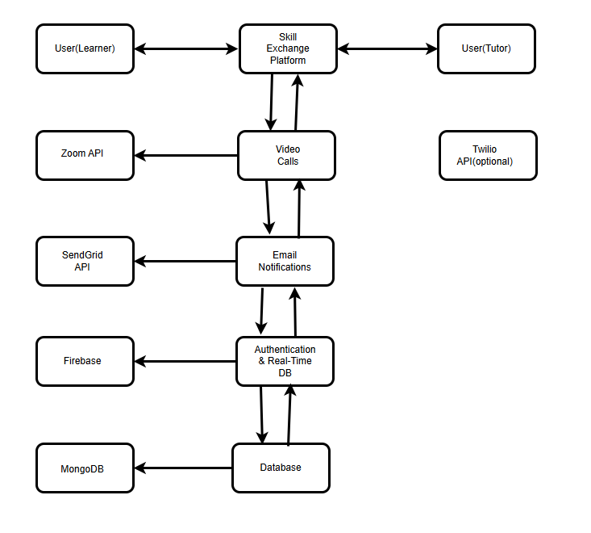

Product Functionality
The Skill Exchange Platform is designed to provide users with a seamless and interactive experience for exchanging skills and languages.

Major Functions of the System:

- User Profile Management:
  - Allow users to create and manage profiles, including listing skills they know and skills they want to learn.
  - Enable users to update their availability and preferences.
- Matching System:
  - Match users based on their skills, availability, and preferences.
  - Provide a list of potential matches for users to connect with.
- Scheduling System:
  - Allow users to schedule skill-sharing sessions at mutually convenient times.
  - Send reminders and notifications for upcoming sessions.
- Video Call Integration:
  - Integrate with Zoom or similar services to facilitate video calls during skill-sharing sessions.
  - Provide a seamless experience for users to join and conduct video calls.
- Email Notifications:
  - Send email notifications for session reminders, new messages, and other important updates.
  - Use SendGrid or similar services for reliable email delivery.
- Search and Filtering:
  - Allow users to search for specific skills or languages.
  - Provide filtering options based on availability, location, and user ratings.
- Feedback and Ratings:
  - Enable users to rate and review each other after sessions.
  - Display user ratings and reviews on profiles to build trust and credibility.
- Admin Dashboard:
  - Provide an admin interface to manage users, sessions, and platform settings.
  - Monitor platform activity and resolve user issues.

Design and Implementation Constraints
These constraints are necessary to ensure the platform meets its functional and non-functional requirements while adhering to best practices and industry standards. Below are the key constraints:
1. Technology Stack:
- Frontend: The frontend must be developed using HTML, CSS, and JavaScript for building a dynamic and responsive user interface.
- Backend: The backend must be developed using Node.js with Express.js for server-side logic.
- Database: The platform must use MongoDB as the NoSQL database for storing structured and unstructured data.
2. Third-Party Integrations:
- Zoom API: Must be integrated for video call functionality during skill-sharing sessions.
- Firebase Realtime Database: Must be used for real-time data synchronization and messaging.
3. Design and Modelling Standards:
- UML modelling: The system must be modelled using the Unified Modelling Language (UML) for creating use case diagrams, class diagrams, sequence diagrams, and other design artifacts.
4. Security Considerations:
- Data Encryption: All user data transmitted over the internet must be encrypted using SSL/TLS protocols.
- Authentication: Secure user authentication mechanisms must be implemented to prevent unauthorized access.
5. Performance and Scalability:
- Response Time: The platform must handle user requests with a response time of less than 2 seconds under normal load.
- Scalability: The platform must be designed to support up to 50 concurrent users without performance degradation.
6. Hardware Limitations:
- Device Compatibility: The platform must be compatible with desktop, mobile, and tablet devices, ensuring a responsive design.
- Browser Support: The platform must support major web browsers, including Chrome, Firefox, Safari, and Edge.
7. Development Standards:
- Coding Standards: The codebase must adhere to industry-standard coding practices, including proper documentation, modular design, and consistent naming conventions.
- Version Control: The project must use Git for version control, with the repository hosted on GitHub or GitLab.

Assumptions and Dependencies
Assumptions:
- Third-Party API Availability:
  - Zoom, Twilio, SendGrid, and Firebase APIs will remain functional and accessible throughout the project.
- User Behaviour:
  - Users will provide accurate information in their profiles (e.g., skills, availability).
- Internet Connectivity:
  - Users will have stable internet access for real-time features like messaging and video calls.
- Device Compatibility:
  - Users will access the platform using modern browsers (e.g., Chrome, Firefox) on desktop, mobile, or tablet devices.
- Regulatory Compliance:
  - The platform will comply with data protection regulations (e.g., GDPR) without major design changes.
- Development Timeline:
  - The team will have sufficient time and resources to complete the project on schedule.
Dependencies:
- Third-Party Services:
  - The platform depends on Zoom, Twilio, SendGrid, and Firebase for key functionalities.
- Development Tools:
  - The project relies on React.js (frontend), Node.js/Express.js (backend), and PostgreSQL (database).
- Cloud Infrastructure:
  - Deployment depends on cloud services like AWS or Heroku.
- Team Expertise:
  - The project depends on the team's proficiency in using the chosen technologies.
- User Adoption:
  - The platform's success depends on user engagement and adoption.

Specific Requirements

External Interface Requirements

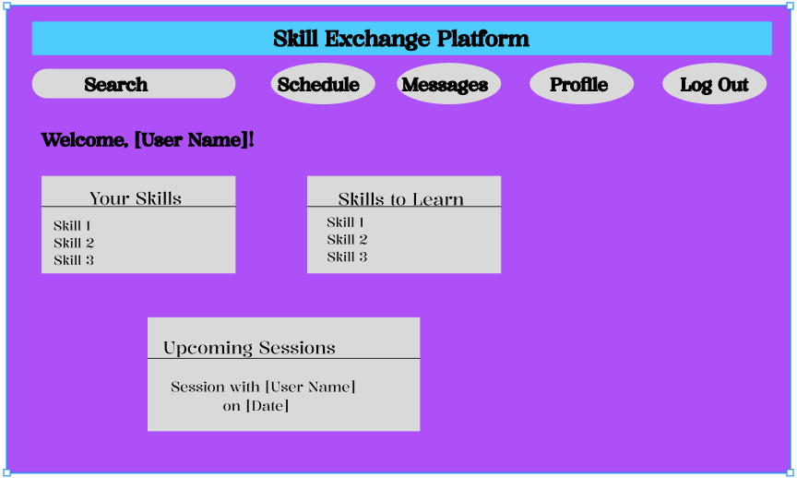
User Interfaces

Description of User Interaction
- Navigation Bar:
  - The top navigation bar includes tabs for Profile, Search, Messages, Schedule, and Logout.
  - Users can click on these tabs to navigate to different sections of the platform.
- Profile Section:
  - Displays the user's name and a welcome message.
  - Shows two sections: Your Skills (skills the user can teach) and Skills to Learn (skills the user wants to learn).
  - Users can edit their profile to add or remove skills.
- Search Section:
  - Allows users to search for other users based on skills, availability, or preferences.
  - Users can view profiles of potential matches and send session requests.
- Messages Section:
  - Provides a real-time messaging interface for users to communicate with each other.
  - Users can send text messages, share files, or schedule sessions directly through the chat.
- Schedule Section:
  - Displays upcoming skill-sharing sessions.
  - Users can view session details (e.g., date, time, participant) and join video calls directly from this section.
- Logout:
  - Allows users to securely log out of the platform.
Interaction Methods:
- Touch Screen (Mobile/Tablet):
  - Users can tap on buttons, menus, and links to navigate through the platform.
  - Swipe gestures can be used to scroll through lists (e.g., search results, messages).
- Mouse and Keyboard (Desktop):
  - Users can click on buttons and links to navigate.
  - Keyboard shortcuts can be provided for quick access to frequently used features (e.g., Ctrl + S to save profile changes).
Key Features:
- Responsive Design: The interface adapts to different screen sizes (desktop, mobile, tablet) for optimal user experience.
- Intuitive Layout: Clear and organized sections make it easy for users to find and use features.
- Real-Time Updates: Messages and session details are updated in real-time without requiring page reloads.

Hardware Interfaces
Supported Device Types:
- Desktop Computers:
  - Accessed via web browsers (e.g., Chrome, Firefox).
  - Uses keyboard and mouse for input, and a monitor for output.
- Mobile Devices (Smartphones and Tablets):
  - Accessed via mobile browsers or a future mobile app.
  - Uses touchscreen for input, and built-in microphone and camera for video calls.
- Laptops:
  - Accessed via web browsers.
  - Uses built-in keyboard, touchpad, webcam, and microphone for input and output.

Nature of Data and Control Interactions:
- Input Devices:
  - Keyboard/mouse (desktop/laptop) for typing and navigation.
  - Touchscreen (mobile/tablet) for tapping and scrolling.
- Output Devices:
  - Monitor/display for viewing the interface.
  - Speakers/headphones for audio during video calls.
- Communication Devices:
  - Webcam and microphone for real-time video and audio.
  - Network interface for data exchange with the server.

Software Interfaces
The Skill Exchange Platform integrates with external software components like Zoom, SendGrid, Firebase, and MongoDB to enable video calls, email notifications, user authentication, and data management. These integrations ensure a seamless and functional user experience.

1. Zoom API:
- Purpose: Enables video call functionality for skill-sharing sessions.
- Connection: The platform integrates with the Zoom API to generate meeting links and allow users to join video calls directly from the platform.
- Data Interaction: The platform sends session details (e.g., date, time) to Zoom and receives meeting links to display to users.
2. SendGrid API:
- Purpose: Sends email notifications and reminders to users.
- Connection: The platform integrates with SendGrid’s email API to send automated emails (e.g., session reminders, new message alerts).
- Data Interaction: The platform sends email content (e.g., subject, body) to SendGrid, which handles email delivery.
3. Firebase:
- Purpose: Manages user authentication and real-time data synchronization.
- Connection: The platform integrates with Firebase for user login, profile management, and real-time updates (e.g., new messages, session changes).
- Data Interaction: User data (e.g., login credentials, profile information) is stored and retrieved from Firebase in real-time.
4. MongoDB:
- Purpose: Stores structured and unstructured data (e.g., user profiles, session details).
- Connection: The platform connects to a MongoDB database to store and retrieve data.
- Data Interaction: The platform sends queries to MongoDB to fetch or update data as needed.

Functional Requirements
This section provides a detailed list of the functional requirements for the Skill Exchange Platform. These requirements capture the intended behavior of the system, including the services, tasks, and functions it must perform.

3.2.1 F1: User Profile Management
- Description: The system shall allow users to create, view, and manage their profiles.
- Details:
  - Users can input their skills (skills they can teach) and skills they want to learn.
  - Users can update their availability, contact information, and preferences.
  - Profiles shall include a rating system where users can rate and review each other after sessions.

3.2.2 F2: Matching System
- Description: The system shall match users based on their skills, availability, and preferences.
- Details:
  - The system shall use an algorithm to suggest potential matches for skill-sharing.
  - Users can view profiles of matched users and send session requests.
  - The system shall allow users to filter matches by skill, location, and availability.

3.2.3 F3: Session Scheduling
- Description: The system shall allow users to schedule skill-sharing sessions.
- Details:
  - Users can propose session times and receive confirmations from matched users.
  - The system shall send reminders and notifications for upcoming sessions.
  - Users can reschedule or cancel sessions through the platform.

3.2.4 F4: Real-Time Messaging
- Description: The system shall provide a real-time messaging feature for users to communicate.
- Details:
  - Users can send and receive text messages within the platform.
  - The messaging interface shall support file sharing (e.g., documents, images).
  - Messages shall be stored and accessible for future reference.

3.2.5 F5: Video Call Integration
- Description: The system shall integrate with Zoom for video calls during skill-sharing sessions.
- Details:
  - The system shall generate Zoom meeting links for scheduled sessions.
  - Users can join video calls directly from the platform.
  - The system shall display session details (e.g., date, time, participant) alongside the video call interface.

3.2.6 F6: Email Notifications
- Description: The system shall send email notifications to users for important updates.
- Details:
  - Users shall receive email reminders for upcoming sessions.
  - Notifications shall be sent for new messages, session requests, and profile updates.
  - The system shall use SendGrid for reliable email delivery.

3.2.7 F7: Search and Filtering
- Description: The system shall allow users to search for specific skills or users.
- Details:
  - Users can search for skills they want to learn or users who offer specific skills.
  - The system shall provide filtering options based on availability, location, and user ratings.
  - Search results shall display user profiles with relevant details.

3.2.8 F8: Feedback and Ratings
- Description: The system shall allow users to rate and review each other after sessions.
- Details:
  - Users can leave ratings (e.g., 1-5 stars) and written reviews for their session partners.
  - Ratings and reviews shall be displayed on user profiles to build trust and credibility.
  - The system shall calculate and display average ratings for each user.

3.2.9 F9: Admin Dashboard
- Description: The system shall provide an admin interface to manage users and platform settings.
- Details:
  - Admins can view and manage user accounts, sessions, and messages.
  - The dashboard shall include analytics on platform usage (e.g., active users, session frequency).
  - Admins can resolve user-reported issues and monitor platform activity.

Use Case Model

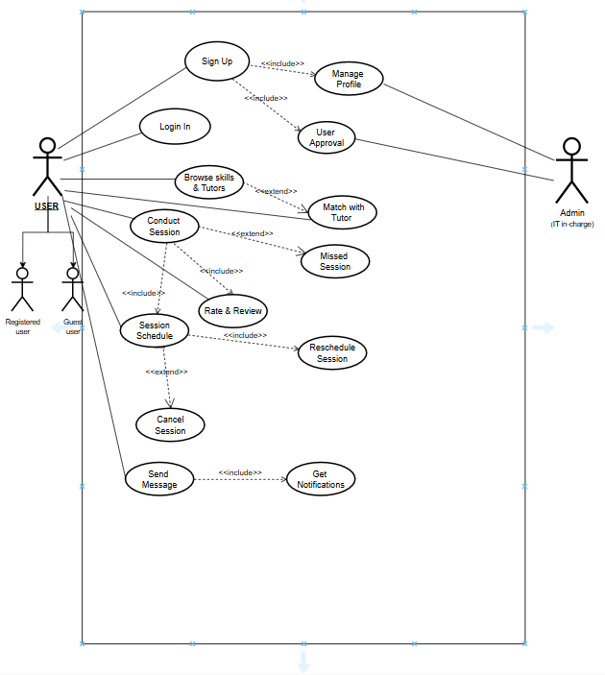

Use Case Specification:

Use Case 1: Sign Up
Author: S.Apurupa
Purpose: To allow new users to create an account on the platform.
Requirements Traceability: F1 (User Profile Management)
Priority: High
Preconditions: User must not already have an account.
Post Conditions: User account is created and stored in the database.
Actors: New User
Extends: None
Flow of Events:
  - Basic Flow: User navigates to the sign-up page, fills in required details (e.g., name, email, password), and submits the form.
  - Alternative Flow: User enters invalid data (e.g., duplicate email), and the system prompts for correction.
  - Exceptions: System fails to create the account due to technical issues.
Includes: Manage profile, User aproval
Notes/Issues: Ensure email validation and password strength requirements.
Use Case 2: Manage Profile
Author: Ch.Arsha Akshara
Purpose: To allow users to update and manage their profile information.
Requirements Traceability: F1 (User Profile Management)
Priority: Medium
Preconditions: User must be logged in.
Post Conditions: Profile information is updated and saved.
Actors: Registered User
Extends: None
Flow of Events:
  - Basic Flow: User navigates to the profile section, edits information, and saves changes.
  - Alternative Flow: User attempts to save incomplete or invalid data, and the system prompts for correction.
  - Exceptions: System fails to save changes due to technical issues.
Includes: None
Notes/Issues: Ensure real-time updates and data validation.
Use Case 3: Login
Author: S.Apurupa
Purpose: To allow registered users to access their accounts.
Requirements Traceability: F1 (User Profile Management)
Priority: High
Preconditions: User must have an existing account.
Post Conditions: User is logged in and can access platform features.
Actors: Registered User
Extends: Sign Up
Flow of Events:
  - Basic Flow: User enters email and password, and the system verifies credentials.
  - Alternative Flow: User enters incorrect credentials, and the system prompts for re-entry.
  - Exceptions: System fails to authenticate due to technical issues.
Includes: None
Notes/Issues: Implement secure authentication mechanisms.
Use Case 4: Browse Skills & Tutors
Author: N.Mokshitha
Purpose: To allow users to search for skills and tutors.
Requirements Traceability: F7 (Search and Filtering)
Priority: Medium
Preconditions: User must be logged in.
Post Conditions: User views a list of skills and tutors.
Actors: Registered User
Extends: Match with Tutor
Flow of Events:
  - Basic Flow: User enters search criteria and views results.
  - Alternative Flow: No results found, and the system displays a message.
  - Exceptions: System fails to retrieve search results due to technical issues.
Includes: None
Notes/Issues: Ensure efficient search algorithms and filters.
Use Case 5: Match with Tutor
Author: N.Mokshitha
Purpose: To match users with tutors based on skills and availability.
Requirements Traceability: F2 (Matching System)
Priority: High
Preconditions: User must have a complete profile.
Post Conditions: User receives a list of matched tutors.
Actors: Registered User
Extends: None
Flow of Events:
  - Basic Flow: System suggests tutors based on user profile and preferences.
  - Alternative Flow: No matches found, and the system suggests broadening search criteria.
  - Exceptions: System fails to generate matches due to technical issues.
Includes: None
Notes/Issues: Ensure accurate matching algorithms.
Use Case 6: Conduct Session
Author: K.Pushpak Vishnu
Purpose: To allow users to conduct skill-sharing sessions.
Requirements Traceability: F5 (Video Call Integration)
Priority: High
Preconditions: Session must be scheduled and confirmed.
Post Conditions: Session is completed, and users can rate each other.
Actors: Registered User, Tutor
Extends: Missed Session
Flow of Events:
  - Basic Flow: Users join the session via Zoom link and conduct the session.
  - Alternative Flow: Technical issues prevent session start, and users reschedule.
  - Exceptions: System fails to generate Zoom link or handle session data.
Includes: Schedule Session, Rate & Review.
Notes/Issues: Ensure reliable video call integration.
Use Case 7: Rate & Review
Author: K.Pushpak Vishnu
Purpose: To allow users to rate and review each other after sessions.
Requirements Traceability: F8 (Feedback and Ratings)
Priority: Medium
Preconditions: Session must be completed.
Post Conditions: Ratings and reviews are saved and displayed on profiles.
Actors: Registered User
Extends: None
Flow of Events:
  - Basic Flow: User submits a rating and review for the session partner.
  - Alternative Flow: User skips rating, and the system prompts later.
  - Exceptions: System fails to save ratings due to technical issues.
Includes: None
Notes/Issues: Ensure fair and accurate rating system.
Use Case 8: Reschedule Session
Author: K.Pushpak Vishnu
Purpose: To allow users to reschedule sessions.
Requirements Traceability: F3 (Session Scheduling)
Priority: Medium
Preconditions: Session must be scheduled but not yet started.
Post Conditions: Session is rescheduled, and both parties are notified.
Actors: Registered User
Extends: None
Flow of Events:
  - Basic Flow: User requests rescheduling, and the other party confirms.
  - Alternative Flow: Other party declines, and the session remains unchanged.
  - Exceptions: System fails to update session details due to technical issues.
Includes: None
Notes/Issues: Ensure clear communication and notifications.
Use Case 9: Cancel Session
Author: N.Mokshitha
Purpose: To allow users to cancel scheduled sessions.
Requirements Traceability: F3 (Session Scheduling)
Priority: Medium
Preconditions: Session must be scheduled but not yet started.
Post Conditions: Session is cancelled, and both parties are notified.
Actors: Registered User
Extends: None
Flow of Events:
  - Basic Flow: User cancels the session, and the system notifies the other party.
  - Alternative Flow: User attempts to cancel after the session start time, and the system denies the request.
  - Exceptions: System fails to cancel the session due to technical issues.
Includes: None
Notes/Issues: Ensure timely notifications and updates.
Use Case 10: Send Message
Author: Ch.Arsha Akshara
Purpose: To allow users to send messages to each other.
Requirements Traceability: F4 (Real-Time Messaging)
Priority: High
Preconditions: User must be logged in.
Post Conditions: Message is sent and stored in the chat history.
Actors: Registered User
Extends: None
Flow of Events:
  - Basic Flow: User composes and sends a message to another user.
  - Alternative Flow: Message fails to send, and the system retries or notifies the user.
  - Exceptions: System fails to send or store messages due to technical issues.
Includes: Get Notifications
Notes/Issues: Ensure real-time message delivery and storage.
Use Case 11: Get Notifications
Author: S.Apurupa
Purpose: To notify users about important updates (e.g., new messages, session reminders).
Requirements Traceability: F6 (Email Notifications)
Priority: Medium
Preconditions: User must be logged in.
Post Conditions: User receives notifications via email or in-app alerts.
Actors: Registered User
Extends: None
Flow of Events:
  - Basic Flow: System sends notifications based on user activity (e.g., new message, session reminder).
  - Alternative Flow: User disables notifications, and the system stops sending alerts.
  - Exceptions: System fails to send notifications due to technical issues.
Includes: None
Notes/Issues: Ensure timely and accurate notifications.

Other Non-functional Requirements

Performance Requirements
NF1) Concurrent Users & Scalability:
The system must support a minimum of 500 concurrent users and scale up to 10,000 daily active users during peak hours without performance degradation.

NF2) Response Time:
Typical page loads and transaction responses (e.g., submitting an exchange request or joining a tutoring session) should complete within 2 seconds under normal load conditions.

NF3) Data Query Efficiency:
Database operations (queries, updates, and retrievals) should be optimized to respond within 1 second for standard operations.

NF4) Load Balancing:
The architecture must include load balancing mechanisms to distribute user traffic evenly across servers and ensure reliability during traffic surges.

NF5) Real-Time Communication:
For features involving synchronous sessions (e.g., live chat or video conferencing for tutoring), the system should maintain low latency (<150ms) and minimal jitter to ensure seamless interactions.

Safety and Security Requirements
1. Data Encryption:
- All communications must use SSL/TLS protocols, and sensitive user data should be stored using strong encryption standards (e.g., AES-256).
2. User Authentication & Access Control:
- Implement role-based access control (RBAC) to restrict access to sensitive features. All user passwords should be securely hashed (e.g., salted hashing) and follow a robust password policy.
3. Session Management:
- Secure session handling must be implemented, including automatic logout after 15 minutes of inactivity to mitigate unauthorized access.
4. Compliance:
- The system must comply with applicable data protection regulations (such as GDPR) to ensure user privacy and proper handling of personal data.
5. Security Audits & Vulnerability Management:
- Regular security assessments and vulnerability scans should be conducted. Any identified risks must be promptly addressed and mitigated.
6. Input Validation:
- Incorporate comprehensive input validation and sanitation to prevent common vulnerabilities such as SQL injection, cross-site scripting (XSS), and other code injection attacks.

Software Quality Attributes
1. Reliability:
Ensure high availability (targeting 99.5% uptime) with robust error-handling and failover mechanisms to maintain continuous operation.

2. Usability:
Design an intuitive, user-friendly interface with responsive design principles to support a variety of devices (desktop, tablet, mobile). Provide accessibility features to serve users with disabilities.

3. Maintainability:
Develop modular, well-documented code that adheres to established coding standards to facilitate easy maintenance and future enhancements.

4. Scalability:
The platform's architecture should allow for both vertical and horizontal scaling to handle an increasing number of users and feature additions without major redesign.

5. Interoperability:
Provide standardized APIs to integrate seamlessly with third-party services (e.g., language translation tools, social media logins, payment gateways) and support data exchange between modules.

6. Testability:
Adopt automated testing frameworks for unit, integration, and performance testing to ensure that new features and updates do not compromise system stability.

7. Portability:
Ensure that the platform is compatible across various operating systems and browsers, offering a consistent experience for all users.

Other Requirements
1. Localization & Multi-Language Support:
Provide support for multiple languages to facilitate both the language exchange feature and to serve a diverse, global audience.

2. Operational Requirements:
Implement system monitoring and alerting mechanisms to quickly identify and resolve operational issues. Establish procedures for routine system maintenance and scheduled downtime notifications.

3. Backup & Recovery:
Schedule regular data backups and develop a disaster recovery plan to ensure business continuity in case of data loss or system failure.

4. Documentation:
Maintain comprehensive documentation for both end-users (user manuals, FAQs) and developers (technical specifications, API documentation) to support ease of use and future development.

5. Integration Requirements:
Plan for integration with external services (e.g., educational tools, peer review systems, payment services) to enrich the platform’s functionality.

6. Legal & Regulatory:
Adhere to all relevant laws and regulations, including intellectual property rights and data protection laws. Establish clear user agreements and privacy policies.

Appendix A – Data Dictionary

<Data dictionary is used to track all the different variables, states and functional requirements that you described in your document. Make sure to include the complete list of all constants, state variables (and their possible states), inputs and outputs in a table. In the table, include the description of these items as well as all related operations and requirements.>

Appendix B - Group Log
<Please include here all the minutes from your group meetings, your group activities, and any other relevant information that will assist in determining the effort put forth to produce this document>

