**ROAD ACCIDENT ANALYSIS OF UK**

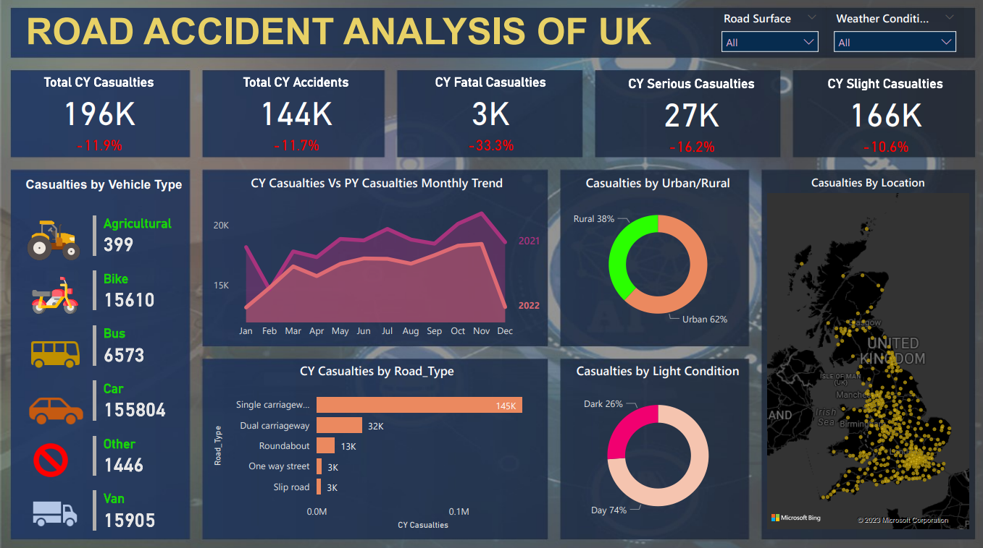

Accident report according to road conditions

When the road is wet

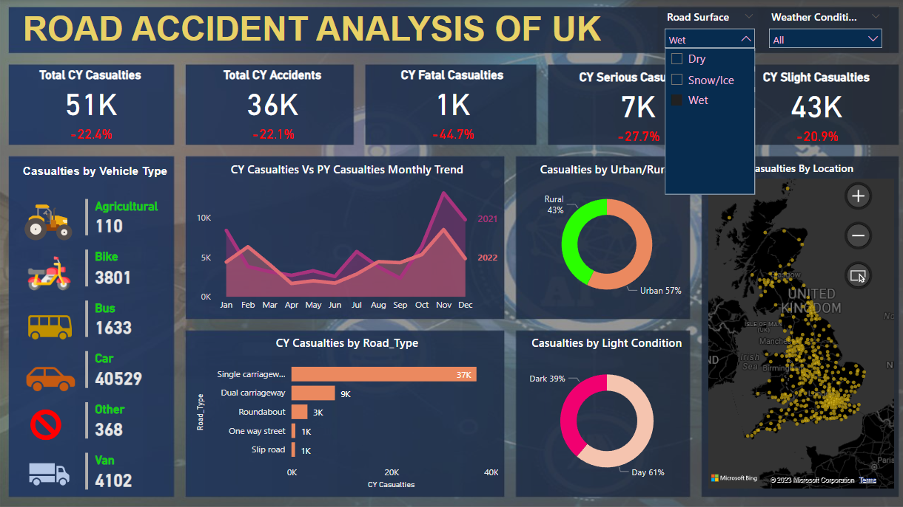

When the road is dry

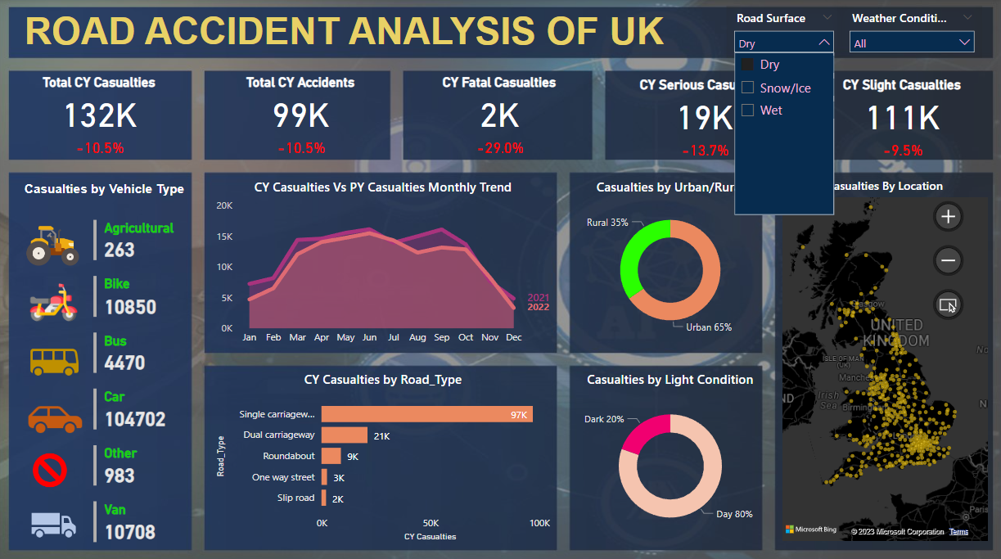

Accident report according to weather conditions

When the weather is rainy

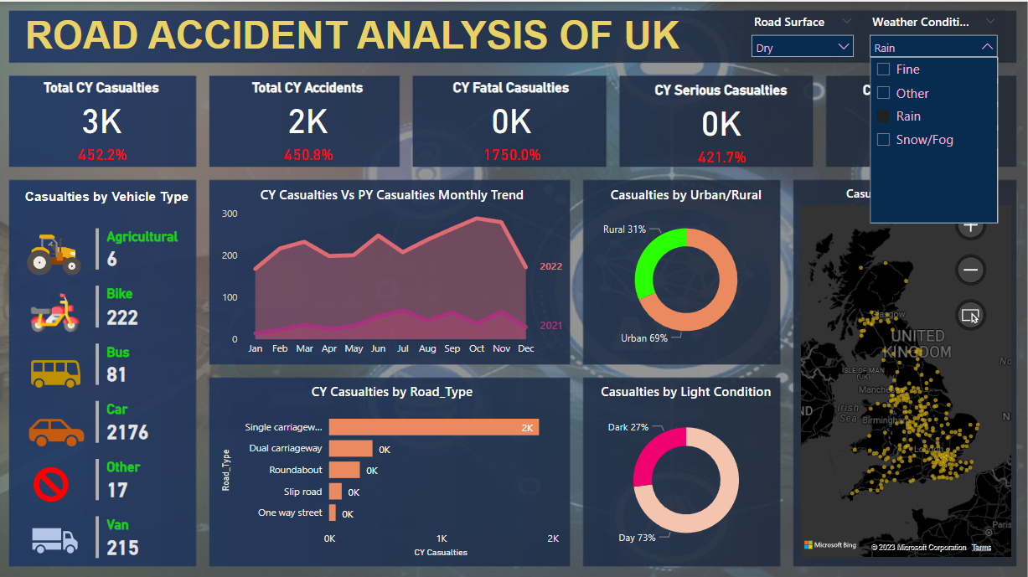

When weather is fine

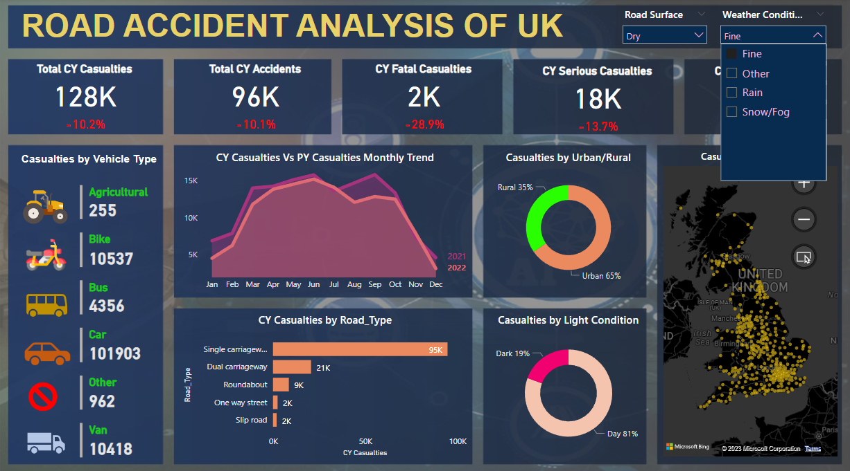

Casualties by vehicle type

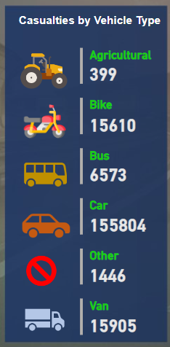

Requirement Gathering:

1. Primary KPI – Total Casualties and Total Accidents values for Current Year and YoY growth.
2. Primary KPI – Total Casualties by Accident Severity for Current Year and YoY growth.
3. Secondary KPI’s – Total Casualties with respect to vehicle type for Current Year.
4. Monthly trend showing comparison of casualties for Current Year and Previous Year.
5. Casualties by Road Type for Current Year.
6. Current Year Casualties by Area/Location & by Day/Night.
7. Total Casualties and Total Accidents by Location.

To do this we need to follow three main steps which are:

1. Data Cleaning
2. Data Modelling
3. Data Visualization
4. Data Cleaning

Sample data:

Accident_Index, Accident Date, Day_of_Week , Junction_Control, Junction_Detail, Accident_Severity , Latitudec, Light_Conditions, Local_Authority_(District), Carriageway_Hazards, Longitude, Number_of_Casualties , Number_of_Vehicles, Police_Force, Road_Surface_Conditions, Road_Type, Speed_limit, Time, Urban_or_Rural_Area, Weather_Conditions, Vehicle_Type

This is just the heading of sample data to make sure you get the idea about what data we are dealing with.

First, we must clean the data and format it before importing it to Power BI then import the data to Power Bi and perform the data transformation using power bi functionalities.

Then I’ve created a new table named ‘Calendar’ in Power BI itself with time intelligence functions having columns as Date, Year, Month and Month Number.

Then with the help of model view I’ve linked Data table and Calendar table with the Accident date column in Data Table on date column in Calendar table to create a one-to-many relation from Calendar to Data table.

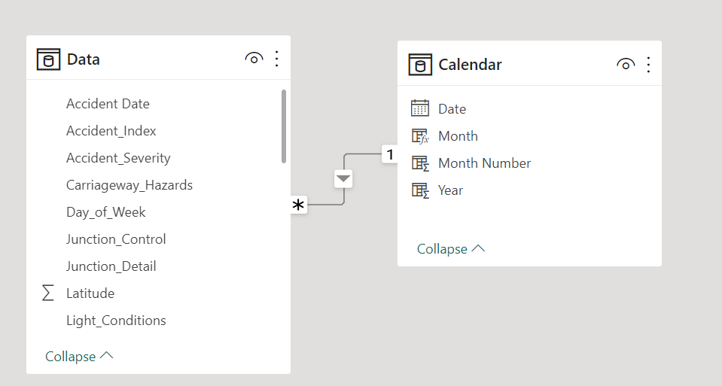

Before starting to solve the problems we can see we need these 4 main measures to build our visualization.

PY Accidents

PY Casualties

YoY Accidents

YoY Casualties

DAX for these are:

PY Accidents = CALCULATE(COUNT(Data[Accident_Index]), SAMEPERIODLASTYEAR('Calendar'[Date]))

PY Casualties = CALCULATE(SUM(Data[Number_of_Casualties]), SAMEPERIODLASTYEAR('Calendar'[Date]))

YoY Accidents = ([CY Accidents Count] - [PY Accidents]) / [PY Accidents]

YoY Casualties = ([CY Casualties] - [PY Casualties]) / [PY Casualties]

**Primary KPI 1 –**

**Total Casualties and Total Accidents values for Current Year and YoY growth.**

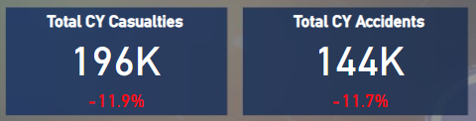

For visualization I ‘ve used card and Fields as CY Casualties for fist card and PY Casualties for second card and I’ve grouped them together.

This below image is for Total Current Year Casualties

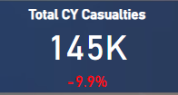

145K –> Field – CY Casualties

-9.9% -> Field - YoY Casualties

This below image is for Total Current Year Accidents

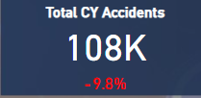

105K –> Field – CY Accidents Count

-9.8% -> Field - YoY Accidents

Then I’ve applied the same logic for other KPI’s as well wherein I’ve created the first card of number and second card is of percent showing comparison to previous year to get insights.

**Primary KPI 2 –**

**Total Casualties by Accident Severity for Current Year and YoY growth.**

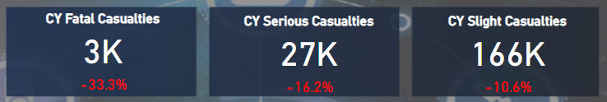

This below image is for Current Year Fatal Accidents

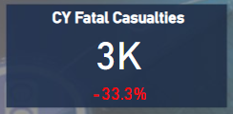

3K –> Field – CY Casualties

-33.3% -> Field - YoY Casualties

Filter –

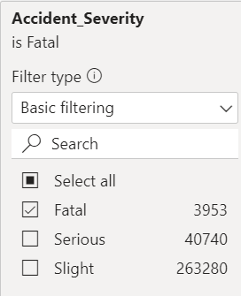

This below image is for Current Year Serious Accidents

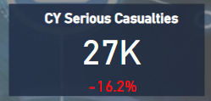

27K –> Field – CY Casualties

-16.2% -> Field - YoY Casualties

Filter –

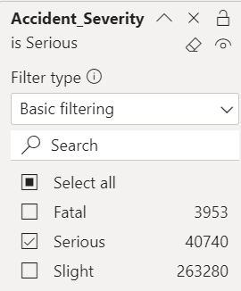

This below image is for Current Year Slight Accidents

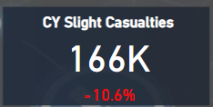

124K –> Field – CY Casualties

-9.1% -> Field - YoY Casualties

Filter –

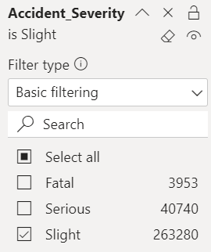

**Secondary KPI’s 3 –**

**Total Casualties with respect to vehicle type for Current Year.**

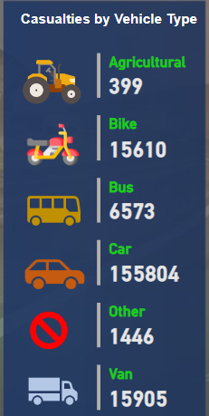

To create this, I’ve used photos for the left side and have used the multi row card on the right side for the metrics.

First, I’ve made a new measure by right clicking vehicle type fields and have grouped the vehicles based on Agricultural, Bike, Bus, Car, Van and Other.

Fields will be:

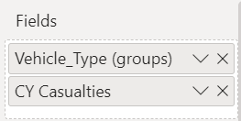

**Monthly trend showing comparison of casualties for Current Year and Previous Year (KPI 4).**

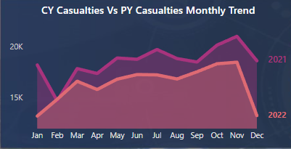

These are the measures that are being used to create this line chart

From Calendar

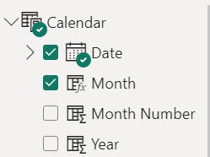

And from data table:



This is the field values:

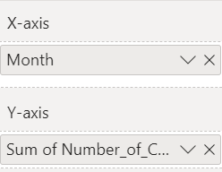

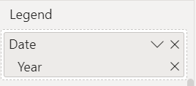

**Casualties by Road Type for Current Year.**

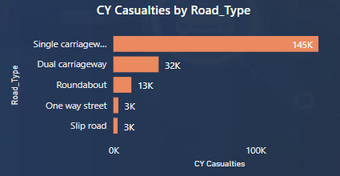

This is a stacked bar chart

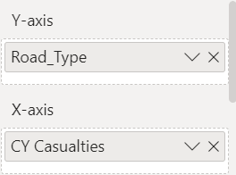

**Current Year Casualties by Area/Location & by Day/Night.**

For Area/Location

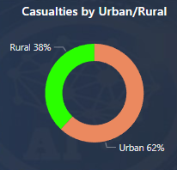

Field for this donut chart are:

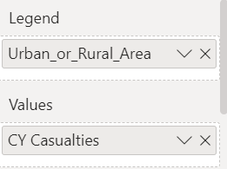

Measures used for this donut chart are:

From Data table:





**For Light – Day/Night**

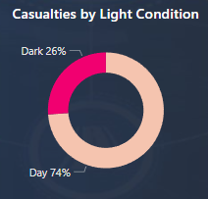

Field for this donut chart are:

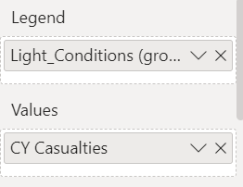

Measures used for this donut chart are:

From Data table:





**Total Casualties and Total Accidents by Location.**

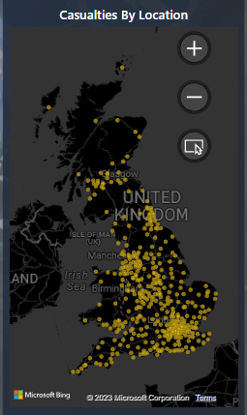

Fields used to create this map are:

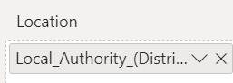

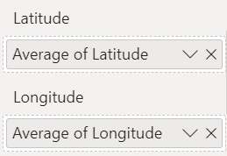

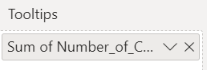

Slicers



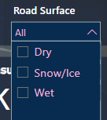

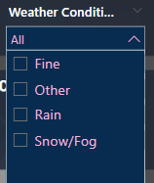

Fields used for the Road Surface slicers are:

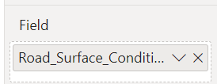

Fields used for the weather Conditions slicers are:

