

Mini Project Report
of
OSDL LAB

Hotel Management System

SUBMITTED
BY

Student Number | Registration  Number | Section | Roll Number
Apurv Arora | 240953640 | CCE – A | 55

School of Computer Engineering
Manipal Institute of Technology, Manipal. April 2026



DEPARTMENT OF COMPUTER SCIENCE & ENGINEERING

Manipal
08/04/2026

CERTIFICATE

This is to certify that the project titled Hotel Management System is a record of the bonafide work done by Student(s) Apurv Arora (reg no. 240963640) submitted in partial fulfilment of the requirements for the award of the Degree of Bachelor of Technology (B.Tech.) in COMPUTER AND COMMUNICATION ENGINEERING of Manipal Institute of Technology, Manipal, Karnataka, (A Constituent Institute of Manipal Academy of Higher Education), during the academic year 2025-2026.

Name and Signature of Examiners:

ABSTRACT

The Hotel Management System is a Java-based application designed to manage hotel operations efficiently using object-oriented programming and file handling techniques. The system allows users to perform operations such as adding rooms, booking rooms, displaying room details, managing customer records, and handling checkout processes.
The application is developed using Java and JavaFX to provide both console-based and graphical user interfaces. Instead of using a database, data persistence is achieved through serialization, where objects such as rooms and customers are stored and retrieved from files.
The project demonstrates the practical implementation of core programming concepts such as classes and objects, inheritance, polymorphism, collections, multithreading, and event-driven programming. It also highlights how backend logic can be integrated with a user-friendly interface to create a complete working system.

INTRODUCTION

The Hotel Management System is designed to simplify and automate the process of managing hotel operations. Traditional manual systems are inefficient and prone to errors, especially when handling multiple rooms and customers.
This system provides functionalities such as:
- Adding and managing different types of rooms
- Booking rooms for customers
- Viewing room and customer details
- Handling customer checkout and room availability
Technologies used:
- Java (Core logic and OOP concepts)
- JavaFX (Graphical User Interface)
- Maven (Project build and dependency management)
- File Handling (Serialization for data storage)
The main focus of the project is to apply object-oriented programming concepts and build a complete application without using a database.

PROBLEM STATEMENT & OBJECTIVES

Problem Statement

Managing hotel operations manually can lead to problems such as:
- Duplicate or inconsistent records
- Difficulty in tracking room availability
- Inefficient booking and checkout processes
- Data loss when the system is closed
To overcome these issues, a structured software system is required that can efficiently manage rooms and customers while ensuring data persistence.

Objectives

• To design a system for managing hotel rooms and customers
• To implement object-oriented concepts such as inheritance and polymorphism
• To manage data using collections like ArrayList and HashMap
• To implement file handling using serialization for data persistence
• To develop a user-friendly interface using JavaFX
• To simulate real-world operations such as booking, billing, and room cleaning

METHODOLOGY

The project was developed step by step following a basic database design approach.
Step 1: Requirement Analysis
The system was designed to:
- Add and manage rooms
- Book rooms for customers
- Display room and customer details
- Handle checkout and room availability

Step 2: Class Identification
The following main classes were identified:
- Room
- DeluxeRoom
- SuiteRoom
- Customer
- RoomType (Enum)
- CleaningThread
- HotelManagement

Step 3: System Design
- Base class Room created for common properties
- Subclasses DeluxeRoom and SuiteRoom extend Room
- Customer class manages booking details
- HashMap used to map rooms to customers
- ArrayLists used for storing data

Step 4: Implementation
- Core logic implemented using Java
- File handling implemented using serialization
- Multithreading used for room cleaning simulation

Step 5: GUI Development
- JavaFX used to create user interface
- Layouts like VBox and HBox used for arrangement
- Buttons used for different operations
- Event handling used to trigger backend logic

SYSTEM DESIGN AND CLASS STRUCTURE
Room Class
- Base class for all room types
- Contains attributes like room number, type, price, availability

DeluxeRoom & SuiteRoom
- Extend Room class
- Add extra features
- Demonstrate inheritance

Customer Class
- Stores customer details
- Links customer to room

RoomType Enum
- Defines room categories
- Associates price with each type

HotelManagement Class
- Contains main logic
- Handles file operations (save/load)

CleaningThread Class
- Simulates room cleaning
- Demonstrates multithreading

RESULTS & OUTPUT
The system was successfully tested and produced the following results:
- Rooms can be added and displayed correctly
- Customers can book rooms and receive billing details
- Room availability updates correctly after booking and checkout
- Data persists using file storage
- JavaFX interface allows easy interaction

SCREENSHOTS AND CODE

Sample UI screen
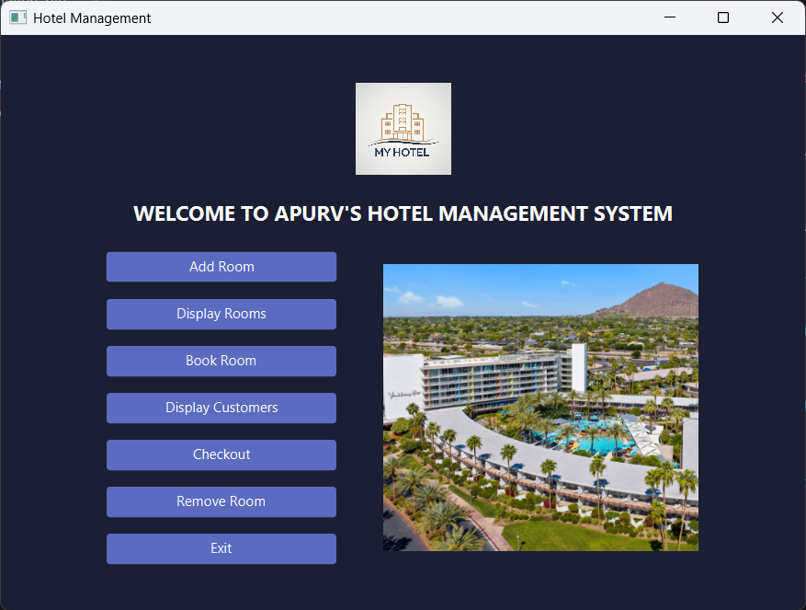
Operations
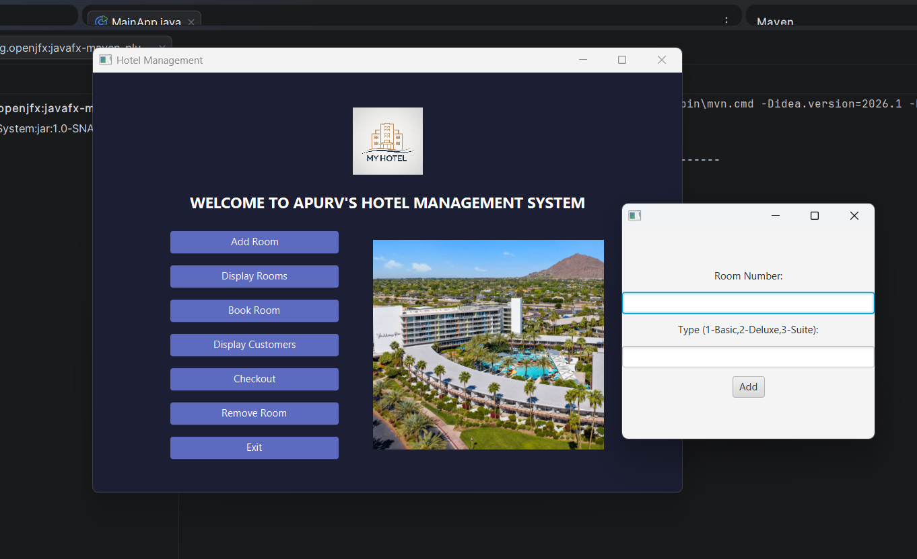
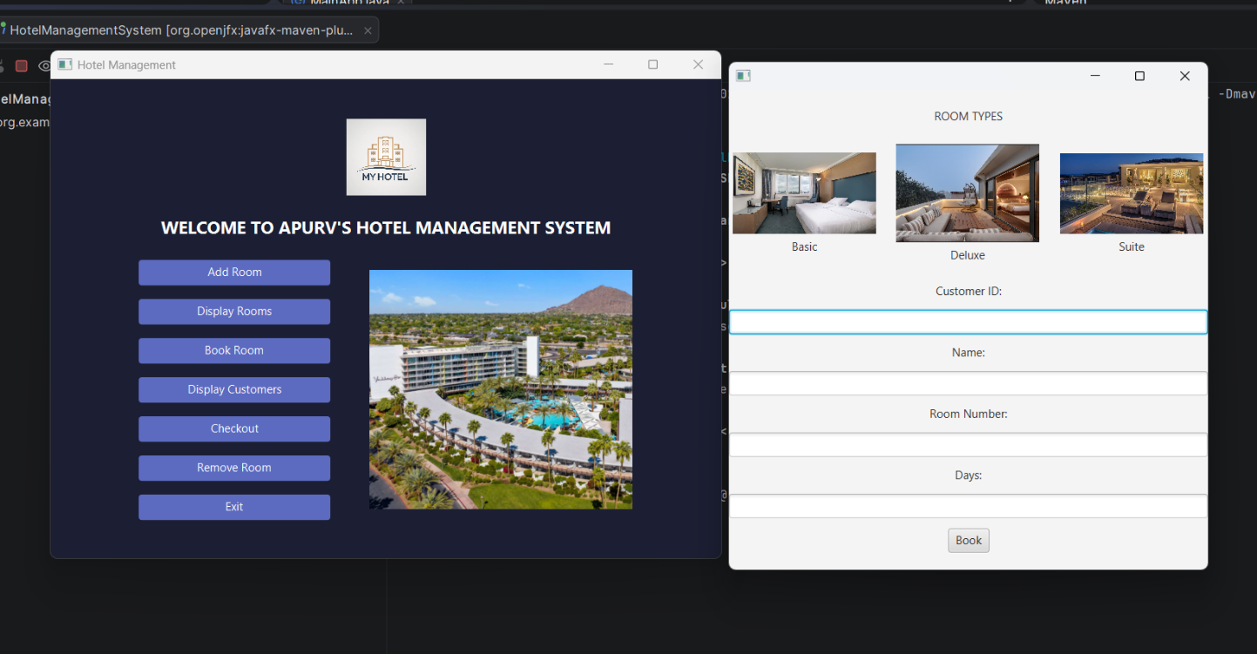

Etc.

File Structure
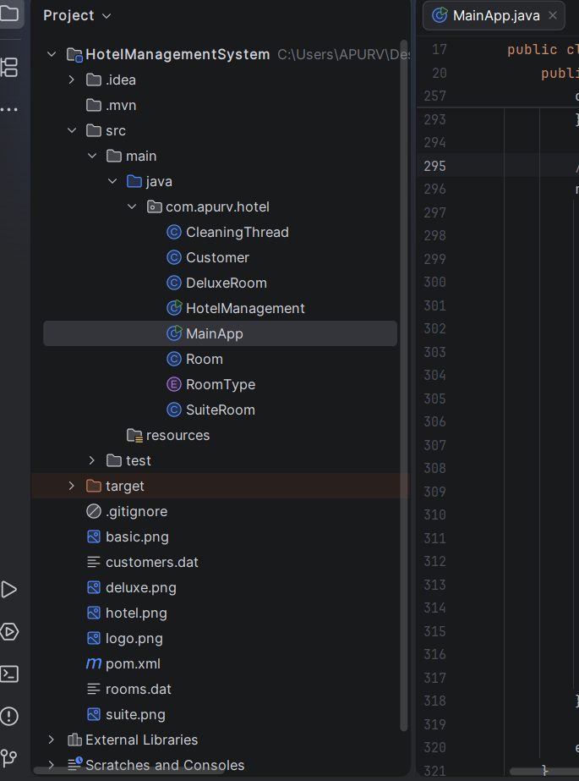
CODES

MAIN APP – JAVA FX

package com.apurv.hotel;
import javafx.application.Application; //base class for javaFX
import javafx.application.Platform; //platform.runLater
import javafx.geometry.Pos;
import javafx.scene.Scene;
import javafx.scene.control.*; //buttons,labels,alerts etc
import javafx.scene.image.Image; //loading image
import javafx.scene.image.ImageView; //displaying image
import javafx.scene.layout.VBox;
import javafx.scene.layout.HBox;
import javafx.stage.Stage;
import java.util.ArrayList;
import java.util.HashMap;
public class MainApp extends Application {
@Override
public void start(Stage stage) { //start method -> entry point
String base = "C:/Users/APURV/Desktop/JAVA/intelliJ/HotelManagementSystem/"; //img location
// logo and hotel images
ImageView logo = new ImageView(new Image("file:///" + base + "logo.png"));
logo.setFitHeight(80);
logo.setPreserveRatio(true); //avoids distortion of the image
ImageView hotelImg = new ImageView(new Image("file:///" + base + "hotel.png"));
hotelImg.setFitHeight(250);
hotelImg.setPreserveRatio(true);
// buttons
Button addRoomBtn = new Button("Add Room");
Button displayRoomBtn = new Button("Display Rooms");
Button bookRoomBtn = new Button("Book Room");
Button displayCustBtn = new Button("Display Customers");
Button checkoutBtn = new Button("Checkout");
Button removeRoomBtn = new Button("Remove Room");
Button exitBtn = new Button("Exit");
Button[] btns = {addRoomBtn, displayRoomBtn, bookRoomBtn,
displayCustBtn, checkoutBtn, removeRoomBtn, exitBtn};
for (Button b : btns) { //loop to apply consistent styling to all buttons
b.setPrefWidth(200);
b.setStyle("-fx-background-color:#5c6bc0; -fx-text-fill:white;");
}
// same as backend code of console version
ArrayList<Room> rooms = new ArrayList<>();
HotelManagement.loadRooms(rooms);
ArrayList<Customer> customers = new ArrayList<>();
HotelManagement.loadCustomers(customers);
HashMap<Integer, Customer> map = new HashMap<>();
for (Customer c : customers) {
map.put(c.getRoomNumber(), c);
}
// ui layout
Label heading = new Label("WELCOME TO APURV'S HOTEL MANAGEMENT SYSTEM");
heading.setStyle("-fx-text-fill:white; -fx-font-size:18px; -fx-font-weight:bold;");
//v box left to store buttons
VBox left = new VBox(15, addRoomBtn, displayRoomBtn, bookRoomBtn,
displayCustBtn, checkoutBtn, removeRoomBtn, exitBtn);
left.setAlignment(Pos.CENTER_LEFT);
//v box right for hotel image
VBox right = new VBox(hotelImg);
right.setAlignment(Pos.CENTER);
//h box center to separate between buttons and image
HBox center = new HBox(40, left, right);
center.setAlignment(Pos.CENTER);
//parent alignment
VBox root = new VBox(20, logo, heading, center);
root.setAlignment(Pos.CENTER);
root.setStyle("-fx-background-color:#1c1f33;");
stage.setScene(new Scene(root, 700, 500));
stage.setTitle("Hotel Management");
stage.show();
// add room button
addRoomBtn.setOnAction(e -> {
Stage s = new Stage(); //opens a new window when button is clicked
TextField rno = new TextField(); //text field : scanner sc
TextField type = new TextField();
Button submit = new Button("Add"); //user clicks this to submit
VBox v = new VBox(10,
new Label("Room Number:"), rno,
new Label("Type (1-Basic,2-Deluxe,3-Suite):"), type,
submit);
v.setAlignment(Pos.CENTER);
//put the above vbox content into the memory
s.setScene(new Scene(v, 300, 250));
s.show();
submit.setOnAction(ev -> { //backend logic runs here
int num = Integer.parseInt(rno.getText()); //get text from the text field and convert to integer
int t = Integer.parseInt(type.getText());
RoomType rt = null; //convert to enum
if (t == 1) rt = RoomType.STANDARD;
else if (t == 2) rt = RoomType.DELUXE;
else if (t == 3) rt = RoomType.SUITE;
if (rt == null) return;
Room room; //create objects
if (rt == RoomType.DELUXE)
room = new DeluxeRoom(num, rt, rt.getPrice(), true, true);
else if (rt == RoomType.SUITE)
room = new SuiteRoom(num, rt, rt.getPrice(), true, true, true, true);
else
room = new Room(num, rt, rt.getPrice());
rooms.add(room); //add room,save and show confirmation
HotelManagement.saveRooms(rooms);
new Alert(Alert.AlertType.INFORMATION, "Room added").show();
s.close();
});
});
// display rooms
displayRoomBtn.setOnAction(e -> {
VBox v = new VBox(10);
if (rooms.size() == 0)
v.getChildren().add(new Label("No rooms available"));
for (Room r : rooms) { //enhanced for loop to traverse through each room
v.getChildren().add(new Label( //get children returns all the elements inside the vbox
r.getRoomNumber() + " | " +
r.getRoomType() + " | " +
r.getPrice() + " | " +
r.isAvailable()));
}
//display this in a new window
new Stage() {{
setScene(new Scene(v, 400, 300));
setTitle("Rooms");
show();
}};
});
// book room
bookRoomBtn.setOnAction(e -> {
Stage s = new Stage();
//take inputs
TextField cidField = new TextField();
TextField nameField = new TextField();
TextField roomField = new TextField();
TextField daysField = new TextField();
//submit button
Button submitBtn = new Button("Book");
//add 3 images of the rooms
ImageView basicImg = new ImageView(new Image("file:///" + base + "basic.png"));
basicImg.setFitWidth(150);
basicImg.setPreserveRatio(true);
ImageView deluxeImg = new ImageView(new Image("file:///" + base + "deluxe.png"));
deluxeImg.setFitWidth(150);
deluxeImg.setPreserveRatio(true);
ImageView suiteImg = new ImageView(new Image("file:///" + base + "suite.png"));
suiteImg.setFitWidth(150);
suiteImg.setPreserveRatio(true);
//wrapping the images with labels
VBox bBox = new VBox(5, basicImg, new Label("Basic"));
VBox dBox = new VBox(5, deluxeImg, new Label("Deluxe"));
VBox sBox = new VBox(5, suiteImg, new Label("Suite"));
bBox.setAlignment(Pos.CENTER);
dBox.setAlignment(Pos.CENTER);
sBox.setAlignment(Pos.CENTER);
//checking the alignment of the images horizontally
HBox imgRow = new HBox(20, bBox, dBox, sBox);
imgRow.setAlignment(Pos.CENTER);
//customer details -> vertically
VBox form = new VBox(10,
new Label("Customer ID:"), cidField,
new Label("Name:"), nameField,
new Label("Room Number:"), roomField,
new Label("Days:"), daysField,
submitBtn);
form.setAlignment(Pos.CENTER);
//COMBINES EVERYTHING, ROOM TYPE+IMAGE ROW+FORM BELOW
VBox layout = new VBox(20, new Label("ROOM TYPES"), imgRow, form);
layout.setAlignment(Pos.CENTER);
//display the combined stuff
s.setScene(new Scene(layout, 500, 500));
s.show();
//fetch remaining details after submission
submitBtn.setOnAction(ev -> {
int id = Integer.parseInt(cidField.getText());
int roomNo = Integer.parseInt(roomField.getText());
int days = Integer.parseInt(daysField.getText());
boolean booked = false;
for (Room r : rooms) {
if (r.getRoomNumber() == roomNo && r.isAvailable()) {
r.setAvailable(false); //if room is available, book it and set availability to false
//add customer and put the billing logic
Customer c = new Customer(id, nameField.getText(), roomNo);
customers.add(c);
map.put(roomNo, c);
HotelManagement.saveRooms(rooms);
HotelManagement.saveCustomers(customers);
double total = r.getPrice() * days;
new Alert(Alert.AlertType.INFORMATION,
"Booking Done\nTotal: " + total).show();
booked = true;
break;
}
}
if (!booked)
new Alert(Alert.AlertType.ERROR, "Room not available").show();
s.close();
});
});
// display customers
displayCustBtn.setOnAction(e -> {
VBox v = new VBox(10);
if (customers.size() == 0)
v.getChildren().add(new Label("No customers found"));
for (Customer c : customers) {
v.getChildren().add(new Label(
c.getCustomerId() + " | " +
c.getName() + " | Room: " +
c.getRoomNumber()));
}
new Stage() {{
setScene(new Scene(v, 400, 300));
setTitle("Customers");
show();
}};
});
// checkout
checkoutBtn.setOnAction(e -> {
TextInputDialog d = new TextInputDialog();
d.setHeaderText("Enter Customer ID");
d.showAndWait().ifPresent(val -> { //show, wait for i/p, cont only if user enters something
int id = Integer.parseInt(val);
for (int i = 0; i < customers.size(); i++) { //search customers
if (customers.get(i).getCustomerId() == id) {
int roomNo = customers.get(i).getRoomNumber(); //fetch room no
for (Room r : rooms) {
if (r.getRoomNumber() == roomNo) {
new Thread(() -> { //cleaning thread
try { Thread.sleep(3000); } catch (Exception ignored) {}
r.setAvailable(true); //checkout done
Platform.runLater(() ->
new Alert(Alert.AlertType.INFORMATION,
"Room cleaned").show());
}).start();
}
}
customers.remove(i);
map.remove(roomNo);
HotelManagement.saveRooms(rooms);
HotelManagement.saveCustomers(customers);
break;
}
}
});
});
// remove room
removeRoomBtn.setOnAction(e -> {
TextInputDialog d = new TextInputDialog();
d.setHeaderText("Enter Room Number");
d.showAndWait().ifPresent(val -> {
int num = Integer.parseInt(val);
for (int i = 0; i < rooms.size(); i++) {
if (rooms.get(i).getRoomNumber() == num &&
rooms.get(i).isAvailable()) {
rooms.remove(i);
HotelManagement.saveRooms(rooms);
new Alert(Alert.AlertType.INFORMATION, "Room removed").show();
return;
}
}
new Alert(Alert.AlertType.ERROR,
"Room is booked or not found").show();
});
});
exitBtn.setOnAction(e -> stage.close());
}
public static void main(String[] args) {
launch();
}
}

CLEANING THREAD
package com.apurv.hotel;
public class CleaningThread extends Thread {
private Room room;
public CleaningThread(Room room) {
this.room = room;
}
public void run() {
System.out.println("Room " + room.getRoomNumber() + " is being cleaned...");
try {
Thread.sleep(3000); // 3 seconds
} catch (InterruptedException e) {
System.out.println("Cleaning interrupted!");
}
room.setAvailable(true); //set the room to be available after it is cleaned.
System.out.println("Room " + room.getRoomNumber() + " is now available!");
}
}

ENUM ROOM TYPE

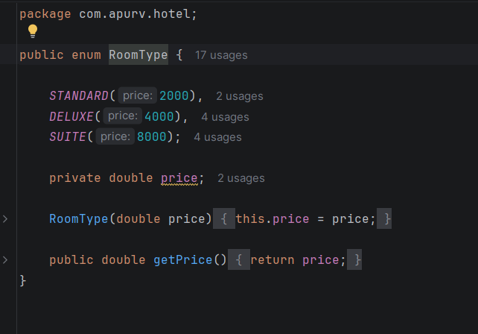
ROOM CLASSES AND INHERITANCE

Room.java
package com.apurv.hotel;
import java.io.Serializable;
public class Room implements Serializable {
private int roomNumber;
private RoomType roomType;
private double price;
private boolean isAvailable;
public Room(int roomNumber, RoomType roomType, double price) {
this.roomNumber = roomNumber;
this.roomType = roomType;
this.price = price;
this.isAvailable = true;
}
public int getRoomNumber() {
return roomNumber;
}
public RoomType getRoomType() {
return roomType;
}
public double getPrice() {
return price;
}
public boolean isAvailable() {
return isAvailable;
}
public void setAvailable(boolean status) {
this.isAvailable = status;
}
public void displayRoom() {
System.out.println("Room No: " + roomNumber);
System.out.println("Type: " + roomType);
System.out.println("Price: " + price);
System.out.println("Available: " + isAvailable);
System.out.println("----------------------");
}
}

Deluxe Room .java
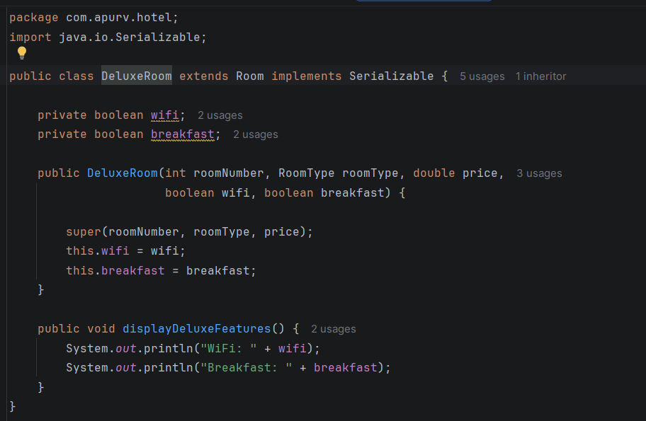

SUITE ROOM.JAVA
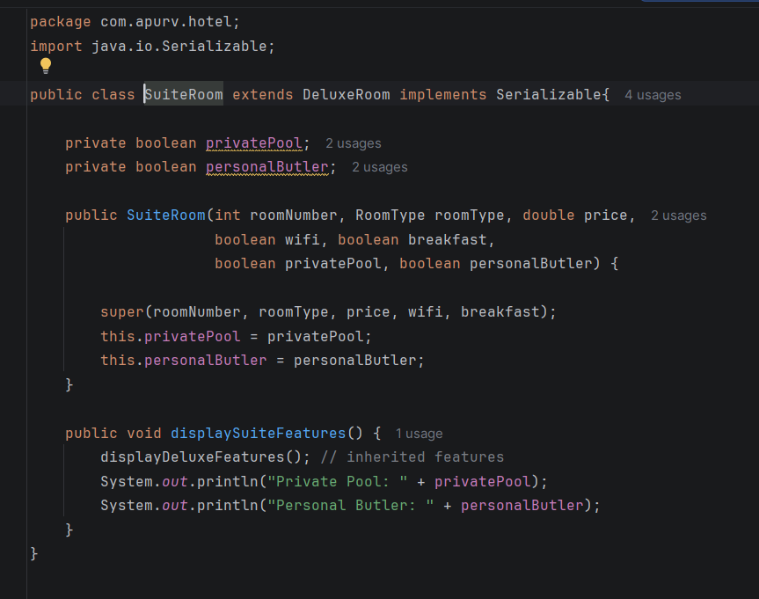

CONCLUSION, LIMITATIONS & FUTURE WORK

Conclusion
The Hostel Management System successfully demonstrates the implementation of OOP concepts along with the integration of JavaFX.

LIMITATIONS
- No database integration (uses file storage instead)
- Limited input validation in GUI
- No multi-user support
- No advanced UI styling

FUTURE WORK
- Integrate database using JDBC
- Add login/authentication system
- Improve UI design and responsiveness
- Add real-time booking updates
- Extend to web or mobile application

REFERENCES
• Java Documentation
• JavaFX Documentation
• Maven Documentation
• OOP Concepts (Textbooks/Lab Manual)

END.

