|  |  |  |
| --- | --- | --- |
|  |  | ISM 6225  Distributed information systems |

Assignment 2 – Object oriented Programming Introduction

Primary objective: Develop familiarity with object oriented programming

Secondary objective: develop comfort with Linked Lists

*Estimated time: 15 hours*

## Introduction

Conversations with recent graduates suggests that employers expect most students to be comfortable with standard questions on data structures and algorithms. Students have also shared that their prior experience often did not give them a good introduction to object-oriented programming.

This assignment aims to give students the opportunity to familiarize themselves with object oriented programming, while simultaneously using basic sorting algorithms to develop familiarity with Linked lists and implementing algorithms with linked lists.

This is a group assignment, to give students the opportunity to learn to work in teams to develop deliverable solutions. To accomplish this, students are expected to use the GitHub source control and collaboration system to develop their solution.

The operations you are asked to complete in this assignment are fairly standard linked list operations. You are encouraged to read about these operations and their solutions online.

## Activity

Create a new project in Visual Studio, create a Github repository for the project, add the files provided for the project on Canvas into the project, and complete the implementations of the 8 methods indicated in StockList.cs. To the extent possible, share the development effort. Teams with unequal development effort will lose credit will lose credit.

The assignment methods ask you to traverse the list and sort it in various ways. Some utility methods have already been implemented for you. These should give you a sense of how to work with lists.

## Submission

Your submission includes three components:

1. A link to your Github repository
2. A screenshot showing Program.cs running
3. The output from the command, for all team members. This shows the number of changes made by each Github ID. To run this command, open the command prompt (CMD), navigate to the folder containing the project repository (use the cd command), and type the command:

git log --author="Git User Name" --pretty=tformat: --numstat

## Grading scheme

Method implementations : 3.2

General engineering practice, including comments and shared development effort : 0.6

Self-reflection (how much time did you spend, what did you learn, how the assignment could have been made more useful for you) : 0.2

Total : 4

**Solution:**

Link of Git Hub Repository:

Screenshot Showing Program.cs running

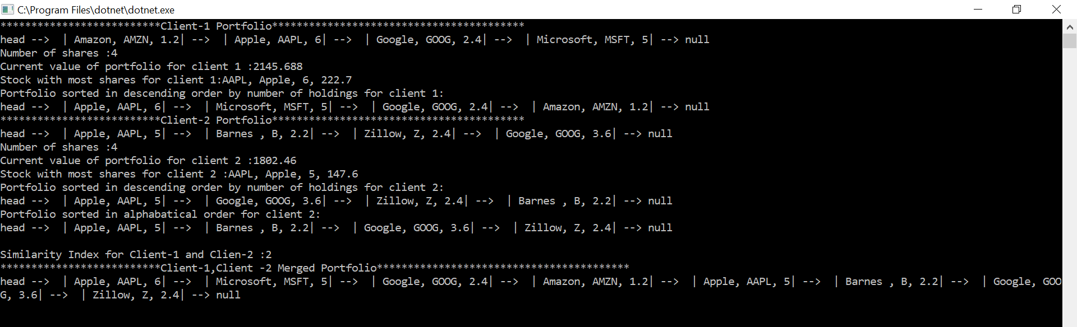

Git Log:

C:\Users\APURV SHINDE\source\repos\Assignment_2\Assignment_2>git log --author="Apurv52" --pretty=tformat: --numstat

2 3 Assignment_2/Assn2_StockList_Students_3.cs

22 0 Assignment_2/Assn2_StockList_Students_1.cs

2 0 Assignment_2/Assn2_Program.cs

13 17 Assignment_2/Assn2_StockList_Students_3.cs

234 225 Assignment_2/Assn2_StockList_Students_1.cs

9 1 Assignment_2/Assn2_StockList_Students_3.cs

17 2 Assignment_2/Assn2_StockList_Students_1.cs

39 0 Assignment_2/Assn2_ClientPortfolio.cs

64 0 Assignment_2/Assn2_Program.cs

34 0 Assignment_2/Assn2_Stock.cs

245 0 Assignment_2/Assn2_StockList_Students_1.cs

48 0 Assignment_2/Assn2_StockList_Students_2.cs

45 0 Assignment_2/Assn2_StockList_Students_3.cs

26 0 Assignment_2/Assn2_StockNode.cs

0 12 Assignment_2/Program.cs

25 0 Assignment_2.sln

8 0 Assignment_2/Assignment_2.csproj

12 0 Assignment_2/Program.cs

63 0 .gitattributes

261 0 .gitignore

C:\Users\APURV SHINDE\source\repos\Assignment_2\Assignment_2>git log --author="RustemKh" --pretty=tformat: --numstat

32 2 Assignment_2/Assn2_StockList_Students_3.cs

9 0 Assignment_2/Assn2_StockList_Students_3.cs

0 7 Assignment_2/Assn2_StockList_Students_3.cs

29 4 Assignment_2/Assn2_StockList_Students_3.cs

3 0 Assignment_2/Assn2_Program.cs

C:\Users\APURV SHINDE\source\repos\Assignment_2\Assignment_2>git log --author="sidrazaheer" --pretty=tformat: --numstat

6 6 Assignment_2/Assn2_StockList_Students_2.cs

18 1 Assignment_2/Assn2_StockList_Students_2.cs

1 1 Assignment_2/Assn2_StockList_Students_1.cs

1 1 Assignment_2/Assn2_StockList_Students_1.cs

13 1 Assignment_2/Assn2_StockList_Students_2.cs

0 5 Assignment_2/Assn2_Program.cs

10 2 Assignment_2/Assn2_StockList_Students_2.cs

1 0 Assignment_2/Assn2_Program.cs

1 0 Assignment_2/Assn2_Program.cs