**CSL I Lab: Mini Project Synopsis**

Academic Year: 2019-20 Class: TE IT B Group ID:- 05

Group Members:-

|  |  |  |  |
| --- | --- | --- | --- |
| **Roll No** | **Name** | **Contact Number** | **Email ID** |
| 37010 | HarshalBhosale | 9673779572 | Harshalbhosale24@gmail.com |
| 37018 | Shubham Dube | 7588403183 | Shubhamdube.akole@gmail.com |
| 37027 | ApurvKalane | 9272007020 | apurvakalane@gmail.com |
| 37071 | Shantanu Warkari | 9011255411 | Shantanuwarkari777@gmail.cpom |

Name of Guide :- Prof. Smita Khavate.

**Project Title :- Housing Society Management System**

**Problem statement :** Co-operative housing societies are an immense responsibility to manage. With their sizes increasing every day to take a form similar to integrated townships, managing them has become a task of its own. To reduce manual work , providing services. Methodology computer and system logins for communication and information.

**Abstract :** In society all the work is decided in meetings and maintenance bills, contact no of members are noted on the papers. There is no automated system for doing all the things that generally happen in society , so that members can come to know what is happening in society. This system of maintaining a society is made in such a way , so that the most common problem faced in residential societies are solved. This system is a cloud based system to manage day-to-day activities of any co-operative housing society . they require the co-ordination among the respective management societies coupled with the vendors which provide these services so that the appropriate convenience can be provide. The main functionality of the system is to provide services like renting, selling apartments and complaint chat box.

**Scope of Mini-project :**It is difficult to manage housing society along with daily job. Being a society committee member you must manage day to day administration related activities like accounting maintenance security etc So by using this product it will be possible to do society billing & accounting, security , manage complaints and request and facility management on a single platform.

**Requirement analysis :**

1. User’s data, apartment documentations.
2. User information (Name, Contact no)
3. Apartment Documentation (Wing, Apartment No, Address)

**ER Diagram:**

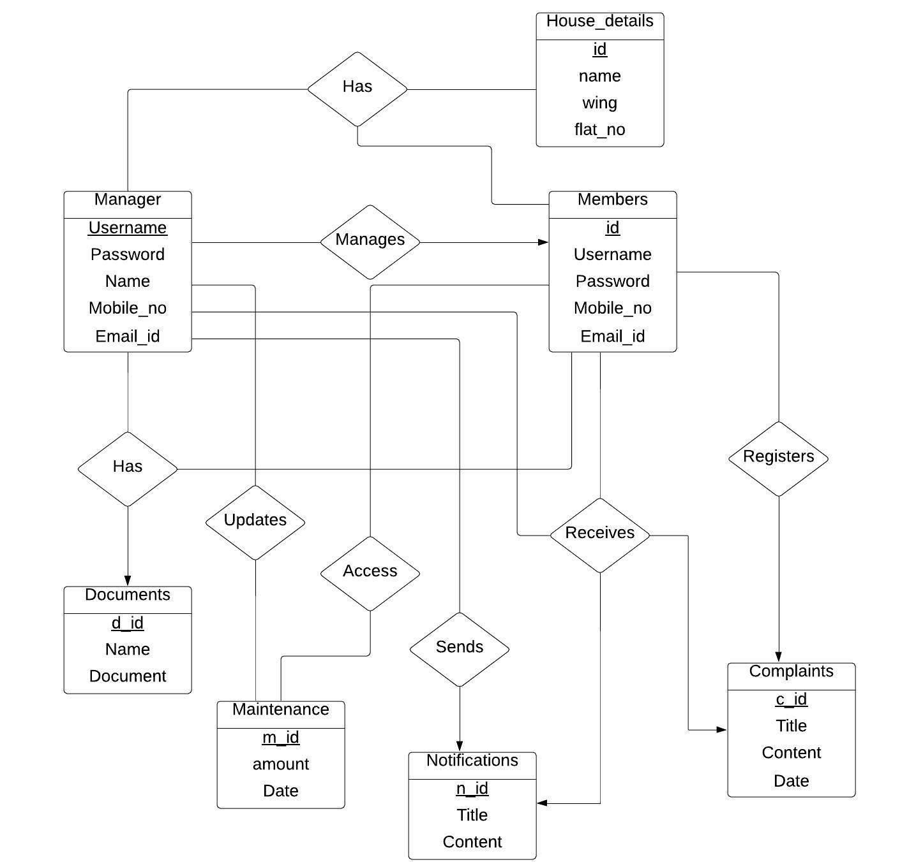

**Schema Diagram :**

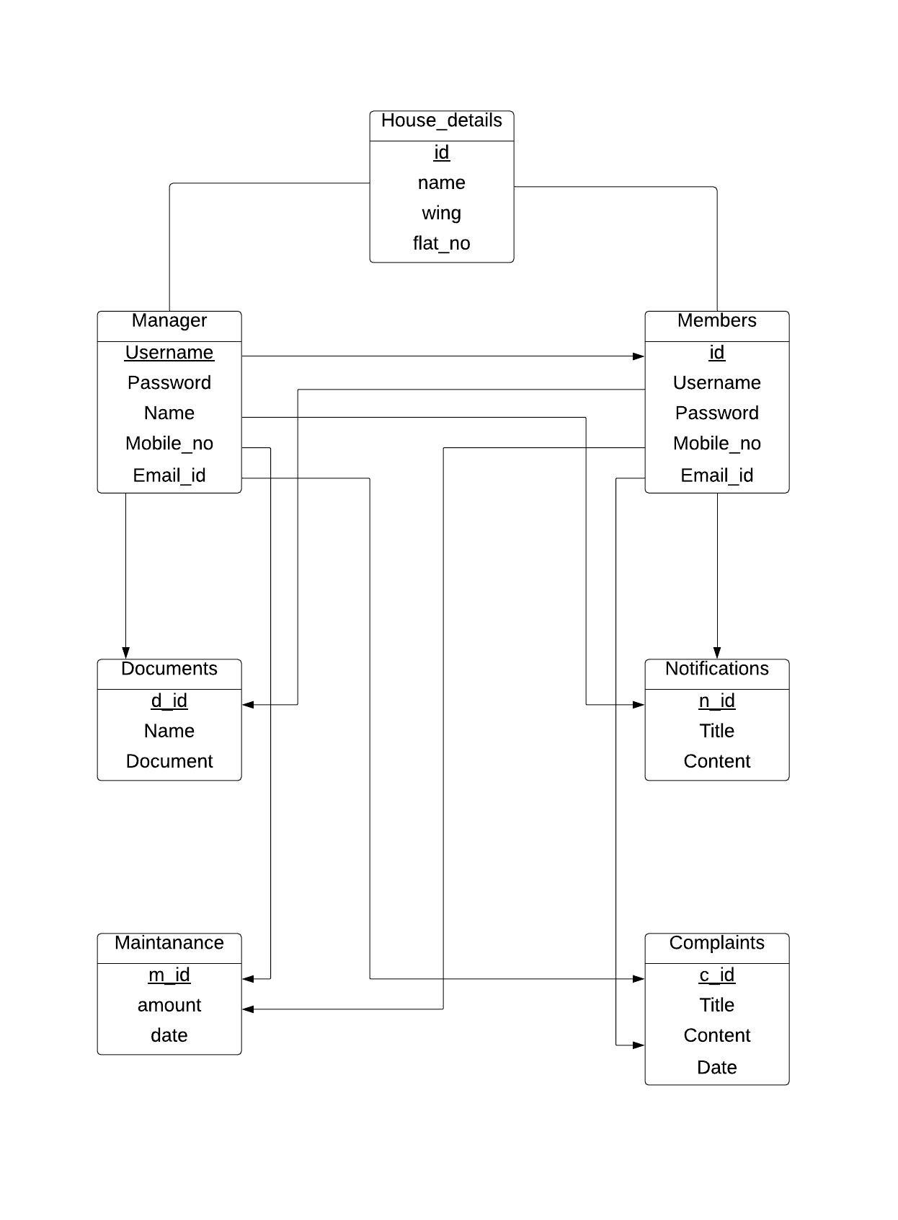

**H/w and S/w requirement**:

|  |  |
| --- | --- |
| **Platform :** | Java |
| **Programming Language :** | Java swing |
| **Database :** | MySQL , Oracle |
| **Project Type :** | Desktop Application |

**Future Scope :** The proposed system is for desktop application, this can be extended to website or android application

**Conclusion :** Society management system come up with the actual working of a society, by working “in the cloud,” where housing society management providers can rapidly implement and operate applications that are secure and not expensive, while enjoying lower maintenance and upgrade costs throughout the relationship. Message and Email alerts for various happenings in the society can be added to the system so that users do not miss the updates and happenings of the society. Administration, working, online complaint box, etc. are the key features of our project. The software is flexible enough to be modified and implemented as per user requirements. We have tried our best to make this system free and user–friendly website to Society members. It is a timely and cost effective solution to your society management problems which will make you money, save you money and make your job easier.

**References (If any) :**

[1] Maharashtra Co-operative Housing Societies Act; [MCS Act] 1960.

[2] Seedhouse, D. (1986), Foundation for Health Achievement, Health Policy, vol. 7, issue, 3.

[3] United Nations, (1948), The Bill of Human Rights.

[4] Online Society Management System - Software for Cooperative Society - Society123.com

[5]https://mysocietyclub.com/

https://mysocietyclub.com/

**Signature of Teacher**