**INDEX**

1. Introduction --------------------- 2

2. Purpose --------------------- 2

3. Project Scope --------------------- 2

4. Project Audience --------------------- 2

5. System Architecture --------------------- 3

6. Functions --------------------- 3

6.1 int customer_registration () --------------------- 3

6.2 int view_customer () --------------------- 3

6.3 int view_stock () --------------------- 3

6.4 int file_maintainance () --------------------- 3

6.5 int edit_customer () --------------------- 4

6.6 int delete_customer () --------------------- 4

6.7 int add_stock () --------------------- 4

6.8 int edit_stock () --------------------- 4

6.9 int shop_here () --------------------- 4

6.10 int report () --------------------- 4

6.11 int modify_stock_after_purchase (int pid, int preq) --------------------- 4

7. Structure --------------------- 5

7.1 typedef struct customer -------------------- 5

7.2 typedef struct stock -------------------- 5

8. Flowchart -------------------- 5

8.1 Add stock -------------------- 6

8.2 Customer Registration -------------------- 8

8.3 Main Function ------------------ 10

9. Flow Diagram ------------------ 11

10. Data Flow Diagram ------------------ 12

1. **Introduction**

Online Shopping Portal is a menu driven online shopping system that allows user to search through the stocks and buy maximum three products at a time. In this online shopping system customers get 5 percent cashback after the purchase of more than Rs. 200. Program allows the user to view product details and purchase item, and all these changes are stored and can be viewed anytime. Only an authorized company person is allowed to update customer database to change the details of customers.

1. **Purpose**

Main objective of this online shopping portal is to provide users a better and convenient interface to shop groceries online. This online portal can also be beneficial in bridging the gap between sellers and consumers. In addition, there is also specialised algorithms to provide suitable and efficient cashback to the respective customers. So that this online model can be beneficial for both the retailers and consumers with respect to user experience.

1. **Project Scope**

This project aims to create a user-friendly online shopping system where user is allowed to buy maximum of three grocery items at a time. It can generate a detailed sales invoice. All the information about a particular customer or a product is stored in a retrievable manner. It also provides cashback to the customers according to their purchase.

1. **Project Audience**

The audience are the people who wants to buy groceries online using this online shopping portal.

1. **Online Shopping Portal**

This is a menu driven online shopping system that allows user to search through the stocks and buy maximum three products at a time. In this online shopping system customers get 5 percent cashback after the purchase of more than Rs. 200. Program allows the user to view product details and purchase item, and all these changes are stored and can be viewed anytime. Only an authorized company person is allowed to update customer database to change the details of customers

1. **Function:**

**6.1 int customer_registration();**

This function allows the user to enter the customer’s name, address, phone number and also ask the user to enter password. Unique user id is generated automatically and cashback points are also accumulated.

Customer Name and Address should be maximum 20 characters, Phone number should always be 10 digits, Password should be ranged between 3-8 characters.

**6.2 int view_customer();**

This function displays an details about customer. In the following format:

DETAILED CUSTOMER REPORT

Customer ID Name Address Phone Number Cashback Points

**6.3 int view_stock();**

This function displays an organised stock report. In the following format:

DETAILED STOCK REPORT

Product ID Description Unit Price Total Stock Available

**6.4 int file_maintainance();**

Employees can edit Customer, delete customer, add item/stock and edit stock after proper authentication.

**6.5 int edit_customer();**

This function validates authenticity of the customer using customer id and allows the user to modify name, address and telephone details.

**6.6 int delete_customer ();**

This function validates a customer id and allows the employee to delete the record of the customer.

**6.7 int add_stock ();**

This function allows the addition of new products to the stock database with respect to product name, unit price and stock. Product id is unique and generated automatically within the range of 1001-9999

**6.8 int edit_stock ();**

This function allows the details of the product to be changed after the validation of product id. Description, stock and unit price can be modified.

**6.9 int shop_here();**

This function validates authenticity of the customer using customer id and allows the user for shopping by enter product ID and Units required after that checkout option allow user to checkout Sales bills.

**6.10 int report ();**

This function displays all the customer and stock details in an organised format.

**6.11 int modify_stock_after_purchase(int pid,int preq);**

This function modifies the stock available after each and every purchase.

1. **STRUCTURE**

**7.1 typedef struct customer**

Customer structure used to handle the customer database overall the application

**7.2 typedef struct stock**

Structure stock used to handle the stock database overall the application

1. **Flowchart**

**8.1 Add_stock**

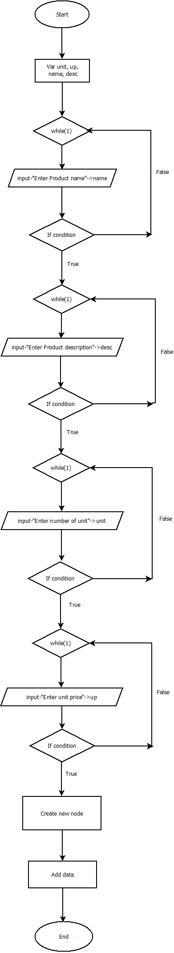

**8.2 Customer Registration**

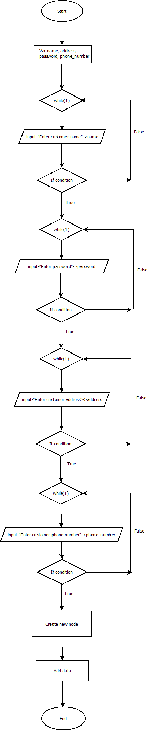

**8.3 Main Function**

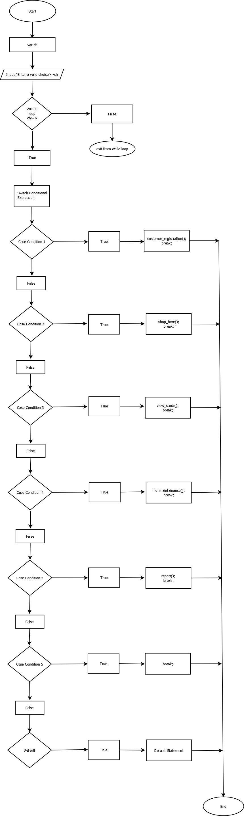

1. **Flow Diagram**

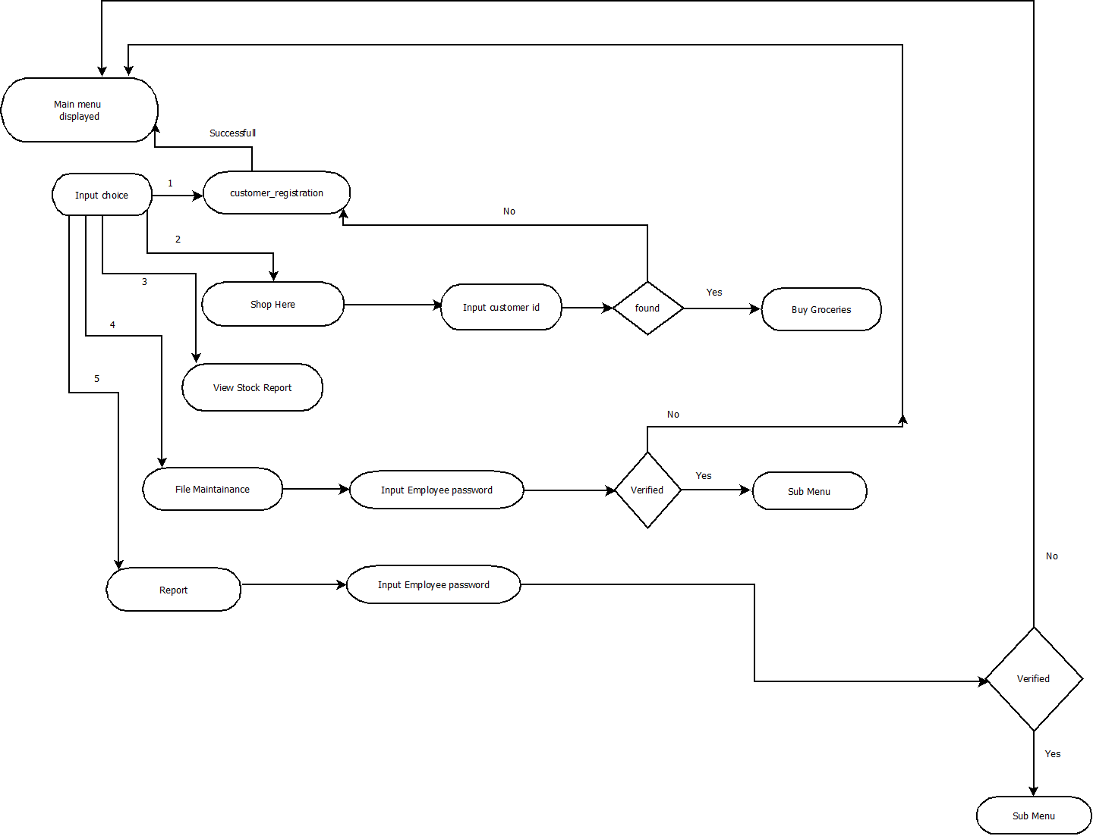

1. **Data Flow Diagram**

**Level 0**

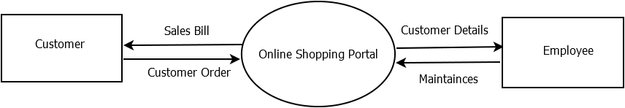

**Level 1**

