## **FileZilla**

## **Pre-requisites:**

* FileZilla setup file ' FileZilla_3.57.0_win64_sponsored2-setup.exe' setup file must be downloaded from below-
* **URL:** https://filezilla-project.org/download.php?type=client
* User should have administrator rights to install the FileZilla setup file 'FileZilla_3.57.0_win64_sponsored2-setup.exe

## **Installation:**

* + - Log in to the machine where FileZilla will be installed.
    - Navigate to the directory where 'FileZilla_3.57.0_win64_sponsored2-setup.exe' file is copied.
    - Double click on 'FileZilla_3.57.0_win64_sponsored2-setup.exe'. After that the 'License Agreement' windows will be opened.

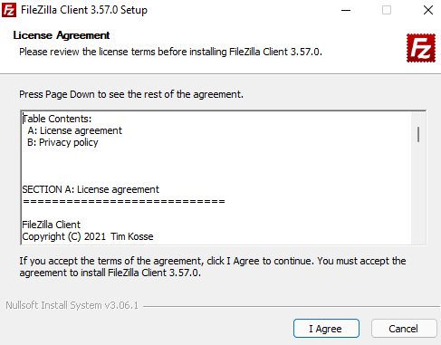

* + - Click on 'Next' Button. After that 'Optional Offer' windows will be opened.

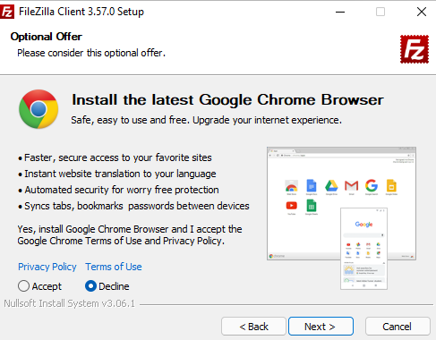

* + - Click on 'Next' Button. After that 'Choose Installation Options' windows will be opened.

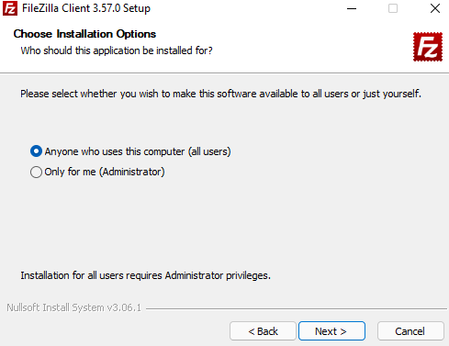

* + - Click on 'Next' Button. After that 'Choose Components' windows will be opened.

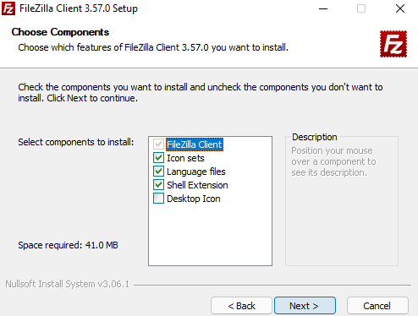

* + - Click on 'Next' Button. After that 'Choose Install Location' windows will be opened.

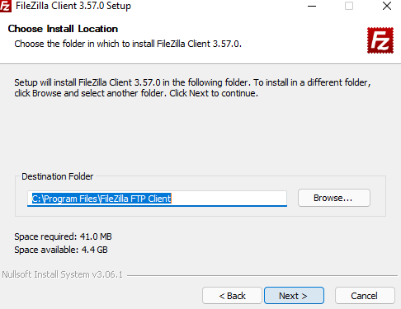

* + - Click on 'Next' Button. After that 'Choose Start Menu Folder' windows will be opened.

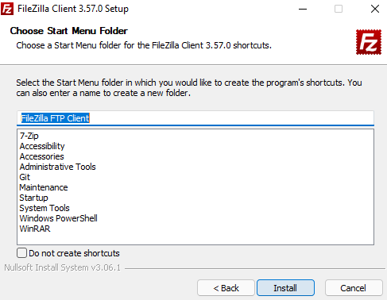

* + - Click on 'Install' Button. After the installation 'Completing FileZilla Client 3.57.0 Setup' windows will be opened.

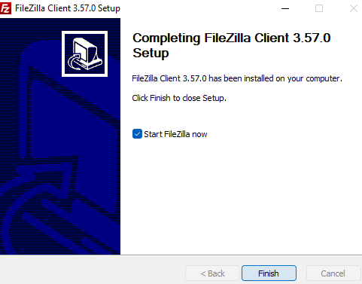

* + - Then Click on 'Finish' Button

## **Verification:**

* Log in to the machine where FileZilla is copied.
* Navigate to the specific directory where ' FileZilla_3.57.0_win64_sponsored2-setup.exe' is copied. (C:\Share\FileZilla).
* ' FileZilla Client 3.57.0.exe' must be present into the directory.

