## **Firefox**

## **Pre-requisites:**

* Firefox setup file ' Firefox_Setup_96.0.3.exe' setup file must be downloaded from below-
* **URL:** <https://cdn.stubdownloader.services.mozilla.com/builds/firefox-latest-ssl/en-US/win/c4138c546ea31a10dc48cdfe1af8b76dcd680ae2d4b55369e0f919a1440bc3b4/Firefox%20Setup%2096.0.3.exe>
* User should have administrator rights to install the Firefox setup file 'Firefox_Setup_96.0.3.exe

## **Installation:**

* + - Log in to the machine where Firefox will be installed.
    - Navigate to the directory where 'Firefox_Setup_96.0.3.exe' file is copied.
    - Double click on 'Firefox_Setup_96.0.3.exe'. After that the 'Extraction' Process will be started and 'Welcome to the Mozilla Firefox Setup Wizard' windows will be opened.

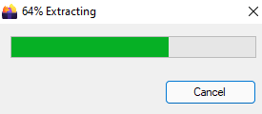

* Click on 'Next' Button. After that 'Welcome to the Mozilla Firefox Setup Wizard ' windows will be opened.

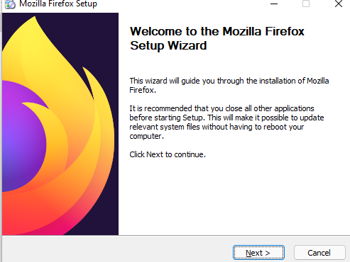

* + - Click on 'Next' Button. After that 'Setup Type' windows will be opened.

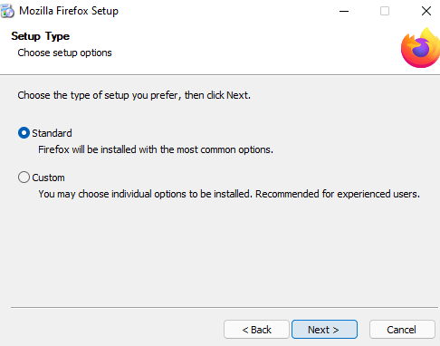

* + - Click on 'Next' Button. After that 'Summary' windows will be opened.

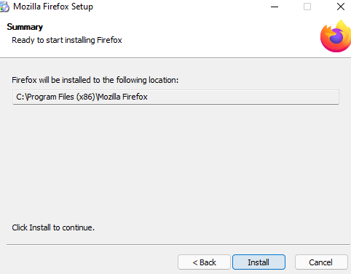

* + - Click on 'Install' Button. After the installation 'Completing the Mozilla Firefox Setup Wizard' windows will be opened. Then ‘Click’ on Finish.

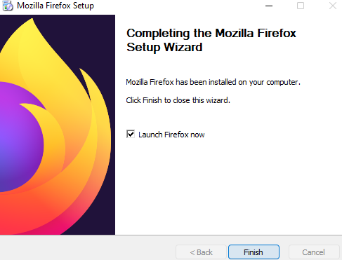

## **Verification:**

* + - Log in to the machine where Firefox has been installed.
    - Open 'Control Panel'.
    - Navigate to 'Programs\Programs and Features'.
    - 'Mozilla Firefox (x86 en-US)' must be present in the installed software list.

