**Installation of Grafana**

## **Install Grafana:**

## **Disable** **the SELinux status**

**Prerequisite:**

1. Centos 7.9(RHEL) should be already installed on machine with the following architecture.

RAM: 2 GB RAM

HD: 10 GB Avg local disk storage.

Software requirement: GOLANG (go1.11.5 linux/amd64)

**Steps:**

1. Disable SELinux

The first step is to check the SELinux status and disable it if it is enabled.

**Command:**

# getenforce

2. Modify SELinux configurations as follows:

**Command:**

# vim /etc/sysconfig/selinux

**Note:** Change SELINUX=enforcing to SELINUX=disabled

3. Reboot system.

**Command:**

# reboot

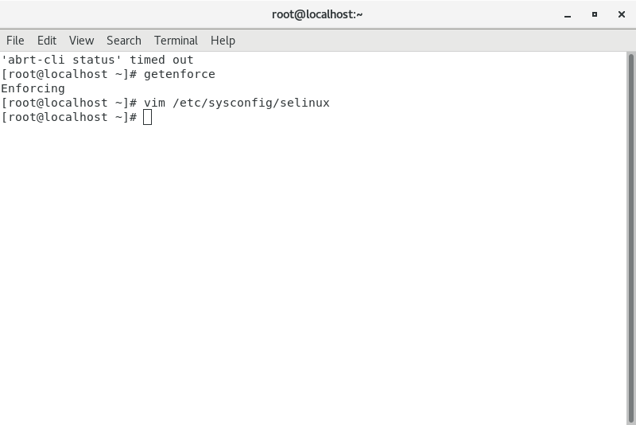

## **Install Grafana:**

**Prerequisite :**

Item No 2.1.1 must be performed.

**Steps :**

1. Installing Grafana via YUM Repository

Create a repo file.

**Command:**

# vim /etc/yum.repos.d/grafana.repo

2.Add the following contents to file:

**Content:**

[grafana]

name=grafana

baseurl=https://packages.grafana.com/oss/rpm

repo_gpgcheck=1

enabled=1

gpgcheck=1

gpgkey=https://packages.grafana.com/gpg.key

sslverify=1

sslcacert=/etc/pki/tls/certs/ca-bundle.crt

3. Install Grafana

Enter the following command:

**Command:**

# sudo yum install grafana

4. Install additional font packages

Continue with following commands to install the free type and urw fonts.

**Command:**

# yum install fontconfig

# yum install freetype*

# yum install urw-fonts

5. Enable Grafana Service

Check the status of the service.

**Command:**

# systemctl status grafana-server

6. If service is not active, start it using the following command:

# systemctl start grafana-server

7. Enable Grafana service on system boot

**Command:**

# systemctl enable grafana-server.service

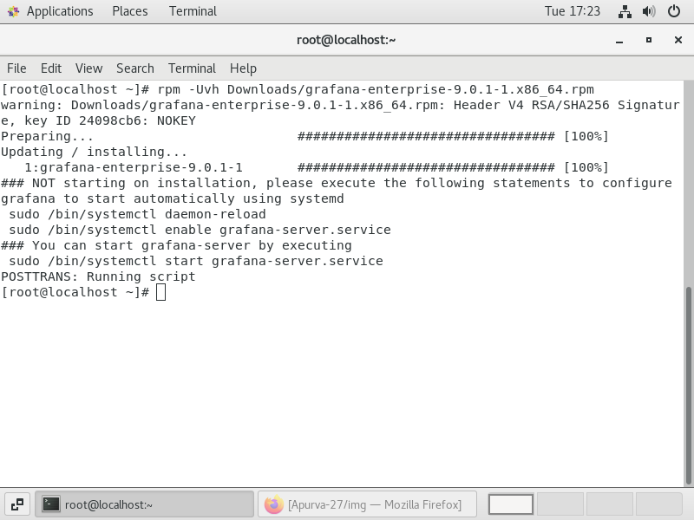

## **Grafana port add on Firewall:**

**Prerequisite:**

Item No 2 must be performed.

**Steps:**

1.Change firewall configuration to allow Grafana port. So run following command.

# firewall-cmd --zone=public --add-port=3000/tcp --permanent

2. Reload firewall service.

Command:

# firewall-cmd –reload

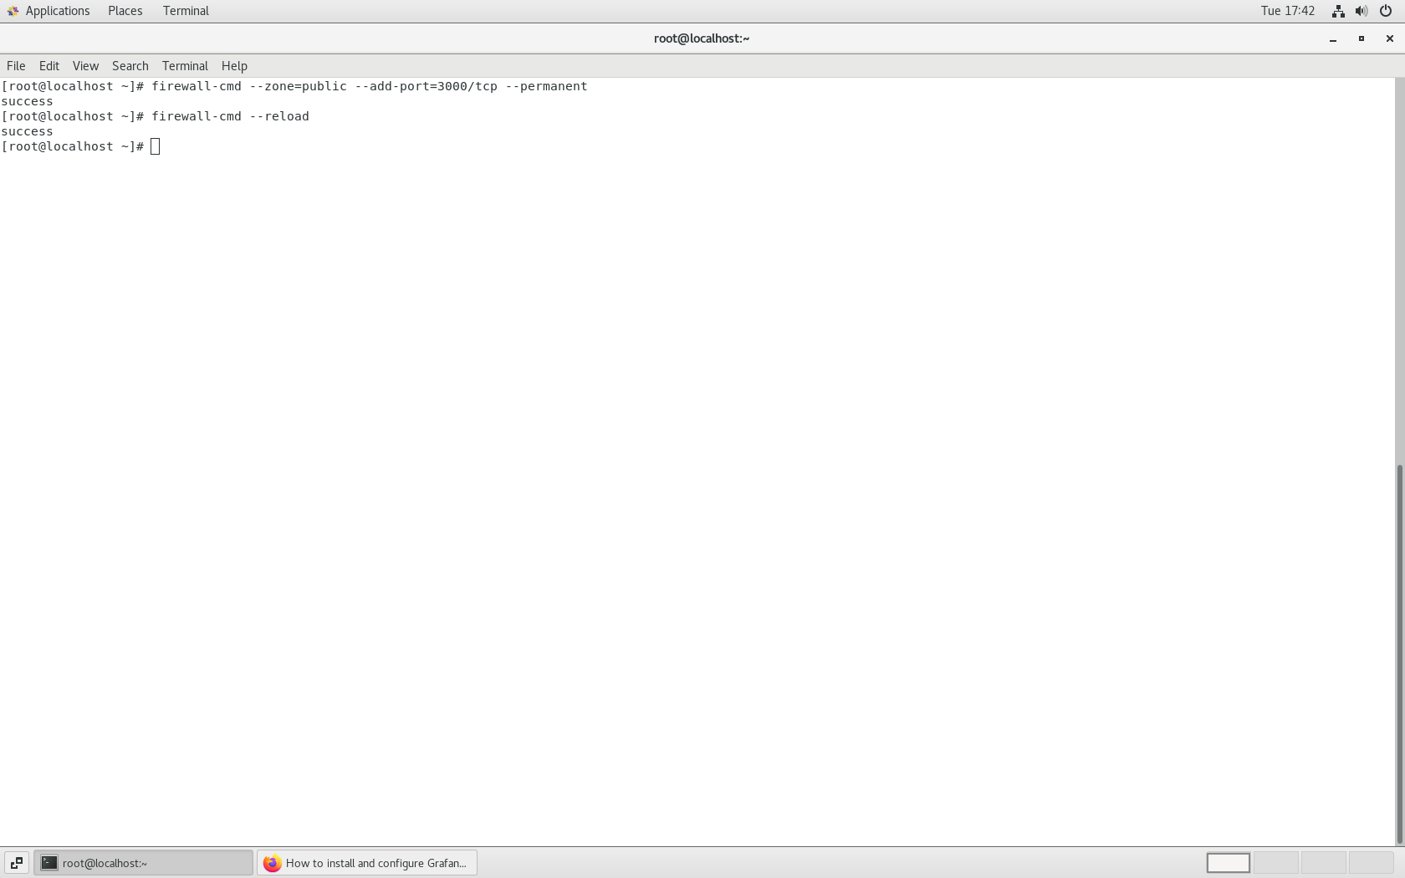

## **Add Data Source (Prometheus) in Grafana**

**Prerequisite :**

Item No 2.1.2 must be performed.

**Steps:**

1. Login grafana server

http://<Your Server IP or Host Name>:3000/

2. Click on data source tab and then click on add data source.

3. Click on prometheus and enter the promether server URL.

4. Click on save and test.

## **Evidence**

**Verification:**

1.Use the following URL to access the Grafana web interface.

http://<Your Server IP or Host Name>:3000/

2.Enter “admin” in the login and password fields for first-time use; then it should ask you to change the password.

3.It should redirect to the Dashboard.

