1. Install Kerberos pre-requisites.

$ yum -y install gcc python-devel krb5-devel krb5-libs krb5-workstation

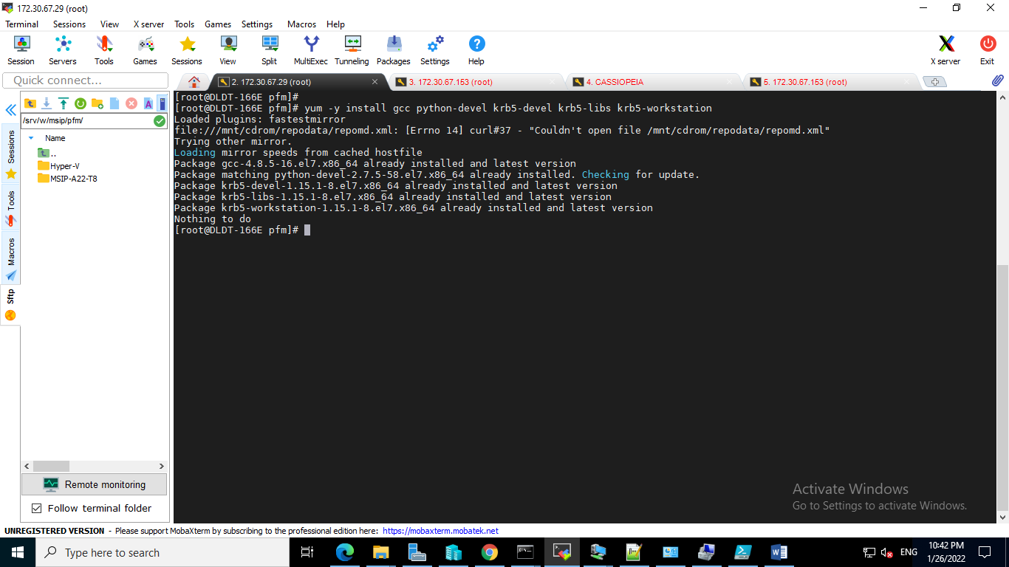

1. Install pywnrm Kerberos.

$ pip install pywinrm[kerberos]

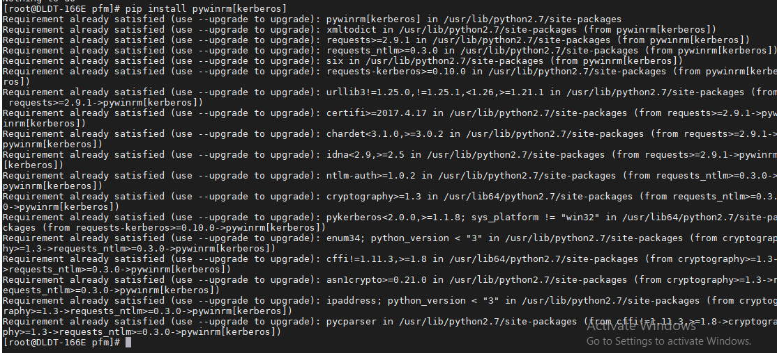

1. Edit the file '/etc/krb5.conf' and do the below configuration:

$ vi /etc/krb5.conf

And do the below configuration

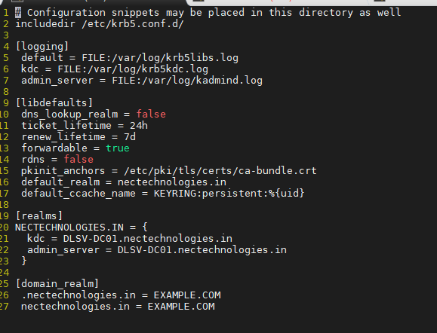

1. Create ticket for user that will used to create WinRM connection with below command.

$ kinit [<user>](mailto:CASSIOPEIA.Admin@NECTECHNOLOGIES.IN)@<domain_name>

Eg: kinit [CASSIOPEIA.Admin@NECTECHNOLOGIES.IN](mailto:CASSIOPEIA.Admin@NECTECHNOLOGIES.IN)

And Enter the password for use when prompted.



1. Verify that ticket has been created with below command:

$ klist

